Q1

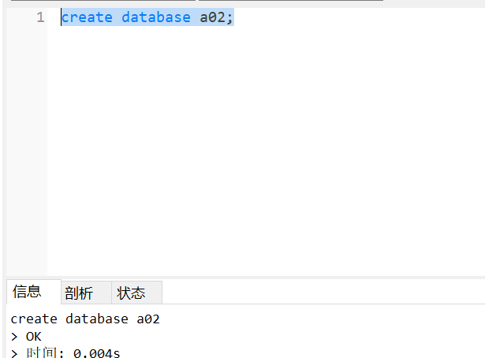

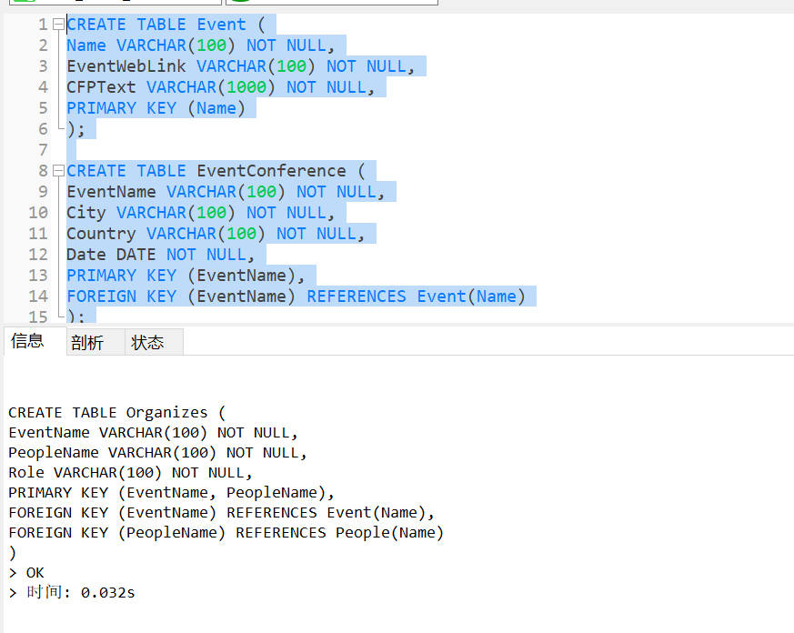

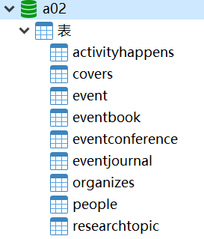

# Q2

set @EventName='The WFCS workshop';

insert into event values(@EventName,

' http://wfcs2019.com',

'The WFCS workshop is the largest IEEE technical event specially dedicated to industrial communication systems. The

aim of this workshop is to provide a forum for researchers, practitioners and developers to review current trends in this

area and to present and discuss new ideas and new research directions.');

insert into eventjournal values(@EventName,'IEEE Communications Society Tech','IEEE');

insert into activityhappens values(@EventName, 'Submission deadline', '2019-04-01'),

(@EventName, 'Notification for acceptance', '2019-04-30'),

(@EventName, 'Deadline for final manuscript', '2019-05-06'),

(@EventName, 'Conference', '2019-05-27');

set @Topic1='INDUSTRIAL COMMUNICATION SYSTEMS AND SOLUTIONS';

set @Area1='Ethernet';

set @Topic2='INDUSTRIAL CYBER-PHYSICAL SYSTEMS (ICPS)';

set @Area2='ICPS communication architectures';

set @Topic3='INDUSTRIAL NETWORK PERFORMANCE EVALUATION';

set @Area3='network';

insert into researchtopic values(@Topic1,@Area1),(@Topic2,@Area2),(@Topic3,@Area3);

insert into covers values(@EventName,@Topic1),(@EventName,@Topic2),(@EventName,@Topic3);

set @Person1='Emiliano Sisinni';

set @Aff1='University of Brescia, Italy';

set @Person2='Gerhard P. Hancke Jr';

set @Aff2='City University of Hong Kong, Hong Kong';

set @Person3='Nuno Pereira';

set @Aff3='Polytechnic Institute of Porto, Portugal';

set @Person4='Tomas Lennvall';

set @Aff4='Örebro University, Sweden';

set @Role1='PROGRAM CO-CHAIRS';

set @Role2='WORK-IN-PROGRESS CHAIRS';

insert into People values (@Person1,@Aff1),(@Person2,@Aff2),(@Person3,@Aff3),(@Person4,@Aff4);

insert into Organizes values

(@EventName, @Person1, @Role1),

(@EventName, @Person2, @Role1),

(@EventName, @Person3, @Role2),

(@EventName, @Person4, @Role2);

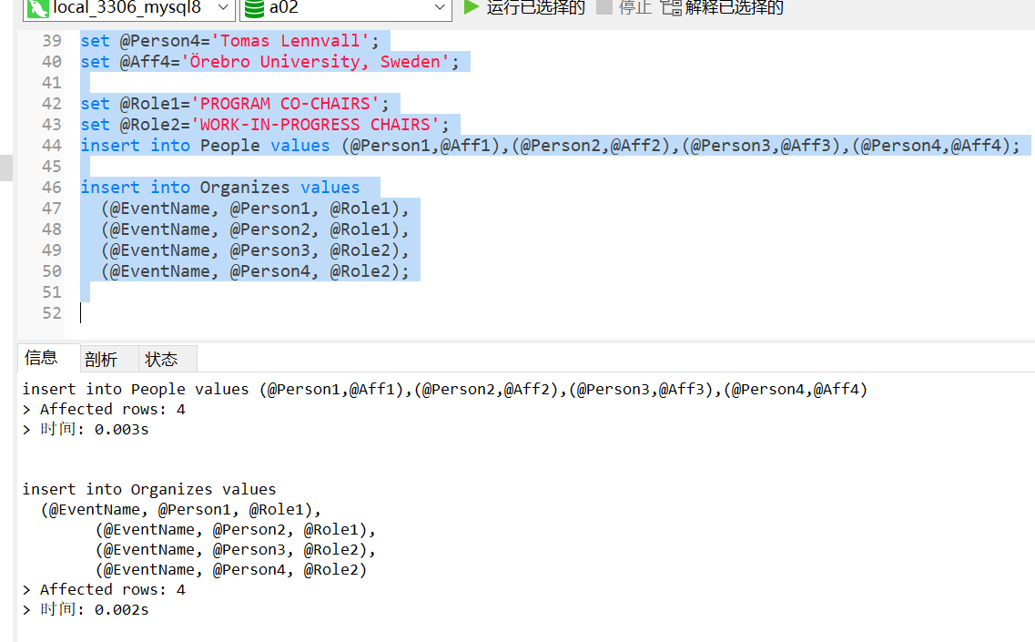

# Q3

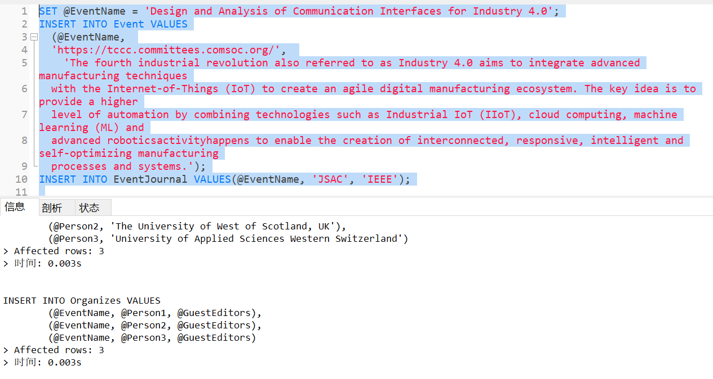

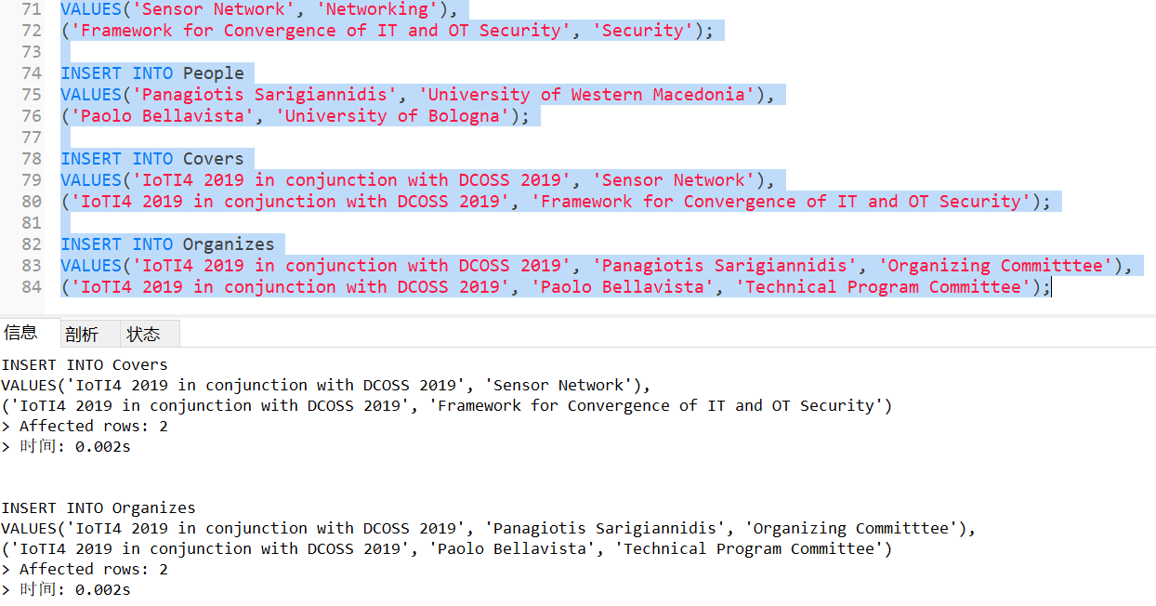

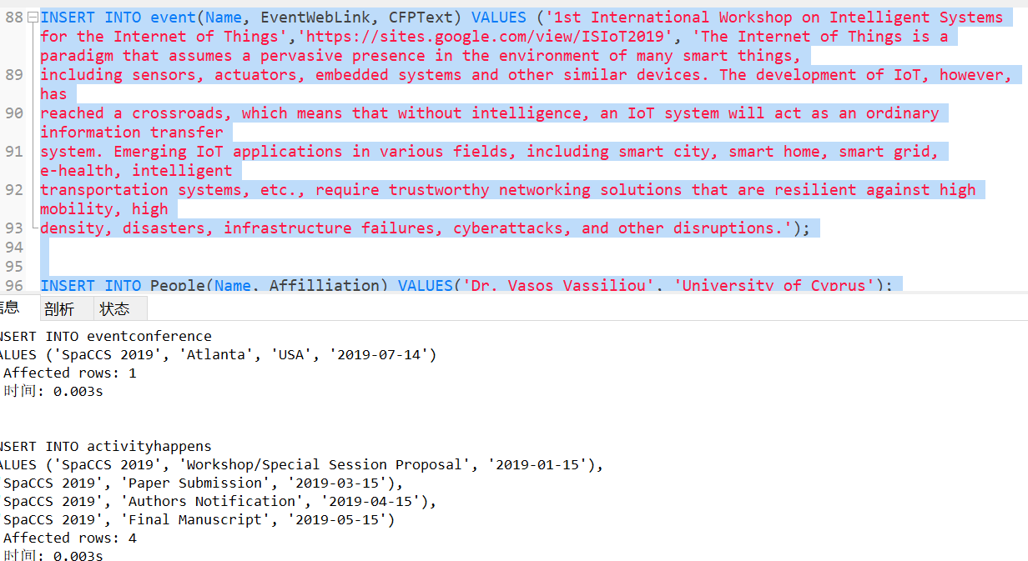

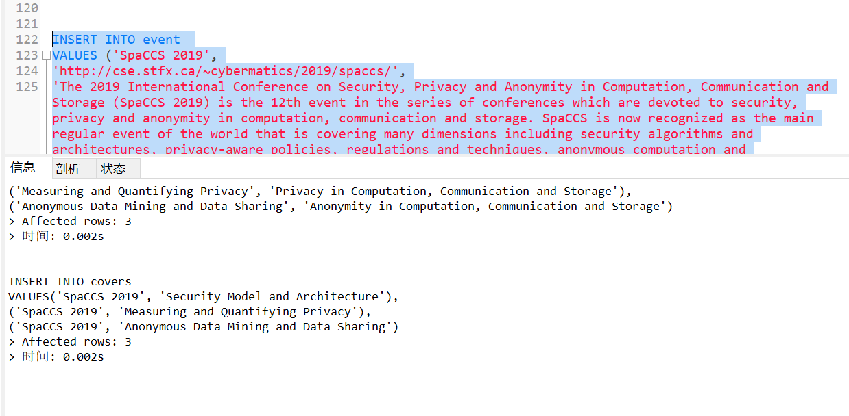

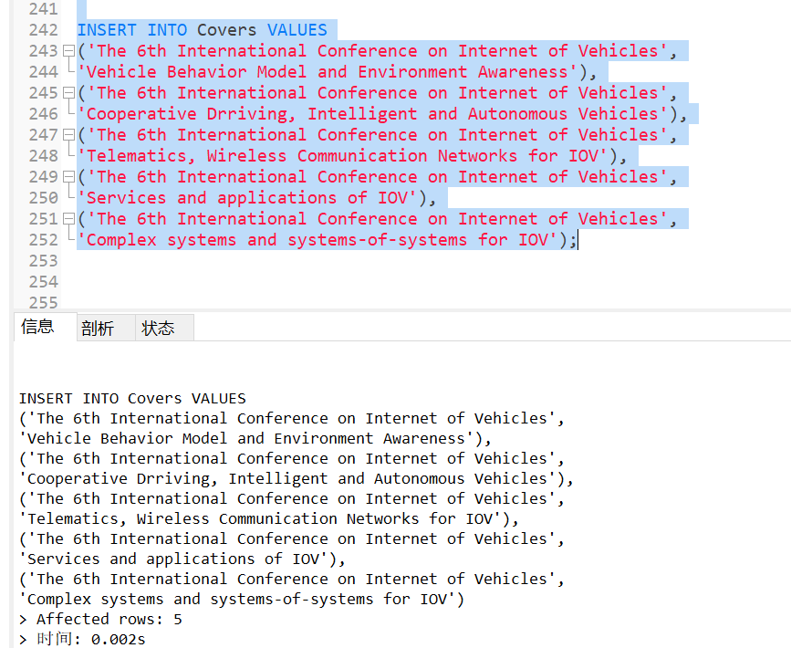

# Q4

1)

select DATE_FORMAT(ec.`Date`,'%Y-%m') as months,count(distinct ec.EventName) as count_event_type,

count(ah.ActivityName) as activity_count

from eventconference ec join activityhappens ah on DATE_FORMAT(ec.Date,'%Y-%m')=DATE_FORMAT(ah.ActivityDate,'%Y-%m')

group by DATE_FORMAT(ec.Date,'%Y-%m');

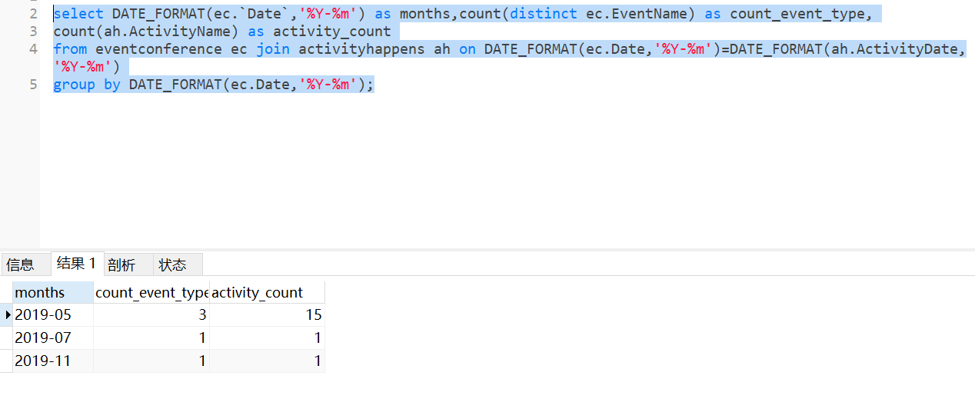

2)

select t2.EventName, t1.ActivityName

from

(

select e.`Name`, ah.ActivityName, ah.ActivityDate

from event e join activityhappens ah on e.`Name`=ah.EventName

) t1,

(

select EventName,min(ActivityDate) as min_activity_date

from activityhappens

group by EventName

) t2

where t1.`Name`=t2.EventName and t1.ActivityDate=t2.min_activity_date;

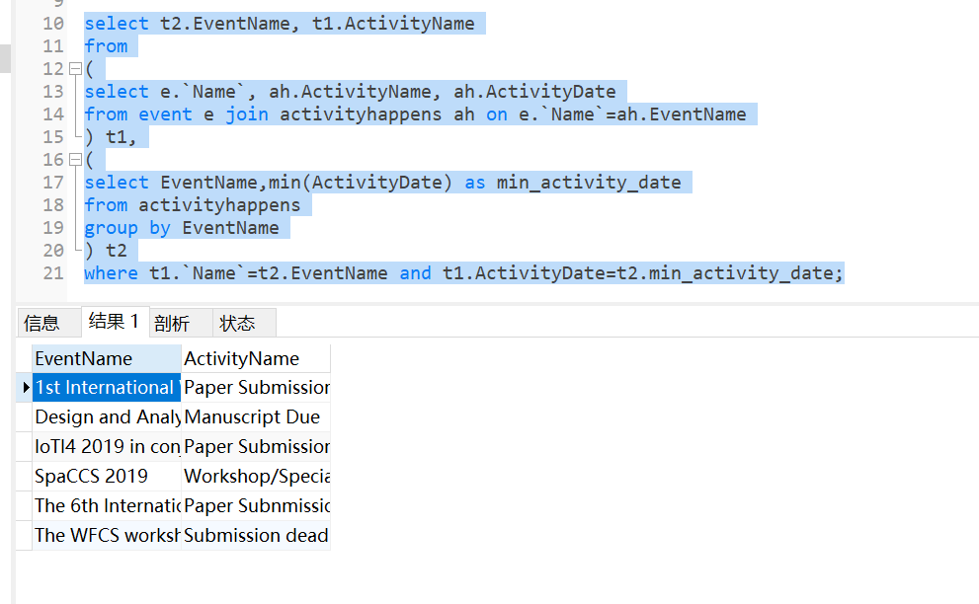

# Cfpcount table

create table cfpcount(

type varchar(100) primary key,

cfp_count int

);

delimiter $

create trigger trg_cfpcount after insert on researchtopic

for each row

begin

declare total int;

select count(type) into total from cfpcount where type=new.area;

if total>0 then

update cfpcount set cfp_count=cfp_count+1 where type=new.area;

else

insert into cfpcount values(new.area,1);

end if;

end $

delimiter $

create trigger trg_cfpcount1 after delete on researchtopic

for each row

begin

declare total int;

select count(type) into total from cfpcount where type=old.area;

if total>0 then

update cfpcount set cfp_count=cfp_count-1 where type=old.area;

else

delete from cfpcount where type=old.area;

end if;

end $

