## Part A

Download the csv files.

## Part B

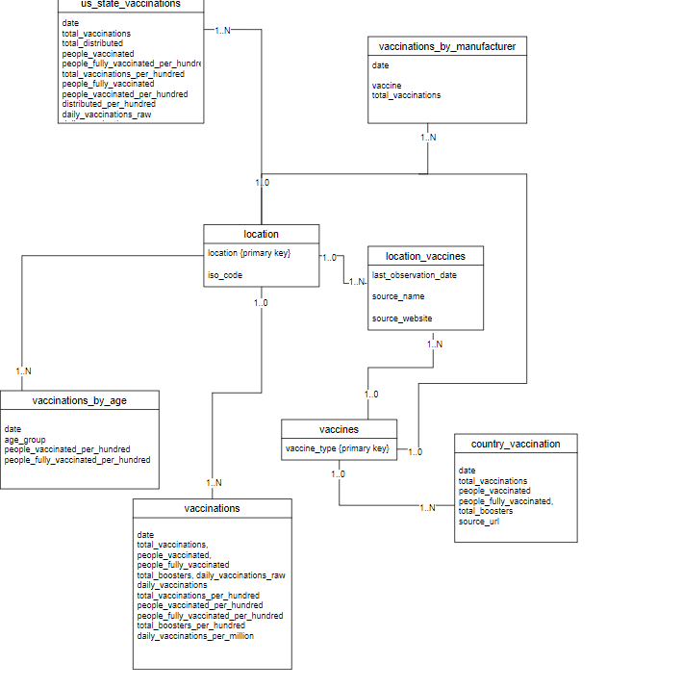

## Part C

Import the csv files into temp tables like following:

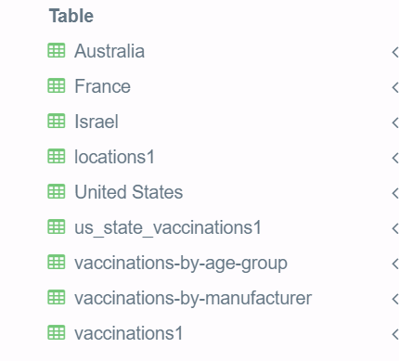

## Part D

Task D.1 For a given country (e.g., Afghanistan), list the total number of vaccines administered in

each observation date recorded in the dataset from the first observation until the end of June 2021.

For the example of Afghanistan, each column in the expected result set will have the following

structure. 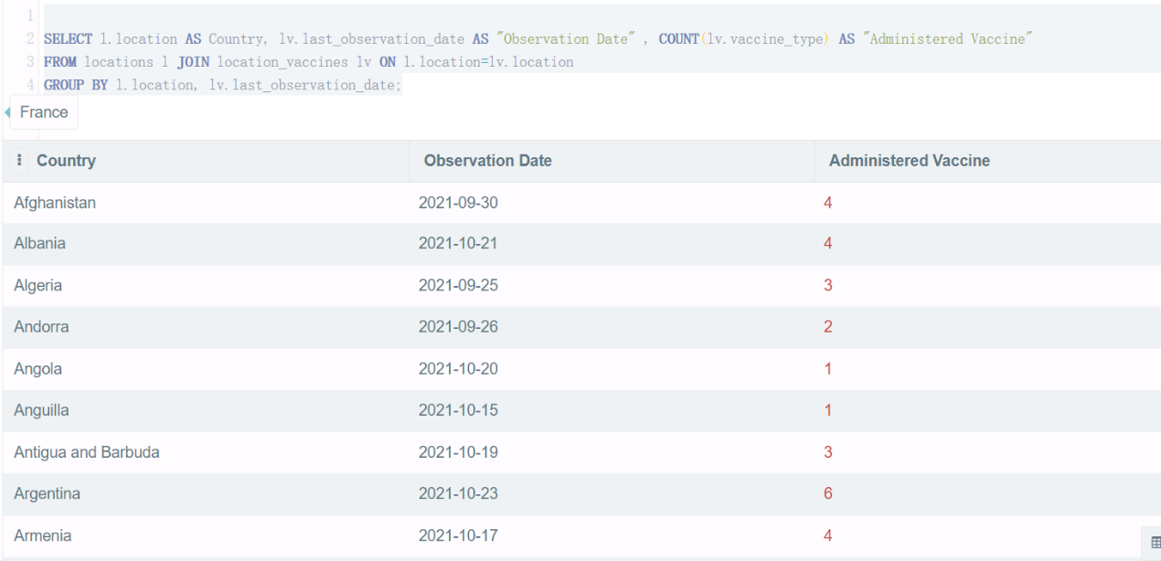

Task D.2 Produces a result set containing cumulative number of COVID-19 doses administered by each country. That is, the name of each country and the cumulative number of doses administered in that country. Each column in the expected result set will have the following structure.

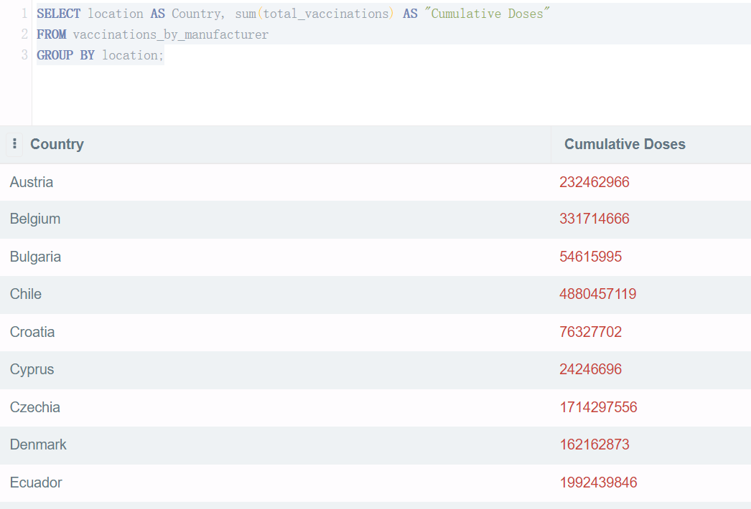

Task D.3 Produce a list of all countries with the type of vaccines (e.g., Oxford/AstraZeneca,

Pfizer/BioNTech) administered in each country. For a country that has administered several types of

vaccine, the result set is required to show several tuples reporting each type of vaccine in a separate

tuple.

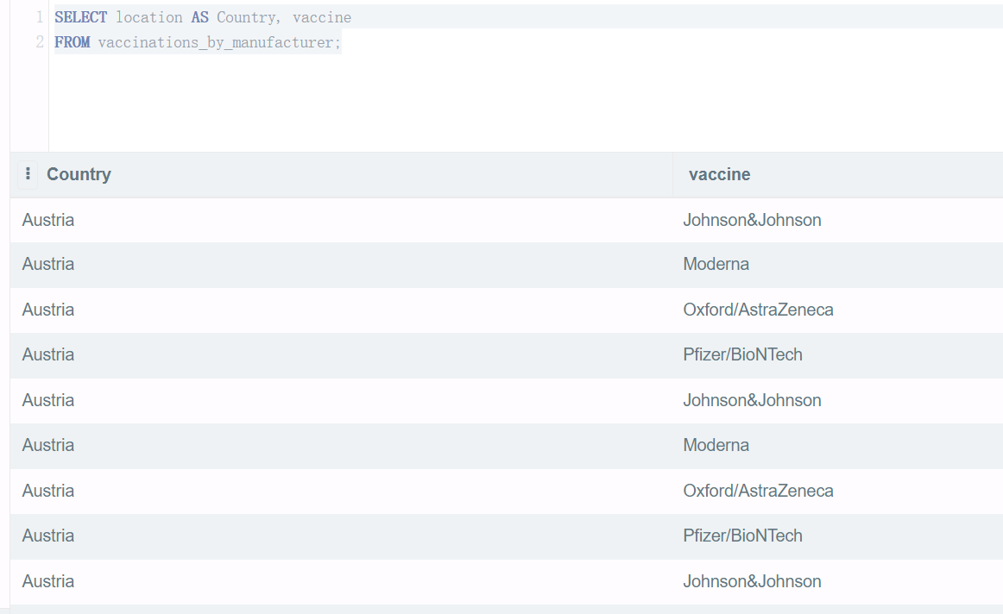

Task D.4 There are different sources of data used to produce the data set. Produce a report showing the total number of vaccines administered according to each data source. Order the result set by the total number of administered vaccines. Source Name Total Administered Vaccines Source URL

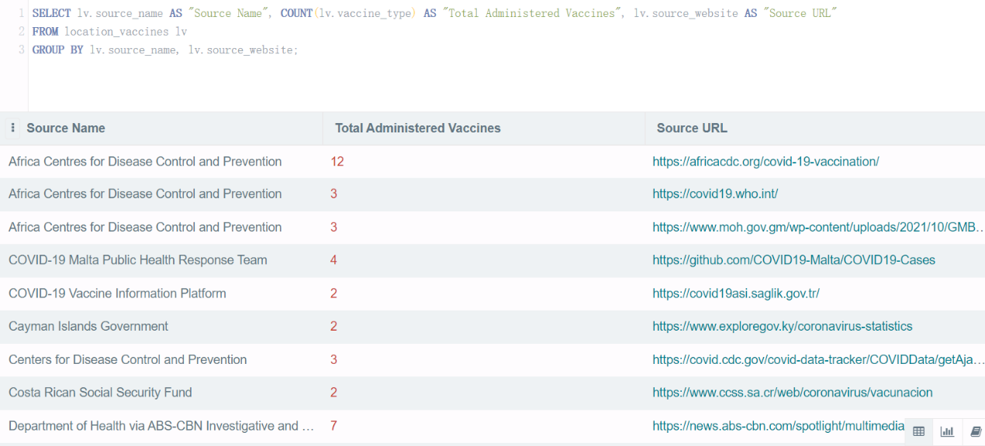

Task D.5 How does various countries compare in the speed of their vaccine administration? Produce a report that lists all the observation dates and, for each date, list the total number of people fully vaccinated in each one of the 4 countries used in this assignment.

