## Task1

### -- Task1.1

ALTER TABLE actor ADD CONSTRAINT PK_ACTORID PRIMARY KEY (actor_id);

/*

Question: Which constraints in Table 1 have been created on these six tables?

*/

primary key and foreign key

### -- Task1.2

ALTER TABLE actor ADD CONSTRAINT PK_ACTORID PRIMARY KEY (actor_id);

ALTER TABLE film ADD CONSTRAINT PK_FILMID PRIMARY KEY (film_id);

ALTER TABLE film_actor ADD CONSTRAINT FK_FILMID1 FOREIGN KEY (film_id) REFERENCES film;

ALTER TABLE category ADD CONSTRAINT PK_CATEGORYID PRIMARY KEY (category_id );

ALTER TABLE language ADD CONSTRAINT PK_LANGUAGEID PRIMARY KEY (language_id );

ALTER TABLE film ADD CONSTRAINT UN_DESCRIPTION UNIQUE(description);

ALTER TABLE actor ADD CONSTRAINT CK_FNAME CHECK (first_name IS NOT NULL);

ALTER TABLE actor ADD CONSTRAINT CK_LNAME CHECK (last_name IS NOT NULL);

ALTER TABLE category ADD CONSTRAINT CK_CATNAME CHECK (name IS NOT NULL);

ALTER TABLE language ADD CONSTRAINT CK_LANNAME CHECK (name IS NOT NULL);

ALTER TABLE film ADD CONSTRAINT CK_TITLE CHECK (title IS NOT NULL);

ALTER TABLE film ADD CONSTRAINT CK_RELEASEYR CHECK (release_year<=2020);

ALTER TABLE film ADD CONSTRAINT CK_RATING CHECK (rating IN('G', 'PG', 'PG-13', 'R', 'NC-17'));

ALTER TABLE film ADD CONSTRAINT CK_SPLFEATURES CHECK (special_features IN(null, 'Trailers',

'Commentaries', 'Deleted

Scenes', 'Behind the Scenes'));

ALTER TABLE film ADD CONSTRAINT FK_LANGUAGEID FOREIGN KEY (language_id) REFERENCES language(language_id);

ALTER TABLE film ADD CONSTRAINT FK_ORLANGUAGEID FOREIGN KEY (original_language_id ) REFERENCES language(language_id);

ALTER TABLE film_actor ADD CONSTRAINT FK_ACTORID FOREIGN KEY (actor_id ) REFERENCES actor(actor_id);

ALTER TABLE film_category ADD CONSTRAINT FK_CATEGORYID FOREIGN KEY (category_id ) REFERENCES category(category_id);

ALTER TABLE film_category ADD CONSTRAINT FK_FILMID2 FOREIGN KEY (film_id ) REFERENCES film(film_id);

## Task2

### -- 1

create sequence FILM_ID_SEQ

start with 20010

increment by 10;

### -- 2

create trigger BI_FILM_ID

before insert on film for each row

begin

select FILM_ID_SEQ.nextval into :new.film_id from dual;

end;

/*

INSERT INTO FILM (TITLE, DESCRIPTION, LANGUAGE_ID) VALUES ('B Movie 1', 'Movie about wasps 1', 1);

select * from film where title='B Movie 1';

*/

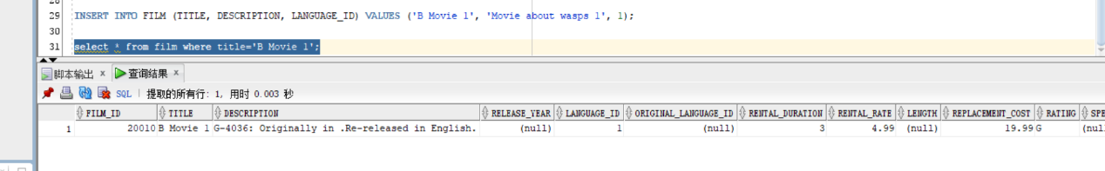

### -- 3

-- drop trigger BI_FILM_DESP;

create trigger BI_FILM_DESP

before insert on film for each row

begin

select :new.rating||'-'||(select count(*)+1 from film where rating=:new.rating)||': '||'Originally in '|| (select name

from language where language_id=:new.original_language_id)

||'.'||'Re-released in '||(select name

from language where language_id=:New.language_id) ||'.'

into :new.description from dual;

end;

/*

INSERT INTO film (title, description, language_id, original_language_id, rating)

VALUES ('B Movie', 'Movie about wasps.', 1, 2, 'PG');

SELECT description FROM film WHERE film_id = 20020;

*/

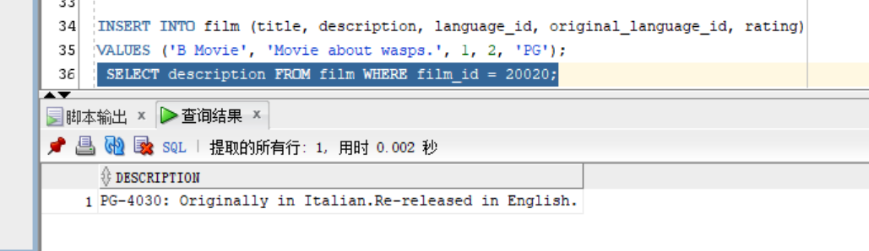

## Task3

### -- 1

select f.title, f.length

from film f

join

(

select min(length) as length from film f join film_category fc on f.film_id=fc.film_id

join category c on c.category_id=fc.category_id

where c.name='Action'

) t on f.length=t.length;

### -- 2

create or replace view MIN_ACTION_ACTORS

as

select distinct a.actor_id, a.first_name, a.last_name

from actor a join film_actor fa on a.actor_id=fa.actor_id

join film f on f.film_id=fa.film_id

join (

select f.title, f.length

from film f

join

(

select min(length) as length from film f join film_category fc on f.film_id=fc.film_id

join category c on c.category_id=fc.category_id

where c.name='Action'

) t on f.length=t.length

) v1 on v1.title=f.title;

SELECT * FROM MIN_ACTION_ACTORS;

### -- 3

create or replace view V_ACTION_ACTORS_2012

as

select distinct a.actor_id, a.first_name, a.last_name

from actor a join film_actor fa on a.actor_id=fa.actor_id

join film f on f.film_id=fa.film_id

join film_category fc on fc.film_id=f.film_id

join category c on c.category_id=fc.category_id

where c.name='Action' and f.release_year=2012;

SELECT * FROM V_ACTION_ACTORS_2012;

### -- 4

create materialized view MV_ACTION_ACTORS_2012

as

select distinct a.actor_id, a.first_name, a.last_name

from actor a join film_actor fa on a.actor_id=fa.actor_id

join film f on f.film_id=fa.film_id

join film_category fc on fc.film_id=f.film_id

join category c on c.category_id=fc.category_id

where c.name='Action' and f.release_year=2012;

SELECT * FROM MV_ACTION_ACTORS_2012;

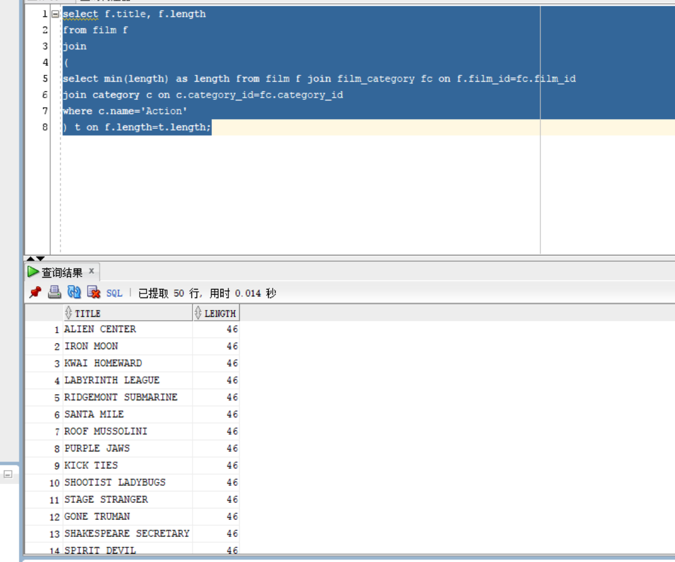

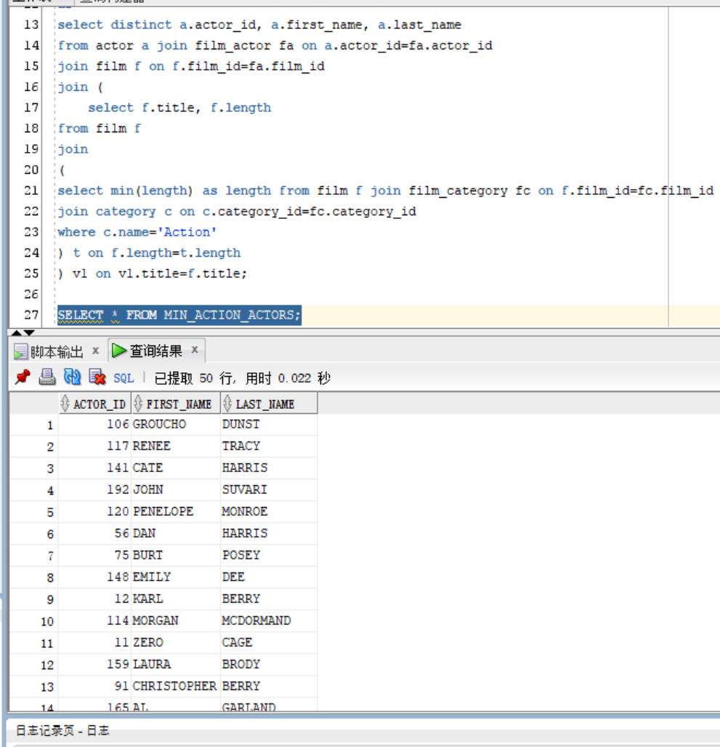

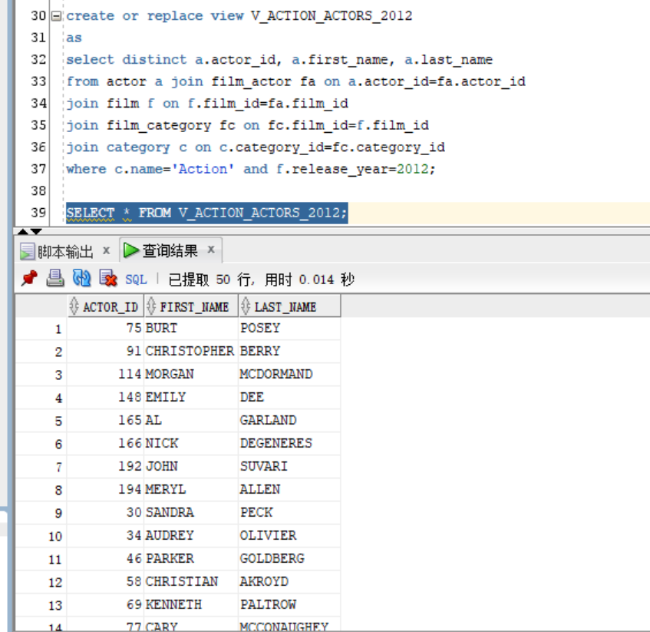

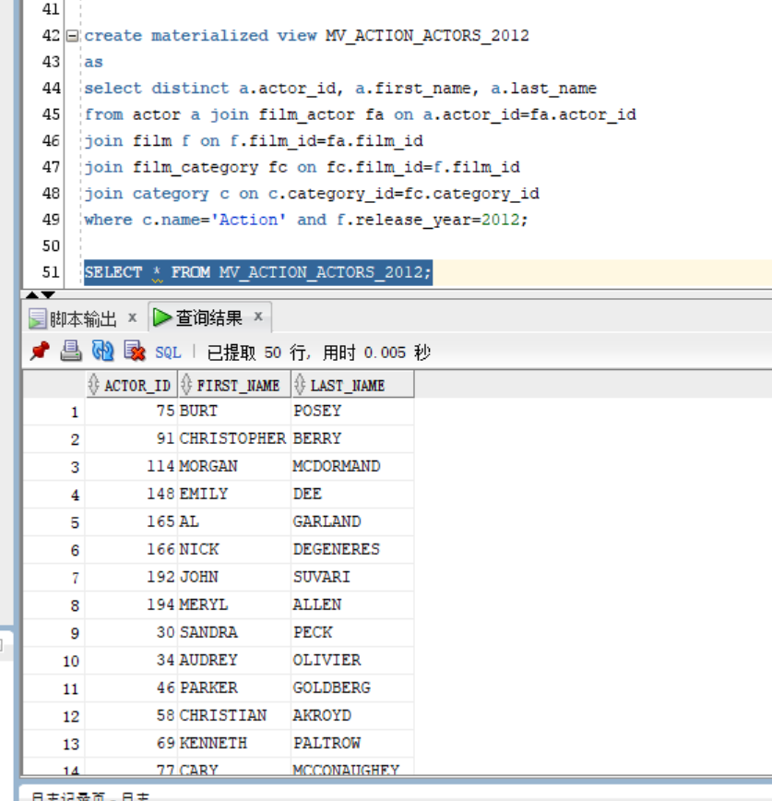

### -- 5

SQL> explain plan for SELECT * FROM V_ACTION_ACTORS_2012;

Explained.

SQL> select * from table(dbms_xplan.display());

PLAN_TABLE_OUTPUT

--------------------------------------------------------------------------------

Plan hash value: 1938178838

--------------------------------------------------------------------------------

------------------

| Id | Operation | Name | Rows | Bytes | Cost

(%CPU)| Time |

--------------------------------------------------------------------------------

------------------

PLAN_TABLE_OUTPUT

--------------------------------------------------------------------------------

| 0 | SELECT STATEMENT | | 121 | 7381 | 223

(1)| 00:00:01 |

| 1 | VIEW | V_ACTION_ACTORS_2012 | 121 | 7381 | 223

(1)| 00:00:01 |

| 2 | HASH UNIQUE | | 121 | 5929 | 223

(1)| 00:00:01 |

|* 3 | HASH JOIN | | 121 | 5929 | 222

(1)| 00:00:01 |

PLAN_TABLE_OUTPUT

--------------------------------------------------------------------------------

|* 4 | HASH JOIN | | 121 | 3993 | 219

(1)| 00:00:01 |

|* 5 | HASH JOIN SEMI | | 19 | 494 | 150

(0)| 00:00:01 |

| 6 | MERGE JOIN CARTESIAN| | 303 | 5757 | 139

(0)| 00:00:01 |

|* 7 | TABLE ACCESS FULL | CATEGORY | 1 | 10 | 3

PLAN_TABLE_OUTPUT

--------------------------------------------------------------------------------

(0)| 00:00:01 |

| 8 | BUFFER SORT | | 303 | 2727 | 136

(0)| 00:00:01 |

|* 9 | TABLE ACCESS FULL | FILM | 303 | 2727 | 136

(0)| 00:00:01 |

| 10 | TABLE ACCESS FULL | FILM_CATEGORY | 20000 | 136K| 11

(0)| 00:00:01 |

PLAN_TABLE_OUTPUT

--------------------------------------------------------------------------------

| 11 | TABLE ACCESS FULL | FILM_ACTOR | 128K| 879K| 69

(2)| 00:00:01 |

| 12 | TABLE ACCESS FULL | ACTOR | 200 | 3200 | 3

(0)| 00:00:01 |

--------------------------------------------------------------------------------

------------------

Predicate Information (identified by operation id):

PLAN_TABLE_OUTPUT

--------------------------------------------------------------------------------

---------------------------------------------------

3 - access("A"."ACTOR_ID"="FA"."ACTOR_ID")

4 - access("F"."FILM_ID"="FA"."FILM_ID")

5 - access("C"."CATEGORY_ID"="FC"."CATEGORY_ID" AND "FC"."FILM_ID"="F"."FILM_

ID")

7 - filter("C"."NAME"='Action')

9 - filter("F"."RELEASE_YEAR"=2012)

28 rows selected.

SQL> explain plan for SELECT * FROM MV_ACTION_ACTORS_2012;

Explained.

SQL> select * from table(dbms_xplan.display());

PLAN_TABLE_OUTPUT

--------------------------------------------------------------------------------

Plan hash value: 1015139828

--------------------------------------------------------------------------------

--------------

| Id | Operation | Name | Rows | Bytes | Cost (%CP

U)| Time |

--------------------------------------------------------------------------------

--------------

PLAN_TABLE_OUTPUT

--------------------------------------------------------------------------------

| 0 | SELECT STATEMENT | | 109 | 1744 | 3 (

0)| 00:00:01 |

| 1 | MAT_VIEW ACCESS FULL| MV_ACTION_ACTORS_2012 | 109 | 1744 | 3 (

0)| 00:00:01 |

--------------------------------------------------------------------------------

--------------

8 rows selected.

based on the execution plans above, the MV_ACTION_ACTORS_2012 indeed speed up the query processing.

## Task4

### -- 1

select *

from film

where instr(description,'Boat')>0 and rownum<=100

order by title;

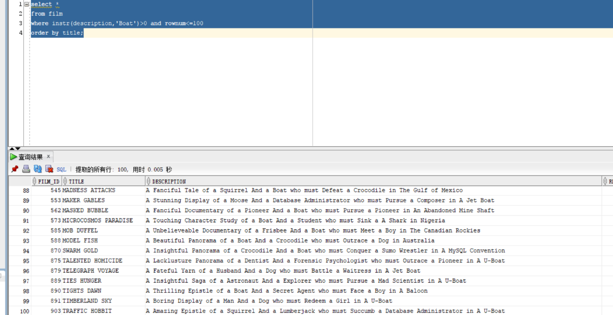

### -- 2

create index IDX_BOAT on film (instr(description,'Boat'));

### -- 3

SQL> explain plan for select *

from film

where instr(description,'Boat')>0 and rownum<=100

order by title;

Explained.

SQL> select * from table(dbms_xplan.display());

PLAN_TABLE_OUTPUT

--------------------------------------------------------------------------------

Plan hash value: 2306941308

----------------------------------------------------------------------------

| Id | Operation | Name | Rows | Bytes | Cost (%CPU)| Time |

----------------------------------------------------------------------------

| 0 | SELECT STATEMENT | | 100 | 15200 | 16 (7)| 00:00:01 |

| 1 | SORT ORDER BY | | 100 | 15200 | 16 (7)| 00:00:01 |

|* 2 | COUNT STOPKEY | | | | | |

|* 3 | TABLE ACCESS FULL| FILM | 100 | 15200 | 15 (0)| 00:00:01 |

----------------------------------------------------------------------------

PLAN_TABLE_OUTPUT

--------------------------------------------------------------------------------

Predicate Information (identified by operation id):

---------------------------------------------------

2 - filter(ROWNUM<=100)

3 - filter(INSTR("DESCRIPTION",'Boat')>0)

16 rows selected.

Execution Plan

----------------------------------------------------------

Plan hash value: 2137789089

--------------------------------------------------------------------------------

-------------

| Id | Operation | Name | Rows | Bytes | Cost (%CPU

)| Time |

--------------------------------------------------------------------------------

-------------

| 0 | SELECT STATEMENT | | 8168 | 16336 | 29 (0

)| 00:00:01 |

| 1 | COLLECTION ITERATOR PICKLER FETCH| DISPLAY | 8168 | 16336 | 29 (0

)| 00:00:01 |

--------------------------------------------------------------------- 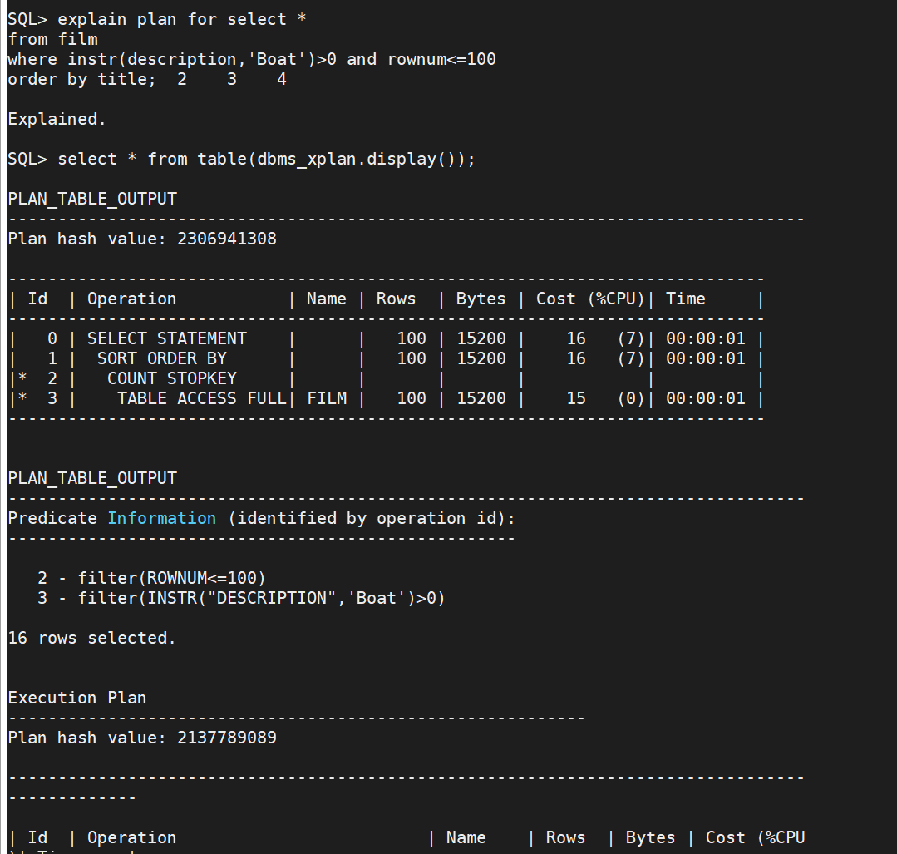

SQL> explain plan for select *

from film

where instr(description,'Boat')>0 and rownum<=100

order by title; 2 3 4

Explained.

SQL> select * from table(dbms_xplan.display());

PLAN_TABLE_OUTPUT

--------------------------------------------------------------------------------

Plan hash value: 2306941308

----------------------------------------------------------------------------

| Id | Operation | Name | Rows | Bytes | Cost (%CPU)| Time |

----------------------------------------------------------------------------

| 0 | SELECT STATEMENT | | 100 | 15200 | 16 (7)| 00:00:01 |

| 1 | SORT ORDER BY | | 100 | 15200 | 16 (7)| 00:00:01 |

|* 2 | COUNT STOPKEY | | | | | |

|* 3 | TABLE ACCESS FULL| FILM | 100 | 15200 | 15 (0)| 00:00:01 |

----------------------------------------------------------------------------

PLAN_TABLE_OUTPUT

--------------------------------------------------------------------------------

Predicate Information (identified by operation id):

---------------------------------------------------

2 - filter(ROWNUM<=100)

3 - filter(INSTR("DESCRIPTION",'Boat')>0)

16 rows selected.

Execution Plan

----------------------------------------------------------

Plan hash value: 2137789089

--------------------------------------------------------------------------------

-------------

| Id | Operation | Name | Rows | Bytes | Cost (%CPU

)| Time |

--------------------------------------------------------------------------------

-------------

| 0 | SELECT STATEMENT | | 8168 | 16336 | 29 (0

)| 00:00:01 |

| 1 | COLLECTION ITERATOR PICKLER FETCH| DISPLAY | 8168 | 16336 | 29 (0

)| 00:00:01 |

--------------------------------------------------------------------------------

-------------

SQL> create index IDX_BOAT on film (instr(description,'Boat'));

Index created.

SQL> explain plan for select *

from film

where instr(description,'Boat')>0 and rownum<=100

order by title; 2 3 4

Explained.

SQL> select * from table(dbms_xplan.display());

PLAN_TABLE_OUTPUT

--------------------------------------------------------------------------------

Plan hash value: 1934079693

--------------------------------------------------------------------------------

------------------

| Id | Operation | Name | Rows | Bytes | Cost

(%CPU)| Time |

--------------------------------------------------------------------------------

------------------

PLAN_TABLE_OUTPUT

--------------------------------------------------------------------------------

| 0 | SELECT STATEMENT | | 100 | 15200 | 5

(20)| 00:00:01 |

| 1 | SORT ORDER BY | | 100 | 15200 | 5

(20)| 00:00:01 |

|* 2 | COUNT STOPKEY | | | |

| |

| 3 | TABLE ACCESS BY INDEX ROWID BATCHED| FILM | 101 | 15352 | 4

(0)| 00:00:01 |

PLAN_TABLE_OUTPUT

--------------------------------------------------------------------------------

|* 4 | INDEX RANGE SCAN | IDX_BOAT | 180 | | 2

(0)| 00:00:01 |

--------------------------------------------------------------------------------

------------------

Predicate Information (identified by operation id):

---------------------------------------------------

PLAN_TABLE_OUTPUT

--------------------------------------------------------------------------------

2 - filter(ROWNUM<=100)

4 - access(INSTR("DESCRIPTION",'Boat')>0)

17 rows selected.

Execution Plan

----------------------------------------------------------

Plan hash value: 2137789089

--------------------------------------------------------------------------------

-------------

| Id | Operation | Name | Rows | Bytes | Cost (%CPU

)| Time |

--------------------------------------------------------------------------------

-------------

| 0 | SELECT STATEMENT | | 8168 | 16336 | 29 (0

)| 00:00:01 |

| 1 | COLLECTION ITERATOR PICKLER FETCH| DISPLAY | 8168 | 16336 | 29 (0

)| 00:00:01 |

---------------------------------------------------------------------

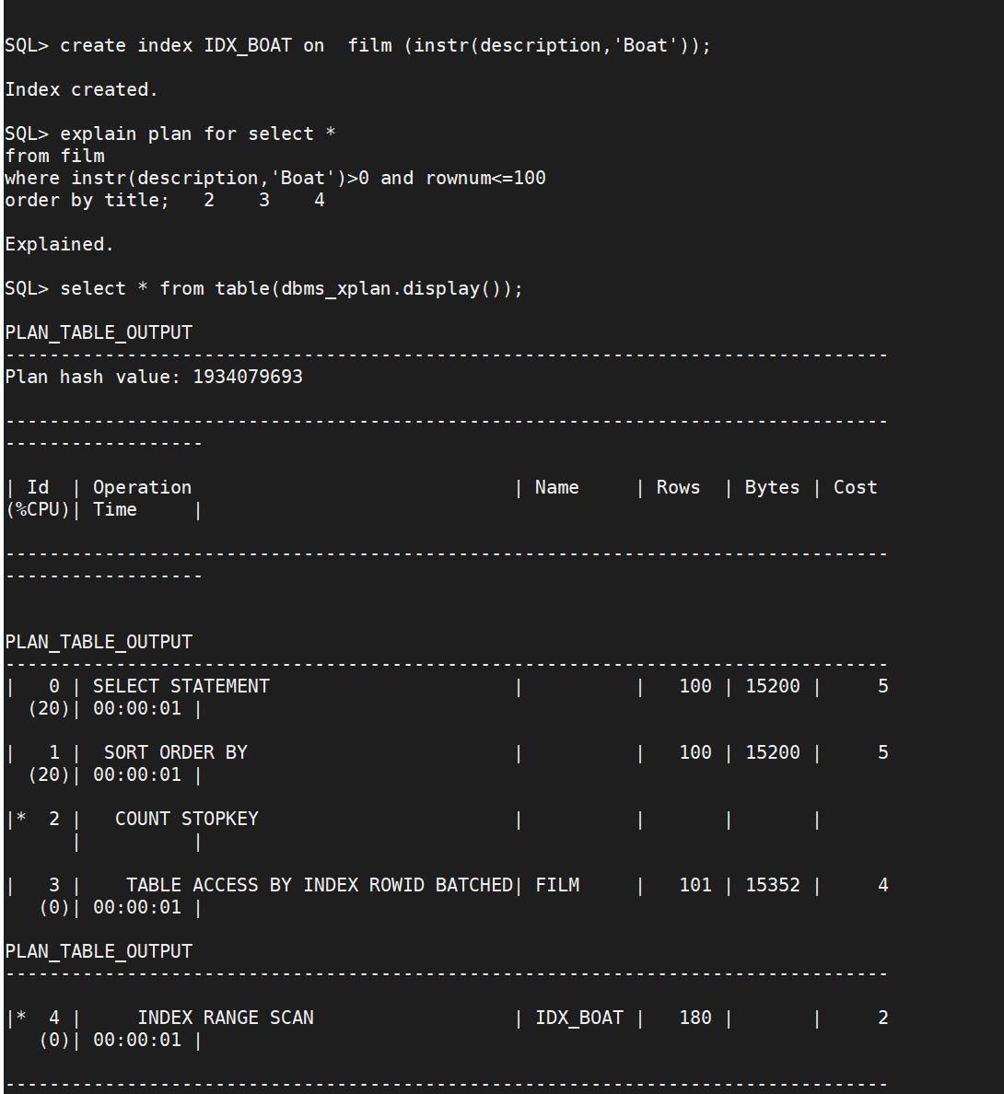

conclusion: the index indeed speed up the query processing.

1. the first one which doesn’t have an index, use “TABLE ACCESS FULL” plan
2. the second one which created an index on column description, use “TABLE ACCESS BY INDEX ROWID BATCHED’ plan
3. the second one consumes time less than first one.

### -- 4

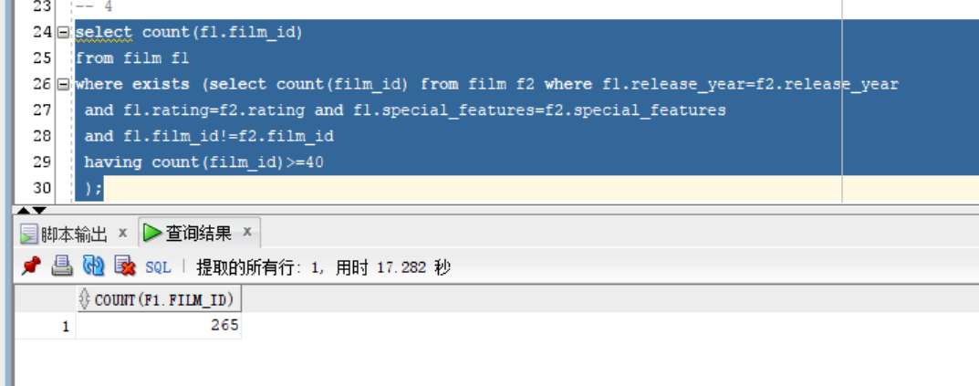

### -- 5

I think in the three columns release_year, rating, and special_features， the column rating and special_features are suitable for using Hash indexes, and the release_year is suitable for B+ tree index.

because the rating column, it only has 'G', 'PG', 'PG-13', 'R', 'NC-17' five values and usually use “=” to query records.

and the special_features column, it only has null, 'Trailers',

'Commentaries', 'Deleted

Scenes', 'Behind the Scenes' values, and also use “=” to find records.

release_year column can use “>”,”<” and “>=”, “<=” to query records. so use B+ tree is more suitable.

## Task5

### -- 1

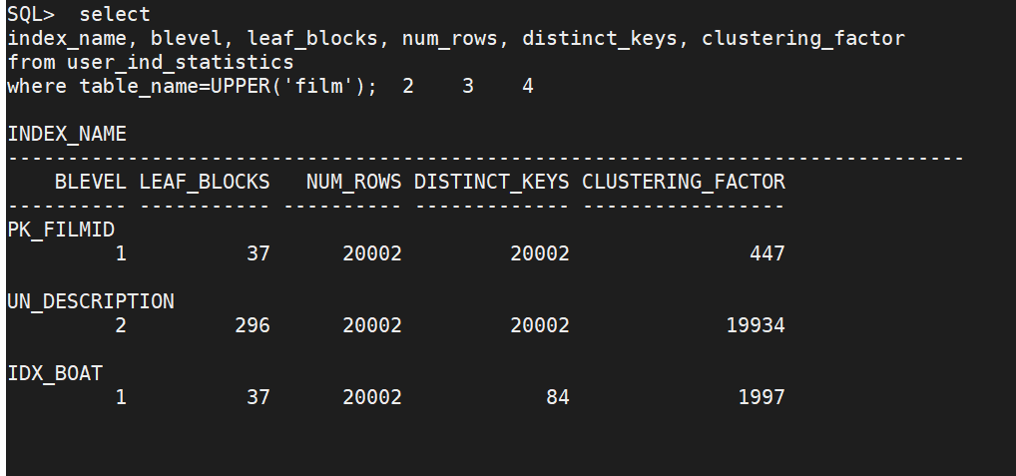

### -- 2

SQL> explain plan for SELECT * FROM FILM WHERE FILM_ID > 100;

Explained.

SQL> select * from table(dbms_xplan.display());

PLAN_TABLE_OUTPUT

--------------------------------------------------------------------------------

Plan hash value: 1232367652

--------------------------------------------------------------------------

| Id | Operation | Name | Rows | Bytes | Cost (%CPU)| Time |

--------------------------------------------------------------------------

| 0 | SELECT STATEMENT | | 19903 | 2993K| 136 (0)| 00:00:01 |

|* 1 | TABLE ACCESS FULL| FILM | 19903 | 2993K| 136 (0)| 00:00:01 |

--------------------------------------------------------------------------

Predicate Information (identified by operation id):

---------------------------------------------------

PLAN_TABLE_OUTPUT

--------------------------------------------------------------------------------

1 - filter("FILM_ID">100)

13 rows selected.

Execution Plan

----------------------------------------------------------

Plan hash value: 2137789089

--------------------------------------------------------------------------------

-------------

| Id | Operation | Name | Rows | Bytes | Cost (%CPU

)| Time |

--------------------------------------------------------------------------------

-------------

| 0 | SELECT STATEMENT | | 8168 | 16336 | 29 (0

)| 00:00:01 |

| 1 | COLLECTION ITERATOR PICKLER FETCH| DISPLAY | 8168 | 16336 | 29 (0

)| 00:00:01 |

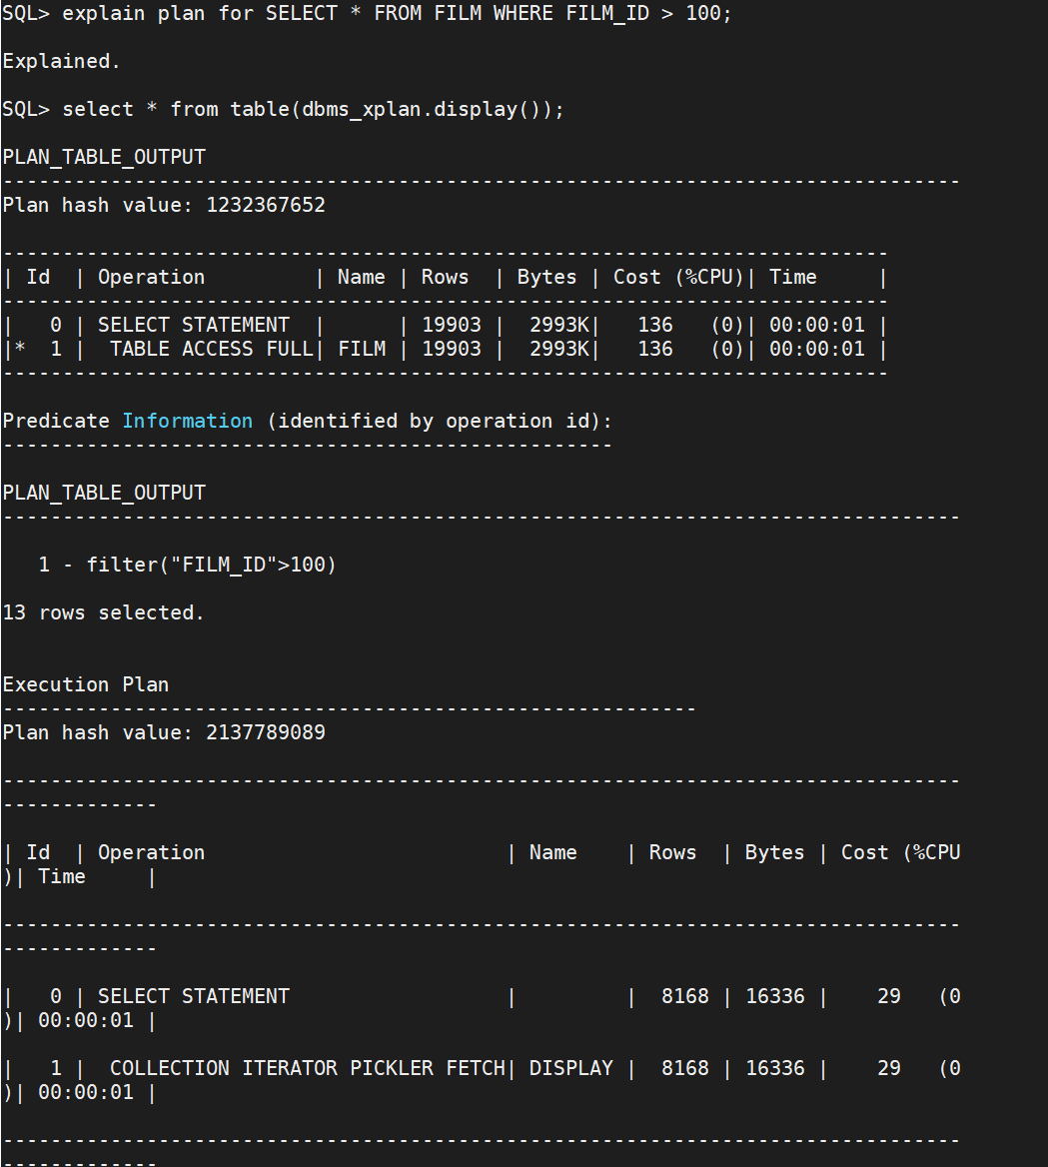

use full access plan

### -- 3

rows number decreased to 8168 compared to the full table records.

### -- 4

SQL> explain plan for SELECT * FROM FILM WHERE FILM_ID > 19990;

Explained.

SQL> select * from table(dbms_xplan.display());

PLAN_TABLE_OUTPUT

--------------------------------------------------------------------------------

Plan hash value: 1620599584

--------------------------------------------------------------------------------

-----------------

| Id | Operation | Name | Rows | Bytes | Cost (

%CPU)| Time |

--------------------------------------------------------------------------------

-----------------

PLAN_TABLE_OUTPUT

--------------------------------------------------------------------------------

| 0 | SELECT STATEMENT | | 30 | 4620 | 3

(0)| 00:00:01 |

| 1 | TABLE ACCESS BY INDEX ROWID BATCHED| FILM | 30 | 4620 | 3

(0)| 00:00:01 |

|* 2 | INDEX RANGE SCAN | PK_FILMID | 30 | | 2

(0)| 00:00:01 |

--------------------------------------------------------------------------------

-----------------

PLAN_TABLE_OUTPUT

--------------------------------------------------------------------------------

Predicate Information (identified by operation id):

---------------------------------------------------

2 - access("FILM_ID">19990)

14 rows selected.

Execution Plan

----------------------------------------------------------

Plan hash value: 2137789089

--------------------------------------------------------------------------------

-------------

| Id | Operation | Name | Rows | Bytes | Cost (%CPU

)| Time |

--------------------------------------------------------------------------------

-------------

| 0 | SELECT STATEMENT | | 8168 | 16336 | 29 (0

)| 00:00:01 |

| 1 | COLLECTION ITERATOR PICKLER FETCH| DISPLAY | 8168 | 16336 | 29 (0

)| 00:00:01 |

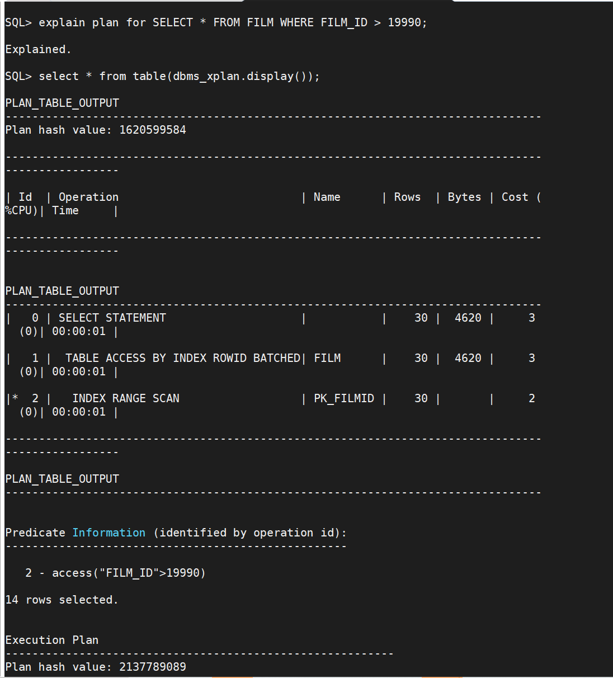

use index range scan. row number is smaller than the task 5.3.

### -- 5

SQL> explain plan for SELECT * FROM FILM WHERE FILM_ID = 100;

Explained.

SQL> select * from table(dbms_xplan.display());

PLAN_TABLE_OUTPUT

--------------------------------------------------------------------------------

Plan hash value: 2104374699

--------------------------------------------------------------------------------

---------

| Id | Operation | Name | Rows | Bytes | Cost (%CPU)| T

ime |

--------------------------------------------------------------------------------

---------

PLAN_TABLE_OUTPUT

--------------------------------------------------------------------------------

| 0 | SELECT STATEMENT | | 1 | 154 | 2 (0)| 0

0:00:01 |

| 1 | TABLE ACCESS BY INDEX ROWID| FILM | 1 | 154 | 2 (0)| 0

0:00:01 |

|* 2 | INDEX UNIQUE SCAN | PK_FILMID | 1 | | 1 (0)| 0

0:00:01 |

--------------------------------------------------------------------------------

---------

PLAN_TABLE_OUTPUT

--------------------------------------------------------------------------------

Predicate Information (identified by operation id):

---------------------------------------------------

2 - access("FILM_ID"=100)

14 rows selected.

Execution Plan

----------------------------------------------------------

Plan hash value: 2137789089

--------------------------------------------------------------------------------

-------------

| Id | Operation | Name | Rows | Bytes | Cost (%CPU

)| Time |

--------------------------------------------------------------------------------

-------------

| 0 | SELECT STATEMENT | | 8168 | 16336 | 29 (0

)| 00:00:01 |

| 1 | COLLECTION ITERATOR PICKLER FETCH| DISPLAY | 8168 | 16336 | 29 (0

)| 00:00:01 |

--------------------------------------------------------------------------------

-------------

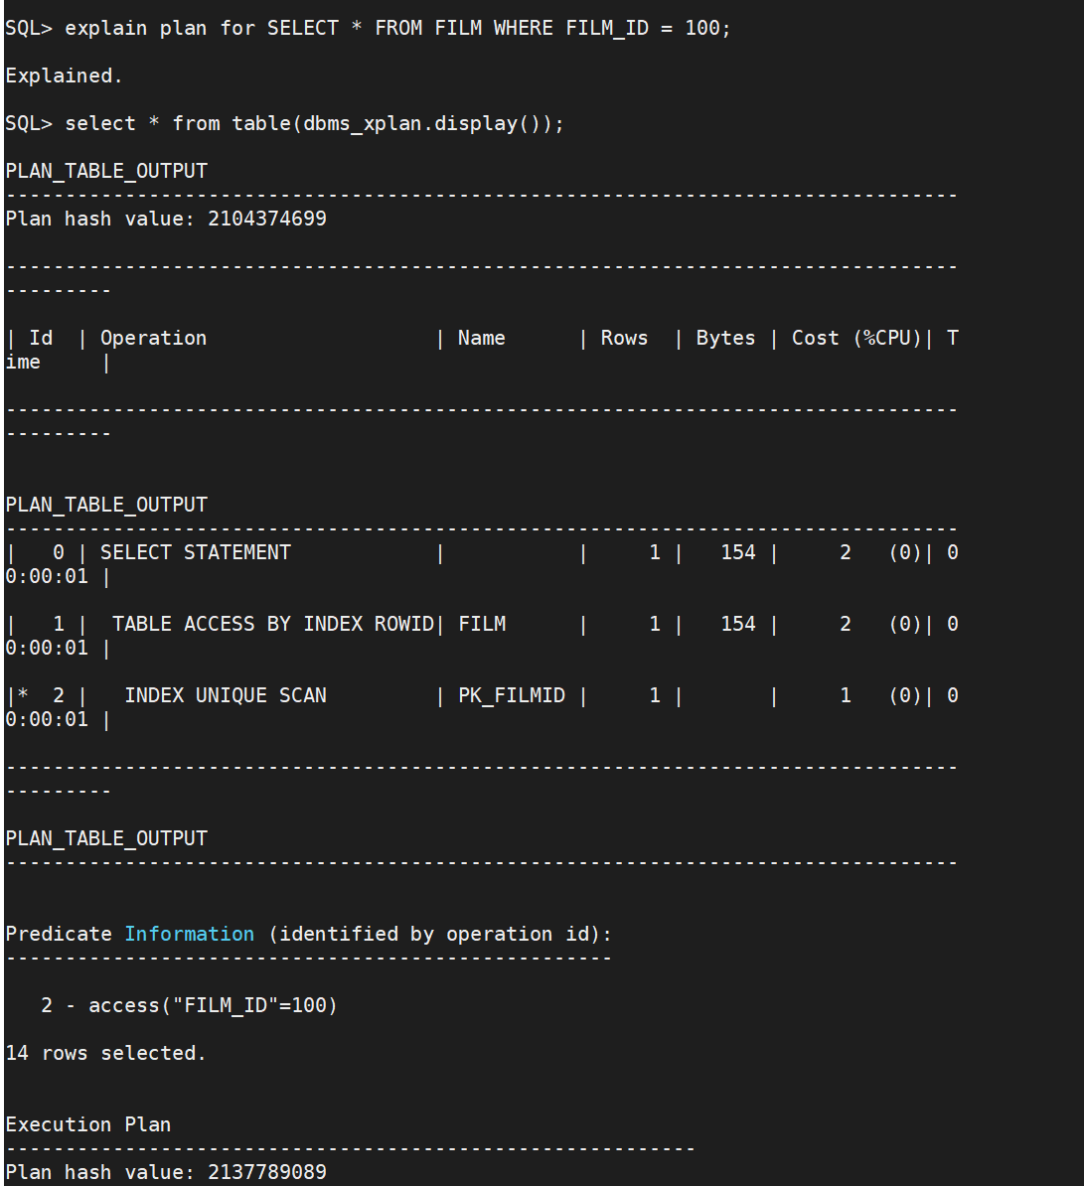

use index unique scan, the row number is only 1.