**实 验 报 告**

实验名称：表的管理

实验课时：2课时

实验地点：

实验时间： 年 月 日 星期 第 周

实验目的及要求：

1. 了解Oracle表和视图的概念。
2. 熟练掌握使用SQL语句创建表。
3. 学习使用SELECT语句查询数据。

实验内容：

创建Employees表、Department表。各表的结构如下所示：

Employees表结构

|  |  |  |  |  |
| --- | --- | --- | --- | --- |
| 列名 | 数据类型 | 长度 | 是否允许为空值 | 说明 |
| EmployeeID | Char | 6 | × | 员工编号，主键 |
| Name | Char | 10 | × | 姓名 |
| Birthday | Date |  | × | 出生日期 |
| Sex | Number | 1 | × | 性别 |
| Address | Char | 20 | √ | 地址 |
| Zip | Char | 6 | √ | 邮编 |
| PhoneNumber | Char | 12 | √ | 电话号码 |
| DepartmentID | Char | 3 | × | 员工部门号，外键 |

Department表结构

|  |  |  |  |  |
| --- | --- | --- | --- | --- |
| 列名 | 数据类型 | 长度 | 是否允许为空值 | 说明 |
| DepartmentID | Char | 3 | × | 部门编号，主键 |
| DepartmentName | Char | 20 | × | 部门名 |
| Note | Varchar2 | 100 | √ | 备注 |

表1 Employees表数据样本

|  |  |  |  |  |  |  |  |
| --- | --- | --- | --- | --- | --- | --- | --- |
| 编号 | 姓名 | 出生日期 | 性别 | 住址 | 邮编 | 电话号码 | 部门号 |
| 000001 | 王林 | 1966-01-23 | 1 | 中山路32-1-508 | 210003 | 83355668 | 2 |
| 010008 | 伍容华 | 1976-03-28 | 1 | 北京东路100-2 | 210001 | 83321321 | 1 |
| 020010 | 王向容 | 1982-12-09 | 1 | 四牌楼10-0-108 | 210006 | 83792361 | 1 |
| 020018 | 李丽 | 1960-07-30 | 0 | 中山东路102-2 | 210002 | 93413301 | 1 |
| 102201 | 刘明 | 1972-10-18 | 1 | 虎距路100-2 | 210013 | 83606608 | 5 |
| 102208 | 朱俊 | 1965-09-28 | 1 | 牌楼巷5-3-106 | 210004 | 84708817 | 5 |
| 108991 | 钟敏 | 1979-08-10 | 0 | 中山路10-3-105 | 210003 | 83346722 | 3 |
| 111006 | 张石兵 | 1974-10-01 | 1 | 解放路34-1-203 | 210010 | 84563418 | 5 |
| 210678 | 林涛 | 1977-04-02 | 1 | 中山北路24-35 | 210008 | 83467336 | 3 |
| 302566 | 李玉珉 | 1968-09-20 | 1 | 热和路209-3 | 210001 | 58765991 | 4 |
| 308759 | 叶凡 | 1978-11-18 | 1 | 北京西路3-7-52 | 210002 | 83308901 | 4 |
| 504209 | 陈琳琳 | 1969-09-03 | 0 | 汉中路120-4-12 | 210018 | 84468158 | 4 |

表2 Departments表数据样本

|  |  |  |  |  |  |
| --- | --- | --- | --- | --- | --- |
| 部门号 | 部门名称 | 备注 | 部门号 | 部门名称 | 备注 |
| 1 | 财务部 | NULL | 4 | 研发部 | NULL |
| 2 | 人力资源部 | NULL | 5 | 市场部 | NULL |
| 3 | 经理办公室 | NULL |  |  |  |

1.用SQL语句建立这两个表的结构并把相应数据插入进去

2. 统计男性女性员工的人数

3.找出所有年龄大于55岁的员工信息

4.找出研发部的所有员工信息

5.查找名为钟敏的员工所在部门的信息

create table Department(

DepartmentID char(3) not null primary key,

DepartmentName char(20) not null,

Note varchar2(100)

);

create table Employees(

EmployeeID char(6) not null primary key,

Name char(10) not null,

Birthday Date not null,

Sex Number(1) not null,

Address char(20),

Zip Char(6),

PhoneNumber char(12),

DepartmentID Char(3) not null,

foreign key (DepartmentID) references Department(DepartmentID)

);

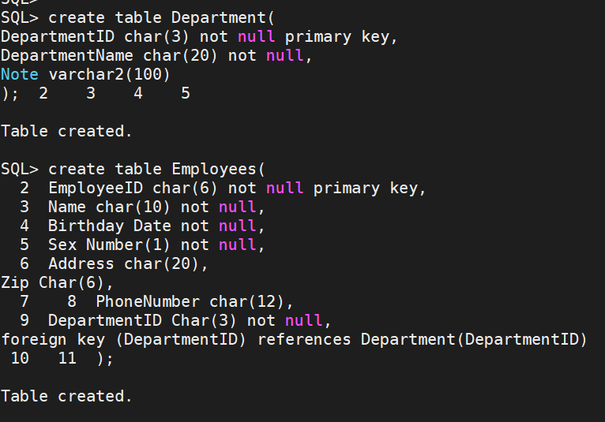

insert into Department values (1,'财务部',NULL);  
insert into Department values (2,'人力资源部',NULL);  
insert into Department values (3,'经理办公室',NULL);  
insert into Department values (4,'研发部',NULL);  
insert into Department values (5,'市场部',NULL);  
  
insert into Employees values('000001','王林', to_date('1966-01-23','YYYY-MM-DD'), 1, '中山路32-1-508', '210003', '83355668', 2);  
insert into Employees values('010008','伍容华', to_date('1976-03-28','YYYY-MM-DD'), 1, '北京东路100-2', '210001', '83321321', 1);  
insert into Employees values('020010','王向容', to_date('1982-12-09','YYYY-MM-DD'), 1, '四牌楼10-0-108','210006', '83792361', 1 );  
insert into Employees values('020018','李丽',to_date('1960-07-30','YYYY-MM-DD'), 0, '中山东路102-2', '210002', '93413301', 1 );  
insert into Employees values('102201','刘明', to_date('1972-10-18','YYYY-MM-DD'), 1, '虎距路100-2', '210013', '83606608', 5 );  
insert into Employees values('102208','朱俊', to_date('1965-09-28','YYYY-MM-DD'), 1, '牌楼巷5-3-106', '210004', '84708817', 5);  
insert into Employees values('108991','钟敏', to_date('1979-08-10','YYYY-MM-DD'), 0, '中山路10-3-105','210003', '83346722', 3 );  
insert into Employees values('111006','张石兵', to_date('1974-10-01','YYYY-MM-DD'), 1, '解放路34-1-203','210010', '84563418', 5 );  
insert into Employees values('210678','林涛', to_date('1977-04-02','YYYY-MM-DD'), 1, '中山北路24-35', '210008', '83467336', 3 );  
insert into Employees values('302566','李玉珉', to_date('1968-09-20','YYYY-MM-DD'), 1, '热和路209-3', '210001', '58765991', 4 );  
insert into Employees values('308759','叶凡',to_date('1978-11-18','YYYY-MM-DD'), 1, '北京西路3-7-52','210002', '83308901', 4 );  
insert into Employees values('504209','陈琳琳', to_date('1969-09-03','YYYY-MM-DD'), 0, '汉中路120-4-12','210018', '84468158', 4 );  
commit;

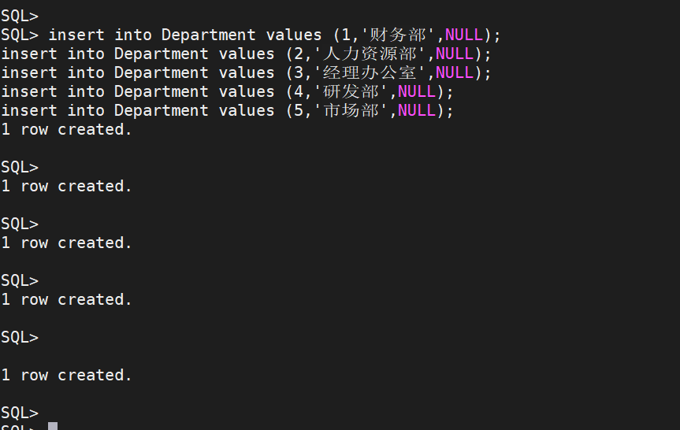

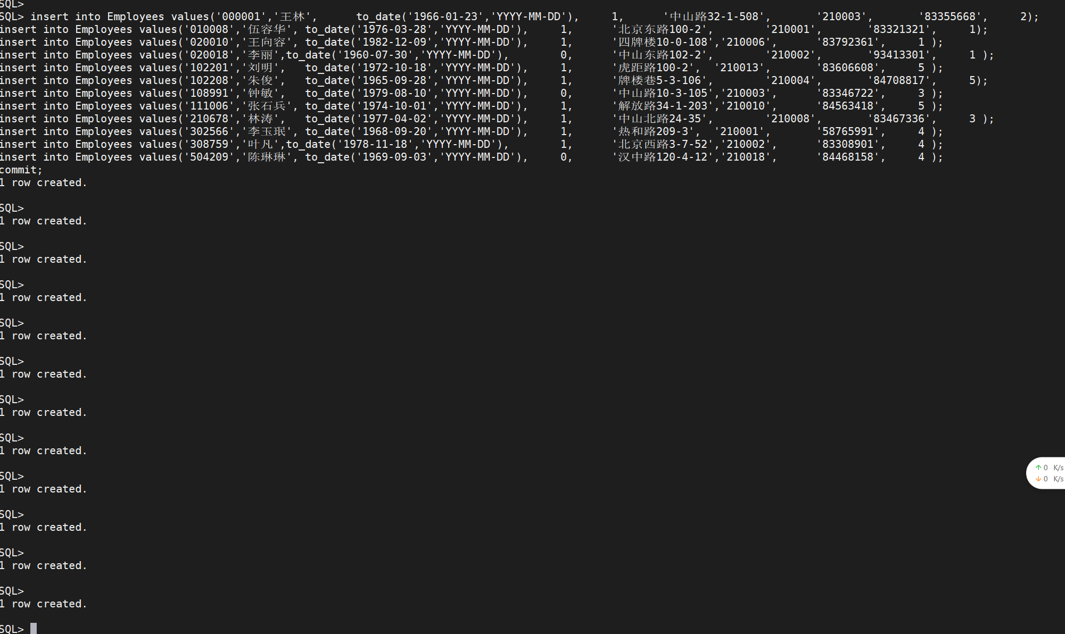

select Sex, count(EmployeeID)

from Employees

group by Sex;

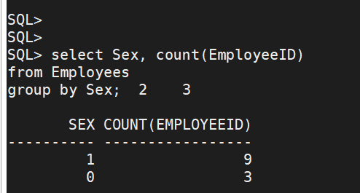

select * from Employees where to_char(sysdate,'YYYY')-to_char(Birthday,'YYYY')>55;

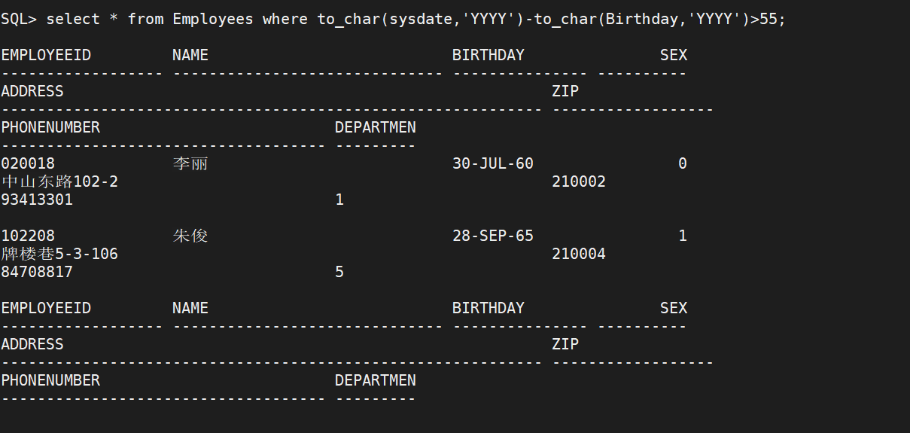  
  
select e.*  
from Employees e join Department d on e.DepartmentID=d.DepartmentID  
where d.DepartmentName='研发部';  
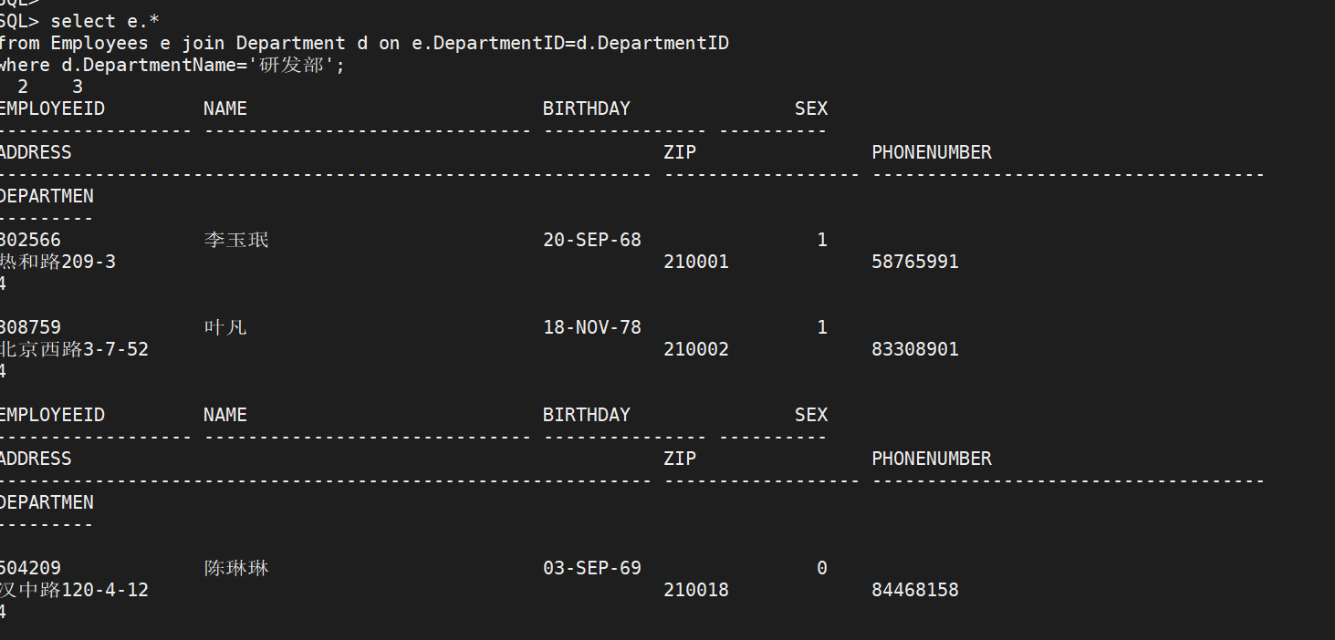  
select d.*  
from Employees e join Department d on e.DepartmentID=d.DepartmentID  
where e.Name='钟敏';

