**实 验 报 告**

实验名称：复杂查询语句的使用

实验课时：2课时

实验地点：

实验时间： 年 月 日 星期 第 周

实验目的及要求：

熟练掌握使用SELECT语句中的表的连接，子查询等较复杂的使用

实验内容：

复制下面的代码创建教师表，学生表，课程表以及成绩表并插入相应数据，根据题目要求完成相应的查询语句。

create table student(

sno varchar2(10) primary key,

sname varchar2(20),

sage number(2),

ssex varchar2(5)

);

create table teacher(

tno varchar2(10) primary key,

tname varchar2(20)

);

create table course(

cno varchar2(10),

cname varchar2(20),

tno varchar2(20),

constraint pk_course primary key (cno,tno)

);

create table sc(

sno varchar2(10),

cno varchar2(10),

score number(4,2),

constraint pk_sc primary key (sno,cno)

);

/*******初始化学生表的数据******/

insert into student values ('s001','张三',23,'男');

insert into student values ('s002','李四',23,'男');

insert into student values ('s003','吴鹏',25,'男');

insert into student values ('s004','琴沁',20,'女');

insert into student values ('s005','王丽',20,'女');

insert into student values ('s006','李波',21,'男');

insert into student values ('s007','刘玉',21,'男');

insert into student values ('s008','萧蓉',21,'女');

insert into student values ('s009','陈萧晓',23,'女');

insert into student values ('s010','陈美',22,'女');

commit;

/******************初始化教师表***********************/

insert into teacher values ('t001', '刘阳');

insert into teacher values ('t002', '谌燕');

insert into teacher values ('t003', '胡明星');

commit; );

/***************初始化课程表****************************/

insert into course values ('c001','J2SE','t002');

insert into course values ('c002','Java Web','t002');

insert into course values ('c003','SSH','t001');

insert into course values ('c004','Oracle','t001');

insert into course values ('c005','SQL SERVER 2005','t003');

insert into course values ('c006','C#','t003');

insert into course values ('c007','JavaScript','t002');

insert into course values ('c008','DIV+CSS','t001'); );

insert into course values ('c009','PHP','t003');

insert into course values ('c010','EJB3.0','t002');

commit;

/***************初始化成绩表***********************/

insert into sc values ('s001','c001',78.9);

insert into sc values ('s002','c001',80.9);

insert into sc values ('s003','c001',81.9);

insert into sc values ('s004','c001',60.9);

insert into sc values ('s001','c002',82.9);

insert into sc values ('s002','c002',72.9);

insert into sc values ('s003','c002',81.9);

insert into sc values ('s005','c005','59');

commit;

1、查询“c001”课程比“c002”课程成绩高的所有学生的学号；

2、查询平均成绩大于60 分的同学的学号和平均成绩；

3、查询所有同学的学号、姓名、选课数、总成绩；

4、查询没学过“谌燕”老师课的同学的学号、姓名；

5、查询课程编号“c002”的成绩比课程编号“c001”课程低的所有同学的学号、姓名；

6、查询出只选修了一门课程的全部学生的学号和姓名

7、查询每门课程的平均成绩，结果按平均成绩升序排列，平均成绩相同时，按课程号降序排列

8、求选了课程的学生人数

9、查询各个课程及相应的选修人数

10、查询两门以上不及格课程的同学的学号及其平均成绩

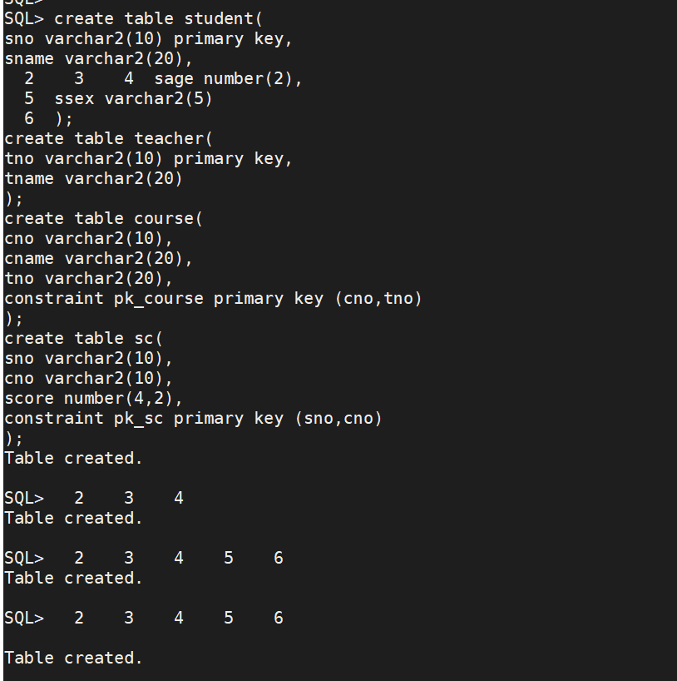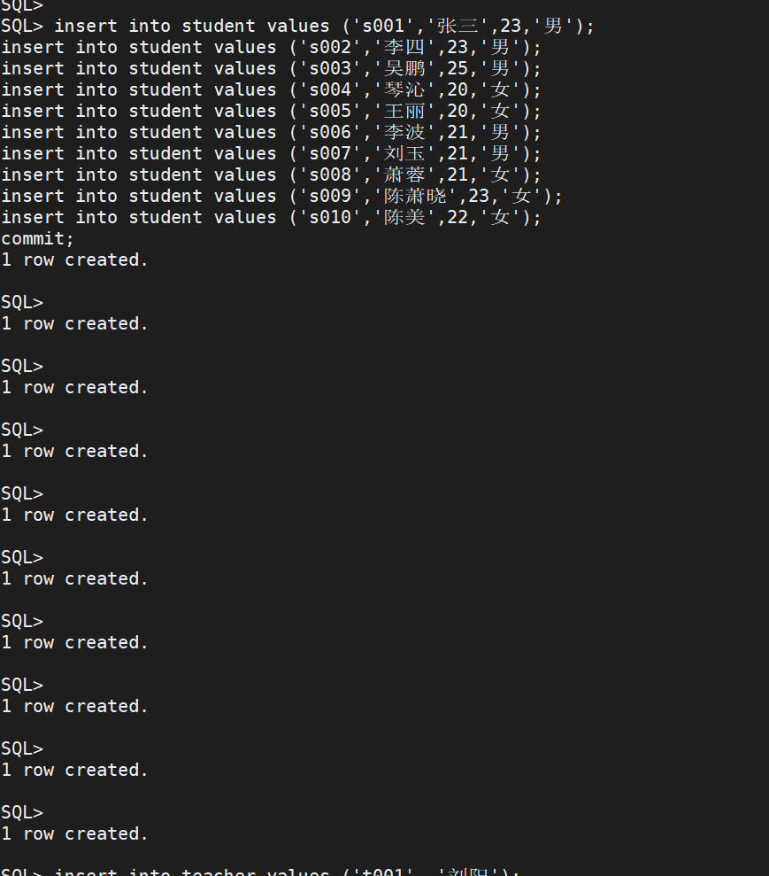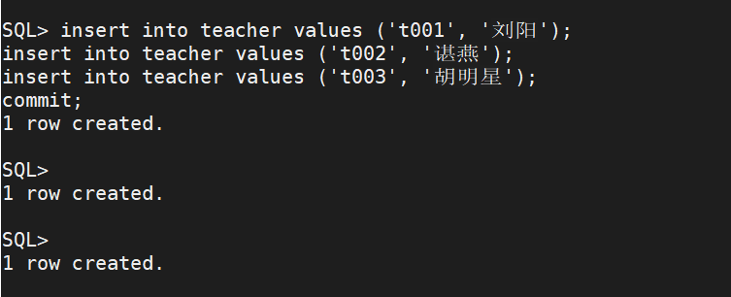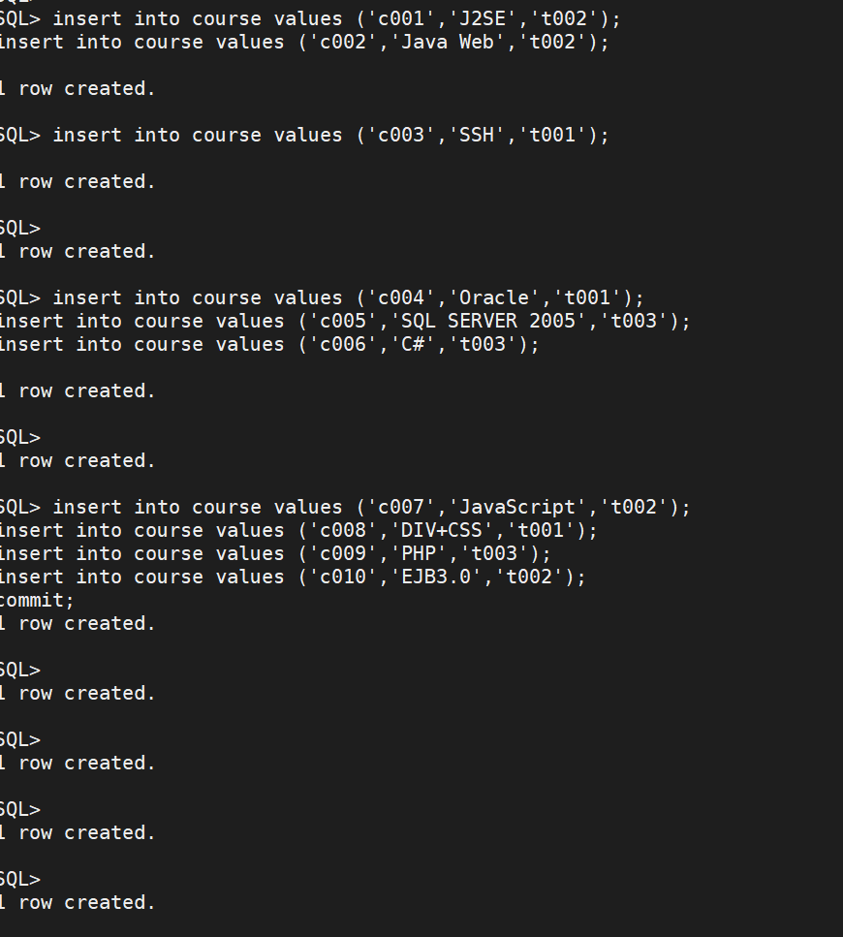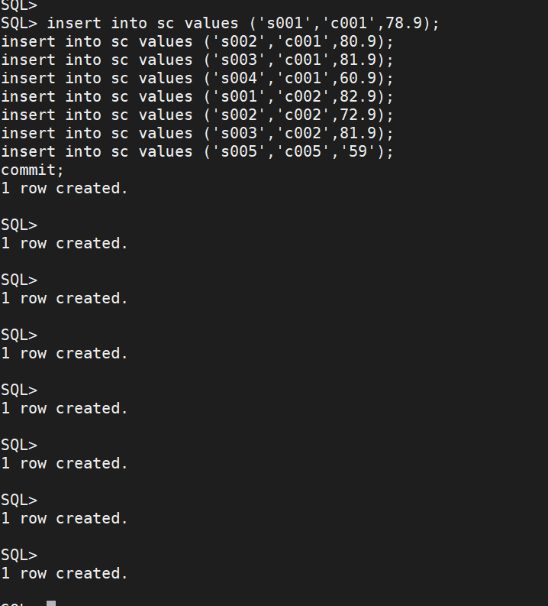

select t1.sno

from

(

select sno, score

from sc

where cno='c001'

) t1,

(

select sno, score

from sc

where cno='c002'

) t2

where t1.sno=t2.sno and t1.score>t2.score;

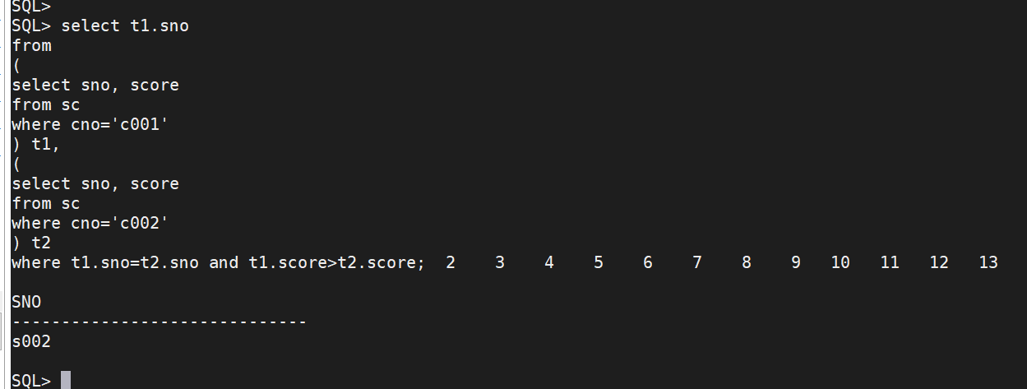

select sno, avg(score)

from sc

group by sno

having avg(score)>60;

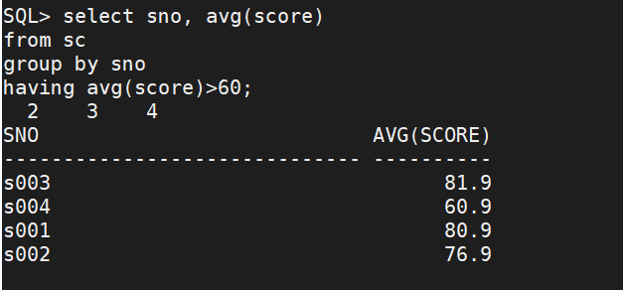

select s.sno, s.sname, count(sc.cno), sum(sc.score)

from student s

join sc on s.sno=sc.sno

group by s.sno, s.sname;

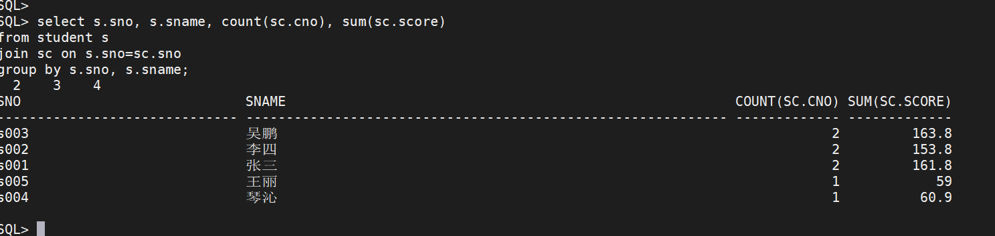

select sno, sname

from student

where sno not in (

select sc.sno

from sc join course c on sc.cno=c.cno

join teacher t on c.tno=t.tno

where t.tname='谌燕'

);

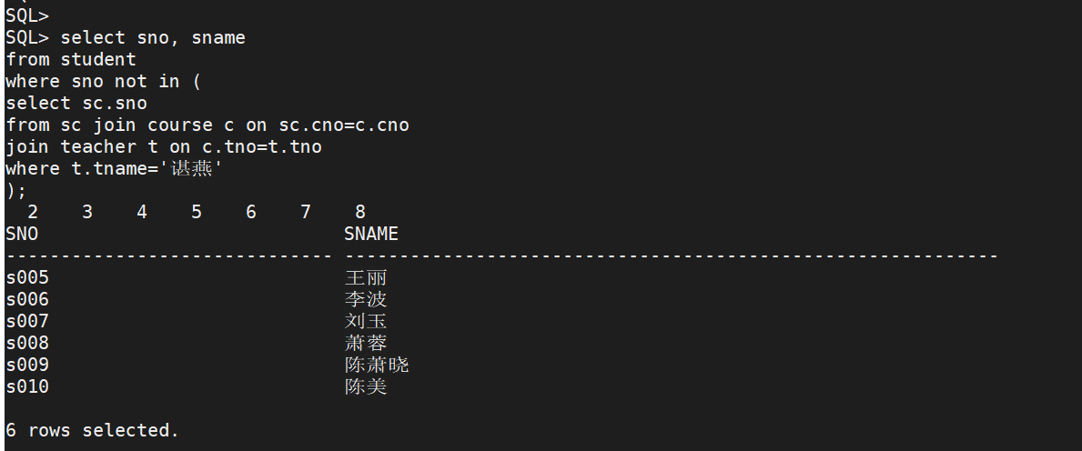

select s.sno, s.sname

from student s

join

(

select t1.sno

from

(

select sno, score

from sc

where cno='c001'

) t1,

(

select sno, score

from sc

where cno='c002'

) t2

where t1.sno=t2.sno and t1.score>t2.score

) t on t.sno=s.sno;

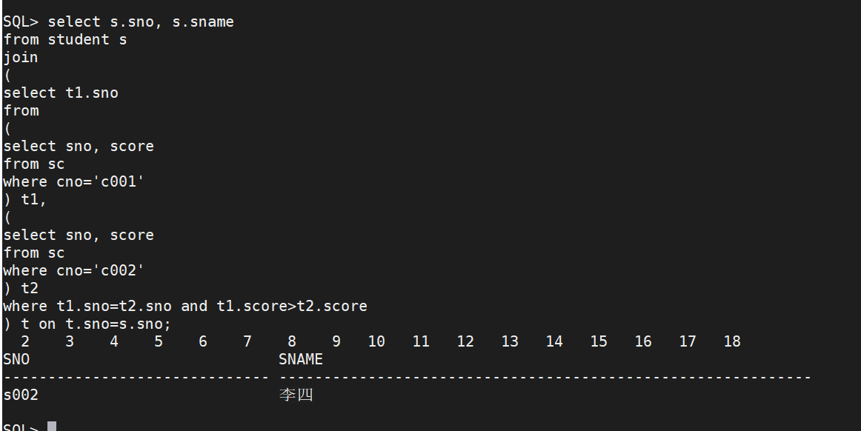

select s.sno, s.sname

from student s join sc on s.sno=sc.sno

group by s.sno, s.sname

having count(sc.cno)=1;

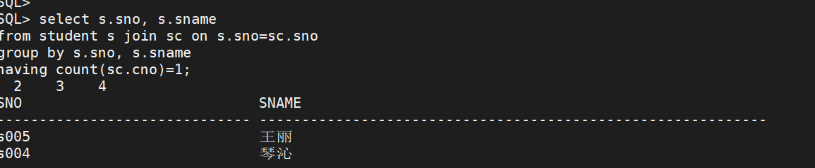

select cno, avg(score)

from sc

group by cno

order by avg(score), cno desc;

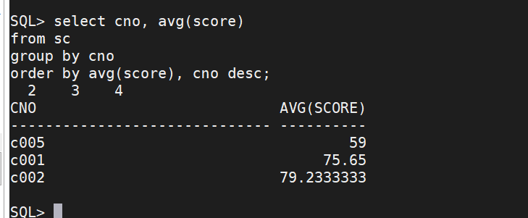

select count(distinct sno)

from sc;

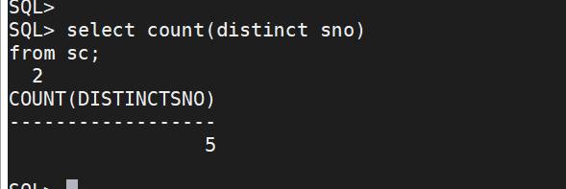

select cno, count(sno)

from sc

group by cno;

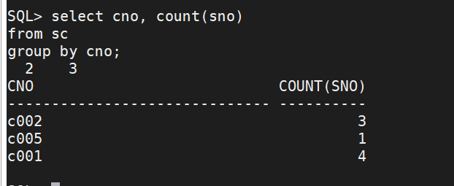

select sno, avg(score)

from sc

where sno in ( select sno from sc where score<60 group by sno having count(cno)>=2)

group by sno;

