1. Write an SQL statement to count the number of users per country (5 marks)

Answer：

select country, count(userid)

from user_tab

group by country;

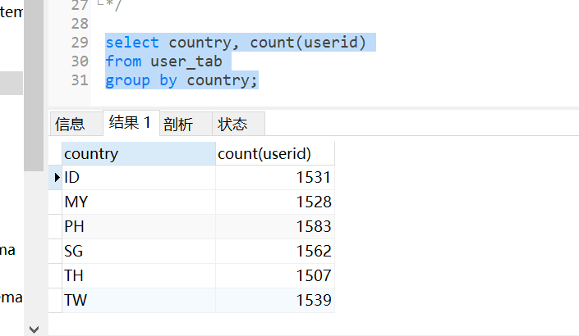

1. Write an SQL statement to count the number of orders per country (10 marks)

Answer：

select u.country, count(o.orderid)

from user_tab u join order_tab o on o.userid=u.userid

GROUP BY u.country;

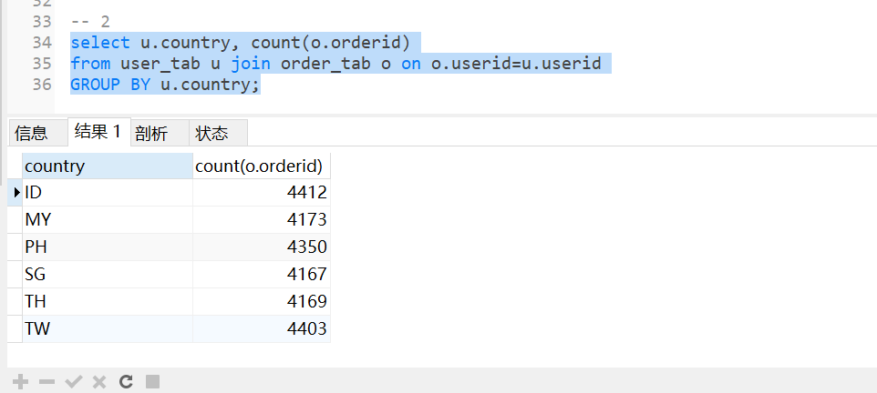

1. Write an SQL statement to find the first order date of each user (10 marks)

Answer：

select t.userid, o.orderid

from

(

select userid, min(order_time) first_order_time

from order_tab

group by userid

) t join order_tab o on t.userid=o.userid and o.order_time=t.first_order_time;

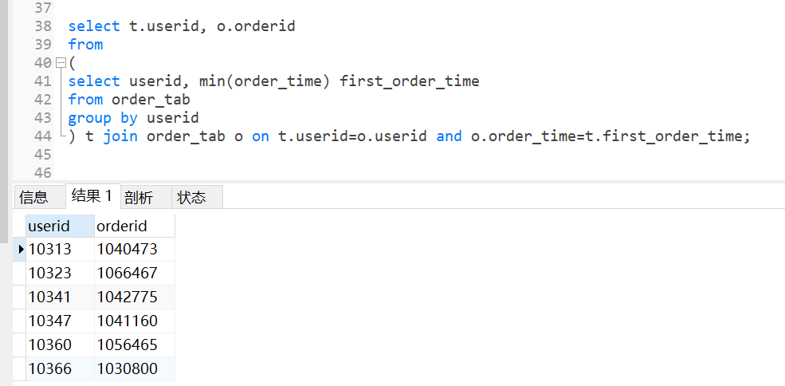

1. Write an SQL statement to find the number of users who made their first order in each country, each day (25 marks)

Answer：

select u.country, t.day, count(t.userid)

from user_tab u

join

(

select userid, day(order_time) as day, min(order_time) first_order_time

from order_tab

group by userid,day(order_time)

) t on t.userid=u.userid

join order_tab o on o.userid=t.userid and o.order_time=t.first_order_time

group by u.country, t.day;

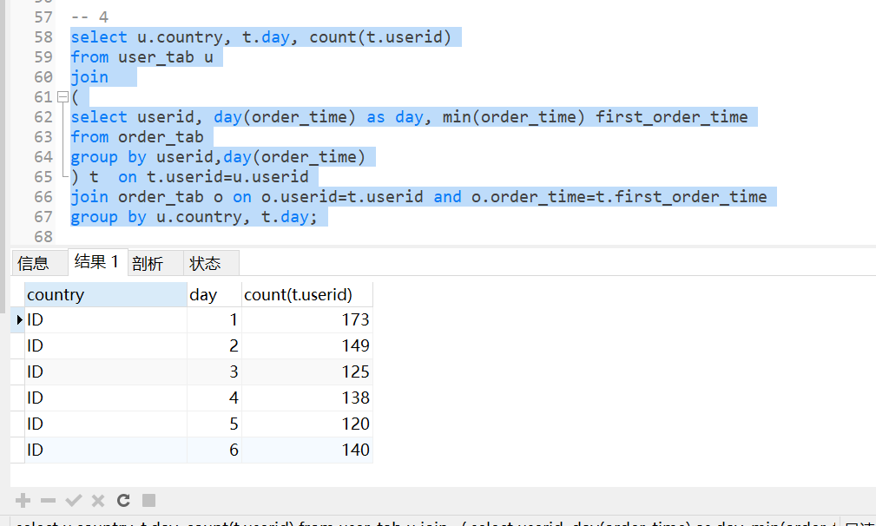

1. Write an SQL statement to find the first order GMV of each user. If there is a tie, use the order with the lower orderid (30 marks)

Answer：

select o.userid, o.gmv

from order_tab o

join

(

select userid, min(order_time) first_order_time

from order_tab

group by userid

) t on o.userid=t.userid;

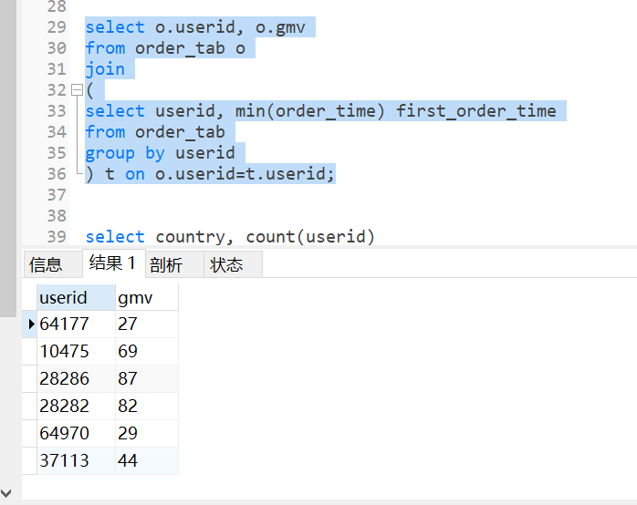

1. Find out what is wrong with the sample data (20 marks)

Answer：