Brief discussion:

As for this requirement, 我筛选出了需要建立entity的名词，such as student、staff, branch, subject 等信息，再根据场景中的描述，确立每个Entity的属性，比如对于Student实体来说，具有studentID, StudentName, Gender, DOB, ContactNumber, Parent, School, Tuition, Level, EnrolDate 等属性。再根据实体之间的关系，建立relationship,比如 一个branch 有多个Staff, 则branch和Staff之间具有一对多关系；另外，一个Tutor可以教多个subjects 因此Staff和Subjects之间是多对多关系。

由于场景中涉及的Staff主要分为Tutor，manager and student care service executors 这些角色均使用staff实体来表示，用Teaching属性表示是否教课。用role属性来表示Staff的角色。

场景中涉及的另外一些诸如Cleanser maintenance 角色使用OtherTmpStaff 来表示。

As for this requirement, I screened out the nouns that need to establish an entity, such as student, staff, branch, subject and other information, and then established the attributes of each Entity according to the description in the scene. For example, for the Student entity, it has a studentID , StudentName, Gender, DOB, ContactNumber, Parent, School, Tuition, Level, EnrolDate and other attributes. Then establish a relationship based on the relationship between entities. For example, if a branch has multiple staff, there is a one-to-many relationship between the branch and the staff; in addition, a Tutor can teach multiple subjects, so the staff and the subjects are many-to-many. relation.

Since the staff involved in the scene are mainly divided into Tutor, the roles of manager and student care service executors are represented by the staff entity, and the teaching attribute is used to indicate whether to teach. The role attribute is used to represent the role of the staff.

Some other roles involved in the scene, such as Cleanser maintenance, are represented by OtherTmpStaff.

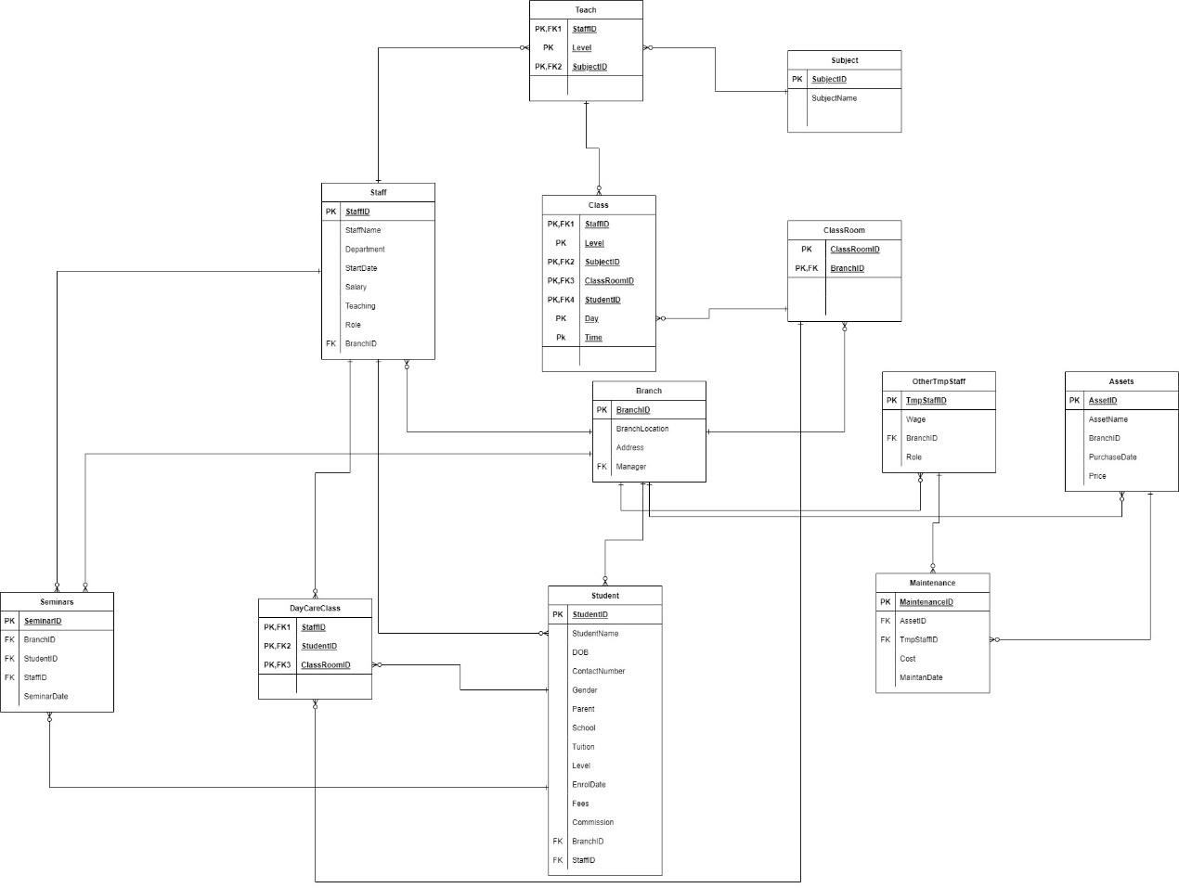

Summary：

Assumption/justifications:

1.A staff can only be 一种身份（either manager or tutor or student care service executors）.

2.一次Seminar活动必须在一个Branch举办，参加Seminar的学生和Staff可以来自多个Branch。

3. An asset must belong to a branch. When need maintanence, 是针对某个branch的asset进行维修。

4. 一个branch的classroom 在同一时间内can only have a unique teaching information (StaffID, Level and SubjectID).

5. 在每个branch中，每天的day care class 有固定的classroom。