## Question 1: Getting the Database Ready

Show the list of tables (there should be none) before the script is executed; use some suitable technique to do that.

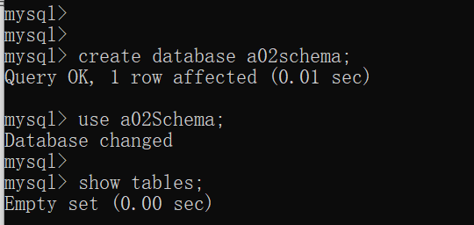

Show the list of tables after the script is executed.

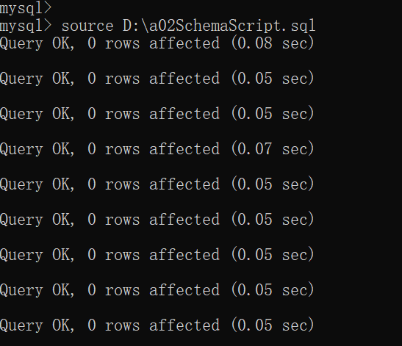

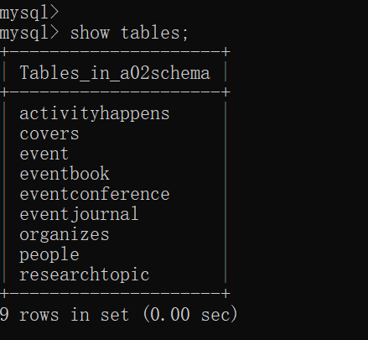

Show the count of rows in the “Event”, “People” and “ResearchTopic” tables using some suitable technique

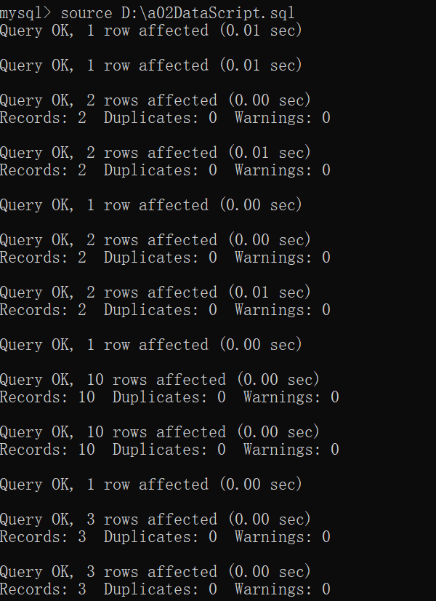

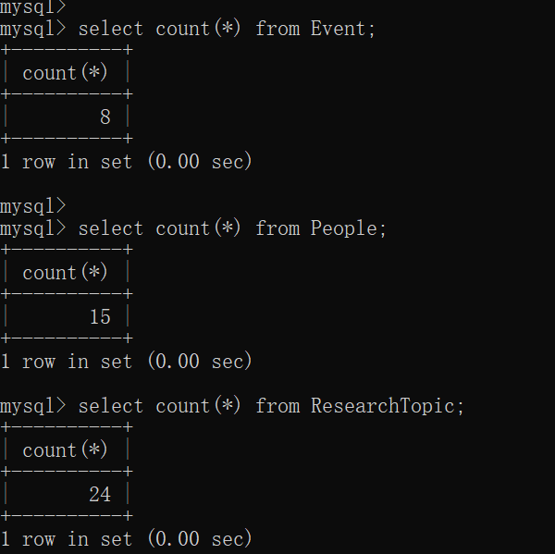

## Question 2: Query the database

Write the following two queries and execute them on the database snapshot produced in Question 1:

a) Display the count of each event type grouped based on the calendar months i.e., how many events of each type happening in the months for which the data is present in the database. You need to show the output only for those months which are present in the database. For EventConference we will consider the EvDate field while for the other two event types, Journal and Book, it will be the ActivityDate of the earliest/lowest activity (from ActivityHappens). You can show this query as three different queries for each event type. Here is a sample output:

select 'Conferences' as EventType,concat(monthname(ec.EvDate),', ', year(ec.EvDate)) as Month, count(e.ID) as count

from Event e join EventConference ec on e.ID=ec.EventID

group by EventType,concat(monthname(ec.EvDate), ', ',year(ec.EvDate))

union

select 'Journal' as EventType, concat(monthname(t.minDate),', ', year(t.minDate)) as Month, count(t.ID) as count

from EventJournal ej

join

(

select e.ID, min(ah.ActivityDate) as minDate

from Event e

join ActivityHappens ah on ah.EventID=e.ID

group by e.ID

) t on ej.EventID=t.ID

group by EventType, concat(monthname(t.minDate),', ', year(t.minDate))

union

select 'Book' as EventType, concat(monthname(t.minDate),', ', year(t.minDate)) as Month, count(t.ID) as count

from EventBook eb

join

(

select e.ID, min(ah.ActivityDate) as minDate

from Event e

join ActivityHappens ah on ah.EventID=e.ID

group by e.ID

) t on eb.EventID=t.ID

group by EventType, concat(monthname(t.minDate),', ', year(t.minDate))

;

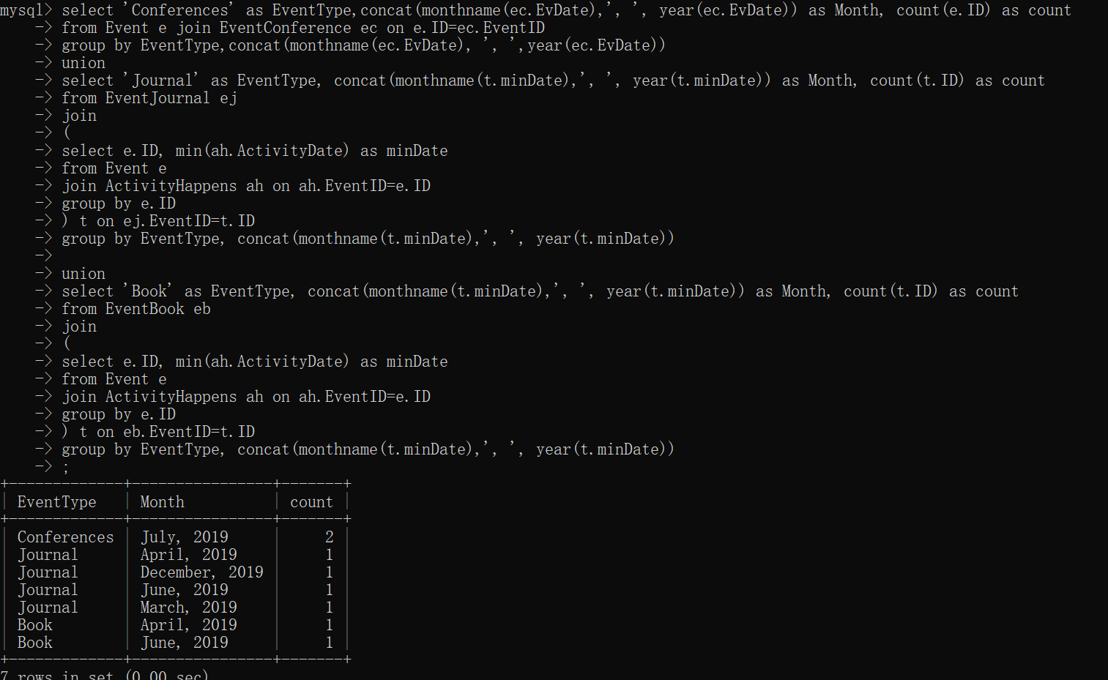

b) Display the one upcoming event for each event type i.e., the event with lowest date value but in future from current date. Assume the current date is “January 01, 2017”. For all event types it will be the ActivityDate of the earliest/lowest activity (from ActivityHappens). You can show this query as three different queries for each event type. Here is a sample output:

select 'Conferences' as EventType,concat(monthname(ec.EvDate),' ',day(ec.EvDate),', ', year(ec.EvDate)) as Date

from Event e join EventConference ec on e.ID=ec.EventID

where ec.EvDate=(select min(EvDate) from EventConference where EvDate>'2017-01-01')

union

select 'Journal' as EventType, concat(monthname(t.minDate),' ',day(t.minDate),', ', year(t.minDate)) as Date

from

(

select min(ah.ActivityDate) as minDate

from EventJournal ej

join Event e on e.ID=ej.EventID

join ActivityHappens ah on ah.EventID=e.ID

where ah.ActivityDate>'2017-01-01'

) t

union

select 'Book' as EventType, concat(monthname(t.minDate),' ',day(t.minDate),', ', year(t.minDate)) as Date

from

(

select min(ah.ActivityDate) as minDate

from EventBook eb

join Event e on e.ID=eb.EventID

join ActivityHappens ah on ah.EventID=e.ID

where ah.ActivityDate>'2017-01-01'

) t

;

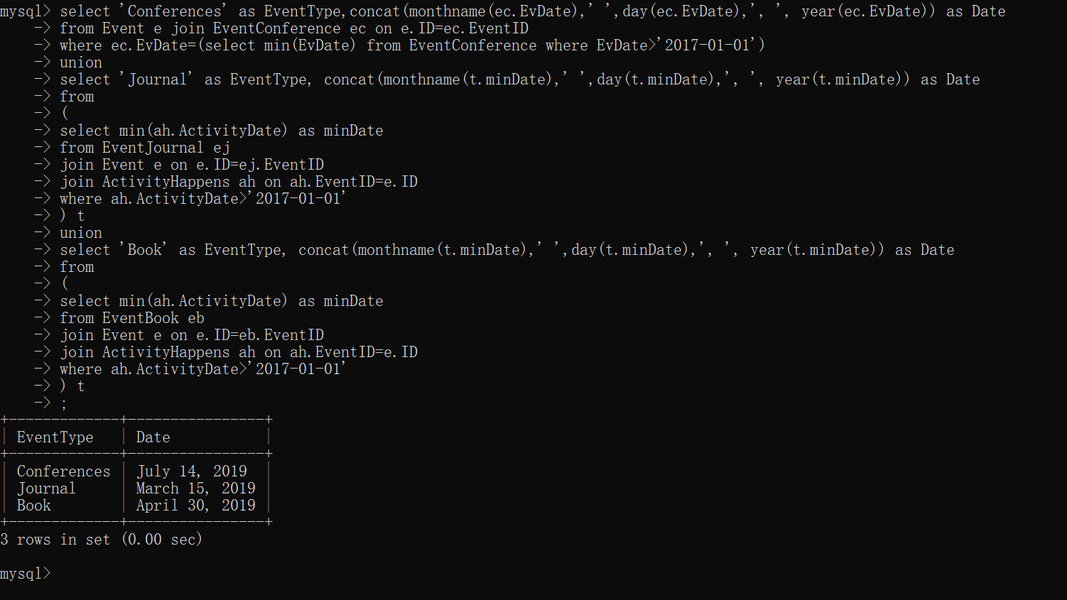

## Question 3: Application Design

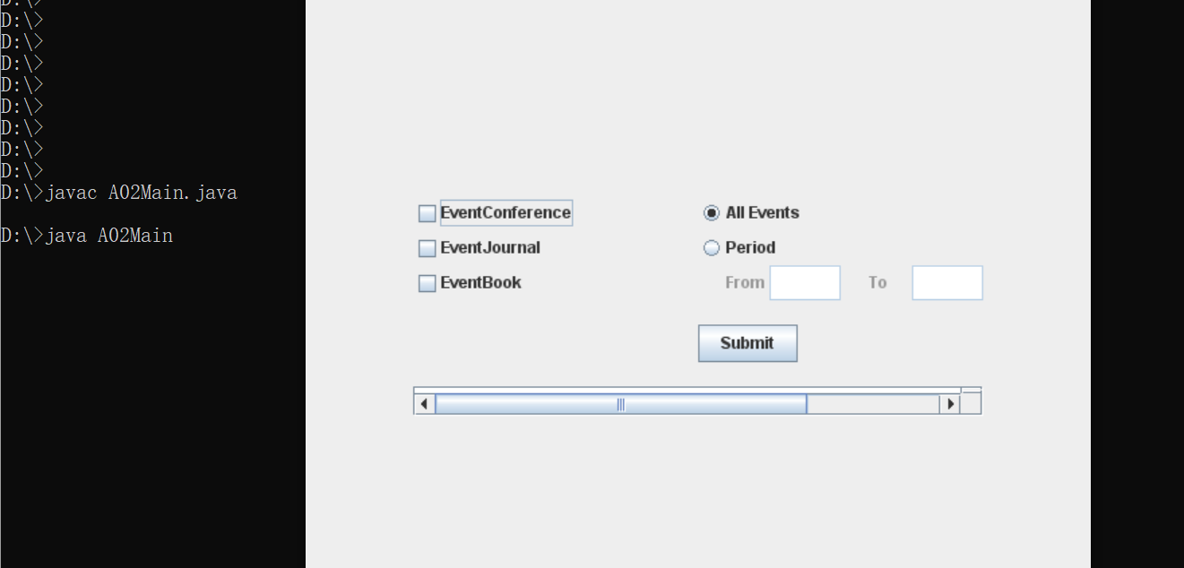

## Question 4: Testing and Reporting

### Test Case 1: Query all events in all date range:

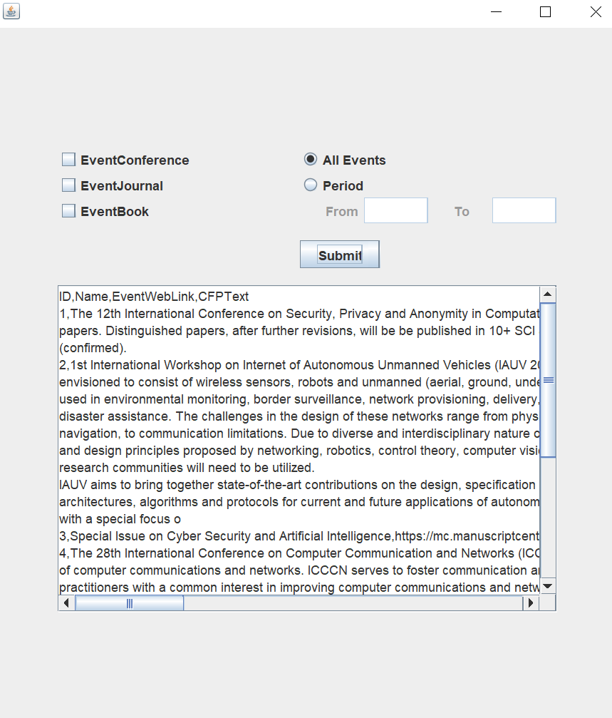

### Test Case 2: Query all events in date range from 2019-04-01 to 2019-07-01:

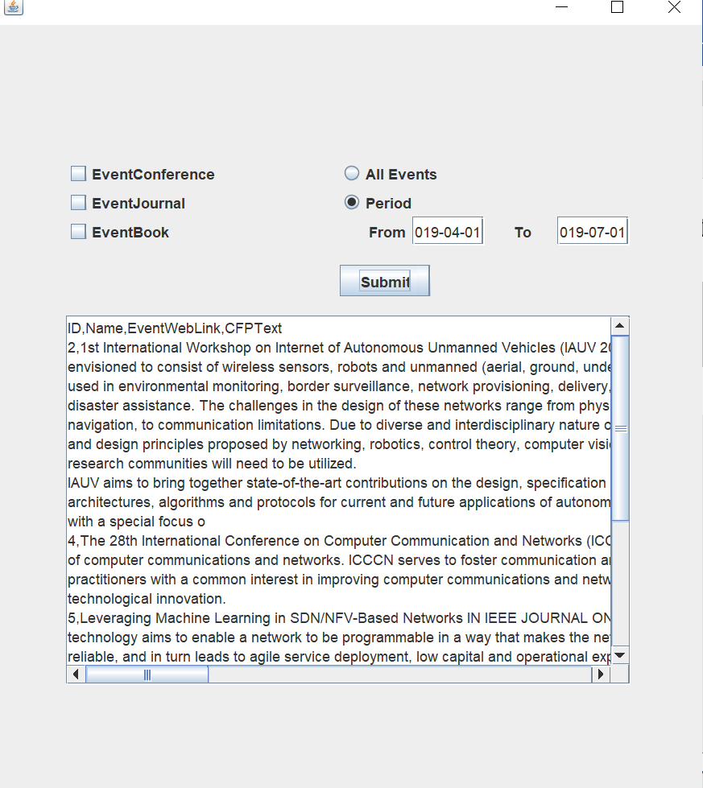

### Test Case 3: Query all conferences events in all date range:



### Test Case 4: Query all conferences events in date range from 2019-04-01 to 2019-07-01:

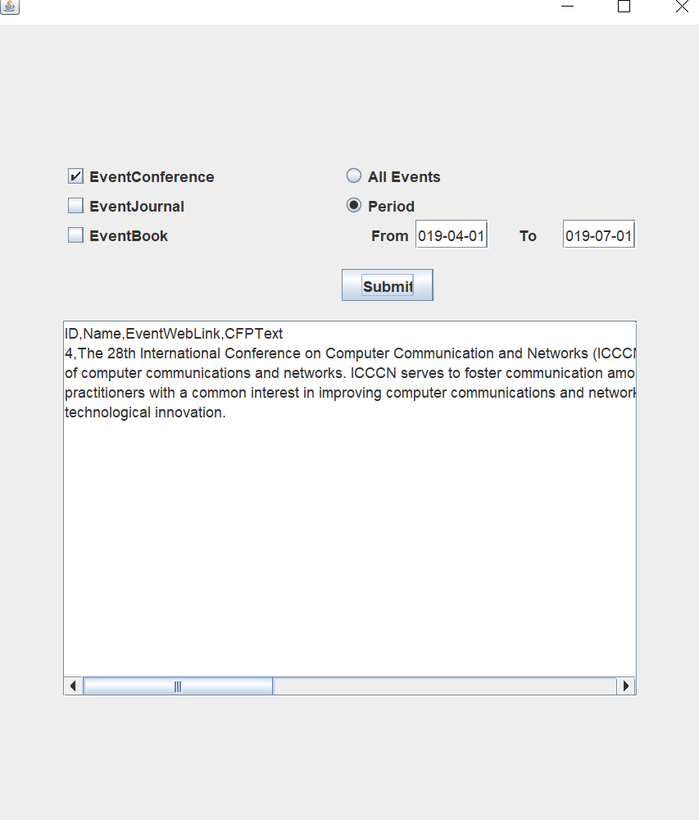

### Test Case 5: Query all journal events in all date range:

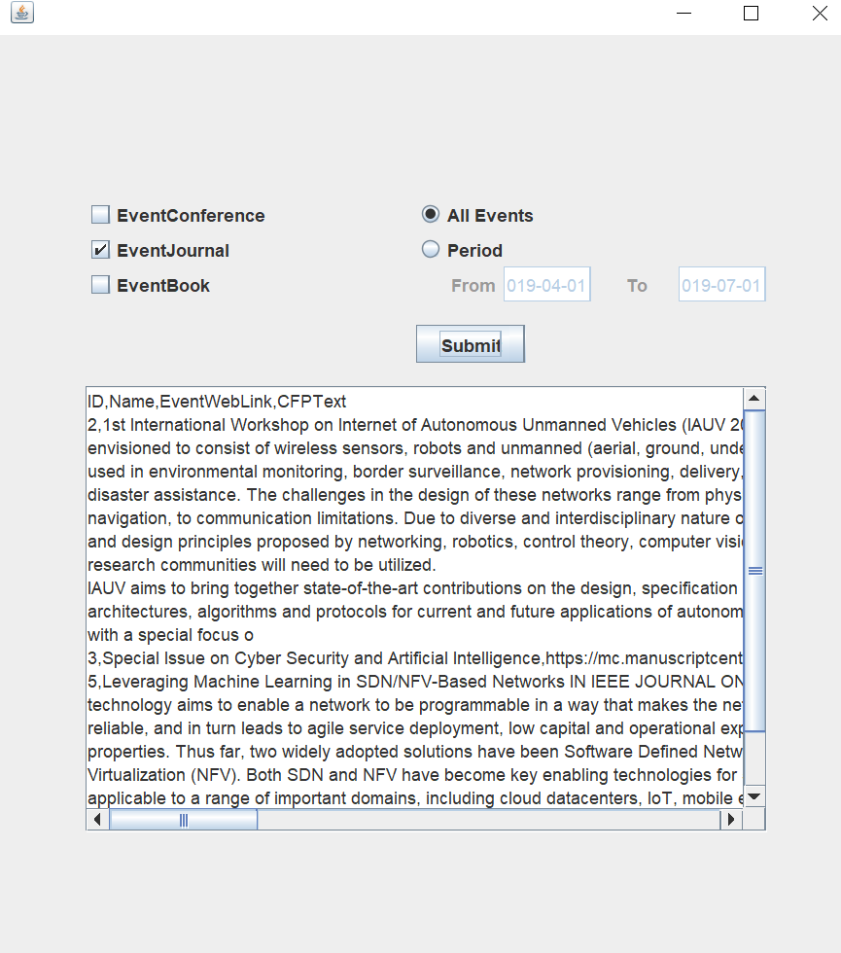

### Test Case 6: Query all journal events in date range from 2019-06-01 to 2019-09-01:

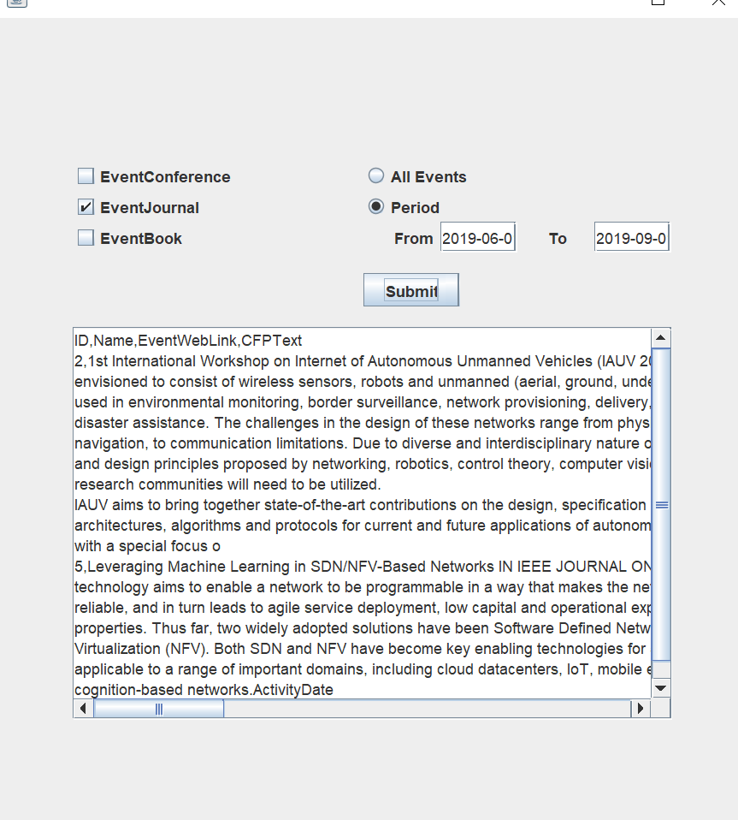

### Test Case 7: Query all book events in all date range:

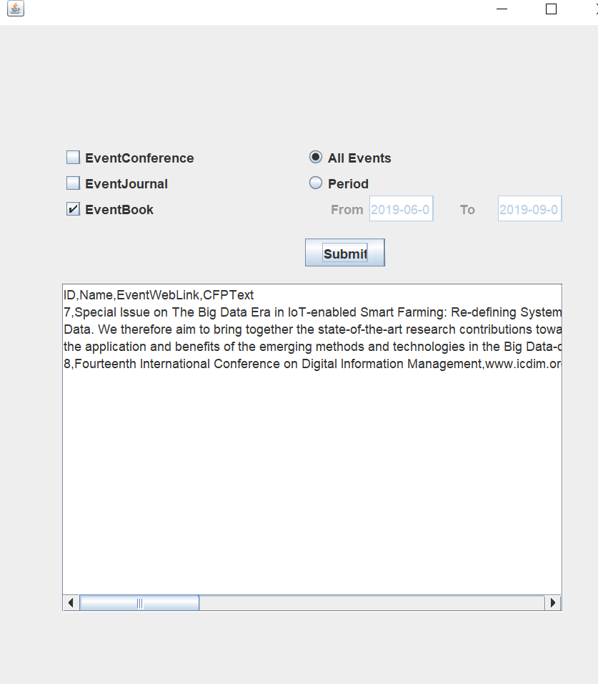

### Test Case 8: Query all book events in date range from 2019-08-01 to 2019-09-01:

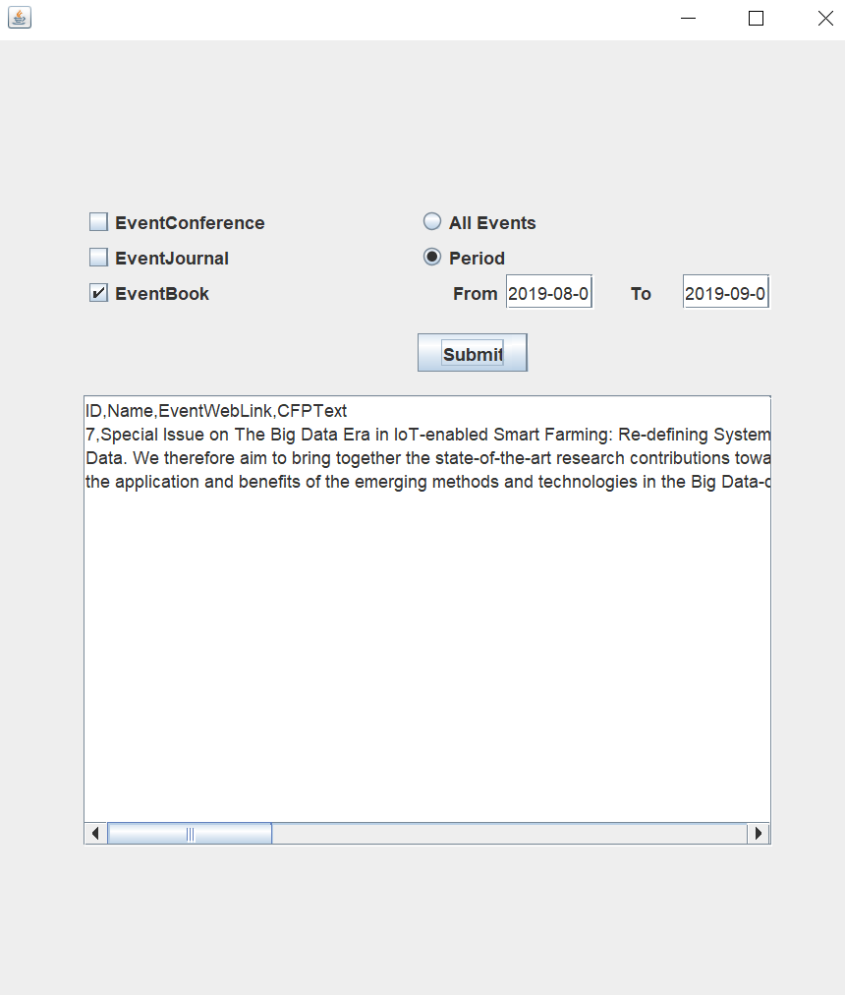

### Test Case 9: Query all book events and journal events in all date range:

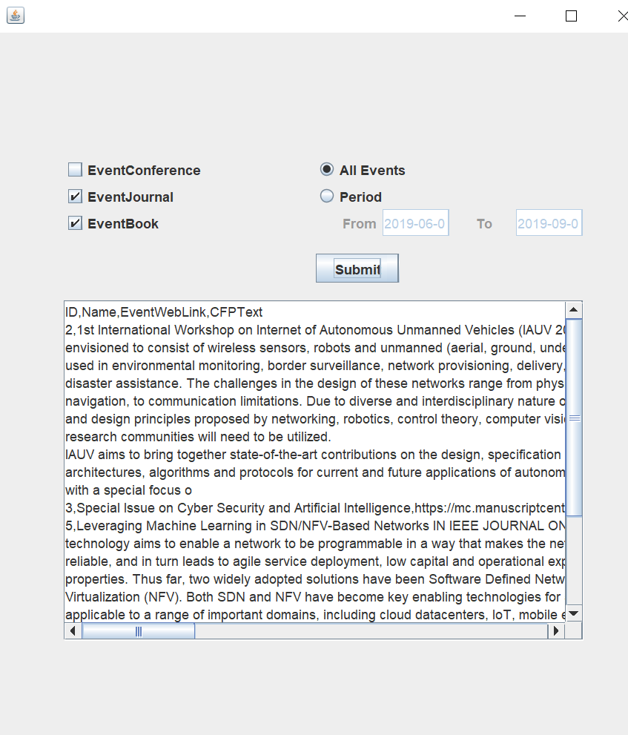

### Test Case 10: Query all book events and journal events in date range from 2019-06-01 to 2019-08-01:

