# Problem 1

1A E-R diagram 6 marks (requirements ER1.1-ER1.6)

1B Schema 5 marks (requirements SR2.1-SR2.5)

1A

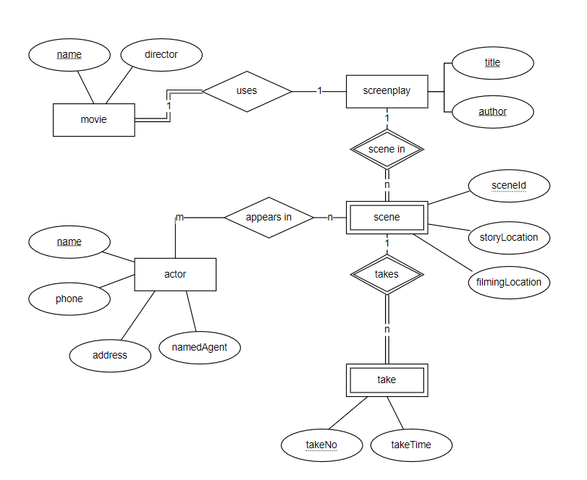

Some important assumptions:

A movie has an unique name, and every movie has director attribute.

A screenplay is identified by its title and author.

An actor is identified by name.

A scene is identified by scene id and its dependant entity (screenplay)’s title and author.

Every taking scene is identified by take no and its dependant entity (scene)’s scene id, title and author.

1B

Movie (name, director)

Screenplay (title, author, movie_name)

*Foreign key (movie_name) is referenced movie(name).*

Scene (sceneId, storyLocation, filmingLocation, titile, author)

*Foreign key (titile, author) is referenced screenplay(titile, author).*

Actor (name, phone, address, namedAgent)

Appears (actor_name, sceneId, titile, author)

*Foreign key (sceneId, titile, author) is referenced scene (sceneId, titile, author).*

*Foreign key (actor_name) is referenced actor(name)*

Take (takeNo, sceneId, titile, author, takeTime)

*Foreign key (sceneId, titile, author) is referenced scene (sceneId, titile, author).*

# Problem 2

2A E-R diagram 6 marks (requirements ER1.1-ER1.6)

2B Schema 5 marks (requirements SR2.1-SR2.5)

2C Design 5 marks (requirements R2.1-R2.5)

2A

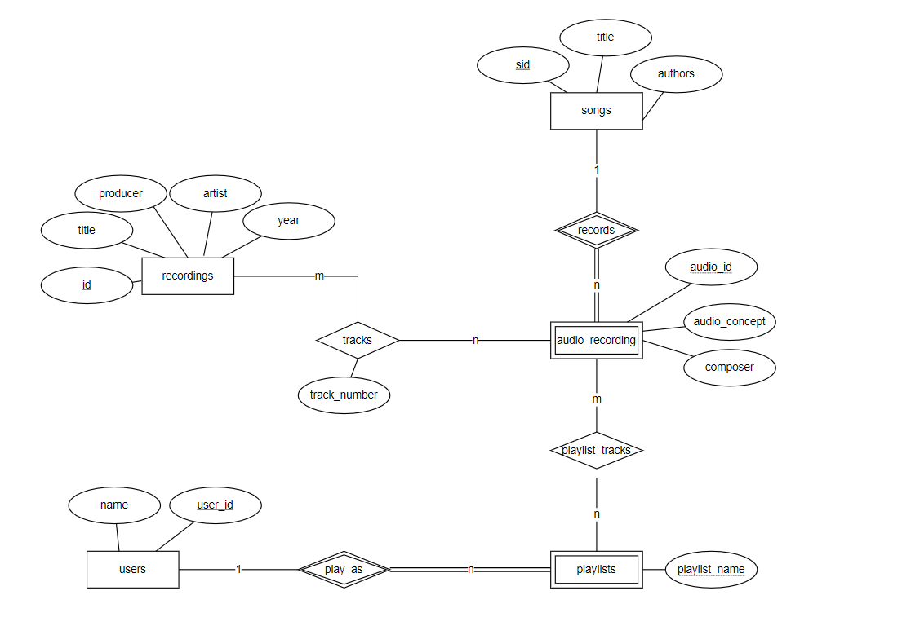

Some important assumptions:

A recording has an unique id.

A song is identified by sid.

An audio recording is dependant on a song, it is identified by audio id and sid.

A user is identified by user_id.

Playlists entity is dependant on users, it is identified by user_id and playlist_name.

A playlist must be a user and can only be one user, but a user may not play as any playlists.

A recording may have many audio recordings and an audio recording can also appear in many recordings.

A playlist can play many audio recording, and an audio recording also can be many playlists to play tracks.

2B

Recordings(id, title, producer, artist, year)

Songs(sid, title, authors)

Audio_recordings(sid, audio_id, audio_concept, composer)

*Foreign key (sid) is referenced Songs(sid).*

Users(user_id, name)

Playlists(user_id, playlist_name)

*Foreign key (user_id) is referenced Users(user_id).*

Playlist_tracks(user_id, playlist_name, sid, audio_id)

*Foreign key (user_id, playlist_name) is referenced Playlists(user_id, playlist_name).*

*Foreign key (sid, audio_id) is referenced Audio_recordings(sid, audio_id).*

Tracks(rid, sid, audio_id, track_number)

*Foreign key (rid) is referenced Recordings(id).*

*Foreign key (sid, audio_id) is referenced Audio_recordings(sid, audio_id).*

2C

In this part, I add a weak entity audio recording, which is dependent on songs for a song can be many composers to make audio recording.

The tracks that appear on an album should refer to audio recordings of songs (not written compositions of songs). So the relationship between recordings and audio recording is N:N.

And it should be audio recordings of songs that are placed on playlists, so change the relationship of songs and playlists to audio recording and playlist.

# Problem 3

3A E-R diagram 6 marks (requirements ER1.1-ER1.6)

3B Schema 5 marks (requirements SR2.1-SR2.5)

3A

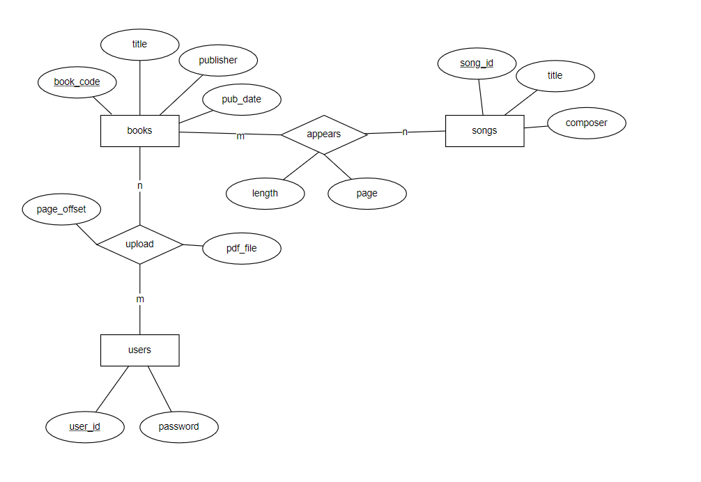

Some important assumptions:

A book has an unique book code.

A user has an unique user id.

A song has an unique sid.

A user can upload many books, a book can be upload by many users.

A song can appear in many books and a book can have many songs.

3B

Books(book_code, title, publisher, pub_date)

Songs(sid, title, composer)

Appears (book_code, sid, length, page)

*Foregin key (book_code) is referenced Books(book_code).*

*Foregin key (sid) is referenced songs(sid).*

Users(user_id, password)

Upload(user_id, book_code, page_offset, pdf_time)

*Foreign key (user_id) is referenced users(user_id).*

*Foreign key (book_code) is referenced Books(book_code).*

# Problem 4

4A E-R diagram 6 marks (requirements ER1.1-ER1.6)

4B Schema 5 marks (requirements SR2.1-SR2.5)

4C Scenerio Description marks (requirement DR4.1)

4A

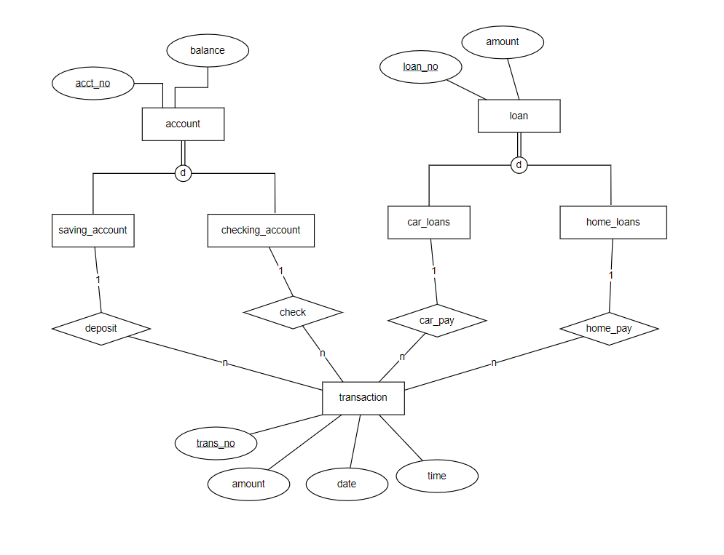

4B

Account (acct_no, balance)

Loan (loan_no, amount)

Saving_account (acct_no)

*Foreign key (acct_no) is referenced to Account(acct_no)*

Checking_account (acct_no)

*Foreign key (acct_no) is referenced to Account(acct_no)*

Car_loans(loan_no)

*Foreign key (loan_no) is referenced to Loan(loan_no)*

Home_loans (loan_no)

*Foreign key (loan_no) is referenced to Loan(loan_no)*

Transaction (trans_no, amount, date, time)

Deposit (acct_no, trans_no)

*Foreign key (acct_no) is referenced to saving_account(acct_no).*

*Foreign key (trans_no) is referenced to transaction(trans_no).*

Check (acct_no, trans_no)

*Foreign key (acct_no) is referenced to checking_account(acct_no)*

*Foreign key (trans_no) is referenced to transaction(trans_no).*

Car_pay (loan_no, trans_no)

*Foreign key (loan_no) is referenced to car_loans(loan_no)*

*Foreign key (trans_no) is referenced to transaction(trans_no).*

Home_pay (loan_no, trans_no)

*Foreign key (loan_no) is referenced to home_loans(loan_no)*

*Foreign key (trans_no) is referenced to transaction(trans_no).*

4C

A bank has four types of accounts, namely savings account, checking account, car loan account and home loan account. The savings account can save money, the checking account can check the balance, the car loan account can repay the loan for purchasing a car, and the mortgage account can repay the loan for purchasing a house.

The system needs to record the user's transaction records, and transaction information such as transaction number, transaction amount, transaction date and time, etc. need to be recorded.