Project SQLite Database Demonstration

## Part 1: Final Database Description

### Description of database

This project is motivated by the needs of my personal experiences. In our real life, we

have a lot of documents, IDs, confidential information papers and etc. These documents

are very important for us, for example when we use online service on government website sometime we need input our driver’s license information there, but you forget it in your car, we need go to the garage or parking lot to get it, however we only need some information of it. Some of you would say we can memorize it, think about it, passport, health card, website login and password, more and more internet account, can you memorize all of them?

Absolutely, there are some awesome apps available on mobile devices and pc, they

provide personal information store service like 1Password, login information, security

notes, credit card, IDs and Software License, available on most of platforms. With this

project, we hope to provide similar service as 1Password.

Application Requirements

The following describe what is required from the application.

R1.1)Provide an indexing information that saves information of IDs, login usernames and passwords, credit cards and everything important for you, we consider all of those things as (person_memo). The database should be able to search and locate for any item and output the information that users need by specific keywords related to the item, also when user find something they want to save from internet, they can do it by this application and user can also share specific part of the information to others.

R1.2)There are multiple customized values to save information of documents, also there

is link to view scanned document. Users are able to edit or update their item any time.

R1.3)The target size of the database should be able to hold all the items for each people and the items up to 500, for security purpose everyone’s database should be isolated, and there is a master password to open the personal database.

R1.4)Application should be a web-based app with UI, and it is able to run on any popular browser. Due Diligence(Copyright Issues) The data are all unique and related personal data information, we would not be in violation of copyrights in making this database, or service, or we could input fake information for demostration.

An Event is determined by its unique ID.

Everyone is identified by PersonID.

Every person organize the event has a role. And a person can organize many events, an event can be organized by many persons.

A show is identified by ShowID.

A show can belong to many events, and an event may have many shows.

A person can have may accounts, An account can only belong to a person.

Account is identified by AcctNo.

An account can pay for many shows, and a show can only be paid by an account.

### ER model

这个项目是基于一些在线活动，如歌唱比赛、读书活动和一些采访节目的场景，根据这些场景设计了数据库模型，可以更好地管理这些。 人们可以组织各种活动并为这些活动做表演。 并且，人们也可以作为观众观看这些在线节目。为了观看这些节目，人们需要拥有一个支付账号用于支付观看节目的费用。

为了清晰地描述上述场景，下面进一步对场景需求进行描述。

This project is based on some online activities such as singing competition, reading books event and some interview shows. People can organize all kinds of events and make shows for the events. And

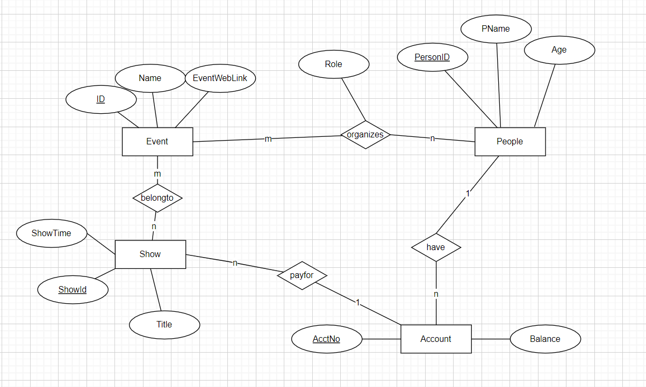

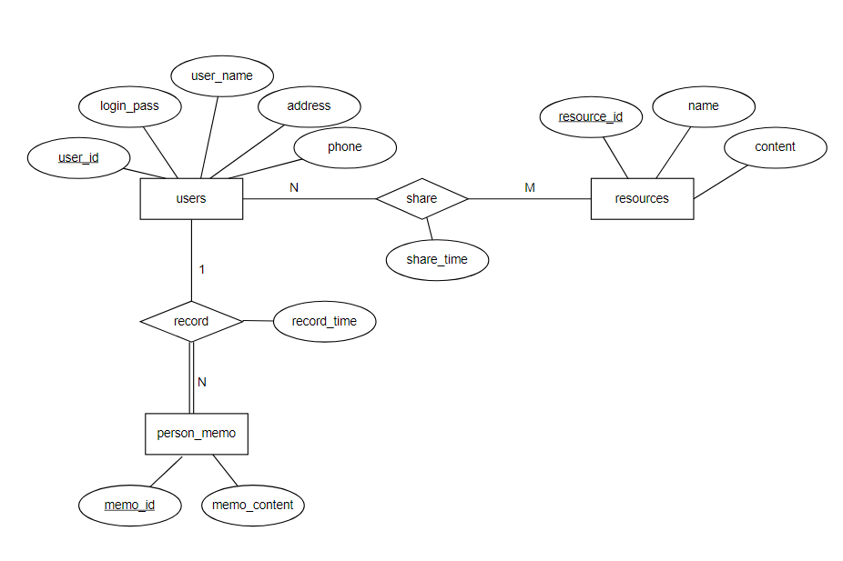

### Cardinality

users: person_memo 1:N

person_memo: users 1:1

users: resources N:N