Student Name

**CS 480 Spring 2022 Written Assignment #01**

Due: **Thursday, February 17th, 11:00 PM CST**

Points: **20**

**Instructions:**

1. Use this document template to report your answers. Name the complete document as follows:

LastName_FirstName_CS480_Written01.doc

1. Submit the final document to Blackboard Assignments section before the due date. No late submissions will be accepted.

**Objectives:**

1. (8 points) Analyze an agent-environment system and apply the PEAS agent description.
2. (12 points) Demonstrate your understanding of a simple informed search algorithm.

**Problem 1:**

Consider the robotic Rubik’s cube solver shown on below (fig. 1). You are welcome to watch a short video about its development online at <https://www.youtube.com/watch?v=x4O8pojMF0w.>



*Figure 1: Open AI robotic Rubik’s cube solver (screen shot from: https://www.youtube.com/watch?v=x4O8pojMF0w).*

Your task is to:

* decide what is the agent and what is the environment in this system **[1 pt]**:

|  |  |  |
| --- | --- | --- |
| **Agent** | **Environment** | **Explanation** |
|  |  |  |

* analyze the system and apply the the PEAS (Performance measure, Environment, Actuators, Sensors) description **[3 pts]**:

|  |  |  |  |  |
| --- | --- | --- | --- | --- |
| **Performance measure** | **Environment** | **Actuators** | **Sensors** | **Explanation** |
|  |  |  |  |  |

* Specify the properties of this environment. Justify your decisions **[4 pts]**:

|  |  |  |
| --- | --- | --- |
| **Property** | **Your choice** | **Explanation** |
| Fully observable? |  |  |
| Multiagent? |  |  |
| Deterministic? |  |  |
| Episodic? |  |  |
| Dynamic? |  |  |
| Discrete? |  |  |
| Known to Agent? |  |  |

**Problem 2:**

Consider the **undirected** graph presented below (fig. 2). Each node represents a single state (you can assume that each state represents a city on a map). If two states are neighbors, there is an edge between them.

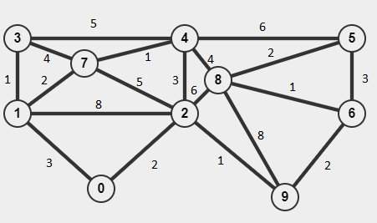

*Figure 2: An undirected graph.*

Assume that edge weights represent **driving distances between cities/states in miles**.

Your task is to utilize the **Hill Climbing algorithm to find a shortest (minimum cost) path** between two states provided data. Here are the steps:

* assume that **repeated states are NOT allowed**,
* select two states / cities (initial and goal states) at random under the condition that there is at least two (2) states between your initial and state goals (that would correspond to **at least** three (3) actions),
* apply the Hill Climbing algorithm and show all steps / actions in Table A below,
* provide a search tree diagram illustrating the path chosen along with evaluation function values and all alternatives (you can paste in a scan or a photo of a hand-drawn diagram or use some software to create it).

**NOTE: The algorithm may get “stuck” and not reach the goal state.**

|  |  |  |  |  |
| --- | --- | --- | --- | --- |
| **TABLE A: Algorithm steps / actions [6 pts]** | | | | |
| Current state | Available actions and their costs | Selected action | Resulting state | Explanation / comments |
|  |  |  |  |  |
|  |  |  |  |  |
|  |  |  |  |  |
|  |  |  |  |  |
|  |  |  |  |  |
|  |  |  |  |  |
|  |  |  |  |  |
|  |  |  |  |  |
|  |  |  |  |  |
|  |  |  |  |  |
|  |  |  |  |  |
|  |  |  |  |  |
|  |  |  |  |  |
|  |  |  |  |  |

|  |
| --- |
| **Tree search diagram [6 pts]** |
|  |

Did the Hill Climbing algorithm pick the best (lowest total cost in miles) path?

|  |
| --- |
| **Your answer:** |
|  |