Student Name

**CS 480 Spring 2022 Written Assignment #02**

Due: **Thursday, March 3rd, 11:00 PM CST**

Points: **80**

**Instructions:**

1. Use this document template to report your answers. Name the complete document as follows:

LastName_FirstName_CS480_Written02.doc

1. Submit the final document to Blackboard Assignments section before the due date. No late submissions will be accepted.

**Objectives:**

1. (20 points) Demonstrate your understanding of MinMax games and a-b pruning algorithm.
2. (60 points) Demonstrate your understanding of propositional logic, its syntax, laws, and inference based on propositional logic.

**Problem 1 [20 pts]:**

Consider the following MinMax game tree

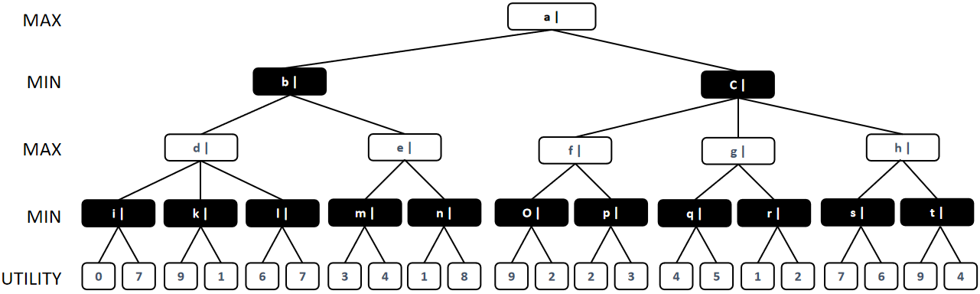

Evaluate MinMax values for all nodes (you can paste in an edited version of this tree below) **[10 pts]**:

|  |
| --- |
| **Your solution:** |
|  |

Now, apply **alpha-beta (a-b) pruning** to prune some of the tree branches. Show (you can paste in an edited version of this tree below) which sections of the tree will be pruned and **justify your answer [10 pts]**:

|  |
| --- |
| **Your solution:** |
|  |

**Problem 2 [20 pts]:**

Use **truth tables** to show that the following sentences are **tautologies [5 pts]**:

1. ¬(p ∧ q) ⇔ ¬p ∨ ¬q **[5 pts]**

Place your truth table here.

1. p ⇒ q ⇔ ¬q ⇒ ¬p **[5 pts]**

Place your truth table here.

1. ((p ⇒ q) ∧ (q ⇒ p)) ⇔ (p ⇔ q) **[5 pts]**

Place your truth table here.

1. (p ∨ q) ∧ (¬q ∨ r) ⇒ (p ∨ r) **[5 pts]**

Place your truth table here.

**Problem 3 [20 pts]:**

Use **deduction** to show (**prove**) that the following sentences are **tautologies**:

1. ¬(p ∧ q) ⇔ ¬p ∨ ¬q **[5 pts]**

|  |  |  |
| --- | --- | --- |
| **Your proof:** | | |
| **Step** | **Resulting sentence** | **Applied law / rule** |
| 1 |  |  |
| 2 |  |  |
| 3 |  |  |
| 4 |  |  |
| 5 |  |  |
| 6 |  |  |
| Add more rows if necessary | Symbols (copy/paste): T⊥∨∧≡⇔¬⇒∴ | | |

1. p ⇒ q ⇔ ¬q ⇒ ¬p **[5 pts]**

|  |  |  |
| --- | --- | --- |
| **Your proof:** | | |
| **Step** | **Resulting sentence** | **Applied law / rule** |
| 1 |  |  |
| 2 |  |  |
| 3 |  |  |
| 4 |  |  |
| 5 |  |  |
| 6 |  |  |
| Add more rows if necessary | Symbols (copy/paste): T⊥∨∧≡⇔¬⇒∴ | | |

1. ((p ⇒ q) ∧ (q ⇒ p)) ⇔ (p ⇔ q) **[5 pts]**

|  |  |  |
| --- | --- | --- |
| **Your proof:** | | |
| **Step** | **Resulting sentence** | **Applied law / rule** |
| 1 |  |  |
| 2 |  |  |
| 3 |  |  |
| 4 |  |  |
| 5 |  |  |
| 6 |  |  |
| Add more rows if necessary | Symbols (copy/paste): T⊥∨∧≡⇔¬⇒∴ | | |

1. (p ∨ q) ∧ (¬q ∨ r) ⇒ (p ∨ r) **[5 pts]**

|  |  |  |
| --- | --- | --- |
| **Your proof:** | | |
| **Step** | **Resulting sentence** | **Applied law / rule** |
| 1 |  |  |
| 2 |  |  |
| 3 |  |  |
| 4 |  |  |
| 5 |  |  |
| 6 |  |  |
| Add more rows if necessary | Symbols (copy/paste): T⊥∨∧≡⇔¬⇒∴ | | |

**Problem 4 [20 pts]:**

Convert the following sentences into **conjunctive normal form** (**CNF**):

1. p ⇔ q **[6 pts]**

|  |  |  |
| --- | --- | --- |
| **Your conversion steps:** | | |
| **Step** | **Resulting sentence** | **Applied law / rule** |
| 1 |  |  |
| 2 |  |  |
| 3 |  |  |
| 4 |  |  |
| 5 |  |  |
| 6 |  |  |
| Add more rows if necessary | Symbols (copy/paste): T⊥∨∧≡⇔¬⇒∴ | | |

1. p ∧ q⇔ p ∨ q **[6 pts]**

|  |  |  |
| --- | --- | --- |
| **Your conversion steps:** | | |
| **Step** | **Resulting sentence** | **Applied law / rule** |
| 1 |  |  |
| 2 |  |  |
| 3 |  |  |
| 4 |  |  |
| 5 |  |  |
| 6 |  |  |
| Add more rows if necessary | Symbols (copy/paste): T⊥∨∧≡⇔¬⇒∴ | | |

1. p ∧ (p ⇒ q)⇒ q **[8 pts]**

|  |  |  |
| --- | --- | --- |
| **Your conversion steps:** | | |
| **Step** | **Resulting sentence** | **Applied law / rule** |
| 1 |  |  |
| 2 |  |  |
| 3 |  |  |
| 4 |  |  |
| 5 |  |  |
| 6 |  |  |
| Add more rows if necessary | Symbols (copy/paste): T⊥∨∧≡⇔¬⇒∴ | | |