Student Name

**CS 480 Spring Written Assignment #04**

Due: **Wednesday, April 27, 11:00 PM CST**

Points: **45**

**Instructions:**

1. Use this document template to report your answers. Name the complete document as follows:

LastName_FirstName_CS480_Written04.doc

1. Submit the final document to Blackboard Assignments section before the due date. No late submissions will be accepted.

**Objectives:**

1. (10 points) Demonstrate your understanding of Bayes Networks.
2. (35 points) Demonstrate your understanding of Decision Networks.

**Problem 1 [10 pts]:**

We are given the following Bayesian network over X2, X3, …, X9. Note that there is no X1.

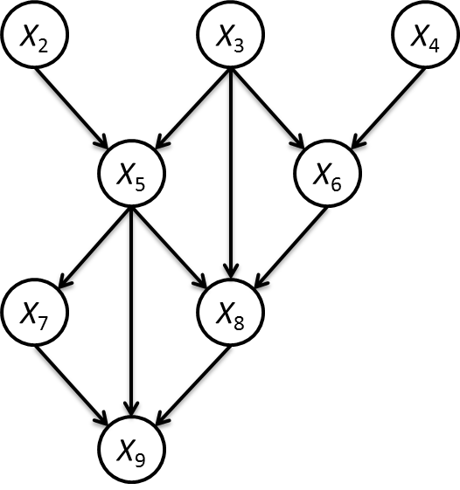

What is the Bayesian network factorization of the joint probability **P**(X2, X3, …, X9)?

|  |
| --- |
| **Your solution:** |
|  |

**Problem 2 [35 pts]:**

We are given the following decision network:

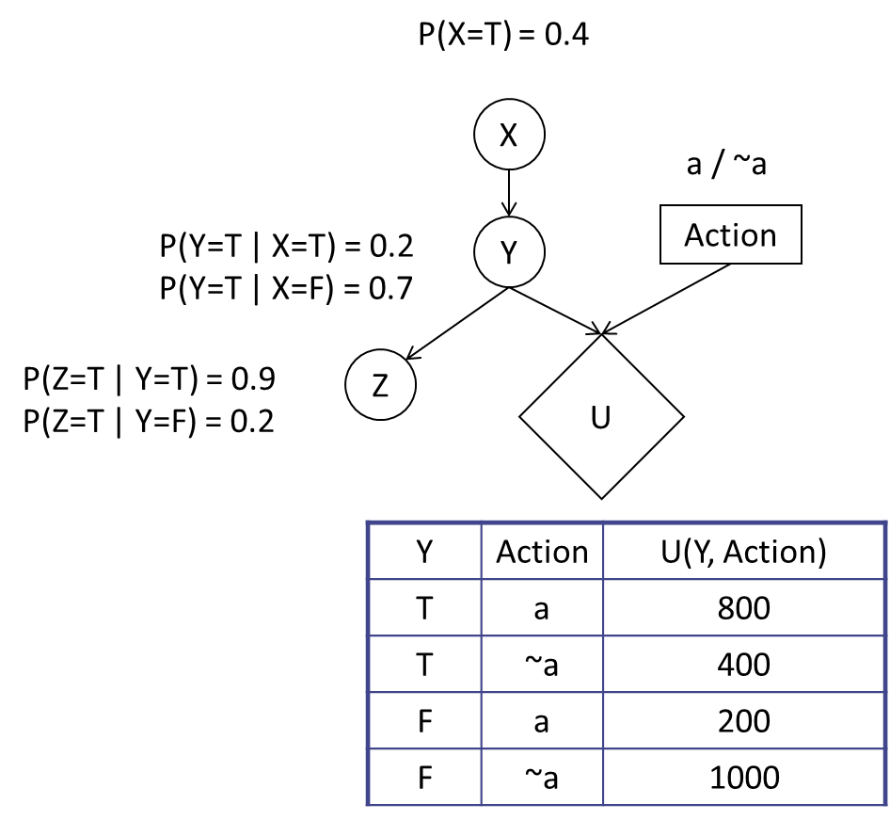

1. Which action should be taken? Justify your decision. **[7 pts]**

|  |
| --- |
| **Your solution:** |
|  |

1. What is the value of information of Z? Justify your decision. **[8 pts]**

|  |
| --- |
| **Your solution:** |
|  |

1. What is the value of information of X? Justify your decision. **[10 pts]**

|  |
| --- |
| **Your solution:** |
|  |

1. Given Z = T, what is the value of information of X? Justify your decision. **[10 pts]**

|  |
| --- |
| **Your solution:** |
|  |