Student Name

**CS 480 Spring Written Assignment #04**

Due: **Wednesday, April 27, 11:00 PM CST**

Points: **45**

**Instructions:**

1. Use this document template to report your answers. Name the complete document as follows:

LastName_FirstName_CS480_Written04.doc

1. Submit the final document to Blackboard Assignments section before the due date. No late submissions will be accepted.

**Objectives:**

1. (10 points) Demonstrate your understanding of Bayes Networks.
2. (35 points) Demonstrate your understanding of Decision Networks.

**Problem 1 [10 pts]:**

We are given the following Bayesian network over X2, X3, …, X9. Note that there is no X1.

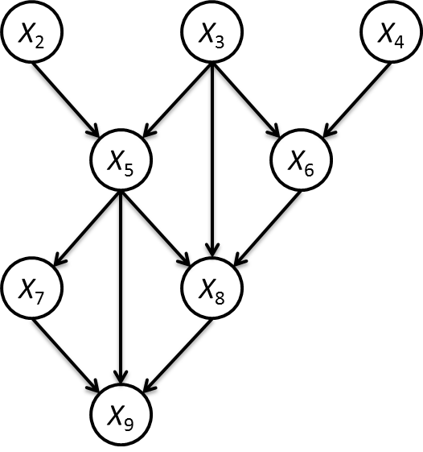

What is the Bayesian network factorization of the joint probability **P**(X2, X3, …, X9)?

|  |
| --- |
| **Your solution:**  As we see that X2, X3, X4 are independent probability so probability of these is *P*(*X*2​,*X*3​,*X*4​)=*P*(*X*2​)*P*(*X*3​)*P*(*X*4​)  if we see that X5 is dependent on X2, X3 so the probability is given as  *P*(*X*2​,*X*3​,*X*5​)=*P*(*X*2​)*P*(*X*3​)*P*(*X*5​∣*X*2​,*X*3​)  if we see that X6 is dependent on X3, X4 so the probability is given as  *P*(*X*3​,*X*4​,*X*6​)=*P*(*X*3​)*P*(*X*4​)*P*(*X*6​∣*X*3​,*X*4​)  if we see that X7 is dependent on X5 so the probability is given as  *P*(*X*2​,*X*3​.......*X*7​)=*P*(*X*2​)*P*(*X*3​)*P*(*X*4​)*P*(*X*5​∣*X*2​,*X*3​)*P*(*X*6​∣*X*3​,*X*4​)*P*(*X*7​∣*X*5​)  if we see that X8 is dependent on X3. X5,X6 so the probability is given as *P*(*X*2​,*X*3​.......*X*8​)=*P*(*X*2​)*P*(*X*3​)*P*(*X*4​)*P*(*X*5​∣*X*2​,*X*3​)*P*(*X*6​∣*X*3​,*X*4​)*P*(*X*7​∣*X*5​)*P*(*X*8​∣*X*5​,*X*3​,*X*6​)  if we see that X9 is dependent on X7. X5,X8 so the probability is given as *P*(*X*2​,*X*3​.......*X*9​)=*P*(*X*2​)*P*(*X*3​)*P*(*X*4​)*P*(*X*5​∣*X*2​,*X*3​)*P*(*X*6​∣*X*3​,*X*4​)*P*(*X*7​∣*X*5​)*P*(*X*8​∣*X*5​,*X*3​,*X*6​)*P*(*X*9​∣*X*7​,*X*5​,*X*8​) |

**Problem 2 [35 pts]:**

We are given the following decision network:

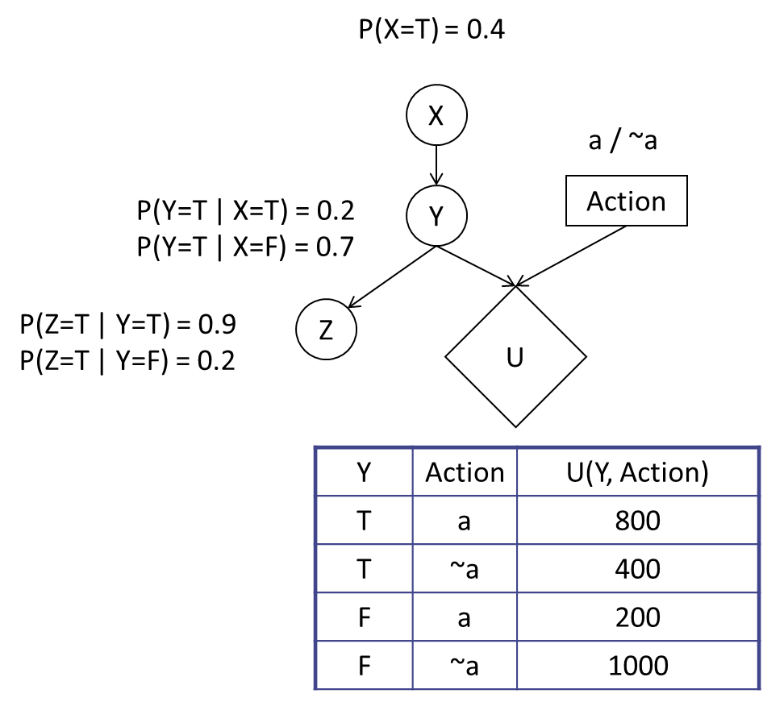

1. Which action should be taken? Justify your decision. **[7 pts]**

|  |
| --- |
| **Your solution:**  Using the variable elimination, we need to find out P(Y=T) and P(Y=F)  So P(Y=F|X=T)=0.8  P(Y=F|X=F)=0.3  P(X=F)=0.6  So, P(Y=T)=0.2X0.4+0.7X0.6=0.5  P(Y=F)=0.8*0.4+0.3*0.6=0.5  So Expected Utility when a:  EU=0.5*800+0.5*200=500  Expected Utility when ~a:  EU=0.5*400+0.5*1000=700  EU(~a)>EU(a)  The action taken must be ~a |

1. What is the value of information of Z? Justify your decision. **[8 pts]**

|  |
| --- |
| **Your solution:** |
| For Z=T, for action a  P(Y|Z=T)=P(Y)*P(Z=T|Y)  (Y=T,P(Y|Z=T))=0.5*0.9=0.45  (Y=F,P(Y|Z=T))=0.5*0.2=0.1  After Normalization < 0.818, 0.182>  EU=0.818*800+0.182*200=690.8  For action ~a  EU=0.818*400+0.182*1000=509.2  MEU=>690.8  For Z=F,  (Y=T,P(Y|Z=F))=0.5*0.1=0.05  (Y=F,p(Y|Z=F))=0.5*0.8=0.4  After normalization <0.111, 0.889>  EU(a)=0.111*800+0.889*200=266.6  EU(~a)=0.111*400+0.889*1000=933.4  MEU=>933.4  Vol(Z)=P(Z=T)*(MEU|Z=T)+P(Z=F)*(MEU|Z=F)-MEU before Z  P(Z=T)*(MEU|Z=T) =0.55*690.8=379.94  P(Z=F)*(MEU|Z=F)=0.45*933.4=420.03  MEU before Z is 700  Value of information of Z=379.94+420.03-700=99.97 |

1. What is the value of information of X? Justify your decision. **[10 pts]**

|  |
| --- |
| **Your solution:** |
| P(Y|X=T)*P(X=T)  For X=T  P(Y=T AND P(Y|X=T))=0.08/0.4=0.2  P(Y=F AND P(Y|X=T))=0.32/0.4=0.8  EU(a)=0.2*800+0.8*200=320  EU(~a)=0.2*400+0.8*1000=880  MEU=>880  For X=F  P(Y=T AND P(Y|X=F))=0.42/0.6=0.7  P(Y=F AND P(Y|X=F))=0.18/0.6=0.3  EU(a)=0.7*400+0.3*200=620  EU(~a)=0.7*400+0.3*1000=580  MEU=>620  Value of Information (X)=0.4*880 +0.6*620-700=24 |

1. Given Z = T, what is the value of information of X? Justify your decision. **[10 pts]**

|  |
| --- |
| **Your solution:** |
| After X, for X=T given Z=T  P(Y|X=T,Z=T)=from the joint distribution=P(X=T)*P(Y|X=T)*P(Y|Z=T)  P(Y=T|X=T,Z=T)=0.4*0.2*0.9=0.072  P(Y=F|X=T,Z=T)=0.4*0.8*0.2=0.064  After normalization:  P(Y=T|X=T, Z=T)=0.072/0.136=0.529  P(Y=F|X=T,Z=T)=0.064/0.136=0.471  EU(a):0.529*800+0.471*200=517.4  EU(~a):0.529*400+0.471*1000=682.6  EMU=>682.6  For X=F and given Z=T  P (Y|X=F, Z=T)=from the joint distribution=P(X=F)*P(Y|X=F)*P(Y|Z=T)  P(Y=T|X=T,Z=T)=0.6*0.7*0.9=0.378  P(Y=F|X=T,Z=T)=0.6*0.3*0.2=0.036  After normalization:  P(Y=T|X=F,Z=T)=0.378/0.414=0.913  P(Y=F|X=F,Z=T)=0.036/0.414=0.087  EU(a)=0.913*800+0.087*200=747.8  EU(~a)=0.913*400+0.087*1000=452.2  MEU=>747.8  Value of information of x when Z=T  Vol(X|Z=T)=P(X=T|Z=T)*MEU(X=T,Z=T)+P(X=F|Z=T)*MEU(X=F,Z=T)-MEU before   =0.247*682.6+0.752*747.8-690.8=40.692 |