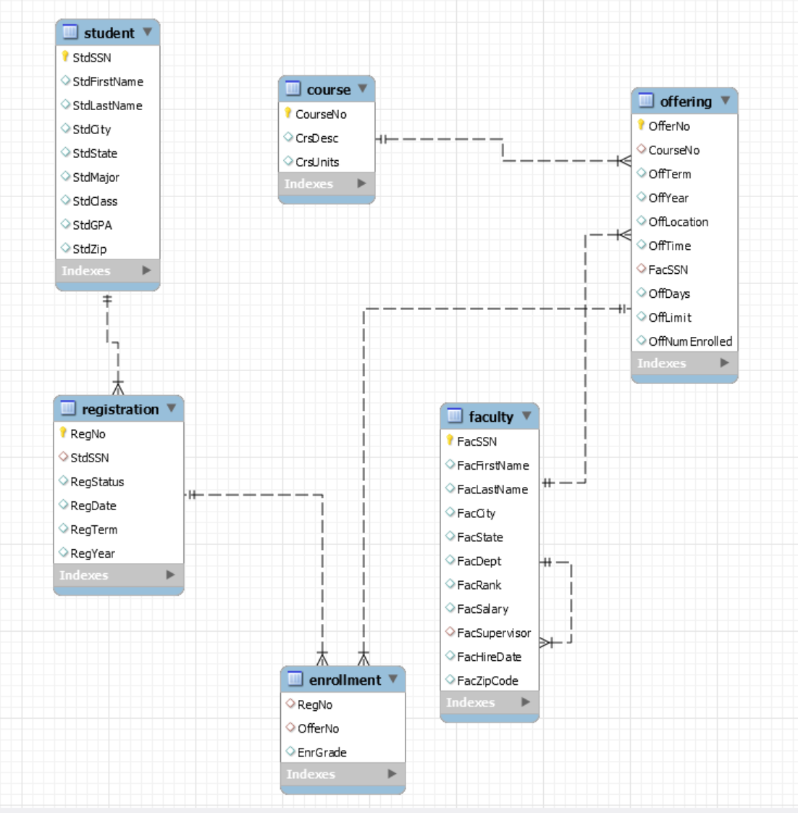

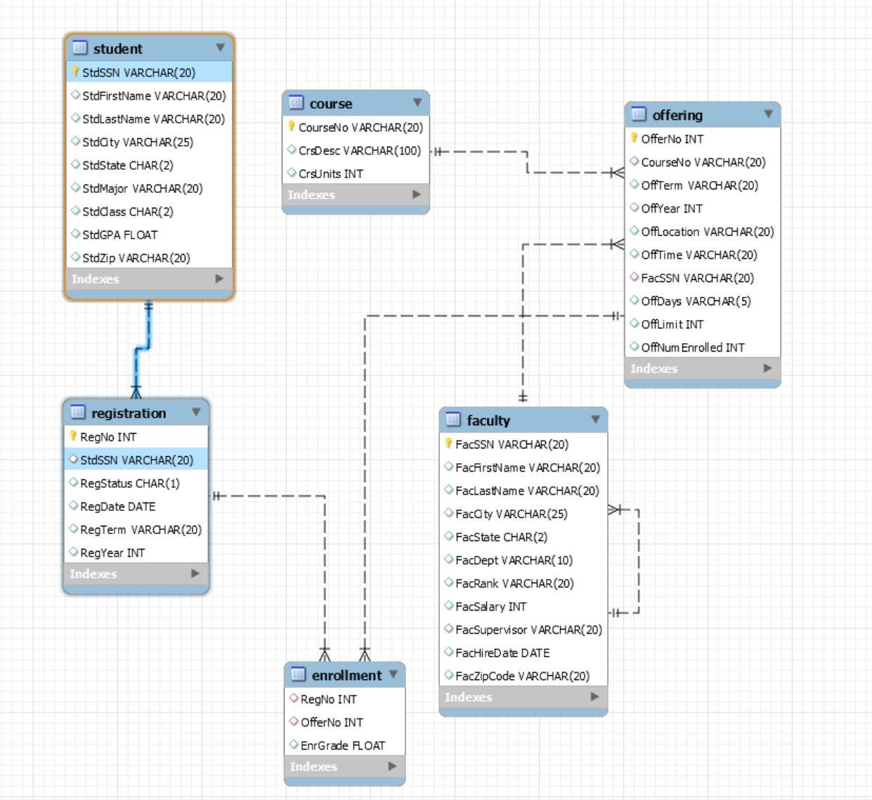

## task2

1. Retrieve the name, city, and grade point average (GPA) of students with a high GPA (greater than or equal to 3.2).

select StdFirstName, StdLastName, StdCity,round(StdGPA,2) as StdGPA from student

where StdGPA>=3.2;

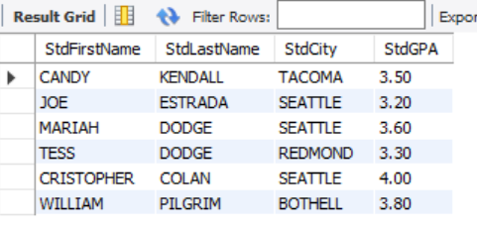

2. List the name, city, and increased salary (increase the salary by 20 percent) of faculty hired after 1996.

select FacFirstName as FirstName, FacLastName as LastName, FacCity as City,

round(FacSalary*1.2,0) as InflatedSalary, DATE_FORMAT(FacHireDate,'%c/%e/%Y')as HireDate

from faculty

where year(FacHireDate)>1996;

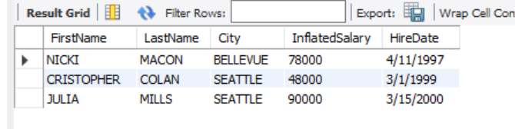

3. List the offering number and course number of Year 2006 offerings which had no instructor (faculty) assigned.

select OfferNo, CourseNo

from offering

where OffYear=2006 and FacSSN is null;

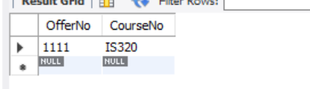

4. List the offer number, course number, offer term, offer year and faculty Social Security number (SSN) for offerings scheduled in fall 2005 or spring 2006.

select OfferNo, CourseNo, OffTerm, OffYear, FacSSN

from offering

where OffYear=2006 and OffTerm='SPRING' or OffYear=2005 and OffTerm='FALL';

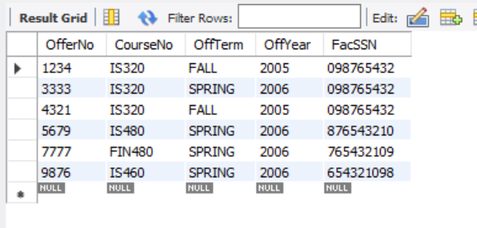

5. List the offering number, course number, and days of offerings containing the words “finance” or “database” in the course description (regardless of uppercase or lowercase letters) and taught in winter 2006.

select OfferNo, CourseNo, OffDays

from offering

where OffYear=2006 and OffTerm='WINTER'

and CourseNo in (select CourseNo from course where lower(CrsDesc) like '%finance%' or lower(CrsDesc) like '%database%');

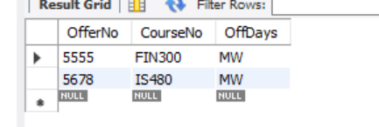

6. List the offer number, course number, and full name of the instructor (faculty) of all FINANCE courses (the course number’s prefix is ‘FIN’) offered in winter 2006 taught by professor. Note: professor’s rank is “PROF” in the database.

select OfferNo, CourseNo, concat(faculty.FacFirstName,' ', faculty.FacLastName) as "Instructor Name"

from offering

join faculty on faculty.FacSSN=offering.FacSSN

where OffYear=2006 and OffTerm='WINTER'

and CourseNo like 'FIN%'

and faculty.FacRank='PROF';

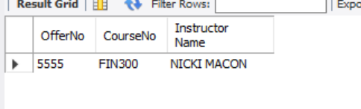

7. Summarize the number of offerings by course

select CourseNo, count(OfferNo) as NumOfferings

from offering

group by CourseNo;

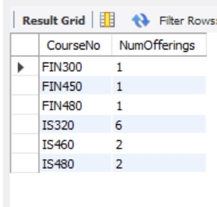

8. Summarize the average GPA of upper-division (junior or senior) students by major. Only list the majors with average GPA greater than 3.3.

select StdMajor, round(avg(StdGPA),1) as AvgGPA

from student

where StdClass='SR' or StdClass='JR'

group by StdMajor

having avg(StdGPA)>3.3;

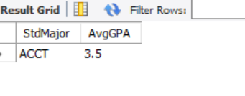

9. Summarize the minimum and maximum GPA of students by major and class.

select StdMajor as Major, StdClass as Class, round(min(StdGPA),1) as MinGPA, round(max(StdGPA),1) as MaxGPA

from student

group by StdMajor, StdClass;

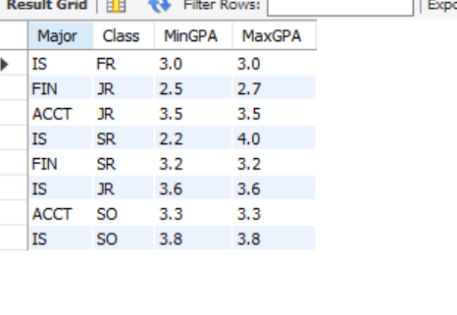

10. Summarize the number of offerings run in 2006 by offering location.

select OffLocation, count(distinct OfferNo) as 2006OfferCount

from offering

where OffYear=2006

group by OffLocation

order by 2006OfferCount desc;

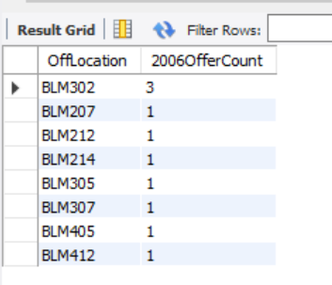

11. List a faculty Leonard Fibon’s teaching schedule in spring 2006. List the offering number, course number, course description, days, location, and time.

select OfferNo, o.CourseNo, CrsDesc, OffDays, OffLocation,OffTime

from faculty f join offering o on f.FacSSN=o.FacSSN

join course c on c.CourseNo=o.CourseNo

where f.FacFirstName='Leonard' and f.FacLastName='Fibon'

and o.OffTerm='SPRING' and o.OffYear='2006';

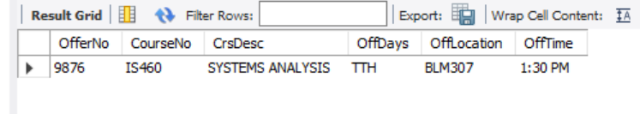

12. List a student Candy Kendall’s course schedule in 2005. List the offering number, course number, days, location, time, and instructor’s last name.

select o.OfferNo, CourseNo, OffDays, OffLocation, OffTime, f.FacLastName

from student s join registration r on s.StdSSN=r.StdSSN

join enrollment e on e.RegNo=r.RegNo

join offering o on o.OfferNo=e.OfferNo

join faculty f on f.FacSSN=o.FacSSN

where s.StdFirstName='Candy' and s.StdLastName='Kendall' limit 1 ;

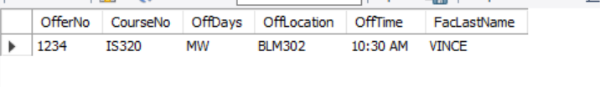

13. List faculty members who have a lower salary than their supervisor. List the faculty member’s name, the faculty member’s salary and the supervisor’s name, the supervisor’s salary.

select Subr.FacFirstName, Subr.FacLastName, Subr.FacSalary, Supr.FacFirstName, Supr.FacLastName, Supr.FacSalary

from faculty Subr join faculty Supr on Subr.FacSupervisor=Supr.FacSSN

where Subr.FacSalary<Supr.FacSalary;

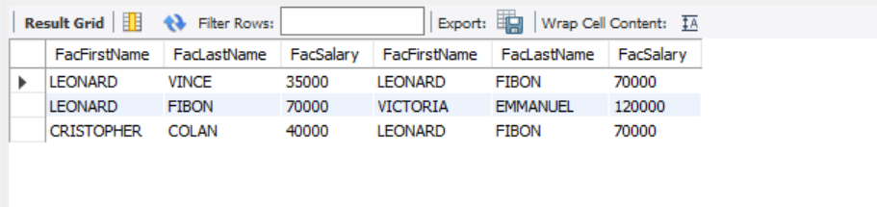

14. List the names of faculty members and the course number for which the faculty member teaches the same course number as his or her supervisor in the same year.

select concat(f1.FacFirstName,' ', f1.FacLastName) as "Faculty Name",o.OffYear as Year, o.CourseNo

from faculty f1 join offering o on f1.FacSSN=o.FacSSN

join faculty f2 on f1.FacSupervisor=f2.FacSSN

join offering o2 on o2.FacSSN=f2.FacSSN

where o.OffYear=o2.OffYear and o.CourseNo=o2.CourseNo ;

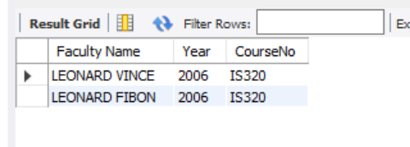

15. List the course number, the offering number, and the average GPA of students enrolled. Only include courses offered in spring term in which the average GPA of enrolled students is greater than 3.0.

select CourseNo, offering.OfferNo, round(avg(StdGPA),2) as AvgGPA

from offering join enrollment on offering.OfferNo=enrollment.OfferNo

join registration on registration.RegNo=enrollment.RegNo

join student on student.StdSSN=registration.StdSSN

where offering.OffTerm='SPRING'

group by CourseNo, offering.OfferNo

having round(avg(StdGPA),2)>3.0;

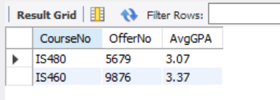

16. For offerings beginning with IS in the associated course number, retrieve the offer number, the course number, the faculty number, and the faculty name. Include an offering in the result even if the faculty is not assigned.

select OfferNo, CourseNo, faculty.FacSSN, FacFirstName,FacLastName

from offering left join faculty on offering.FacSSN=faculty.FacSSN

where CourseNo like 'IS%';

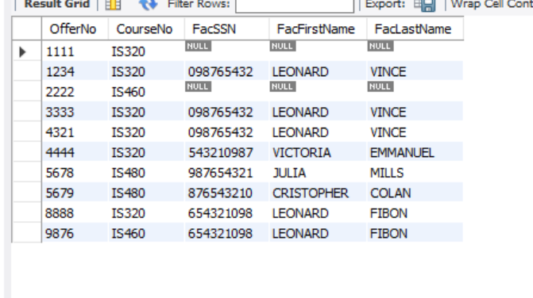

17. Retrieve the Social Security Number (SSN), name (first and last), rank, and salary of faculty who are also students.

select FacSSN as SSN, FacFirstName as FirstName, FacLastName as LastName, FacRank as "Rank",FacSalary as Salary

from faculty

where FacSSN in (select StdSSN from student);

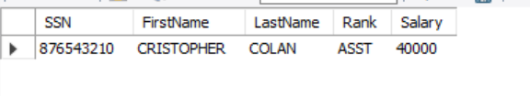

18. List the Social Security Number (SSN), name and city of faculty who only teach in winter term 2006.

select FacSSN, concat(FacFirstName, ' ', FacLastName) as Name, FacCity

from faculty

where FacSSN in (

select FacSSN

from offering

where OffTerm='WINTER' and OffYear=2006

group by FacSSN

having count(FacSSN)=1

);

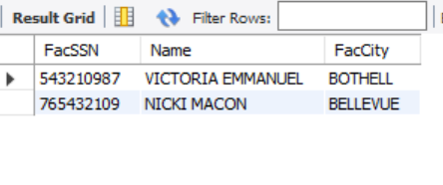

19. List the course number, the course description, the number of offerings, and the average enrollment across offerings.

select c.CourseNo, c.CrsDesc, count(distinct o.OfferNo) as NumOfferings, round(count(e.RegNo)/count(distinct o.OfferNo),0) as AvgEnroll

from course c join offering o on c.CourseNo=o.CourseNo

join enrollment e on e.OfferNo=o.OfferNo

group by c.CourseNo, c.CrsDesc;

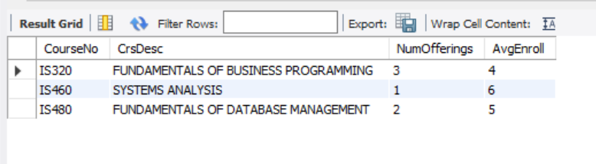

20. List the name of faculty who teach at least one offering of all of the 2006 information systems (IS) courses and his/her supervisor’s name.

select distinct f1.FacFirstName,f1.FacLastName,

concat(f2.FacFirstName,f2.FacLastName) as Supervisor

from faculty f1 join faculty f2 on f1.FacSupervisor=f2.FacSSN

join offering o on o.FacSSN=f1.FacSSN

join course c on o.CourseNo=c.CourseNo

where o.OffYear=2006

and c.CourseNo like 'IS%'

;

