# Overview of the Assignment:

Oracle, IBM DB2 and other ORDBMS that support standard object-relational features.

**Please submit screenshots demonstrating the execution of your SQL statements, both DDL , DML and the results of the SQL statements.**

# Object-relational DBMS

In this exercise, we will construct and query an *AUTOMOBILE* table by using abstract data types (ADTs), VARRAYs, and nested tables. The syntax is for Oracle.

1. Create a *PERSON_TY* abstract data type which has the following fields -- first_name, last_name, date_of_birth. Assign each field an appropriate data type.
2. Create a *DRIVER_TY* abstract data type which has the following fields -- *PERSON_TY,* Drivers_License_ID, Date Driven. Assign each field an appropriate data type.
3. Create a *OWNER_TY* abstract data type which has the following fields -- *PERSON_TY, Date_Purchased, Date_Sold.* Assign each field an appropriate data type.
4. Create a *OWNERS_VA* VARRAY of the *OWNER_TY* abstract data type you created in step 2. Define the VARRAY to allow for 3 *OWNER_TY* elements.
5. Create an *AUTOMOBILE* table which is composed of the following elements:

* A vehicle_identification_number field which is the primary key.
* An OWNER*_VA* VARRAY.
* A nested table named *DRIVERS_NT* which contains the following fields – *DRIVER_TY*. Assign each field an appropriate data type.

1. Insert the following rows into the *AUTOMOBILE* table:  
   **ROW 1**

* The Vehicle Identification Number is 101.
* The first driver is named "Erin Smalltalk", who was born on 5/23/1965, driver license MA101, date driven 3/1/2018.
* The second driver is named "Joe Smalltalk", who was born on 10/7/1982, driver license MA204, date driven 3/15/2018.
* The only owner is named "Lance Smalltalk", who purchased the automobile 1/29/2016.

**ROW 2**

* The Vehicle Identification Number is 102.
* The first driver is named "Julie Goldstein", who was born on 7/19/1977, driver license MA506, date driven 1/5/2016.
* The second driver is named "Max Lucids", who was born on 2/12/1987, driver license MA706, date driven 3/5/2018.
* The first owner is named "George Stephanopolis", who purchased the automobile 7/15/2014 and sold on 6/17/2016.
* The second owner is named "Max Lucids", who purchased the automobile on 6/18/2016.

1. Write a query which lists the first and last names of all drivers, along with the vehicle identification number of the car they drive and date driven.
2. Write a query which lists the first and last names of all owners, along with the vehicle identification number of the car, the date of purchase and sale.

create type PERSON_TY as object(  
first_name *varchar2*(20),  
last_name *varchar2*(20),  
date_of_birth *date*);  
/

create or replace type DRIVER_TY as object(  
Person PERSON_TY,  
Drivers_License_ID *varchar*(30),  
Date_Driven *date*);  
/

create or replace type OWNER_TY as object(  
Person PERSON_TY,  
Date_Purchased *date*,  
Date_Sold *date*);  
/  
create or replace type OWNERS_VA as varray(3) of OWNER_TY;  
/  
  
  
create or replace type DRIVERS_NT as table of DRIVER_TY;  
/  
  
create table AUTOMOBILE(  
vehicle_identification_number *varchar2*(30) primary key,  
Owners OWNERS_VA,  
Drivers DRIVERS_NT  
)  
nested table Drivers store as DRIVERS_NT_TAB;  
/

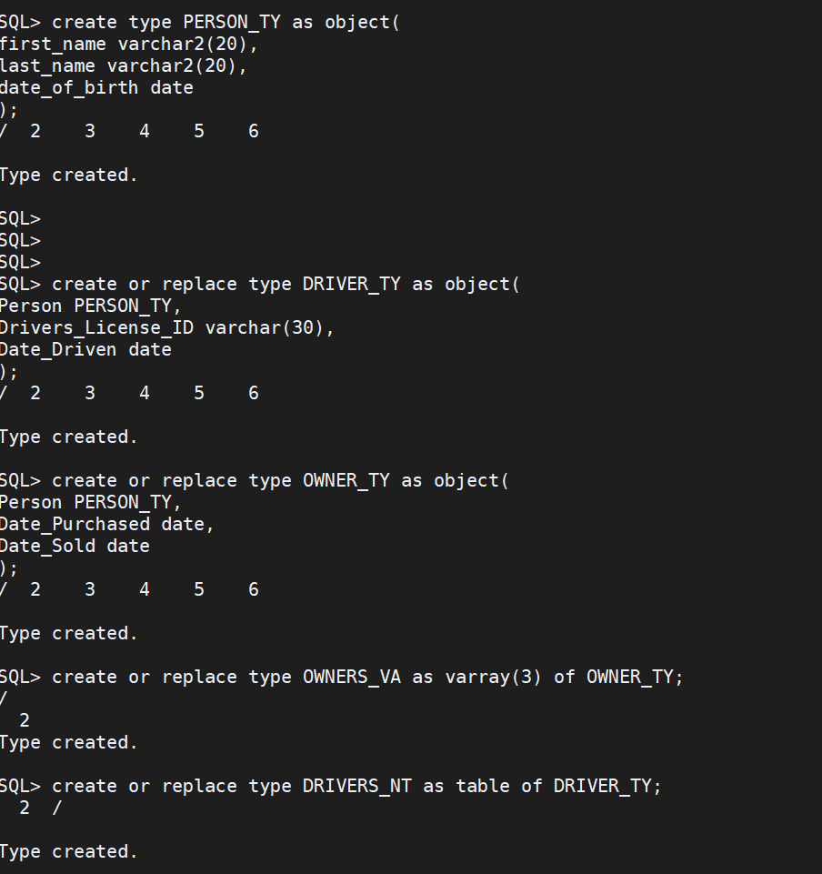

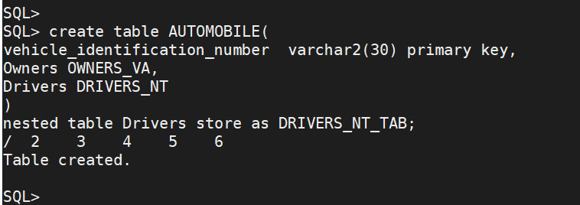

insert into AUTOMOBILE values (101,  
OWNERS_VA( OWNER_TY(PERSON_TY('Lance','Smalltalk',null),to_date('1/29/2016','MM/DD/YYYY'),null) ),  
DRIVERS_NT(DRIVER_TY(PERSON_TY('Erin','Smalltalk',to_date('5/23/1965','MM/DD/YYYY')),'MA101',to_date('3/1/2018','MM/DD/YYYY')),  
DRIVER_TY(PERSON_TY('Joe','Smalltalk',to_date('10/7/1982','MM/DD/YYYY')),'MA204',to_date('3/15/2018','MM/DD/YYYY')))  
);  
/

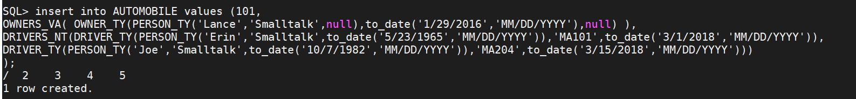

insert into AUTOMOBILE values (102,OWNERS_VA(OWNER_TY(PERSON_TY('George','Stephanopolis',null),to_date('7/15/2014','MM/DD/YYYY'),to_date('6/17/2016','MM/DD/YYYY')),OWNER_TY(PERSON_TY('Max','Lucids',null),to_date('6/18/2016','MM/DD/YYYY'),null)),DRIVERS_NT(DRIVER_TY(PERSON_TY('Julie','Goldstein',to_date('7/19/1977','MM/DD/YYYY')),'MA506',to_date('1/5/2016','MM/DD/YYYY')),DRIVER_TY(PERSON_TY('Max','Lucids',to_date('2/12/1987','MM/DD/YYYY')),'MA706',to_date('3/5/2018','MM/DD/YYYY'))));  
/



select d.Person.first_name, d.Person.last_name, a.vehicle_identification_number, d.Date_Driven  
from AUTOMOBILE a, table(a.Drivers) d  
/

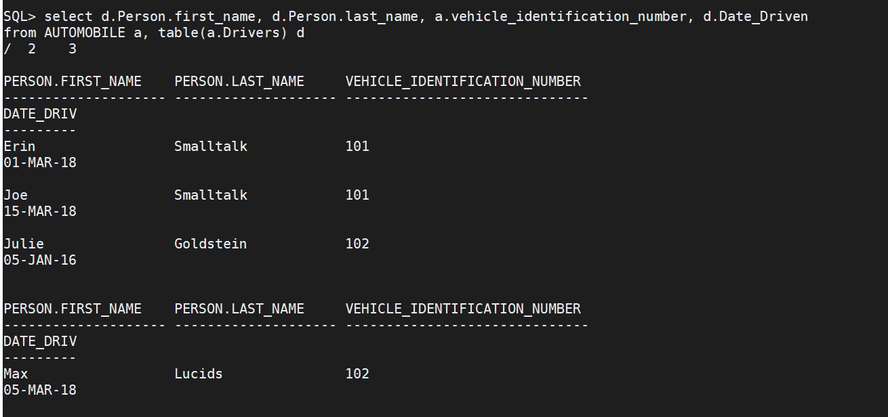

select o.Person.first_name, o.Person.last_name, a.vehicle_identification_number, o.Date_Purchased,o.Date_Sold  
from AUTOMOBILE a, table(a.Owners) o  
/

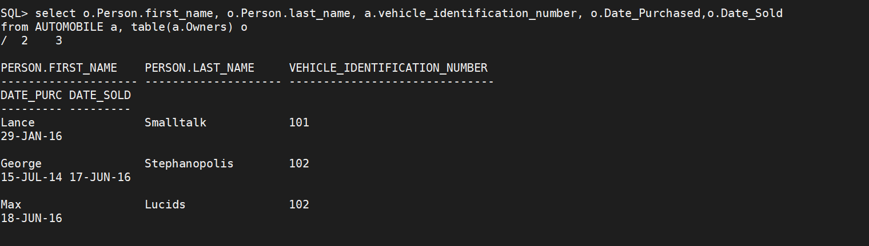

Use the **Ask the Teaching Team Discussion Forum** if you have any questions regarding the how to approach this assignment.

Save your assignment as ***lastnameFirstname_assign6_0.docx*** and submit it in the *Assignments* section of the course.

For help uploading files please refer to the *Technical Support* page in the syllabus.