Use this document to capture the screenshots requested in the instructions for assignment 3.0.

**Name**:

**Date:**

**The submission template uses the following format :**

* Document question number and your code describing what each query is doing.
* Paste in your code.
* Paste in a screenshot of the results running your code.

1. **Document question number and your code describing what each query is doing.**

Paste in your code.

create or replace function next_in_stock_dvd(cust_id numeric) returns text

as $$

declare

next_dvd text;

begin

select d.dvdtitle into next_dvd

from dvd d join rentalqueue rq on rq.dvdid=d.dvdid

join member m on m.memberid=rq.memberid

where m.memberid=cust_id and d.dvdquantityonhand>0

order by rq.dateaddedinqueue limit 1;

return next_dvd;

end;

$$ language plpgsql

;

select next_in_stock_dvd(12);

Paste in a screenshot of the results running your code.

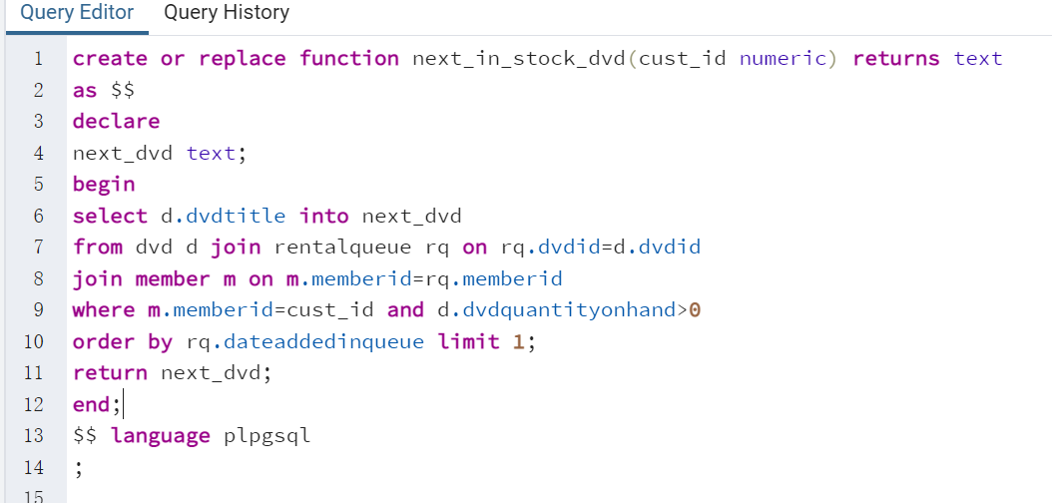

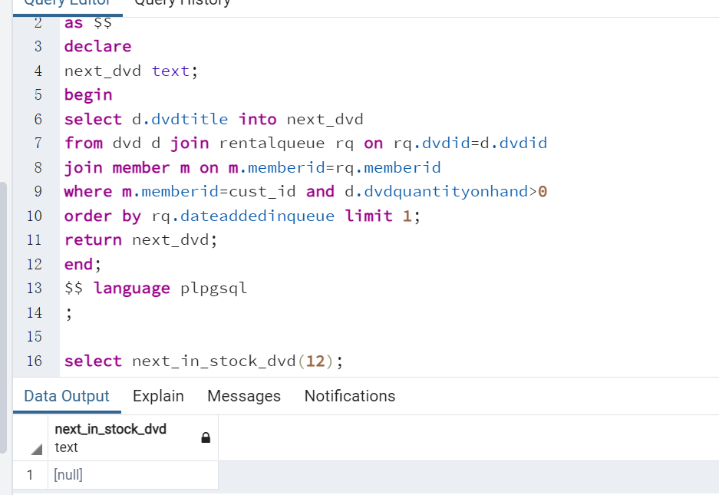

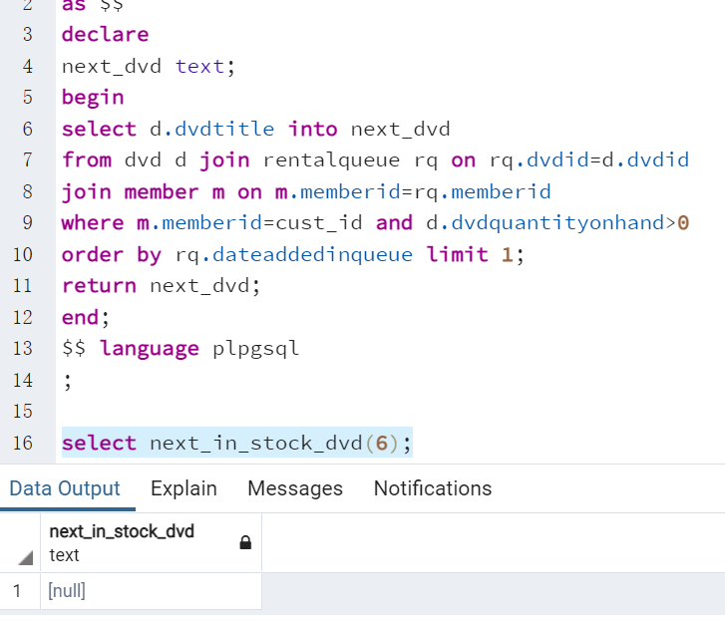

1. **Document question number and your code describing what each query is doing.**

Paste in your code.

create or replace function additional_dvds(cust_id numeric) returns integer

as $$

declare

additional integer;

begin

with tmp

as

(

select t1.memberid, t1.onetime_permit, t1.has_rent,

t1.membershiplimitpermonth, case when t2.plan_rent is null then 0 else t2.plan_rent end as plan_rent,

case when t3.his_has_rent is null then 0 else t3.his_has_rent end as his_has_rent

from

(

select m.memberid,

left(ms.membershiptype,1)::integer as onetime_permit, ms.membershiplimitpermonth,

count(r.dvdid) as has_rent

from member m

left join membership ms on m.membershipid=ms.membershipid

left join rental r on r.memberid=m.memberid

left join payment p on p.memberid=m.memberid

where r.rentalreturneddate is null and r.rentalrequestdate<p.amountpaiduntildate

group by m.memberid, ms.membershiptype, ms.membershiplimitpermonth

union

select m.memberid,

left(ms.membershiptype,1)::integer as onetime_permit, ms.membershiplimitpermonth,

count(r.dvdid) as has_rent

from member m

left join membership ms on m.membershipid=ms.membershipid

left join rental r on r.memberid=m.memberid

left join payment p on p.memberid=m.memberid

where r.rentalrequestdate is null

group by m.memberid, ms.membershiptype, ms.membershiplimitpermonth

) t1

full join

(

select m.memberid,

count(rq.dvdid) as plan_rent

from member m

join membership ms on m.membershipid=ms.membershipid

join payment p on p.memberid=m.memberid

join rentalqueue rq on rq.memberid=m.memberid

where rq.dateaddedinqueue<p.amountpaiduntildate

group by m.memberid

) t2

on t1.memberid=t2.memberid

full join

(

select m.memberid,

left(ms.membershiptype,1)::integer as onetime_permit, ms.membershiplimitpermonth,

count(r.dvdid) as his_has_rent

from member m

left join membership ms on m.membershipid=ms.membershipid

left join rental r on r.memberid=m.memberid

left join payment p on p.memberid=m.memberid

where r.rentalrequestdate <p.amountpaiduntildate and r.rentalreturneddate<p.amountpaiduntildate

group by m.memberid, ms.membershiptype, ms.membershiplimitpermonth

) t3 on t1.memberid=t3.memberid

where t1.has_rent<=t1.onetime_permit

)

select case when onetime_permit-has_rent<membershiplimitpermonth-(his_has_rent+has_rent)

and has_rent+plan_rent<onetime_permit

then onetime_permit-has_rent

else membershiplimitpermonth-(his_has_rent+has_rent)

end into additional

from tmp

where his_has_rent+has_rent+plan_rent<membershiplimitpermonth

and memberid=$1

;

return additional;

end;

$$ language plpgsql

;

select additional_dvds(1);

select additional_dvds(2);

select additional_dvds(3),additional_dvds(4),additional_dvds(5),additional_dvds(6),additional_dvds(7),additional_dvds(8);

Paste in a screenshot of the results running your code.

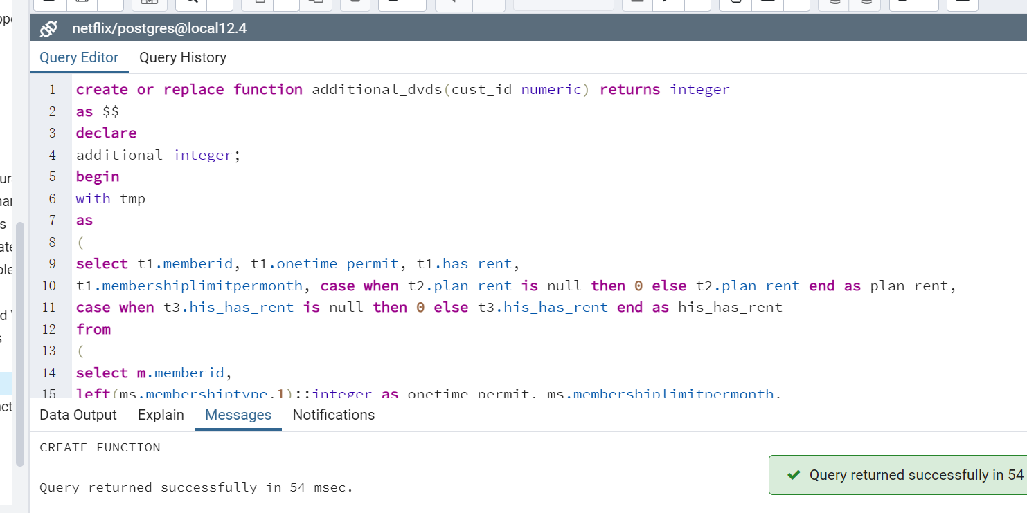

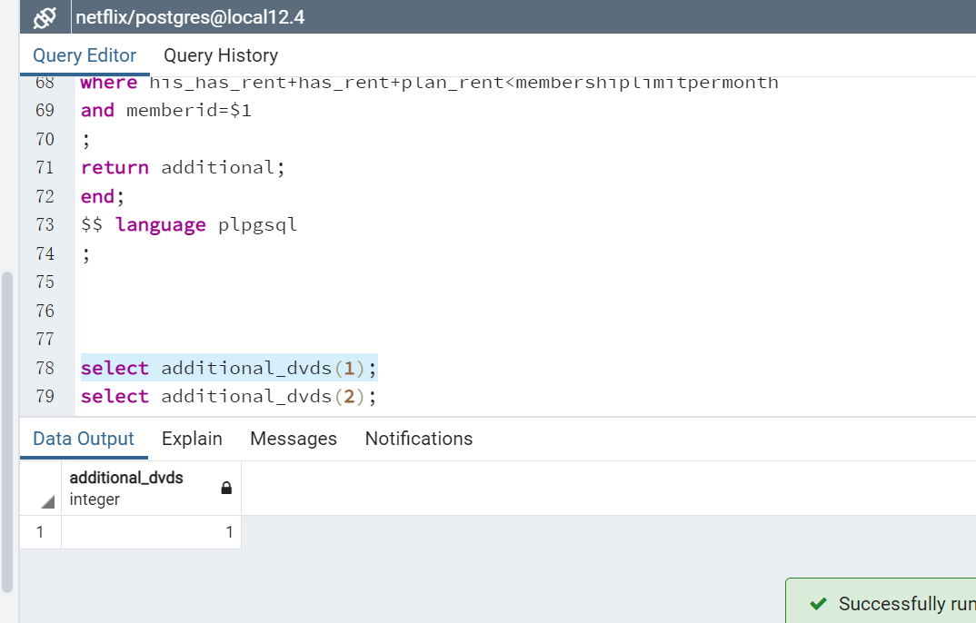

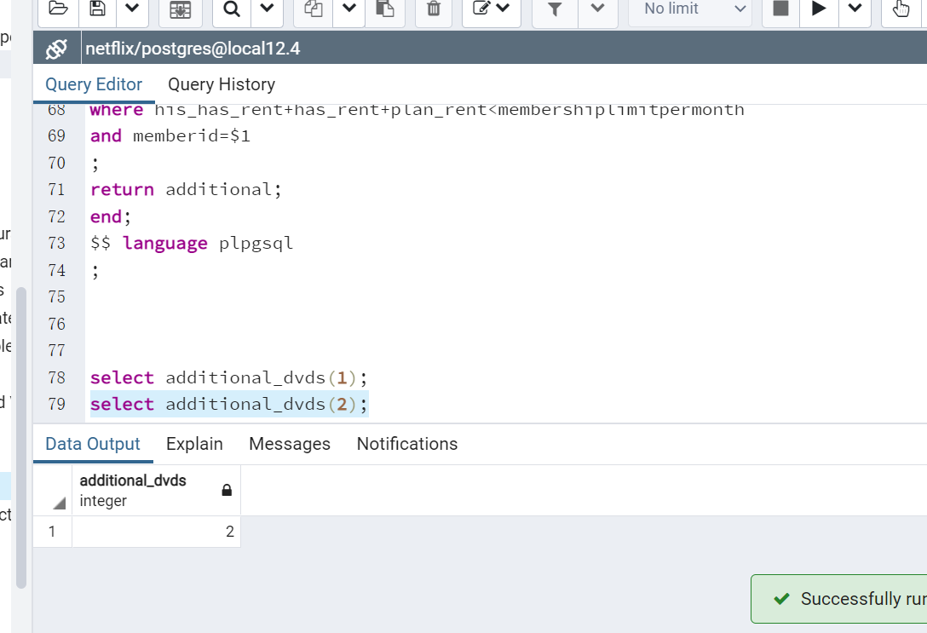

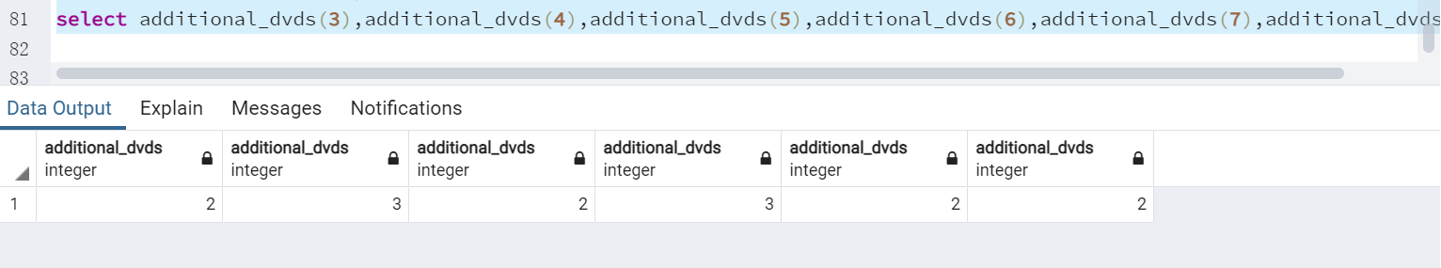

1. **Document question number and your code describing what each query is doing.**

Paste in your code.

create or replace procedure rent_dvd(in cust_id numeric)

as $$

declare

additional integer;

additional_dvd text;

next_rent numeric;

dvd_id numeric;

next_pay numeric;

lost_price numeric;

begin

select additional_dvds(cust_id) into additional;

select next_in_stock_dvd(cust_id) into additional_dvd;

select count(*) into next_rent from rental;

select dvdid into dvd_id from dvd where dvdtitle=additional_dvd;

if dvd_id is not null then

call delete_dvd(cust_id, dvd_id);

insert into rental values (next_rent+1,cust_id, dvd_id,now(),null,null);

select membershipdvdlostprice into lost_price from membership m join member mm on mm.memrbershipid=m.membershipid;

select max(paymentid) into next_pay from payment;

insert into payment values(next_pay+1,cust_id,lost_price, now(),now());

end if;

end;

$$ language plpgsql

;

call rent_dvd(12);

Paste in a screenshot of the results running your code.

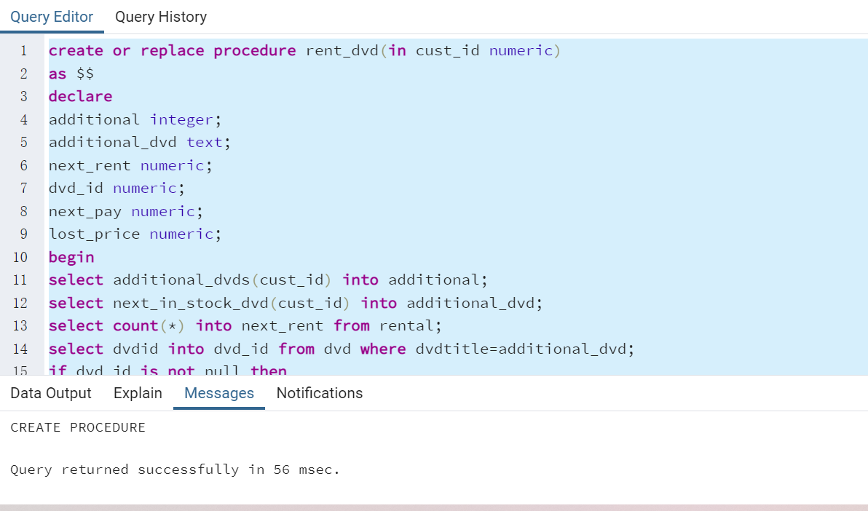

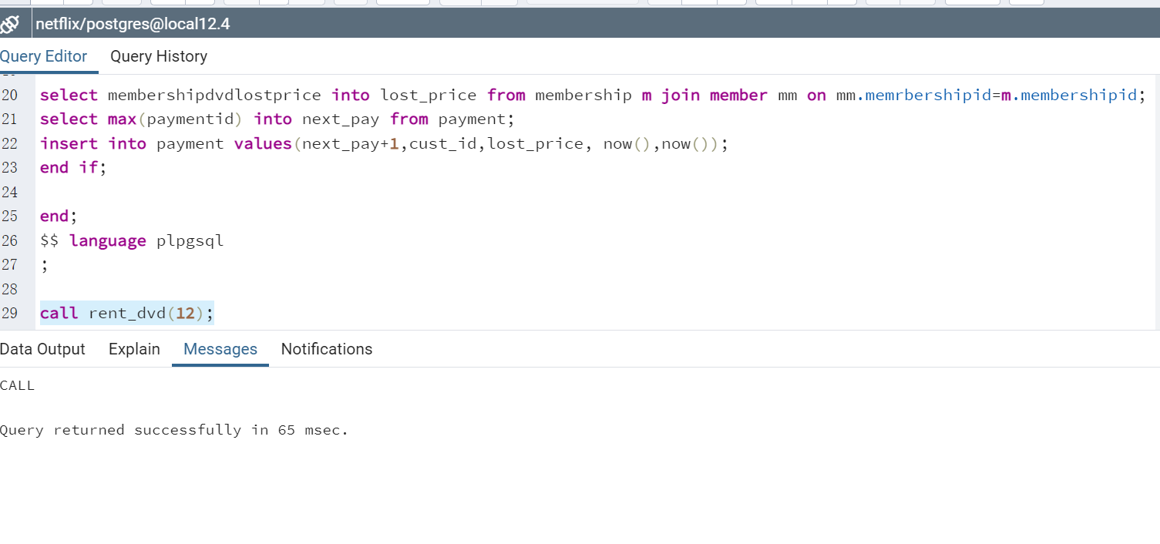

Use the **Ask the Facilitators Discussion Board** if you have any questions regarding the how to approach this assignment.

Save your assignment as ***lastnameFirstname_assign3.0.docx*** and submit it in the *Assignments* section of the course.

For help uploading files please refer to the *Technical Support* page in the syllabus.