Connect to your instance and provide a screenshot of your console window after running the linux command ‘whoami’ (10 points):

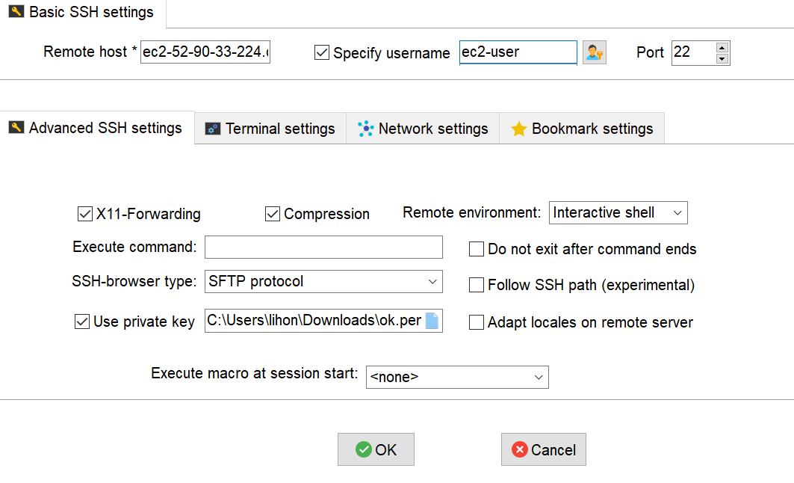

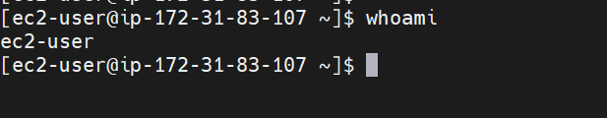

Problem 2: Install MySQL database on your EC2 instance (Points: 25) Now that you have your server in the cloud, connect to it from your local computer and install MySQL Server Database. Provide the full list of commands needed to install, start and verify the status of your MySQL server

wget <https://dev.mysql.com/get/mysql80-community-release-el7-5.noarch.rpm>

sudo yum localinstall mysql80-community-release-el7-5.noarch.rpm

sudo yum install mysql-community-server

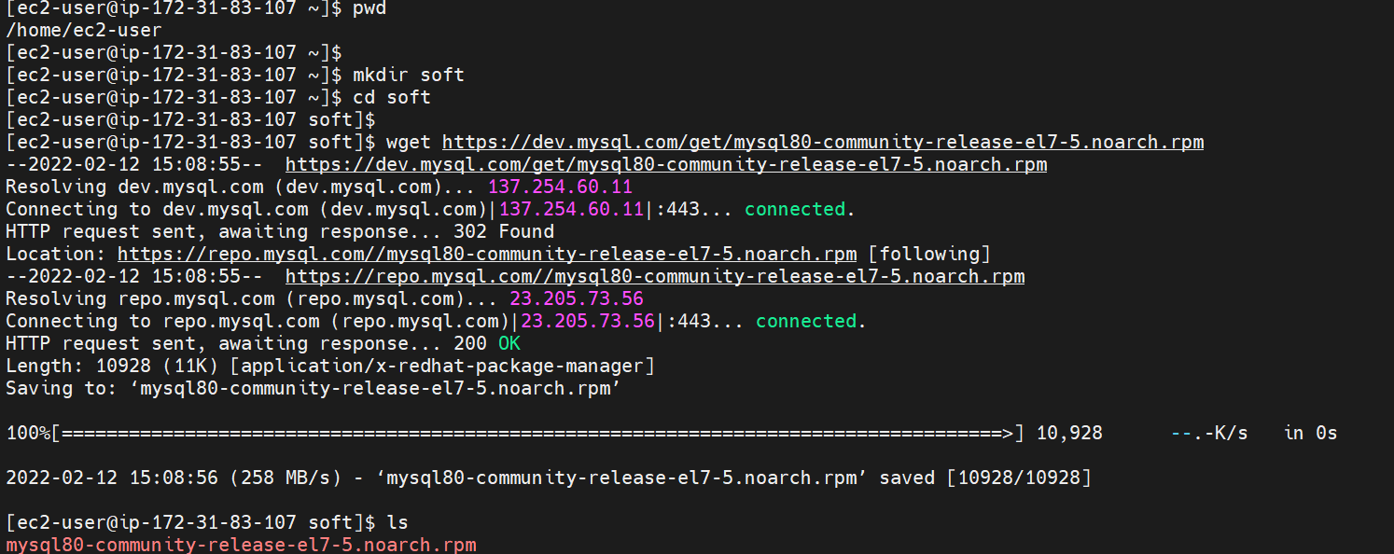

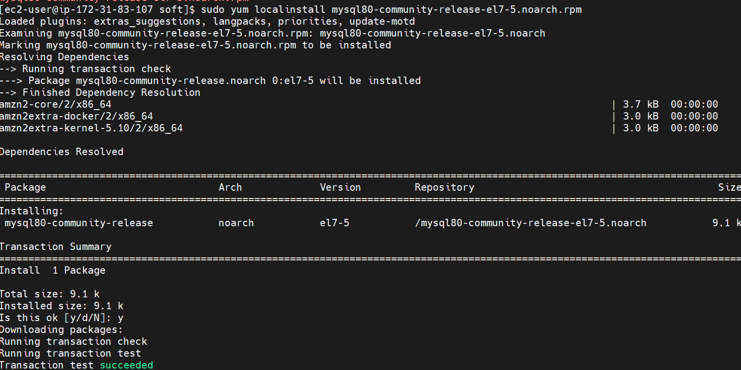

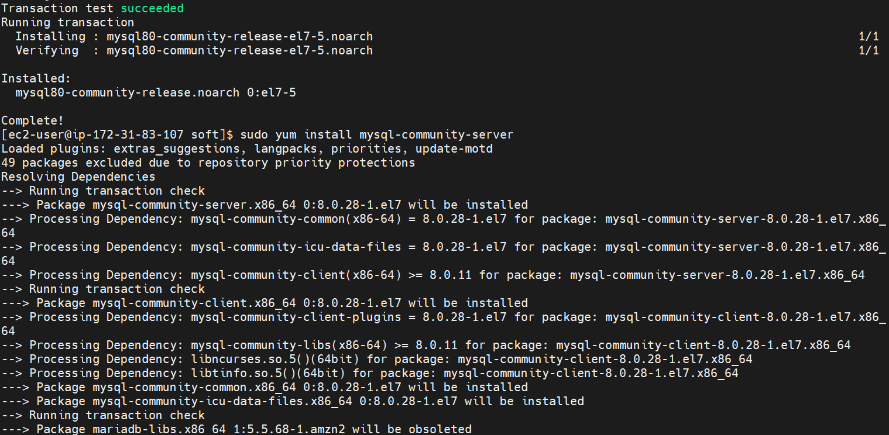

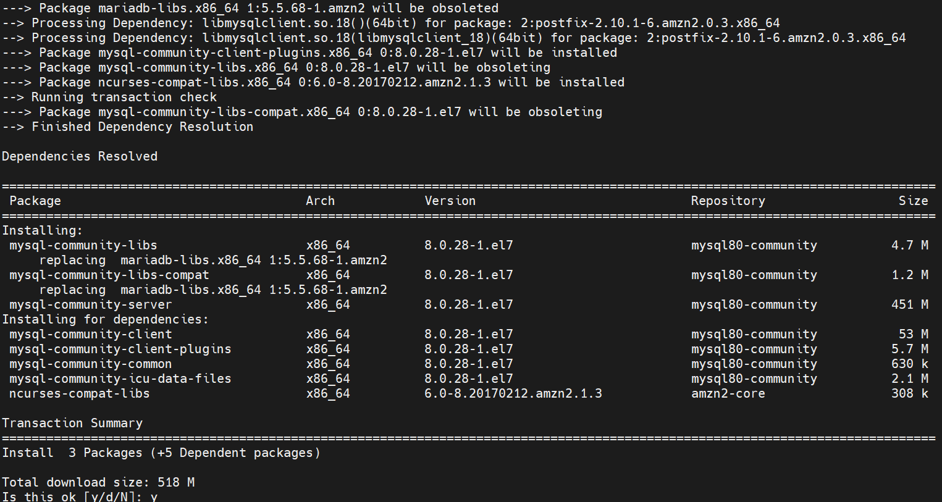

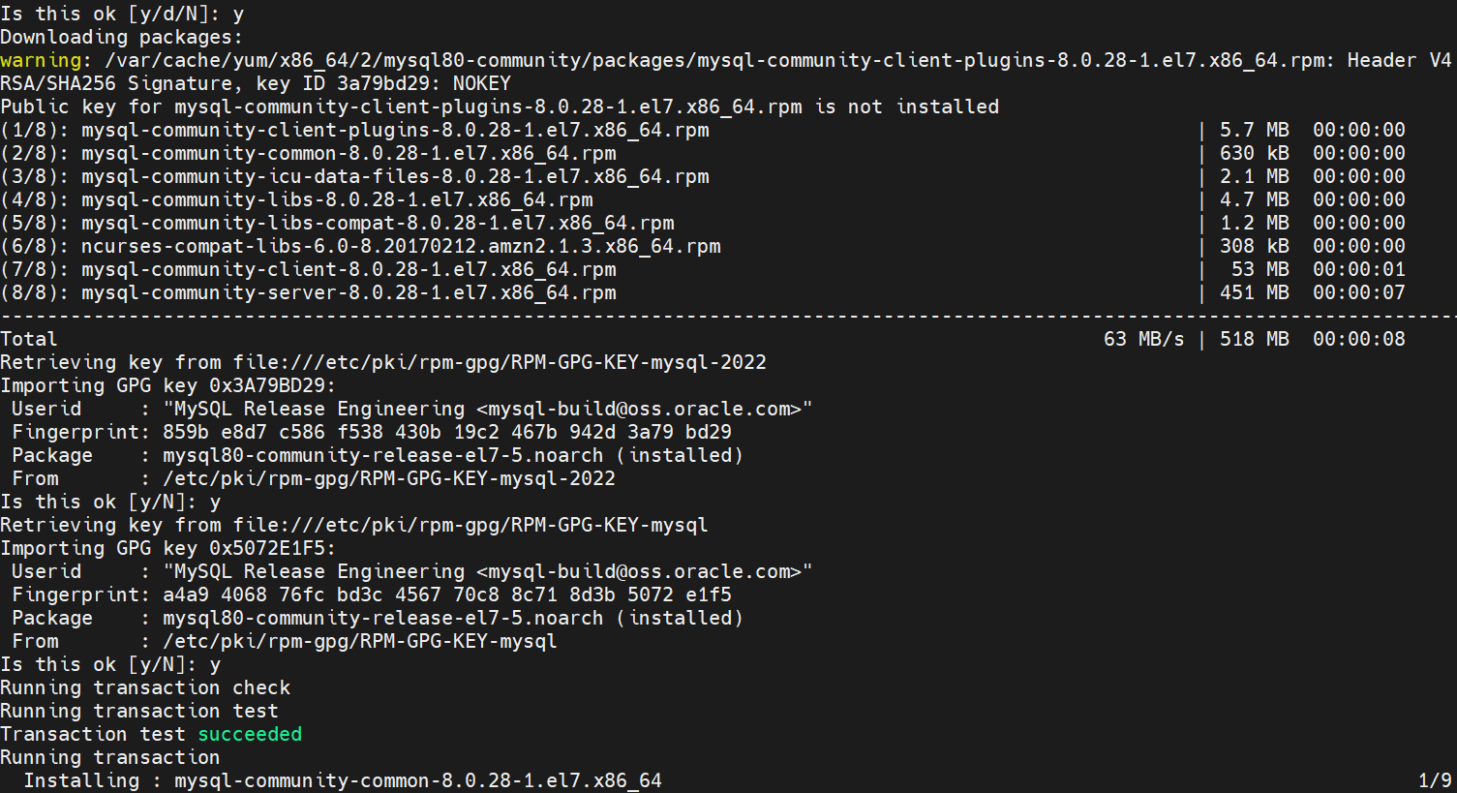

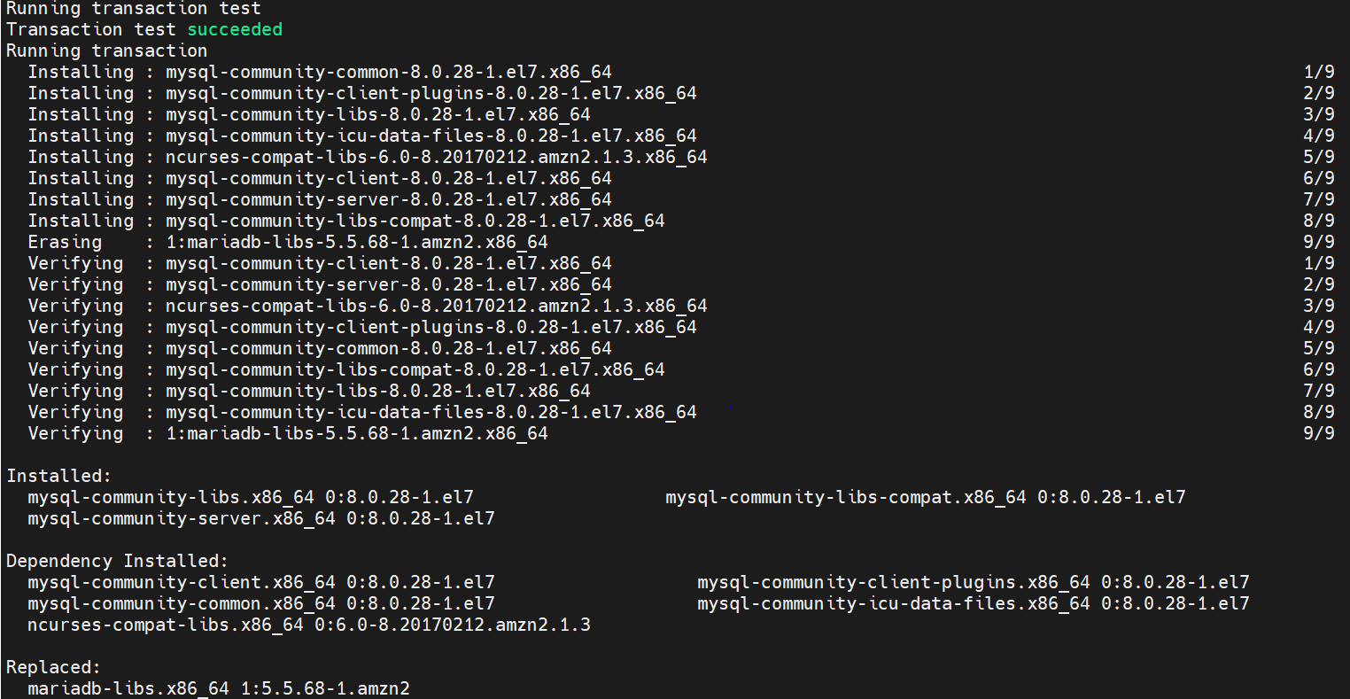

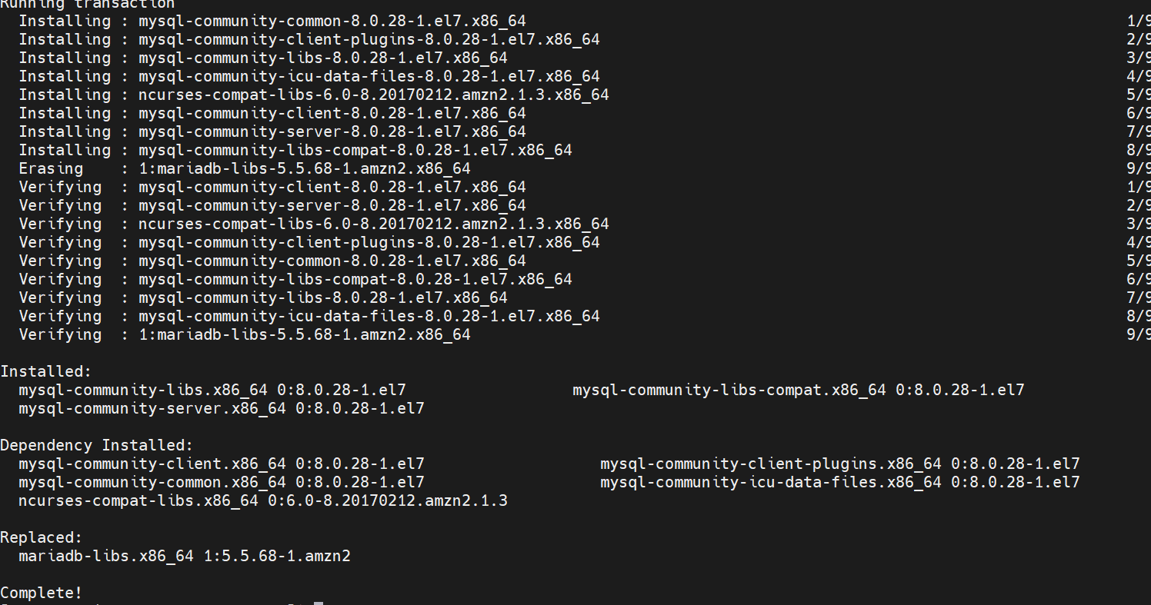

sudo service mysqld start

sudo service mysqld status

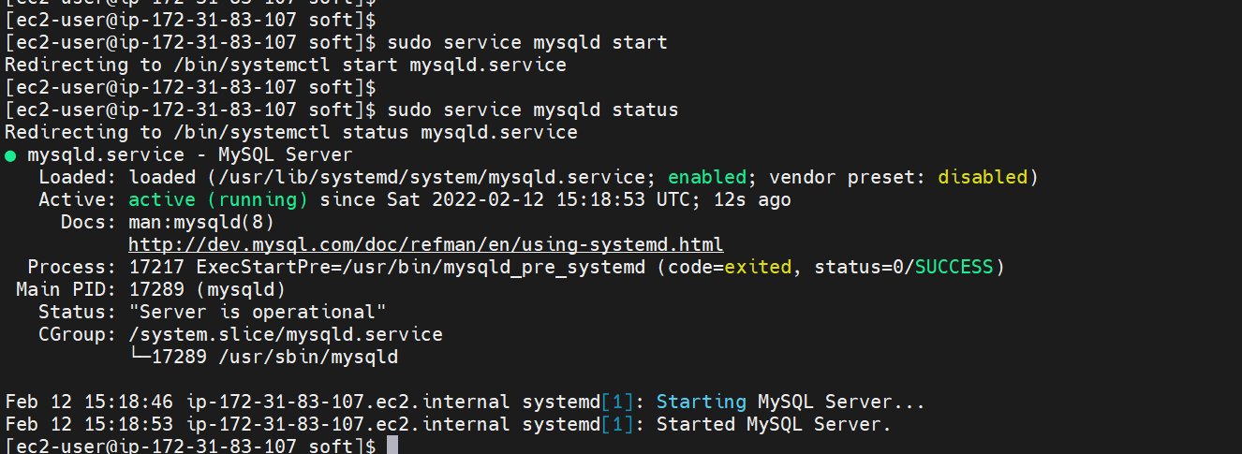

Once your MySQL database is up and running, perform the following SQL command to demonstrate success: SHOW DATABASES; Provide a screenshot of the result of executing the above SQL command (20 points):

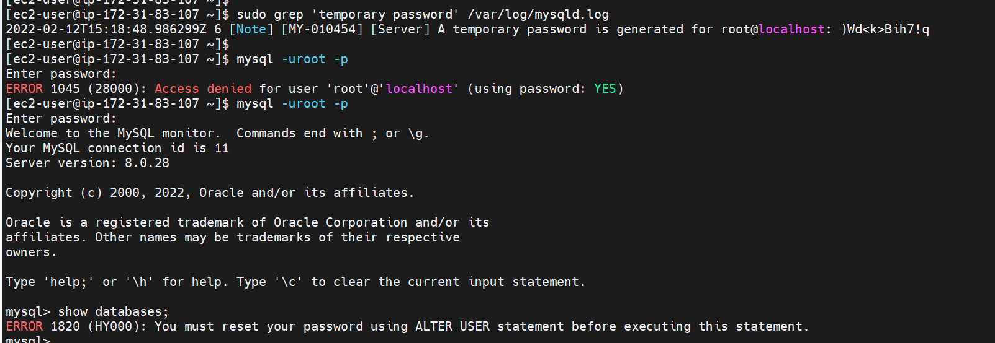

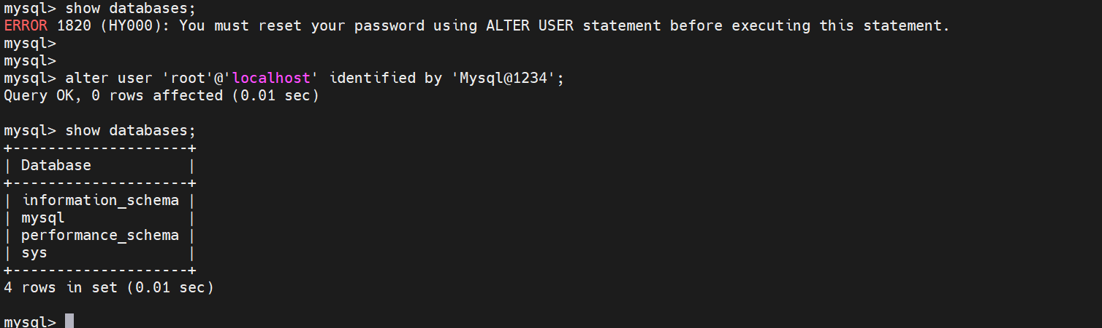

sudo grep 'temporary password' /var/log/mysqld.log

mysql -uroot -p

alter user 'root'@'localhost' identified by 'Mysql@1234';

show databases;

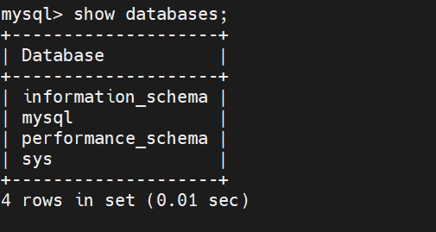

use mysql;

show tables;

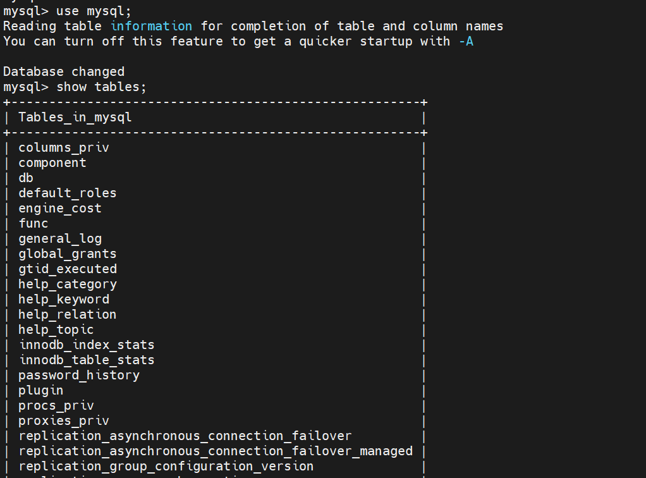

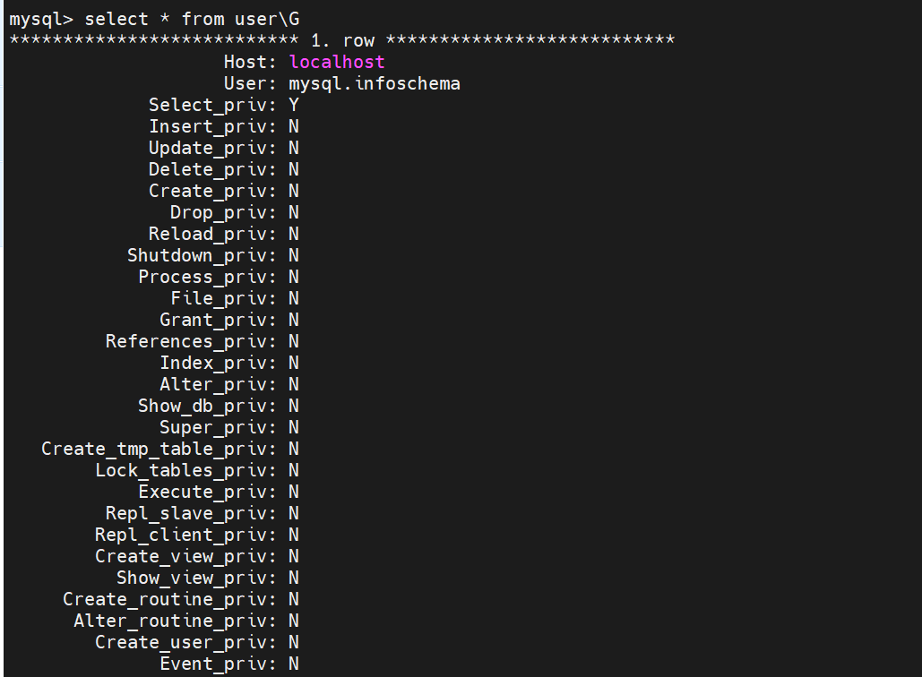

Bonus Problem 1: Install a local SQL client (Points: 5) There are many SQL Clients available to download for free which can be used as a graphical user interface to your MySQL Server. You can easily find lists of free clients through a simple Google search (for example: https://medevel.com/17-sql-client-open-source/ ) or you can opt to use another that you are interested in or familiar with. SQL Workbench is another popular, free option. On your local computer install one of these clients and connect it to your MySQL server running on the EC2 instance. You will need to document, in detail, the steps involved in establishing connectivity between your SQL Client and your MySQL Server. The instructions should be clear enough that the graders can follow them literally and establish a successful connection with their own db instance.

Note: The teaching staff does not provide guidance on bonus problems. We will clarify ambiguities, but not offer troubleshooting tips. Bonus problems are only graded for assignments submitted before the deadline.

Identify which client you chose to install, and step by step instructions for configuring access:

I choose to install the mysql workbench.

Steps for configuring access:

1. Update the connection privileges:

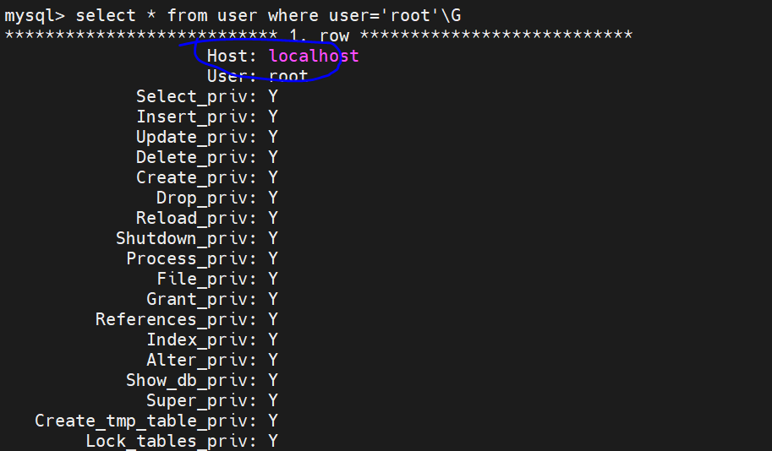

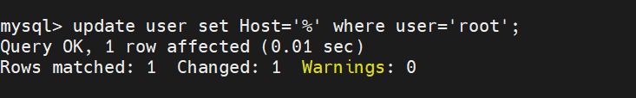

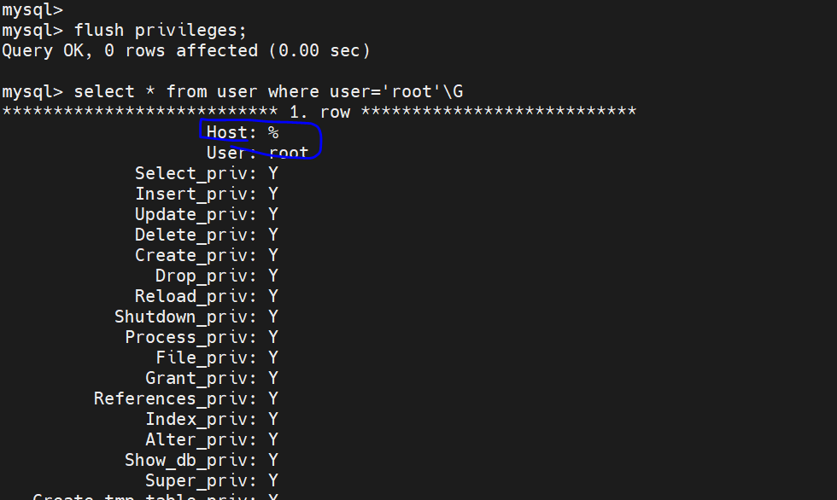

1. Set up new connection:

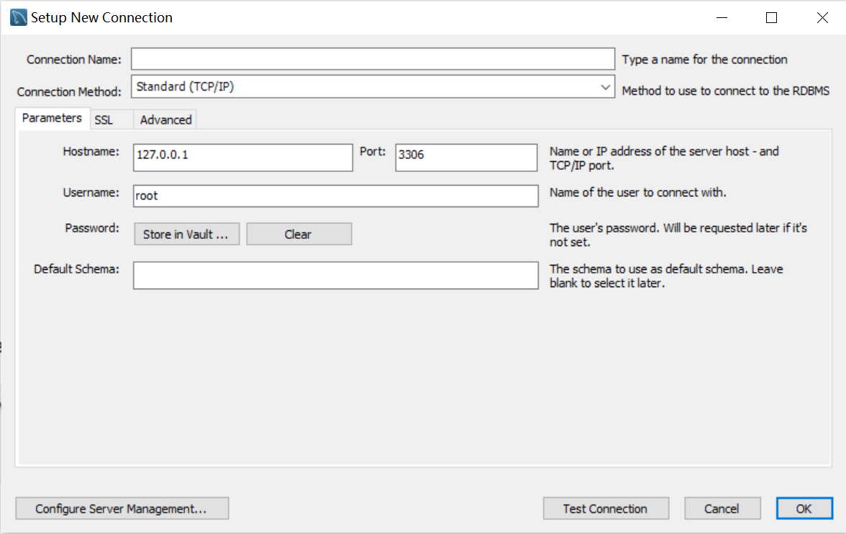

1. Fill up the information about the ssh tunnel and mysql connection info.

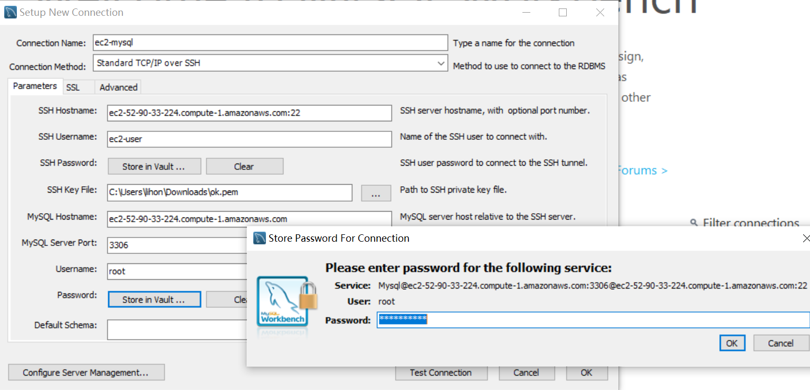

1. Test the connection.

