不迟于2022年2月26日晚上11:59，不接受延误。

您必须返回包含所有SQL文件的exercise .zip(最后一个问题的解释可以作为references.sql文件中的注释编写)。

•在PDF中注明姓名和姓氏。

Exercise 1 :

SQL queries A company wishes to manage its computer equipment using a database. The building is composed of three floors. Each floor has its own Ethernet network (or separate segment). These networks pass through rooms equipped with workstations. A workstation is a machine on which certain software is installed. Four categories of workstations are identified (Unix stations, X terminals, Windows PCs and NT PCs). The database should also describe software installations.

The ParcInfo database schema:

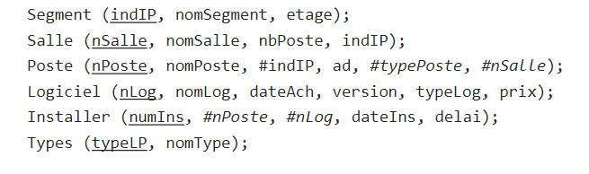

•The domains of the columns:

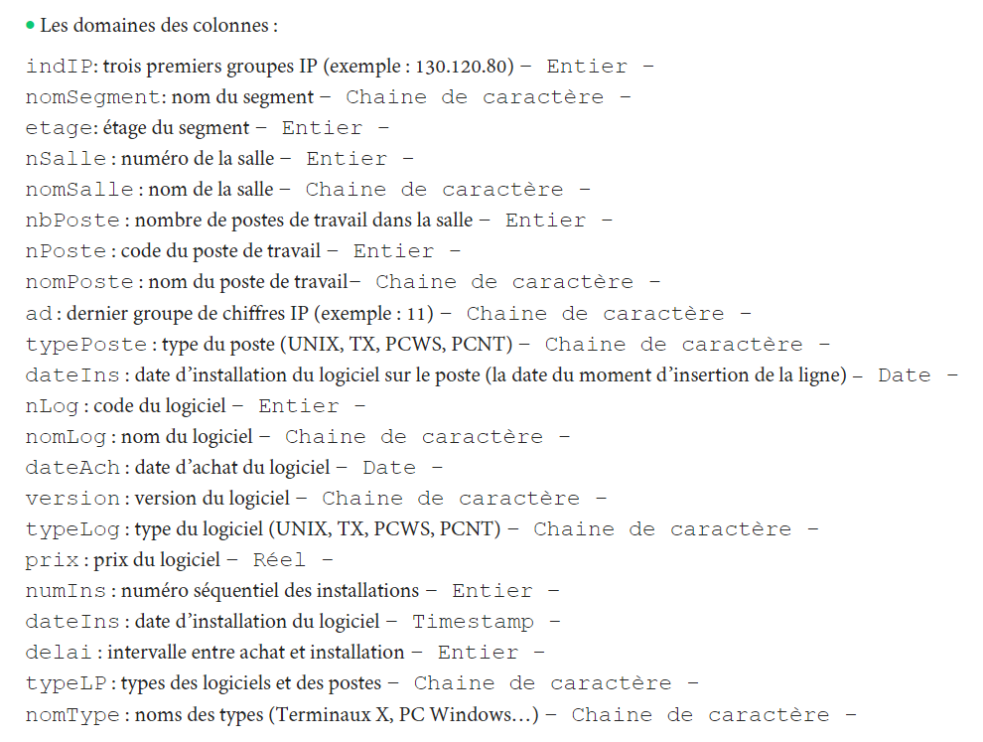

Constraints:

• The names of segments, rooms and stations are non-zero.

• The range of values of column ad extends from 0 to 255.

• The price column is greater than or equal to 0.

• The dateIns column is equal to today's date by default.

• numIns: serial

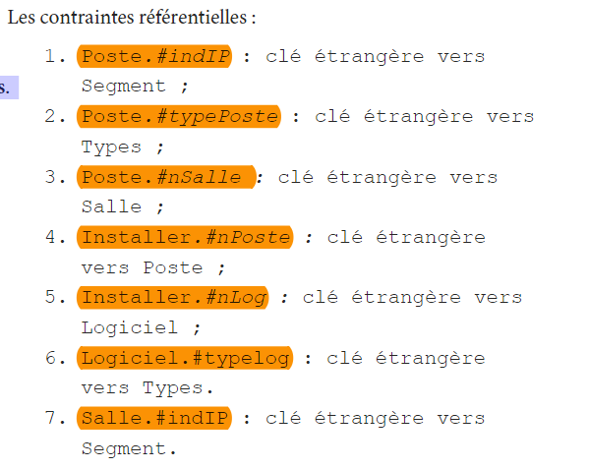

Remark :

All scripts must be wrapped in a transaction (begin transaction; commit;).

1 – Create a ParcInfo.sql file which contains the SQL code necessary to build the ParcInfo schema without defining the referential constraints (i.e without defining the FOREIGN KEY constraints). (20)

2 – Modify the domain of the following columns: indIP, nSalle, nLog, nPoste: Character string, and remove the not null constraint from the dateIns column. Name the file: question2.sql (20)

3 – Run the insertion.sql file to fill in the relationships.

4 – Add the referential constraints in a references.sql file and execute it. (10)

5– Explain the error, and display the lines that caused the problem. (The records in the Software and Room relationship causing the problem) (10)

6- Delete the records that pose a problem and add the reference constraints (Foreign keys). (Add this query to the references.sql file and run it. (30)

7 – If we added the referential constraints in the ParcInfo.sql file, what is the order of the creation and deletion of the relations. To explain. (10) Referential constraints: 1. Position. #indIP: foreign key to Segment;

1. ParcInfo.sql

2. question2.sql

3. run 完成

4. references.sql

5.

alter table add constraint fk_salle_indip foreign key (indIP) references Segment(indIP)

> 1452 - Cannot add or update a child row: a foreign key constraint fails (`yale`.`#sql-16bc_6`, CONSTRAINT `fk_salle_indip` FOREIGN KEY (`indIP`) REFERENCES `segment` (`indIP`))

select * from Salle;

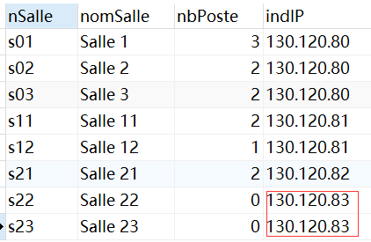

select * from Segment;

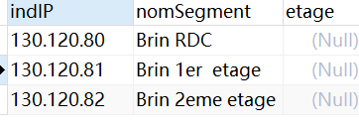

可以发现父表 Segment中 indIP没有为130.120.83 的记录。

6. references.sql

7. 先执行create； 然后insert； 然后delete 不符合外键约束的记录 然后再执行add constraint 语句。