## Task1

create table Emp(

eid int primary key,

ename varchar(20),

age int,

salary float

);

create table Dept(

did int primary key,

budget float,

managerid int,

foreign key (managerid) references Emp(eid)

);

create table Works(

eid int,

did int,

pct_time int,

primary key(eid,did),

foreign key (eid) references Emp(eid),

foreign key (did) references Dept(did)

);

insert into Emp values

(1, 'Jim', 33, 70000.0 ),

(2, 'Zhuo', 33, 70000.0 ),

(3, 'Sid', 33, 70000.0 ),

(4, 'Gusto', 34, 70000.0 ),

(5, 'Andy', 33, 70000.0 ),

(6, 'Mary', 34, 70000.0 ),

(7, 'Mouse', 50, 890000.0 ),

(8, 'Kim', 55, 70000.0 ),

(9, 'Meck', 20, 70000.0 ),

(10, 'Mock', 30, 40000.0 ),

(11, 'Tom', 30, 20000.0 ),

(12, 'Toozy', 40, 80000.0 ),

(13, 'Roro', 54, 90000.0 ),

(14, 'Rara', 34, 780000.0 ),

(15, 'Randy', 34, 40000.0 ),

(16, 'Marry', 45, 80000.0 ),

(17, 'Larry', 32, 35000 ),

(18, 'Jarry', 32, 40000.0 ),

(19, 'Herry', 30, 50000.0 ),

(20, 'Mary', 40, 50000.0 ),

(21, 'MooMoo', 50, 780000.0 ),

(22, 'Giles', 40, 210000.0 ),

(23, 'Deniz',24, 1000000.0 ),

(24, 'Suresh',22, 89000.0 ),

(25, 'Shiva' , 22, 95000.0 ),

(26, 'Airy', 23, 77000.0 ),

(27, 'Kirohashi', 24, 10700.0),

(28, 'Krishna',23, 11000.0 ),

(29, 'Kasi' , 21, 92000.0 ),

(30, 'Raja', 25, 100000.0 ),

(31, 'Bill', 43, 60000.0 ),

(32, 'Bob', 24, 37000.0 ),

(33, 'Ang', 32, 60000.0 ),

(34, 'Dave', 32, 63000.0 ),

(35, 'Kenneth', 36, 65000.0 ),

(36, 'Henry', 32, 160000.0 ),

(37, 'May', 32, 660000.0 ),

(38, 'Balaji', 22, 90000.0 ),

(39, 'Shiva', 28, 10000.0 ),

(40, 'Meck', 25, 100000.0 ),

(41, 'Lee', 23, 50000.0 ),

(42, 'Brian', 33, 47000.0 ),

(43, 'Michael', 36, 80000.0 ),

(44, 'Lisa', 42, 69000.0 ),

(45, 'Steven', 31, 45000.0 ),

(46, 'Charles', 39, 660000.0 ),

(47, 'Justin', 52, 70000.0 ),

(48, 'Aron', 27, 40000.0 ),

(49, 'Ellen', 20, 60000.0 ),

(50, 'William', 35, 90000.0 ),

(51, 'Bobbie', 23, 580000.0 ),

(52, 'Sonia', 33, 570000.0 ),

(53, 'Cindy', 45, 80000.0 ),

(54, 'Kathy', 42, 69000.0 ),

(55, 'Thai', 31, 45000.0 ),

(56, 'Ding', 32, 760000.0 ),

(57, 'Yang', 52, 70000.0 ),

(58, 'Jack', 30, 40000.0 ),

(59, 'Wang', 40, 60000.0 ),

(60, 'Zhong', 35, 90000.0 );

insert into Dept values

(0, 1000000.0, 7 ),

(1, 750000.0, 59 ),

(2, 800000.0, 19 ),

(3, 7000000.0, 22 ),

(4, 6000000.0, 23 ),

(5, 5000000.0, 22 ),

(6, 2500000.0, 7 ),

(7, 3100000.0, 13 ),

(8, 2000000.0, 38 ),

(9, 3005000.0, 27 ),

(10, 4500000.0, 32);

insert into Works values

(1, 1, 10 ),

(1, 2, 10 ),

(1, 6, 80 ),

(2, 0, 60 ),

(2, 7, 40 ),

(3, 0, 100 ),

(4, 5, 80 ),

(4, 9, 20 ),

(5, 0, 100 ),

(6, 1, 70 ),

(6, 2, 30 ),

(7, 0, 25 ),

(7, 6, 50 ),

(7, 10, 25 ),

(8, 0, 33 ),

(8, 3, 33 ),

(8, 8, 33 ),

(9, 0, 100 ),

(10, 1, 20 ),

(10, 2, 80 ),

(11, 2, 50 ),

(11, 5, 50 ),

(12, 0, 100 ),

(13, 2, 30 ),

(13, 7, 70 ),

(14, 0, 33 ),

(14, 3, 33 ),

(14, 10, 33 ),

(15, 4, 70 ),

(15, 5, 30 ),

(16, 0, 100 ),

(17, 9, 100 ),

(18, 3, 100 ),

(19, 2, 100 ),

(20, 0, 100 ),

(21, 0, 33 ),

(21, 1, 33 ),

(21, 2, 33 ),

(22, 3, 50 ),

(22, 5, 50 ),

(23, 4, 100 ),

(24, 0, 100 ),

(25, 0, 100 ),

(26, 0, 100 ),

(27, 3, 20 ),

(27, 9, 80 ),

(28, 0, 100 ),

(29, 0, 100 ),

(30, 1, 100 ),

(31, 4, 30 ),

(31, 6, 70 ),

(32, 3, 50 ),

(32, 10, 50 ),

(33, 10, 100),

(34, 0, 80 ),

(34, 6, 20 ),

(35, 3, 50 ),

(35, 10, 50 ),

(36, 0, 100 ),

(37, 0, 33 ),

(37, 5, 33 ),

(37, 7, 33 ),

(38, 8, 100 ),

(39, 2, 30 ),

(39, 9, 70 ),

(40, 0, 100 ),

(41, 0, 100 ),

(42, 0, 100 ),

(43, 3, 80 ),

(43, 7, 20 ),

(44, 0, 100 ),

(45, 0, 100 ),

(46, 1, 35 ),

(46, 4, 30 ),

(46, 6, 35 ),

(47, 0, 100 ),

(48, 1, 100 ),

(49, 4, 50 ),

(49, 10, 50 ),

(50, 0, 100 ),

(51, 0, 50 ),

(51, 3, 20 ),

(51, 6, 30 ),

(52, 1, 33 ),

(52, 3, 10 ),

(52, 8, 60 ),

(53, 2, 30 ),

(53, 9, 70 ),

(54, 0, 100 ),

(55, 0, 100 ),

(56, 0, 30 ),

(56, 3, 50 ),

(56, 4, 20 ),

(57, 0, 100 ),

(58, 0, 34 ),

(58, 1, 33 ),

(58, 2, 33 ),

(59, 0, 20 ),

(59, 1, 80 ),

(60, 0, 100 );

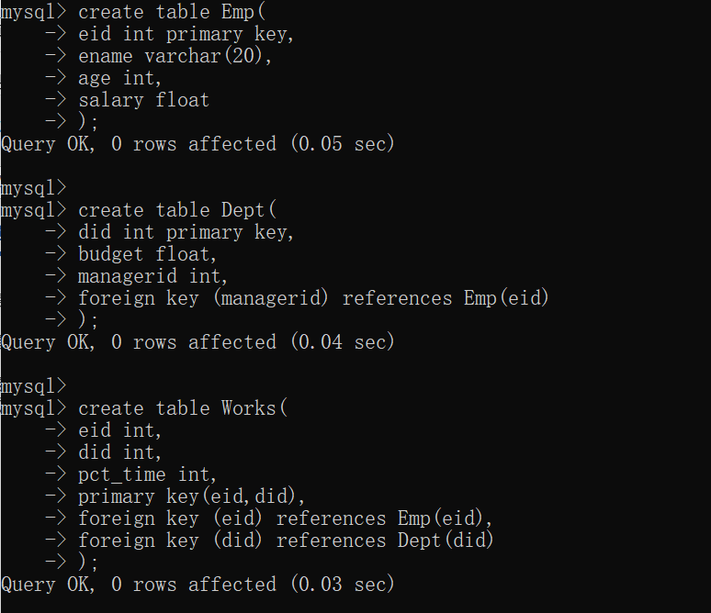

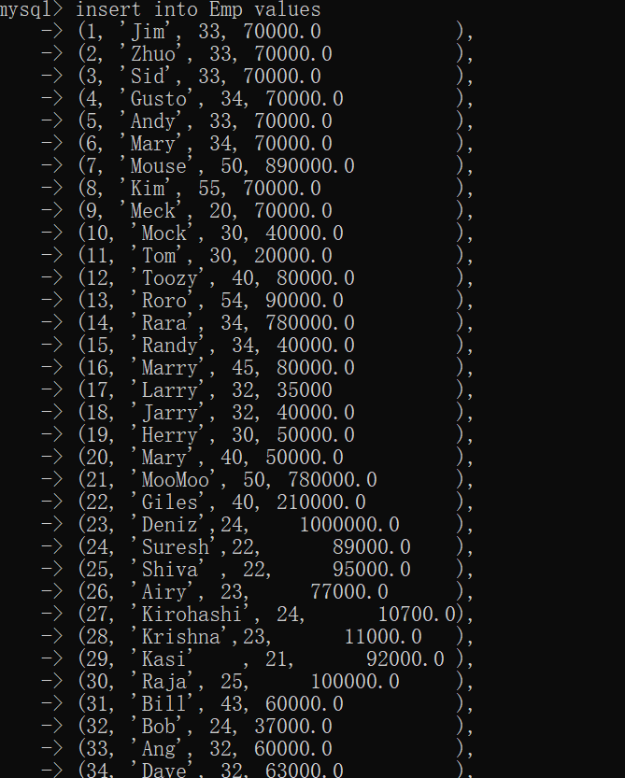

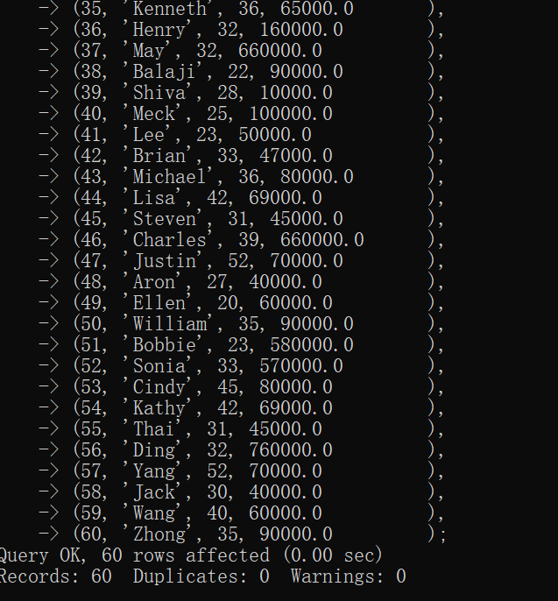

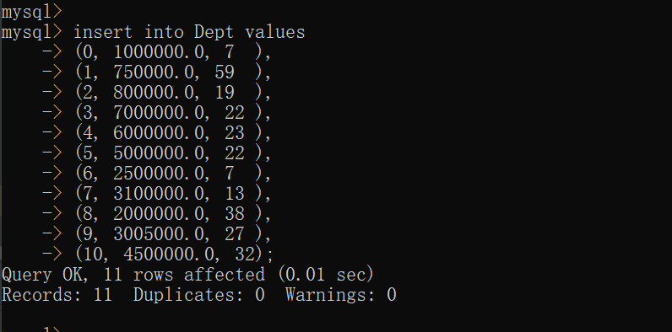

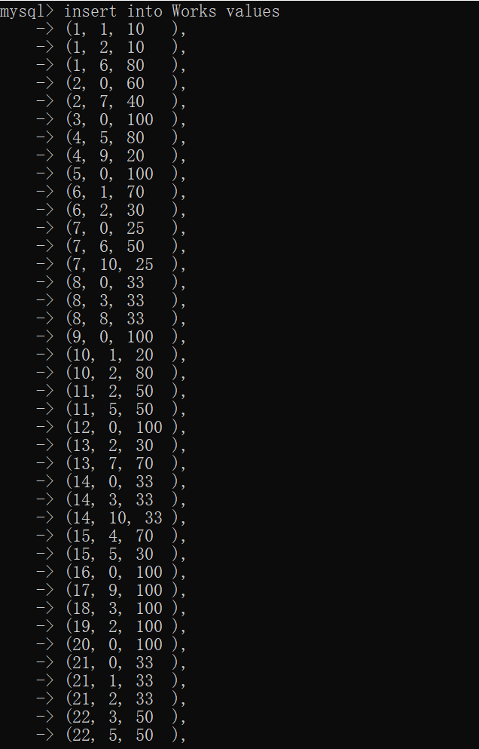

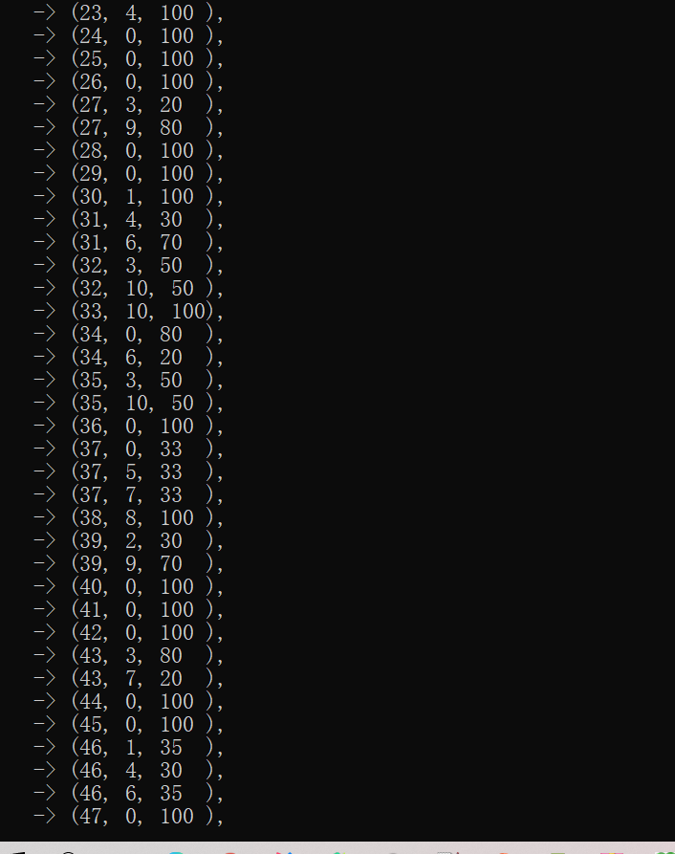

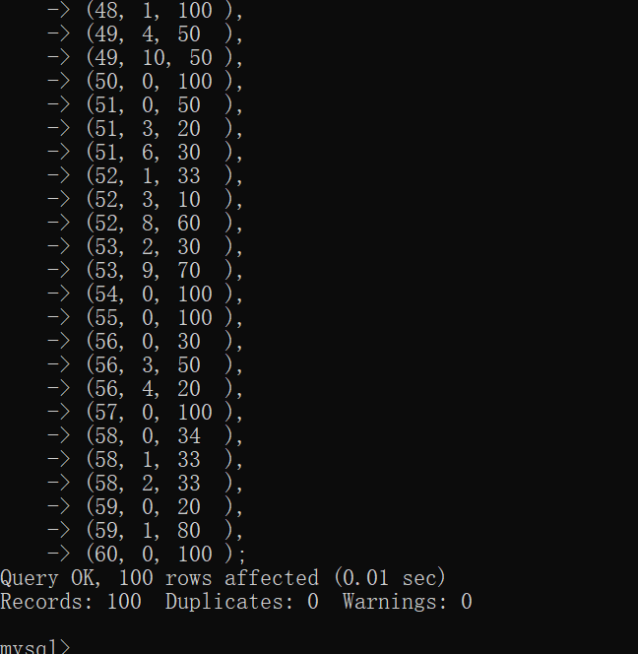

## Task2

select e.ename,e.salary

from Emp e

where e.eid in (

select eid

from Works

where did=0

)

and e.eid in (

select eid

from Works

where did=2

);

select e1.ename, e1.age, e1.salary

from Emp e1

join Works w1 on e1.eid=w1.eid

join (

select w.did,min(e.age) as min_age

from Emp e

join Works w on w.eid=e.eid

group by w.did

) t on t.did=w1.did and t.min_age=e1.age;

select e.ename

from Emp e

join Dept d on d.managerid=e.eid

where d.budget=(

select max(budget)

from Dept

);

select d.did, d.budget, d.managerid

from Dept d

join Works w on d.did=w.did

join Emp e on e.eid=w.eid

group by d.did, d.budget, d.managerid

having avg(e.salary)=

(

select max(avg_salary) as max_avg

from

(

select w.did, avg(e.salary) as avg_salary

from Emp e

join Works w on w.eid=e.eid

group by w.did

) t

);

select *

from Emp

where salary > some (select e.salary from Emp e

join Dept d on d.managerid=e.eid);

