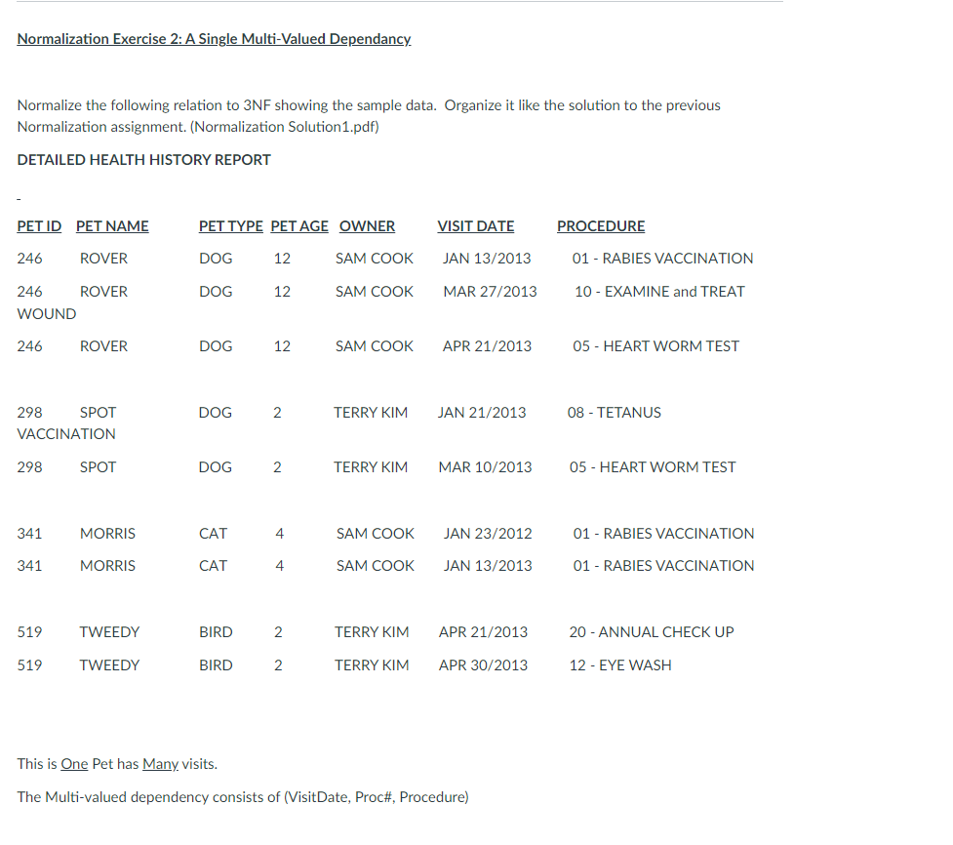

PET_TYPE (**PET TYPE ID**, PET TYPE)

|  |  |
| --- | --- |
| PET TYPE ID | PET TYPE |
| 1 | DOG |
| 2 | CAT |
| 3 | BIRD |

PET (**PET ID**, PET NAME, PET AGE, PET TYPE ID*, OWNER ID*)

|  |  |  |  |  |
| --- | --- | --- | --- | --- |
| PET ID | PET NAME | PET AGE | PET TYPE ID* | OWNER ID* |
| 246 | ROVER | 12 | 1 | 1 |
| 298 | SPOT | 2 | 1 | 2 |
| 341 | MORRIS | 4 | 2 | 1 |
| 519 | TWEEDY | 2 | 3 | 2 |

OWNER (**OWNER ID**, FIRST NAME, LAST NAME)

|  |  |  |
| --- | --- | --- |
| OWNER ID | FIRST NAME | LAST NAME |
| 1 | SAM | COOK |
| 2 | TERRY | KIM |

VISIT DATE (**DATE ID**, MONTH, DAY, YEAR)

|  |  |  |  |
| --- | --- | --- | --- |
| DATE ID | MONTH | DAY | YEAR |
| 1 | JAN | 13 | 2013 |
| 2 | MAR | 27 | 2013 |
| 3 | APR | 21 | 2013 |
| 4 | JAN | 21 | 2013 |
| 5 | MAR | 10 | 2013 |
| 6 | JAN | 23 | 2012 |
| 7 | APR | 30 | 2013 |

PROCEDURE (**PRO ID**, PRO NAME)

|  |  |
| --- | --- |
| PRO ID | PRO NAME |
| 01 | BABIES VACCINATION |
| 10 | EXAMINE and TREAT WOUND |
| 05 | HEART WORM TEST |
| 08 | TETANUS VACCINATION |
| 20 | ANNUAL CHECK UP |
| 12 | EYE WASH |

HEALTH HISTORY (**PET ID**\*, **DATE ID**\*, **PRO ID**\*)

|  |  |  |
| --- | --- | --- |
| PET ID | DATE ID | PRO ID |
| 246 | 1 | 01 |
| 246 | 2 | 10 |
| 246 | 3 | 05 |
| 298 | 4 | 08 |
| 298 | 5 | 05 |
| 341 | 6 | 01 |
| 341 | 1 | 01 |
| 519 | 3 | 20 |
| 519 | 7 | 12 |