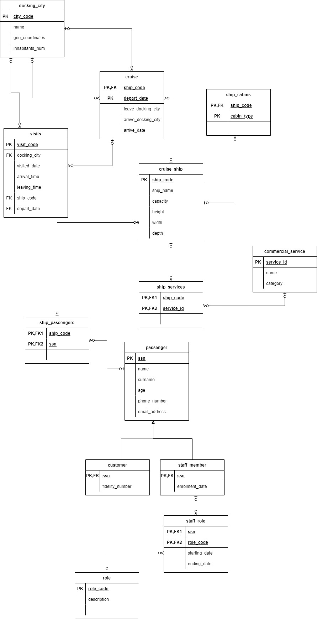

cruise_ship (**ship_code,** ship_name, capacity, height, width, depth**)**

ship_cabins (**ship_code, cabin_type**)

commercial_service (**service_id**, name, category)

ship_service (**ship_code, service_id)**

cruise (**ship_code, depart_date,** leave_docking_city, arrive_docking_city, arrive_date)

docking_city (**city_code**, name, geo_coordinates, inhabitants_num)

visits (**visit_code**, docking_city, visited_date, arrival_time, leaving_time, ship_code, depart_date)

passenger (**ssn**, name, surname, age, phone_number, email_address)

customer (**ssn,** fidelity_number)

staff_member (**ssn**, enrolment_date)

role (**role_code**, description)

staff_role (**ssn, role_code**, starting_date, ending_date)