## Task 1

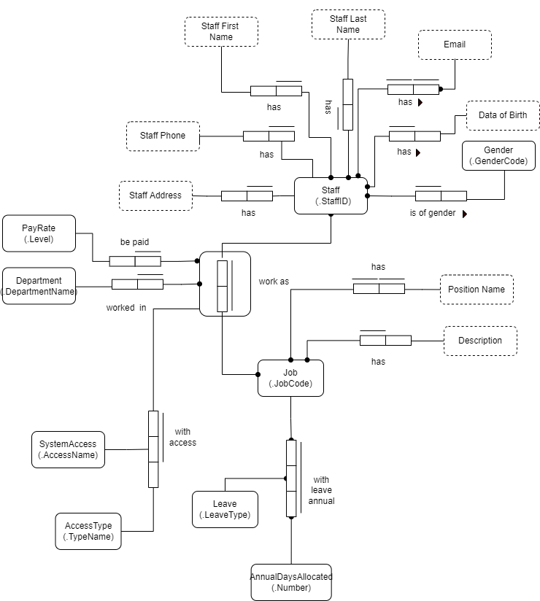

## Task 2

create table Person(

pName varchar(20) primary key

);

create table Repairer(

rName varchar(20) primary key

);

create table Vehicle(

reg int primary key,

pName varchar(20),

constraint fk_owned_by foreign key (pName) references Person(pName)

);

create table Repaired(

reg int,

date date,

rName varchar(20),

cost decimal(5,2),

primary key (reg, date),

constraint fk_vehicle foreign key (reg) references Vehicle(reg),

constraint fk_repairedby foreign key (rName) references Repairer(rName)

);