1Consider the following use case diagram, is it correct to state that:

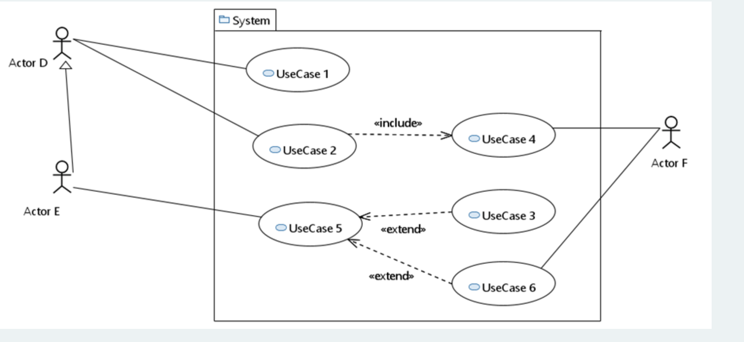



a.

Since UseCase 1 is higher up than UseCase 2 and does not have any dependencies, UseCase 1 will be undertaken first.



b.

Actor E may interact with both UseCase 1 and UseCase 2.



c.

As actor F is on the right-hand side of the diagram, F denotes an external software system.



d.

UseCase 5 can be undertaken irrespective of whether UseCase 3 or UseCase 6 are undertaken.



e.

Extension points determine the conditions under which UseCase 6 will be undertaken.

**Question 2**

Answer saved

Marked out of 6.00

**Flag question**

Question text

Choose all statements which are true regarding the concepts of software quality.



a.

Quality requirements are generally articulated in a precise manner as they mean the same thing to most people.



b.

A  business value and risk exposure analysis can help to determine which quality attributes should be most important to a development.



c.

It is entirely up to development managers to ensure that a quality culture prevails for all software development initiatives.



d.

The desired quality of a product can affect the choice of process used to develop the software.



e.

It is about ensuring that software completely meets both functional and non-functional requirements.

**Question 3**

Answer saved

Marked out of 7.00

**Flag question**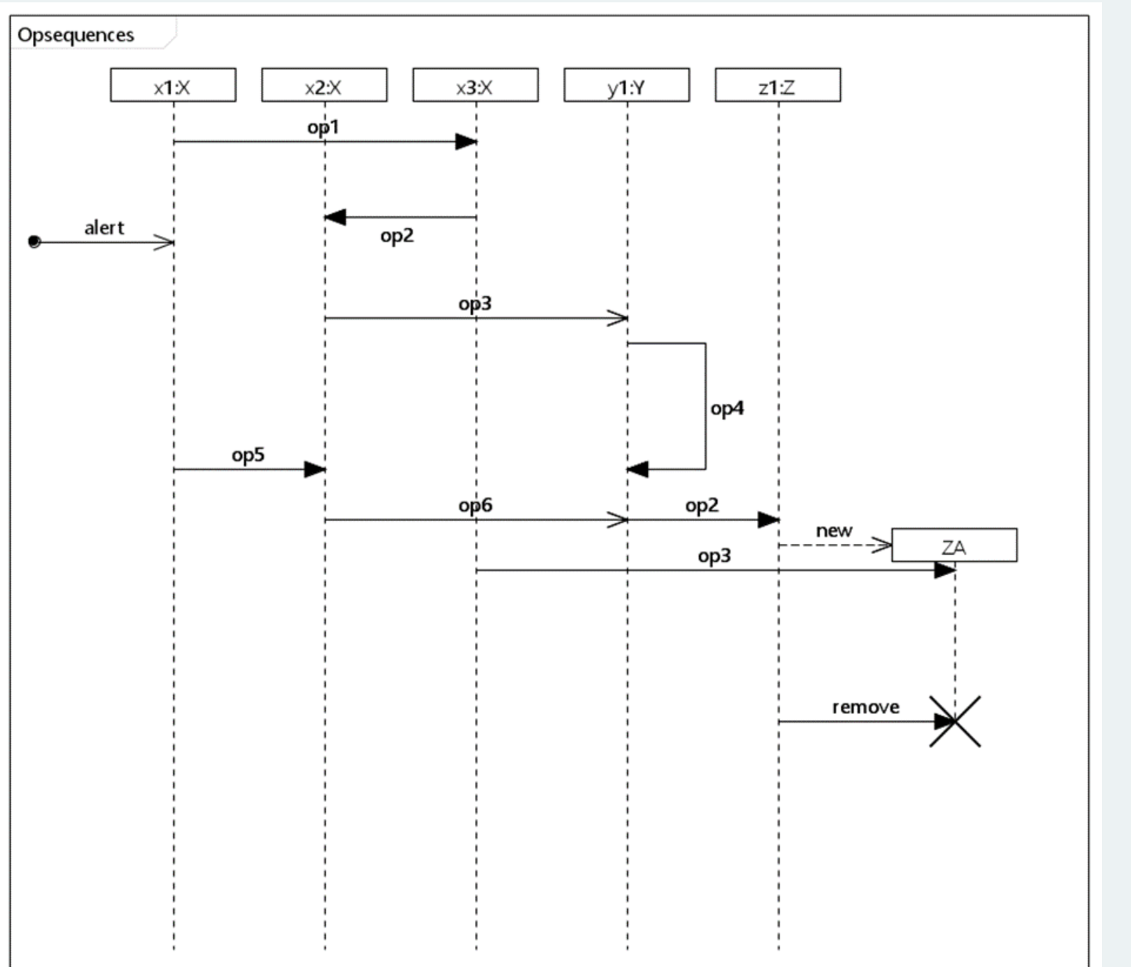

Question text

Given the above sequence diagram, select the correct statements.



a.

The remove message terminates the life of z1.



b.

op6 and op4 are examples of two different message types for class Y.



c.

The op2 message of x2 invoked by the object x3 is the reply message to op1.



d.

The message new does not correspond to an operation of class Z.



e.

op6 and op2 belong to class Y.



f.

The alert message creates x1.

**Question 4**

Answer saved

Marked out of 7.00

**Flag question**

Question text

Students admitted to study at an institution enter at the basic level and are required to pass three exams prior to progressing to the advanced level which also requires three passes.  On passing all exams at the advanced level, a student then graduates.  If a student fails any exam, at either level, they are allowed to resit the exam up to two times before leaving the level in which case the registration of the student is deemed to have been cancelled.

In the following nb denotes the number of basic exams taken, na the number of advanced exams taken, r the number of resits (ra, rb for advanced and basic respectively), g indicating a pass (p) or fail (f) grade (ga, gb for advanced and basic respectively).

Select all state machines reflecting the student progression description above.



a.

4



b.

2



c.

3



d.

None of the options



e.

1

**Question 5**

Answer saved

Marked out of 6.00

**Flag question**

Question text

Choose all statements which are true regarding version management.



a.

Effective agile development is hindered in the absence of version/configuration management tools.



b.

Version/configuration management is only focused on changes to a software system once it is release into production.



c.

Irrespective of the software development process used, version/configuration management can be used to improve software quality.



d.

As long as you document the software development process there is no need for version/configuration management.



e.

Version/ configuration management can be used for controlling non-code related artifacts such as requirements and design documents.

**Question 6**

Not yet answered

Marked out of 7.00

**Flag question**

Question text

Your company has been chosen to implement a UK highway information system project and you are going to use an agile-scrum method.  Given lengthy delays in the procurement of the development, the customer is keen to ensure the system is implemented in the near horizon. This said, the customer has no experience in agile and has long-established organisational quality assurance procedures more inclined to that of a waterfall approach. You will utilise development teams in London (where you are based) and New York as the skills required to undertake the development are spread across these teams.  The following are additional facts about the customer and project:

* The customer has three business analysts (BA) which are knowledgeable about the functional business requirements.  However, there is no single product owner.
* The customer has mandated a project manager (PM) to make high-level decisions about what is in scope and their relative importance.  However, the PM will not always be available at all meetings.
* The project has an appointed Scrum master and an architect manager.  The architect will have responsibility for eliciting non-functional requirements based on discussions with many varied departments within the customers organisation as well as external stakeholders.
* The system developed by the project will need to fit into the customer’s existing IT architecture/infrastructure and interface with many other applications.
* The customer has insisted that the development process be documented according to a specific standard (we will call this S-standard).  In relation to the functional requirements, this will be the responsibility of the BA’s.

Based on the above, choose all statements which are correct:



a.

Your company should select and/or agree, with the customer, that the BA’s should act as the product owner.



b.

Pairs programming should not be used in this project as not all team members are co-located.



c.

The architecture team could undertake their non-functional user requirements elicitation in parallel with functional feature development.  Once these requirements have been documented in a user story and agreed with the customer, they can be prioritized on the product backlog.



d.

The scrum team working on the functional features should completely finish all code iterations and only incorporate non-functional aspects after the user has signed off on their development.



e.

Once user stories are obtained, the project development follows the typical agile scrum process in which a physical white board, in London, is used to visualize and communicate the product backlog for the entire development team and product owners at the same time.



f.

The company should adopt a plan-driven incremental development in which iteration occurs within each activity as this extreme-programming approach will speed up code production.



g.

Your company (via the Scrum manager) should translate the BA documented requirements into user stories and agree these with the customer and thereafter aiding the customer in this respect if necessary.



h.

Since the customer has no experience in agile, your company should provide training in agile until the customer is in a position to produce high-quality user stories which you then prioritise for the product backlog.



i.

In the absence of your company documenting a significant portion of the development process, the customer requirements might not be met.

**Question 7**

Not yet answered

Marked out of 7.00

**Flag question**

Question text

You are part of a software consultancy advising organisations on Agile development.  You have been working with company X to improve their agile proficiency and have observed the following:

The team members are, individually, highly-skilled in specific areas of software development and this has a significant influence on the tasks they choose to implement.  Team members say that they perform better when they are engaged in activities they have a preference for.  This often results in situations where members are not entirely sure what others are working on (all of the time).  This has caused problems when members have tried to substitute for one another as they either lack technical knowledge or sufficient background in what is required.  Most team members are working on multiple development projects whose Product owner is not co-located.  Moreover, in a several projects, the Scrum master also had competing priorities.  Finally, team members say product backlogs and sprint plans were often unrealistic, a situation exacerbated by frequent demands placed on the team by external stakeholders.

In your analysis, you realise that the issues highlighted above have been prevalent for several years extending across different large development projects.

Based on the above scenario, in the following, choose all statements which would better serve company X?



a.

Advise company X to reduce dependencies on single Scrum master/Product owners by way of including additional person(s) to enhance redundancy.



b.

Advise company X to only engage in smaller projects in which every member knows what the other is doing.



c.

Advise company X to have triggers to enable transition to flow-development if sprints become unrealistic.



d.

Advise company X to only allow team members to work on projects utilising their main expertise.



e.

Pay team members more money as this will make working conditions more tolerable.



f.

Advise company X to only engage in projects in which team members, Product owner and Scrum master are co-located.



g.

Advise company X to create a culture conducive for collaboration for solving tasks.

**Question 8**

Not yet answered

Marked out of 6.00

**Flag question**

Question text

A manufacturing company has hired external consultants to develop a new system that will combine the technology support currently provided by several systems spread across varied departments in the organisation.  The following reflects some of the requirements identified for the new system.

1.      The system provides users (from different departments) a single interface to receive data.

2.      The system allows users to seamlessly switch between different modules.

3.      Different modules should be able to share information in real-time.

4.      Data referring to the same or related set of operations should be stored in the same part of the system.

5.      The system will automatically backup its database every two days.

6.      The system allows users to create invoices.

7.      The system allows users to print reports from within any module.

8.      The system allows the Finance department to make/receive payments to/from customer banks.

9.      The system provides notifications and reminders of pending activities.

10.   The system should support more than 220 users simultaneously.

In the context of the above requirements, choose all statements which are correct.



a.

1, 3, 5 and 8 are Non-functional requirements



b.

2, 5, and 9 are Functional requirements



c.

7 and 8 are Functional requirements



d.

3, 4, 6 and 10 are Non-functional requirements



e.

6 and 9 are Functional requirements