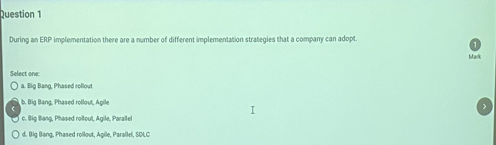

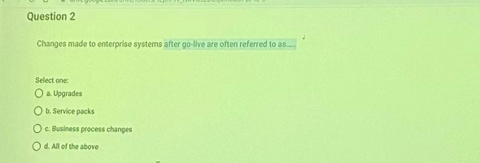

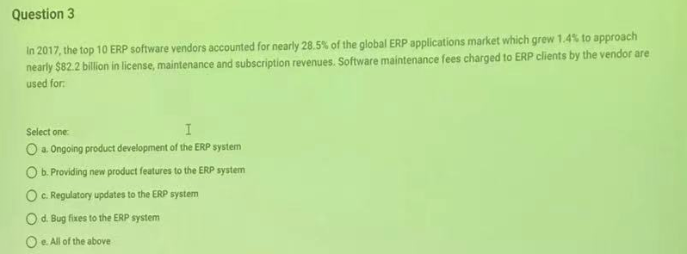

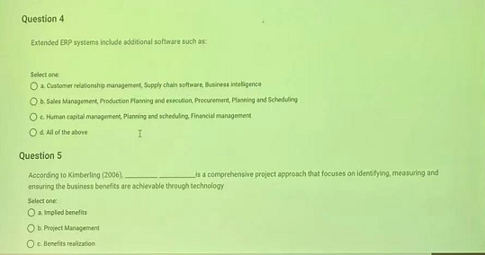

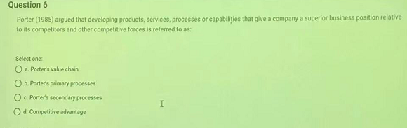

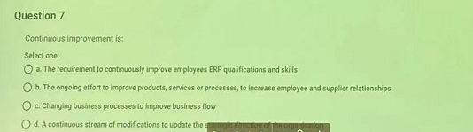

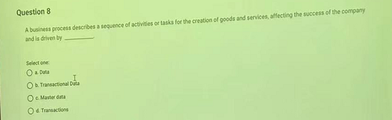

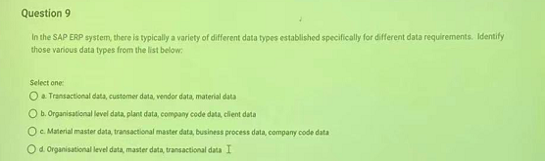

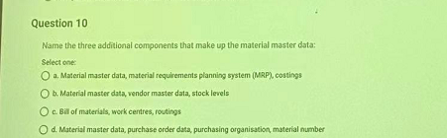

1. C
2. D
3. E
4. A
5. C
6. A OR D（probably A）
7. C and D（probably D）
8. D
9. D
10. C

SHORT ANSWER:

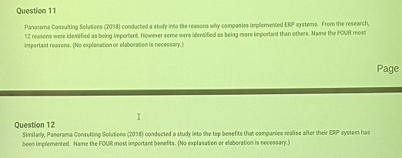

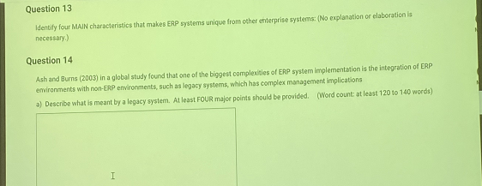



15. S for HANA : applications for HANA database

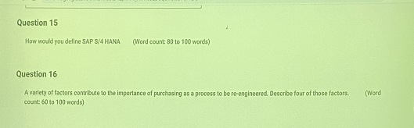

17

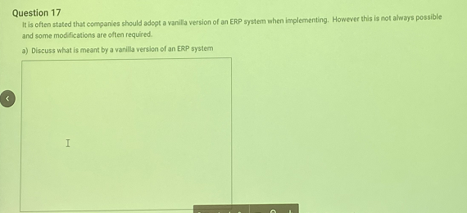

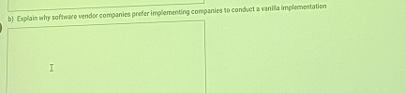

c. modify: change the code (not about the future)

Configure: setting the software



18 CASE STUDY(案例分析)

