**Week1 Introduction**

1. **What is system?**

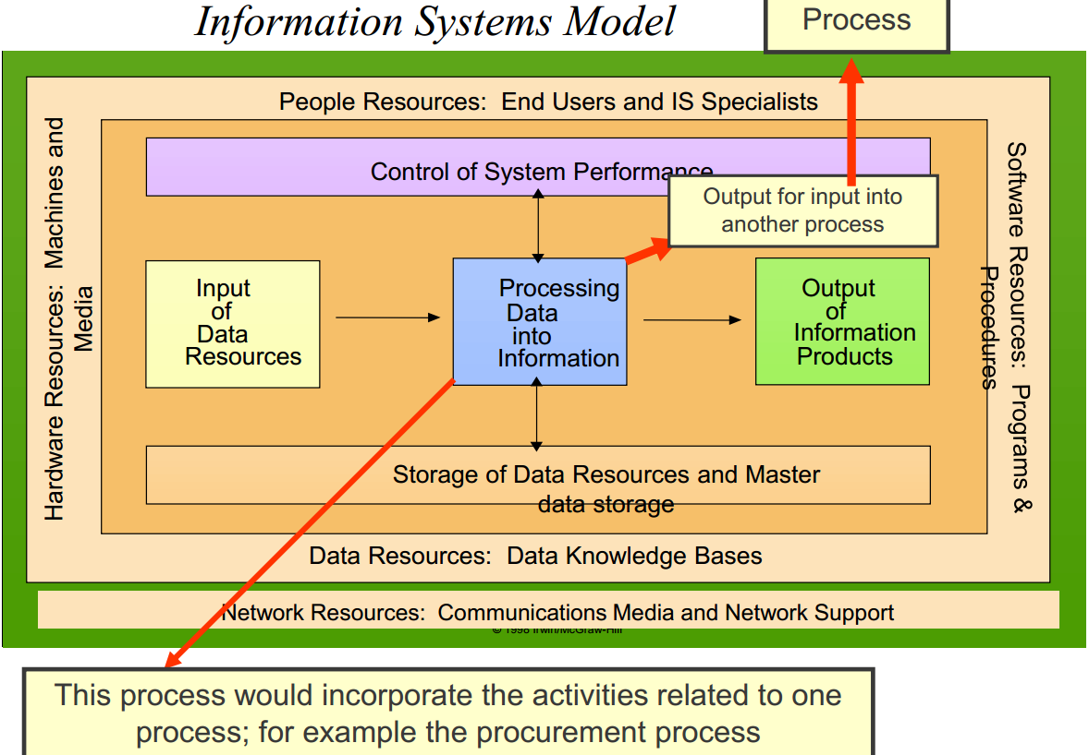

1. **The relationship between organizations and systems**

* Systems impact on all facets of organizational life.
* Organizations rely on systems to support their day to day operations.
* Systems enable:
* People to communicate
* Processes to direct business functions
* Data to be transformed into information

1. **What might an enterprise system look like?**

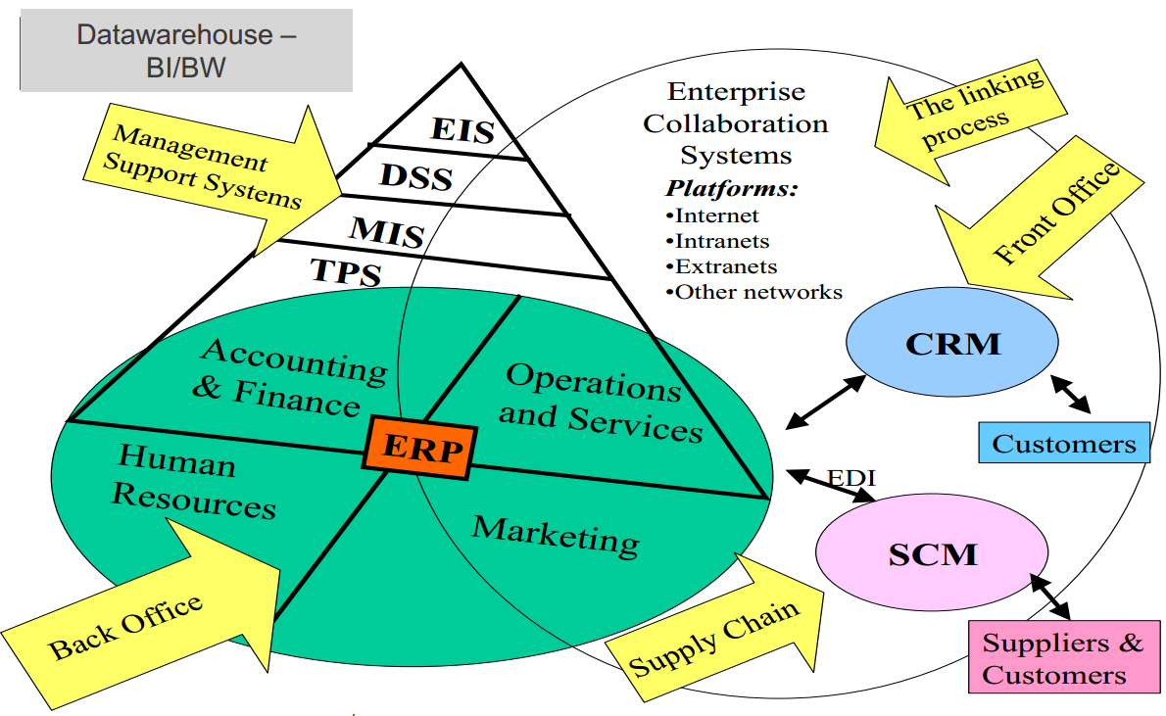

1. **What does an enterprise system do?**

* Bring together previously isolated information systems with the goal of providing a more whole or complete information resource
* This integration includes bringing together: people, processes, information, systems.
* To achieve common strategic business goal.

1. **ES may include**

* Enterprise wide systems such as **ERP** systems
* **Manufacturing** systems
* **SCM**: Supply chain and inventory management systems
* **CRM:** Customer relationship management systems
* **Financial** information systems
* e-Marketing and e-commerce applications
* business intelligence (**BW**)

1. **Definition of ES/ERP system**

An enterprise-wide, modular, integrated, real time information system responsible for transaction processing throughout the enterprise



1. **Decentralized Systems (Legacy Systems)**

Data is maintained locally at the individual departments (Silos)

Departments do not have access to the data of other departments.

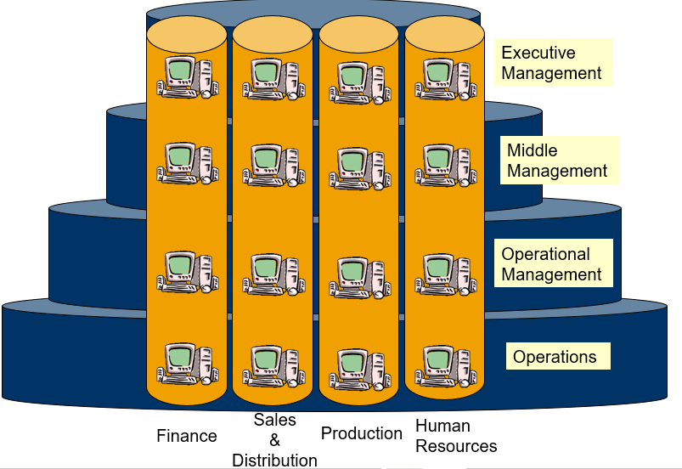

1. **Problems of Decentralized Systems**

* Numerous disparate systems are developed over time.
* Integrating the data becomes time and money consuming.
* Inconsistencies and duplication of data.
* Lack of timely information leads to customer dissatisfaction, loss of revenue and reputation.
* High inventory, material and human resource cost.

1. **Centralized Systems (ERP Systems)**Data is maintained at a central location and is shared with various departments.

Departments have access to the data of other departments.

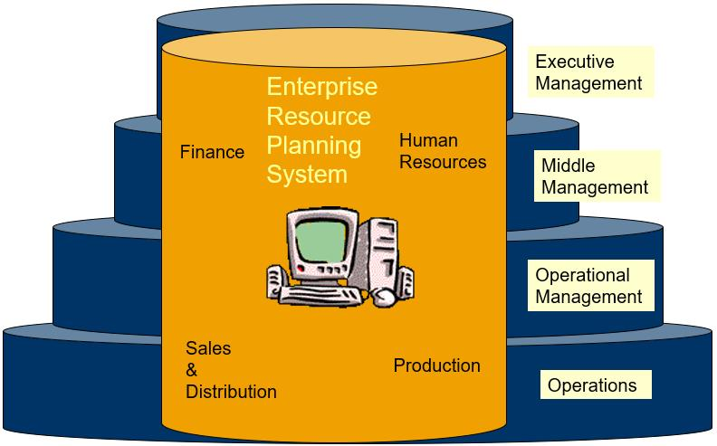

1. **Benefits of a Centralized ERP System**

* **Improve Data Quality**: Eliminates the duplication, discontinuity and redundancy in data.
* **Better Communication**: Provides information across departments in real time.
* **Overall Control**: Provides control over various business processes.
* **Better Performance**: Increases productivity, better inventory management, promotes quality, reduced material cost, effective human resources management, etc.
* **Better customer interaction**: increased throughput, improves customer service.

1. **Benefits of implementing ERP system**

* Enhance all aspects of key operations across a company’s entire back-office
* from planning through execution, management, and control.
* they accomplish this by taking processes and functions that were previously disparate and disjointed, and seamlessly integrating and coordinating them.
* Facilitate more efficient completion of day-to-day tasks.
* Reduce the redundant and overlapping activities that waste time and money by standardizing core procedures.
* Eliminate data silos by creating a single, centralized repository of timely, accurate business data.
* Enable more effective resource allocation and management.

1. **SAP**

Systems, Applications and Products.

1. **SAP ERP Features**

* Enables a company to support and optimize its business processes
* Ties together disparate business functions (integrated business solution)
* Helps the organization run smoothly
* Real-time environment
* Scalable and flexible
* Automation of data updates
* Applicability of best practices - SAP’s software designers choose the best, most efficient ways in which business processes should be handled

1. **Enterprise system vendors (记住三个)**

SAP, ORACLE, Intuit Inc, FIS Global, Fiserv, Cerner Corporation, Microsoft, etc.

**Week2 Business Function & Processes**

1. **Functional area**

Broad category of business activities

* Marketing and Sales (M/S)
* Supply Chain Management (SCM)

1. **Business process**

Set of tasks or activities that produce desired outcomes.

A business process may involve one or many functional areas.

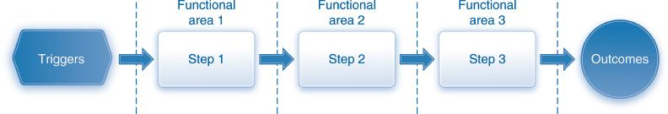

1. **Key Business Process - Fulfillment Process (Sell)**

Fulfillment is concerned with efficiently processing customer orders.

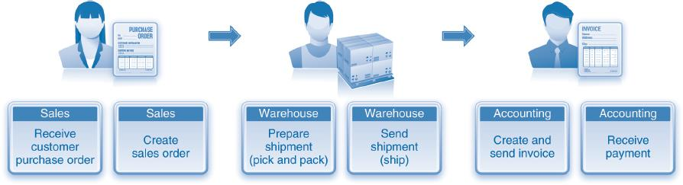

This process would be triggered by a customer purchase order that is received by the sales department.

1. **Key Business Process - Material Planning Process (Plan)**

The purpose of material planning is to match the supply of materials with the demand.

These materials may be Finished goods, Semi-finished goods and raw materials.

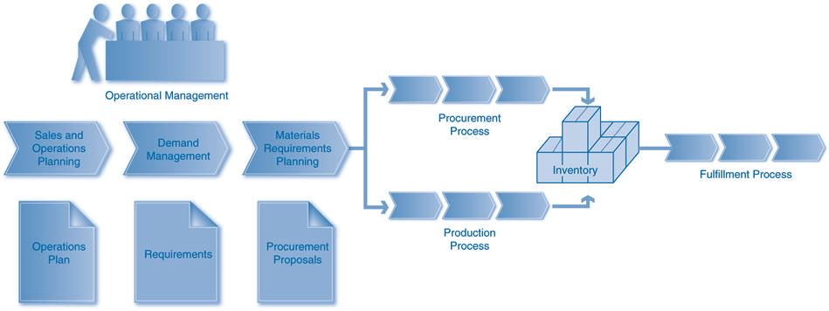

The demand for finished goods is dependent on customer orders while the demand for the other materials is based on the demand for the finished goods.

1. **Key Business Process - Inventory & Warehouse Management (Store)**

IWM is concerned with the storage and movement of materials.

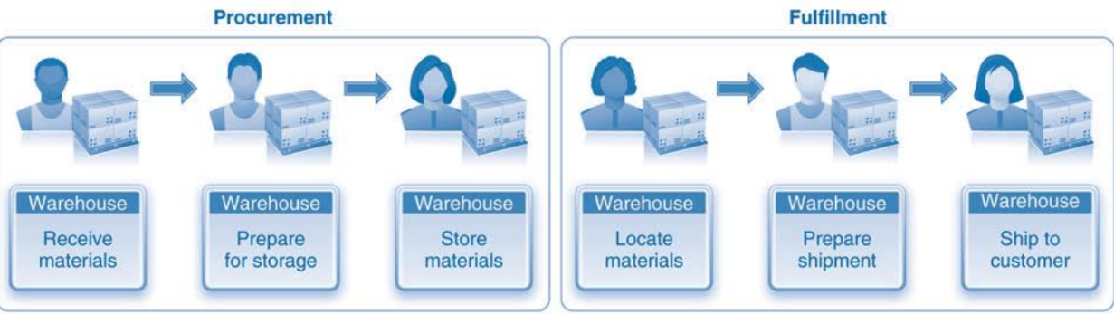

1. **Key Business Process - Procurement Process (Buy)**

The procurement process includes all of the tasks involved in acquiring needed materials externally from a vendor.

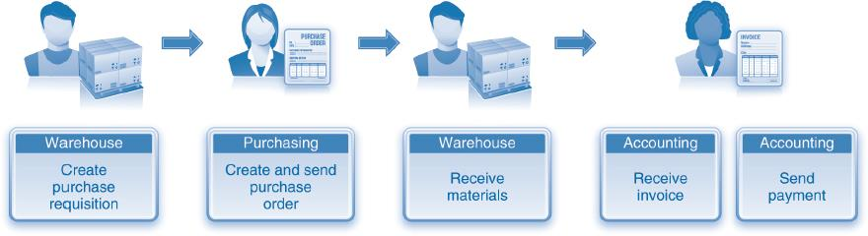

This process would be triggered when the warehouse needs to procure materials, perhaps due to the low levels of inventory.

1. **Key Business Process - Production Process (Make)**

The production process includes all of the tasks involved in acquiring needed materials internally.

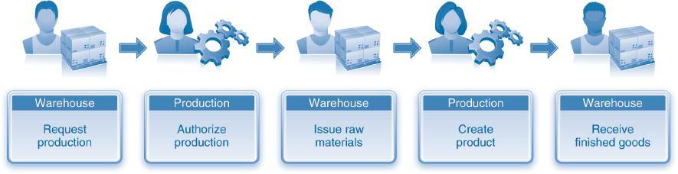

This process would be triggered by a customer order or the material planning process

1. **Accounting & Finance (Track)**

* Financial Accounting – track for external reporting
* Management Accounting – track for internal reporting

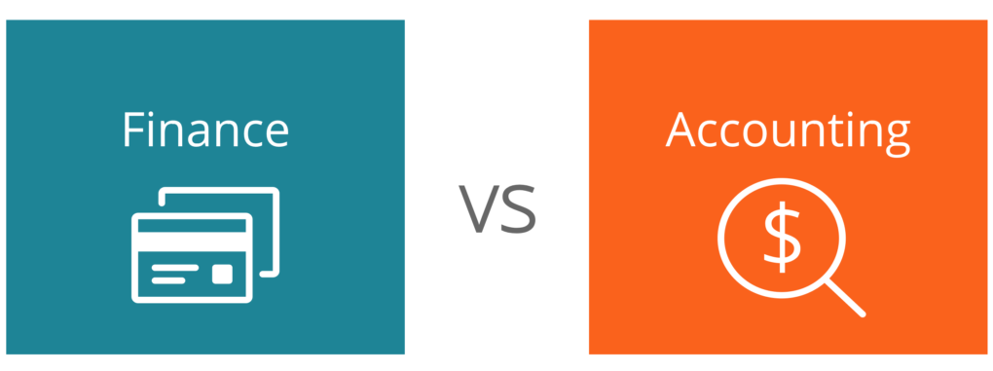

Financial accounting (FI) is concerned with tracking the financial impacts of processes with the goal of meeting legal and regulatory reporting requirements (e.g. profit and loss statement, balance sheet)

Management Accounting or Controlling (CO) is concerned with tracking costs and revenues to assess the profitability of various profits and market segments.

1. **SAP Business Processes (Modules)**

**Sales and Distribution**

records sales orders and scheduled deliveries. Information about the customer (pricing, address and shipping instructions, billing details, and so on) is maintained and accessed from this module.

**Materials Management**

manages the acquisition of raw materials from suppliers (purchasing) and the subsequent handling of raw materials inventory, from storage to work-in-progress goods to shipping of finished

goods to the customer.

**Production Planning**

maintains production information. Here production is planned and scheduled, and actual production activities are recorded.

**Quality Management**

plans and records quality control activities, such as product inspections and material certifications.

**Plant Maintenance**

manages maintenance resources and planning for preventive maintenance of plant machinery in order to minimize equipment breakdowns.

**Asset Management**

helps the company manage fixed-asset purchases (plant and machinery) and related depreciation.

**Human Resources**

facilitates employee recruiting, hiring, and training.

This module also includes payroll and benefits.

**Project System**

facilitates the planning for and control over new research and development (R&D), construction, and marketing projects.

**Financial Accounting**

records transactions in the general ledger accounts. This module generates financial statements for external reporting purposes.

**Controlling serves**

internal management purposes, assigning manufacturing costs to products and to cost centers so the profitability of the company’s activities can be analyzed.

**Workflow** is a set of tools that can be used to automate any of the activities in SAP ERP. It can perform task-flow analysis and prompt employees (by email) if they need to act. The Workflow module works well for business processes that are not daily activities but that occur frequently

enough to be worth the effort to implement the workflow module—such as preparing customer invoices.

**Customer Relationship Management (CRM)**

is a tool for managing and maintaining relationships with customers. It keeps track of business

contacts, employees, clients, contract wins and sales leads.

**Supplier Relationship Management (SRM)**

is a tool for planning for, and managing, all interactions with third party organizations that supply goods and/or services to an organization in order to maximize the value of those interactions.

1. **SAP S4/HANA**

SAP HANA (High-performance Analytic Appliance) is an application that uses **in-memory** database technology that allows the processing of massive amounts of **real-time** data in a short time. The in-memory computing engine allows HANA to process data stored in RAM as opposed to reading it from a disk. This allows the application to provide instantaneous results from customer transactions and data analyses.

**Week 3 ERP Structure**

1. **SAP Key Business Elements**

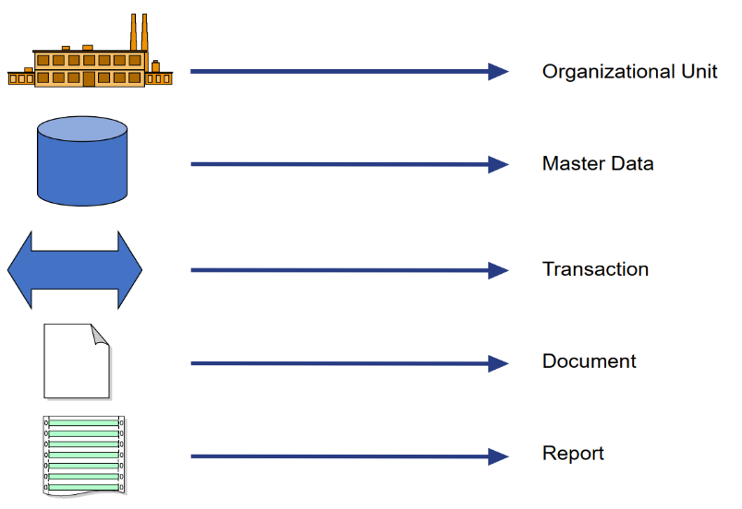

1. **Organizational Elements**

* organizational elements form structures that represent the legal and organizational views of a company. These views include: accounting, manufacturing planning and execution, materials management, and sales and distribution.
* In summary, the organizational elements and their structures form the framework in which all business transactions are processed.

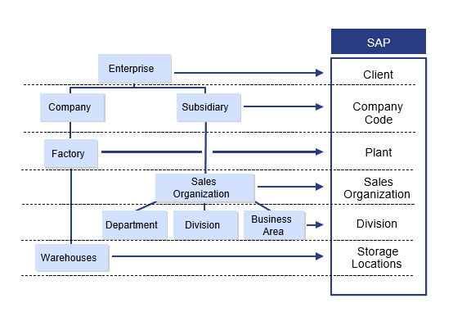

1. **Organizational Elements – Client**

Highest Hierarchical Level in SAP(e.g. a Corporation)

The SAP client concept allows an organization to split a system into logical subunits. Clients may operate as separate business units, where all data is stored in a common database. Access rights for each client are defined during the installation process. Client specific data includes user master data (including authorizations and user groups), data customization and application/business data.

1. **Organizational Elements – Company**

Each company within the enterprise is represented by a company code. Each company code represents a separate legal entity, and it’s the central organizational element in financial accounting. A client can have multiple company codes, but a company code must belong to only one client.

1. **Transaction Data**

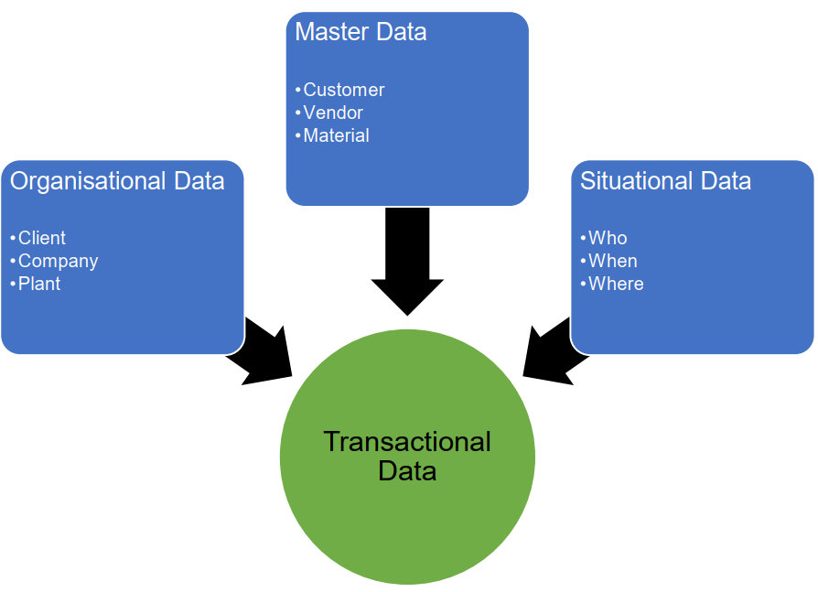

1. **Documents**

Documents record data after the process steps are completed. These include financial accounting [FI] documents, management accounting or controlling [CO] documents, and material documents

1. **Reports**

Reporting is a general term used to describe the ways that users can view and analyze data to help them make decisions and complete their tasks.

1. **MDM (Master Data Management)**

Master Data Management (MDM) is a set of disciplines, technologies, and solutions used to create and maintain **consistent, complete, contextual** and **accurate** data quality business data for all stakeholders (users, and applications) across and beyond the enterprise landscape.

1. **Drivers of MDM**

* Regulatory compliance and reporting
* Partner integration and collaboration
* Global demand and supply chain optimization
* Privacy and data protection
* Meaningful data mining and analytics
* Improved customer insight and interactions

**Week8 Process Integration & Modelling**

1. **Business integration**

Technique that companies use to align the use of their technology assets with their business to meet a shared goal or outcome. The unification of technology and business goals allows companies to operate smoothly as they move forward and adapt.

1. **Benefits of ERP Integration**

* **Increased Transparency and Information Sharing**: when other departments have immediate access to information, documents, or files that they need, it increases response time and boosts office efficiency.
* **Data Accuracy**: with software that accurately stores all information in an easily accessible place, ERP integration eradicates errors and time consuming manual processes.
* **Real-Time Data Access**: Rather than gaining access to critical data tomorrow, next week, or even next month, you can view everything in one place when you need it.
* **Automation**: by integrating your ERP with the rest of your business platforms you can eliminate the need for redundant and manual data entry.

1. **Business process mapping or modelling**

A process model is an abstract representation of a process. It can be as simple as a diagram with boxes and arrows or as complex as computer software that allows for process simulations.

**The reality**: Many organizations have not mapped their processes because

* Too time consuming
* Too much human resources
* Orgs cannot afford to focus on systems implementation and major process reengineering at the same time
* Lack of skills

1. **Why business process modelling or why modeling current process?**

* Standardize process documentation
* Same problem understanding
* Transfers knowledge
* Find shortcomings of current situations
* Supports acceptance of the project
* Supports certification and audits
* Shows potential/limits of re-engineering

1. **Benefits of BPM**

* Formalization of current processes
* Allows for re-engineering—improved process performance
* Provides the base for strategic initiatives
* Greater efficiency
* Increased productivity
* Traceability of compliance processes

1. **Why business process optimization?**

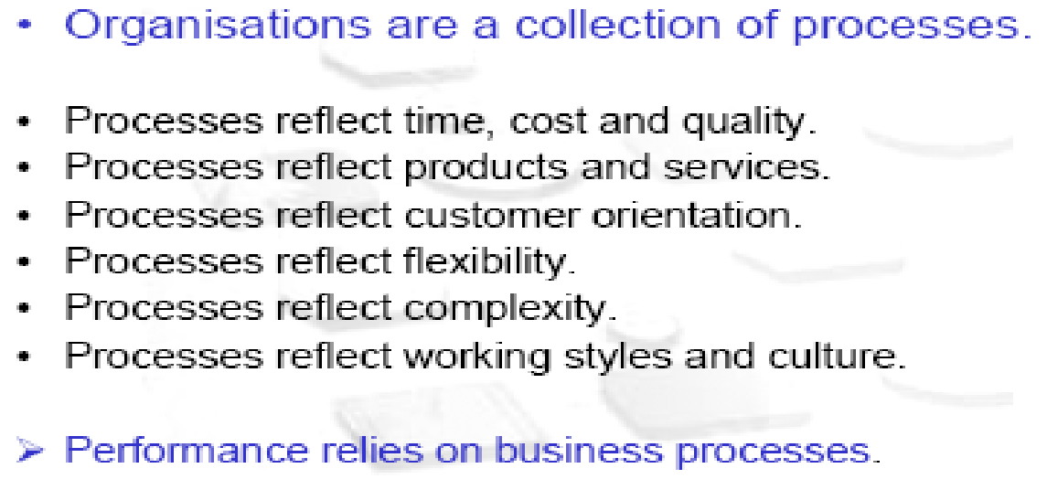

1. **Business process re-engineering (BPR)**

BPR is a management approach aimed at increasing efficiency and effectiveness of the processes that exist within an across organization.

* Business Process Redesign
* Business Transformation
* Business Process Change Management

# Week 9 ERP implementations

1. **Keys to successful ERP implementation**

* Clear **alignment** with overall business strategy
* **Realistic** expectations during implementation planning
* Focus on people, organizational **change management** and **workforce transition**
* Effective **business process management** and **process improvement**
* Strong project **management, governance and controls**

1. **Consequences of unsuccessful implementation**

* Degrade business capability
* Degrade competitive advantage
* Increase operating costs
* Reduce revenue earnings
* Fail to meet critical business requirements
* Poor levels of user satisfaction
* Loss of staff
* Staff will not use the system properly
* Staff not involved in the change
* Leads to Perceived Loss of control

1. **If successful implementation**

* **Projects**

– Deliver functionality & usability to users

– Achieve business goals

– Achieve strategic goals

– Satisfy business stakeholders

* **Project management**

**–** Completes project within budget

– Completes project on time

– Completes project within scope

1. **How to manage change**

Change management strategy and risk management strategy

# Week10 Current Technologies

1. **How to gain more value from system**
2. Use **same system in different ways** to realize more value
3. More focus on **tangible benefits**, such as reduced cost and increased revenue.
4. Emphasize integrating, optimizing and using analytics to improve business performance.
5. Extend systems throughout the organization and implement across a range of functions.
6. Integrate the organization and external systems of customers and suppliers.
7. Aggressively use information and analytics to improve **decision making**.
8. Use strategically for **competitive differentiation**.
9. Tailor systems to sustain competitive advantage & standardize other areas.
10. More likely to implement industry modules.
11. **Top 10 Technology Ranking (Remember at least 3 and example!!)**
12. Analytics and business intelligence
13. Digitalization/digital marketing
14. Cloud computing (SaaS, IaaS, PaaS) e.g. SAP’s Cloud Strategy
15. Mobile applications e.g. SAP Mobility Predictions
16. IOT
17. CRM
18. AI
19. ERP
20. Data central
21. Automation
22. **What is BI**

**BI** (Business Intelligence) is a broad category of applications and technologies for gathering, sorting, analysing, and providing access to data to help enterprise users make better business decisions. The purpose of Business Intelligence is to support better business decision making. Essentially, Business Intelligence systems are data-driven Decision Support Systems which can provide historical, current and predictive views of business operation

1. **Difference between data warehouse and BI**

Data warehouse is a special type of back-end database which manage all aspects of data in the organisation and provides the ability for data to be transformed into information.

On the other hand, **BI** is a broad category of applications and technologies for gathering, sorting, analysing, and providing access to data to help enterprise users make better business decisions.

DW store and provide the necessary data for business intelligence.

1. **BI delivery tools**

Dashboard, report, mobile intelligence

1. **OLTP vs OLAP**

**OLTP:** Online transaction processing shortly known as OLTP supports transaction-oriented applications in a 3-tier architecture. OLTP administers day to day transaction of an organization.

**OLAP:** Online Analytical Processing, a category of software tools which provide analysis of data for business decisions. OLAP systems allow users to analyze database information from multiple database systems at one time.

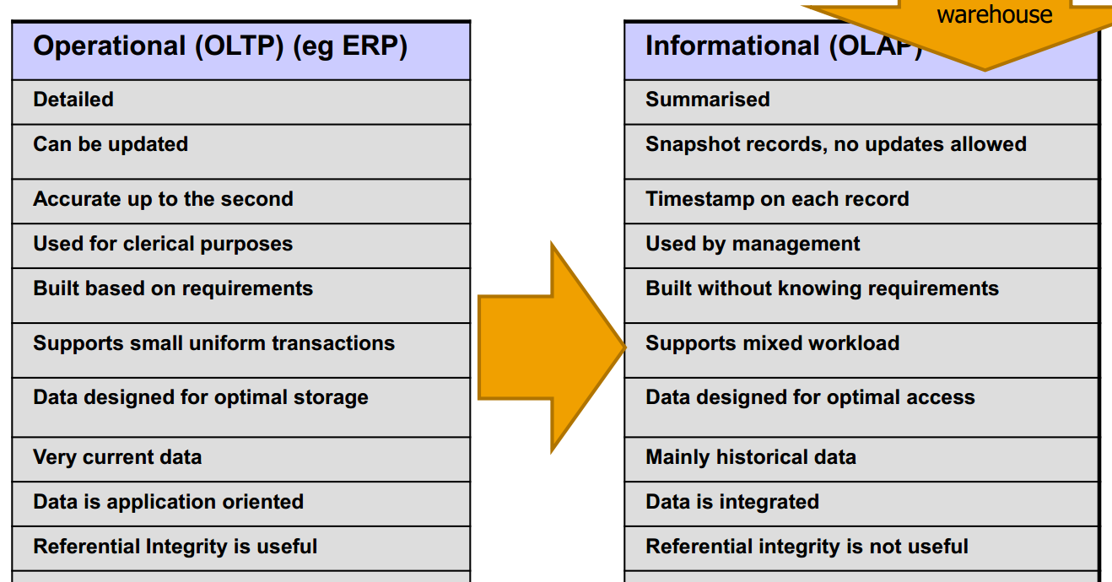

Relational database vs Star Schema (Dimension Modelling)

1. **Design thinking**

Design Thinking is an approach to innovation. It lets us discover opportunities, inspire potentials, and create successful solutions that meet human needs, add business value, and are technically feasible.”

**8. Digital transformation example (Remember at least one!!)**

