UNIVERSITY OF SAINT JOSEPH MBARARA (USJM)
Faculty of Education and Sciences
Bachelor of Science in Information Technology, Year 3
Mid-Semester One Examinations, Academic Year 2026/2027
ANDROID PROGRAMMING: TAKE-HOME PROJECT
Mid-Semester Report: Proposal, Design and Working Prototype
USJM SMART LIBRARY MOBILE
An Android application for searching the university library catalogue and reserving books for pickup
Item | Details
Student name | Henry Tumusiime
Registration number | Your registration number
Course code | Course code
Course lecturer | Lecturer's name
Git repository | https://github.com/<username>/<RegNo>_Tumusiime_AndroidExam
Date of submission | Date

Contents

If the contents list is empty, right-click it in Word and choose Update Field → Update entire table.

1. Problem Statement

1.1 Background
The University of Saint Joseph Mbarara (USJM) library serves students and staff across all faculties. It runs Koha, an integrated library system, for cataloguing and circulation. Most library services, however, still happen at the circulation desk: students ask whether a book is in, where it is shelved, and then queue to borrow it.

1.2 The problem
From my observation of the USJM library, students face three related difficulties:
- Long queues at the circulation desk, especially at busy times such as before lectures and during examinations, because searching, checking availability and borrowing are all done at the desk.
- Low awareness of the existing system. Many students do not know that the library catalogue can be searched online, or which books are available for their course units.
- No way to hold a book in advance. A student may walk to the library only to find that every copy of a book they need has already been borrowed.
As a result, students lose study time and get frustrated, library resources are under-used, and librarians spend much of their time answering the same availability questions.

1.3 Target users
- Primary: USJM students with Android smartphones, who need to find books quickly and collect them without queuing.
- Secondary: librarians, who prepare reserved books at an express pickup counter and benefit from fewer enquiries at the main desk.

1.4 Why it matters
Most students carry a smartphone, so putting the catalogue in their pocket makes library resources visible to them at the moment they need them. Reserving ahead turns a long desk transaction into a short pickup, which shortens queues for everyone. The app keeps its data on the phone, so it remains usable where campus internet access is unreliable.

1.5 Proposed solution
USJM Smart Library Mobile is an Android application. A student creates an account and signs in with their email and password (and can reset a forgotten password by email), then can browse and search the catalogue, see a book's shelf location and how many copies are available, reserve an available copy for pickup on a chosen date, and manage their reservations. Library rules, such as one reservation per book per student and at most three active reservations, are enforced automatically. The app is the mobile companion of my final-year project, the USJM Smart Library Management System (a web system), and has been approved by the course instructor.

2. Objectives and Scope

2.1 Objectives
General objective: to reduce queuing time and raise awareness of library resources at USJM by giving students mobile access to the catalogue and book reservations.
Specific objectives:
- To provide secure student accounts: sign up, sign in, password reset by email and sign out.
- To design an Android app that displays the library catalogue with live search and real-time availability.
- To implement a validated reservation form that saves reservations persistently in a local SQLite database.
- To let students view and cancel their reservations, with uncollected reservations expiring automatically.
- To test the app with unit tests and manual test cases, and evaluate it against the requirements.

2.2 Scope
The mid-semester prototype uses Firebase Authentication (a cloud service) for student accounts, and stores a sample catalogue and all reservations in SQLite on the phone. The final version will add synchronisation with the Smart Library web system through a REST API, pickup reminder notifications and QR-code look-up. Payments of fines and librarian functions such as issuing and returning books are outside the scope of the mobile app; they remain in the web system.

3. Requirements Specification

3.1 Functional requirements
Priorities follow the MoSCoW method (Must, Should, Could have). The last column shows progress at the mid-semester stage.
ID | The system shall… | Priority | Status
FR1 | let a student create an account with full name, registration number, email and password, validating every field | Must | Done
FR2 | let a student sign in with email and password, keep them signed in on the phone, and block the catalogue until they sign in | Must | Done
FR3 | let a student reset a forgotten password by receiving a reset link at their email address | Must | Done
FR4 | let a signed-in student sign out after confirming | Should | Done
FR5 | display the catalogue from the local database, showing each book's title, author, subject, shelf and availability | Must | Done
FR6 | filter the catalogue by title, author or subject as the user types | Must | Done
FR7 | show a book's details: description, year, shelf location and copies available | Must | Done
FR8 | allow a student to reserve an available book by entering their full name, registration number and pickup date | Must | Done
FR9 | validate every form field and show a clear error message next to any invalid field | Must | Done
FR10 | refuse a reservation when no copy is available, when the student already holds that book, or when the student has 3 active reservations | Must | Done
FR11 | save reservations permanently in SQLite and reduce the book's available copies by one | Must | Done
FR12 | list the student's reservations with their status (Active, Cancelled, Expired) | Must | Done
FR13 | let the student cancel an active reservation after confirming, returning the copy to the shelf | Should | Done
FR14 | expire reservations not collected by their pickup date and return the copies | Should | Done
FR15 | remember the student's name and registration number for the next reservation | Could | Done
FR16 | synchronise the catalogue and reservations with the USJM Smart Library server (REST API) | Should | Final stage
FR17 | send a reminder notification on the morning of the pickup date | Should | Final stage
FR18 | open a book's details by scanning the QR label on the book | Could | Final stage

3.2 Non-functional requirements
ID | Category | Requirement | How the design meets it
NFR1 | Usability | A first-time user can find and reserve a book in under 2 minutes without help. | Four-screen flow, plain language, input hints, pre-filled details.
NFR2 | Performance | The catalogue opens and search results update in under 1 second. | Local SQLite queries; list rows are reused (ViewHolder pattern).
NFR3 | Data integrity | A reservation is saved completely or not at all; copy counts never go below zero. | Database transactions; CHECK constraints on copy counts.
NFR4 | Availability | Once signed in, the catalogue and reservations work without an internet connection. | Catalogue and reservations are stored on the device; Firebase keeps the student signed in.
NFR5 | Compatibility | Runs on Android 7.0 (API 24) and newer, on phones of 5–7 inches, and keeps form input when the screen rotates. | minSdk 24; flexible layouts with ScrollView; saved instance state.
NFR6 | Security and privacy | Passwords are never stored on the phone; new passwords have at least 8 characters with letters and numbers; only the internet permission is requested. | Firebase Authentication stores and checks passwords; Validator enforces password rules; private app storage for profile data.
NFR7 | Maintainability | Code is organised so that rules and screens can change independently. | Layers: screens → repository → database; validation in a plain Java class with unit tests.
NFR8 | Accessibility | Main buttons and inputs are at least 48dp high, with high-contrast text. | Navy and white colour scheme; content description on the back button.

4. System Design

4.1 Use case diagram
Figure 1 shows the student's interactions with the app. A student first signs up or signs in; Firebase Authentication checks the account, and "Reset password by email" extends signing in. "Reserve book for pickup" always includes validating the student's details and choosing a pickup date. Searching extends browsing, and cancelling extends viewing reservations. The device clock triggers the expiry of uncollected reservations.
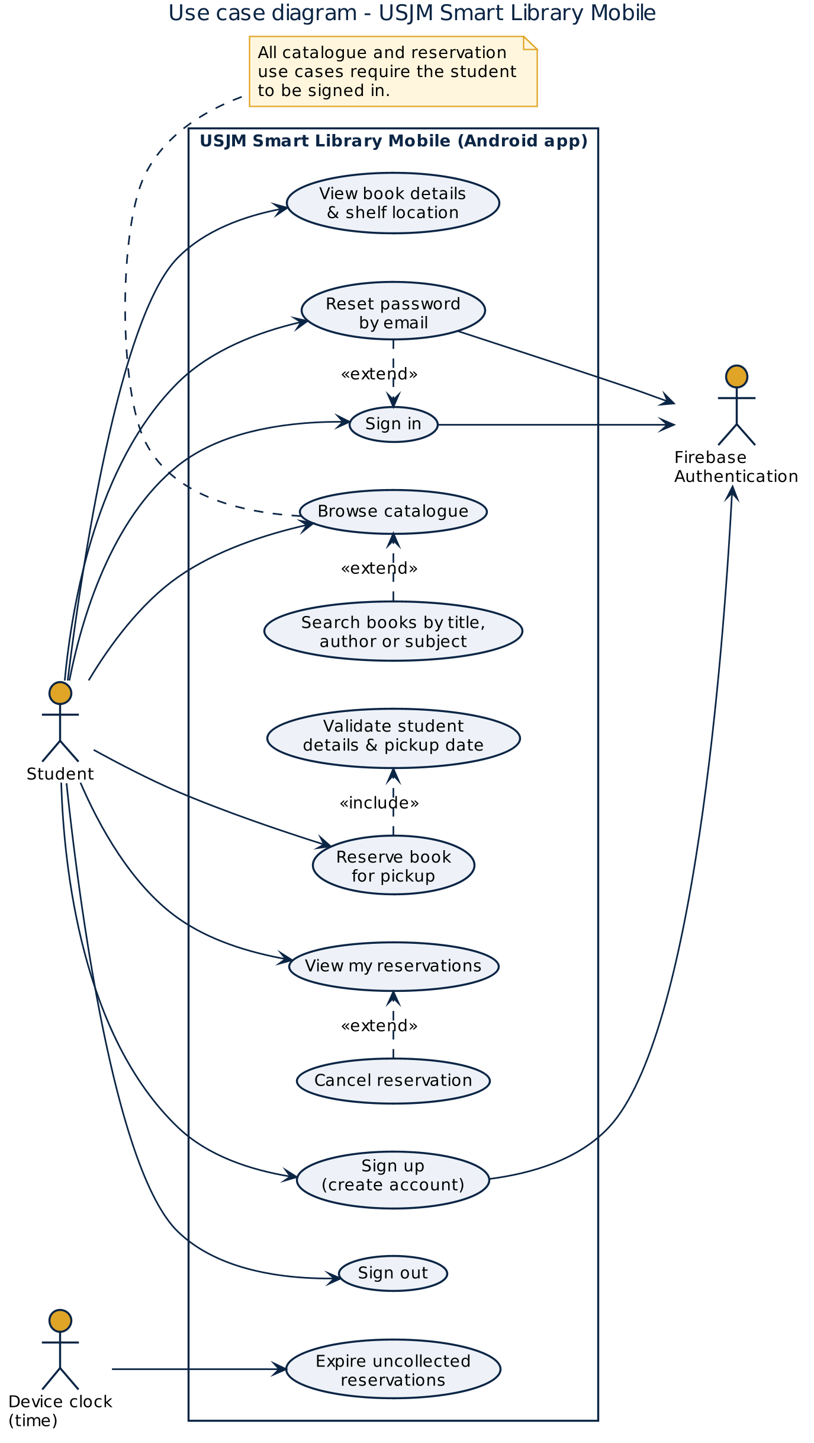
Figure 1: Use case diagram
Use case specification: Reserve book for pickup
Element | Description
Actor | Student
Pre-condition | The student is signed in and has opened the details of a book that has at least one available copy.
Main flow | 1. The student taps "Reserve for pickup".  2. The app shows the form, pre-filled with the signed-in student's name and registration number.  3. The student enters or confirms the name and registration number, and picks a date.  4. The student taps "Confirm reservation".  5. The app validates the fields and checks the library rules.  6. The app saves the reservation, reduces available copies by one, and shows the pickup date, shelf and reservation number.
Alternative flows | 5a. A field is invalid: the app shows the error next to the field and the student corrects it.  5b. A rule is broken (no copy left, a duplicate, or 3 active reservations): the app explains why and saves nothing.
Post-condition | An ACTIVE reservation exists, and the book's available copies have gone down by one.

4.2 Activity diagrams
Figure 2a shows how a student gets into the app: an existing session skips the sign-in screen; otherwise the student signs in, creates an account, or resets a forgotten password by email.
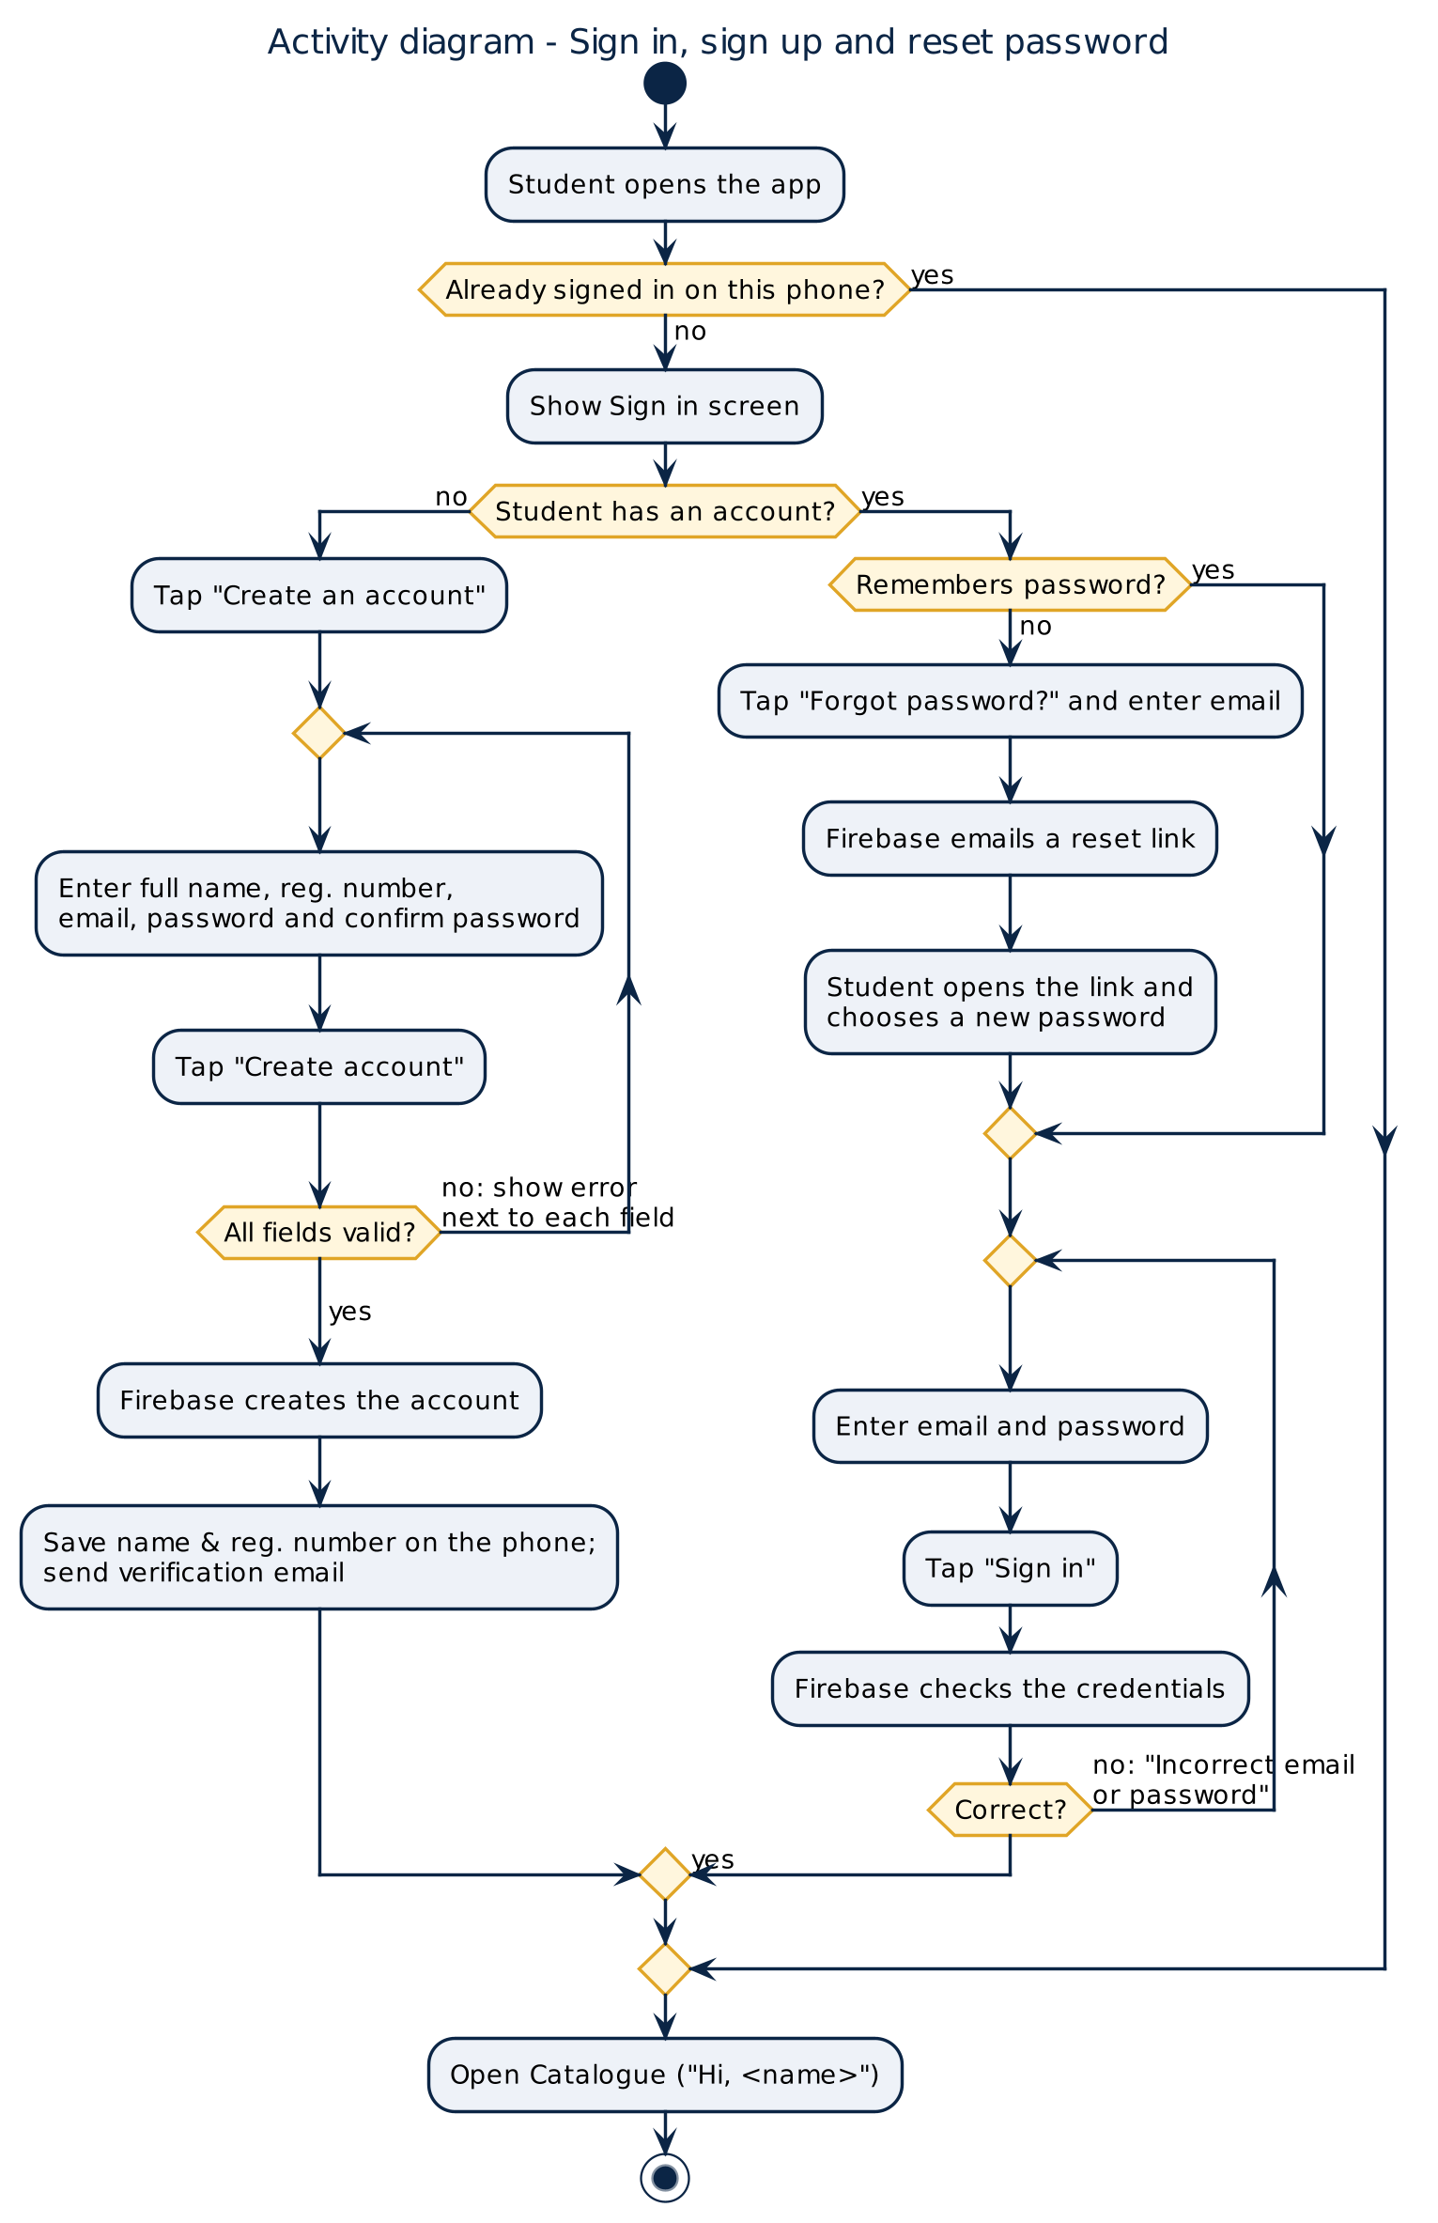
Figure 2a: Activity diagram, sign in, sign up and reset password
Figure 2b shows the reservation process across the student and the app, including the validation loop and the database transaction that either commits or rolls back.
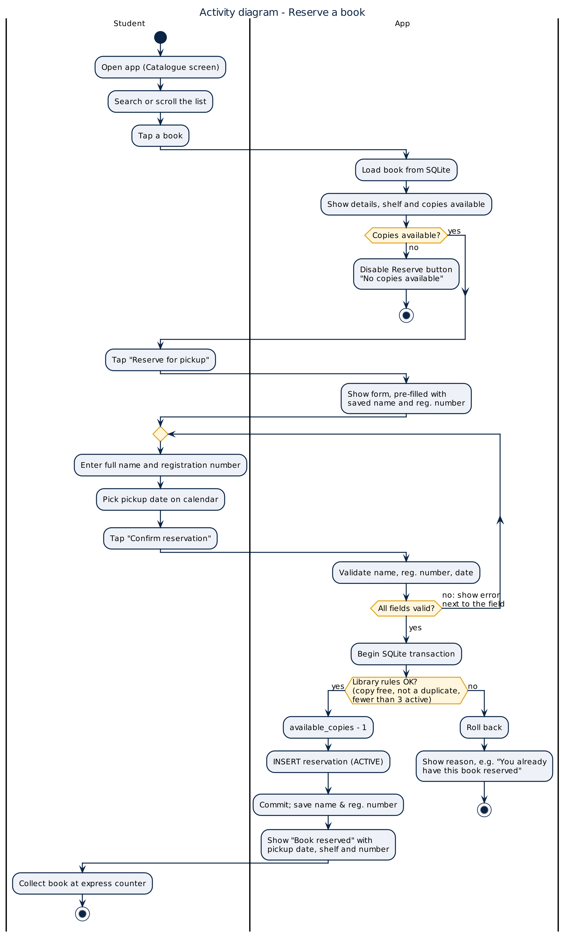
Figure 2b: Activity diagram, reserve a book

4.3 Sequence diagram
Figure 3 shows how the objects in the code work together when the student confirms a reservation: the screen asks the Validator to check the input, then asks the LibraryRepository to save it inside one SQLite transaction.
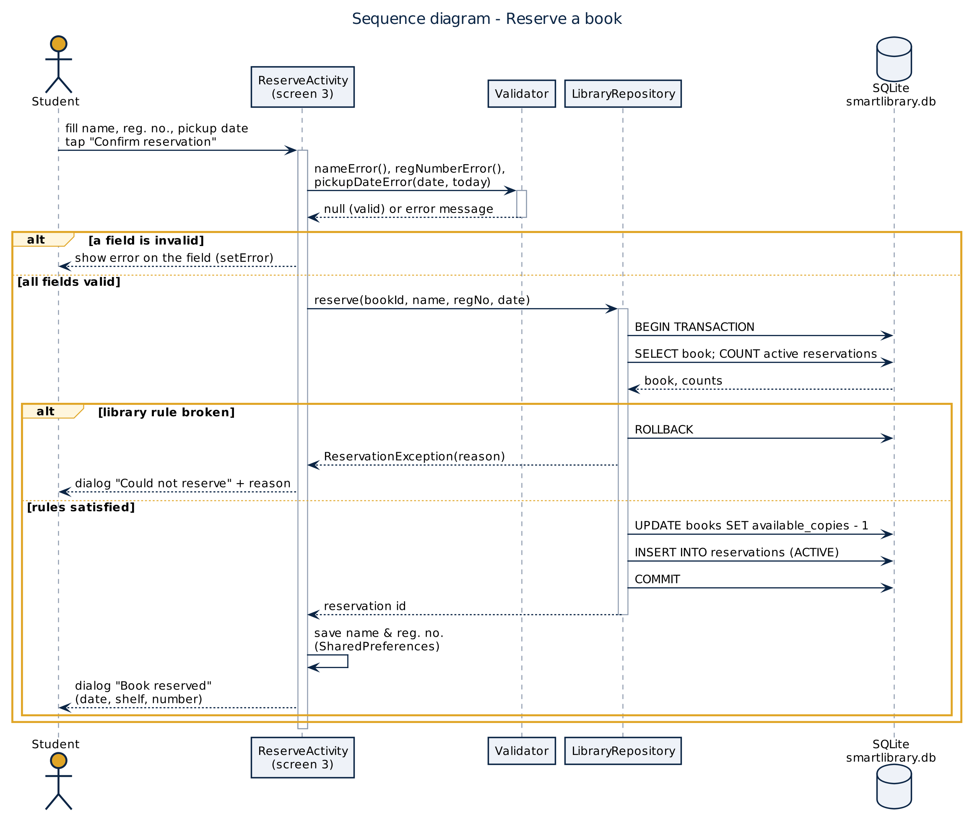
Figure 3: Sequence diagram, reserve a book

4.4 Architecture and database design
The app uses a simple layered architecture. Screens never write SQL; they call the repository, which holds every database query and library rule. This keeps the screens small and makes the rules easy to test and change.
Layer | Classes | Responsibility
Presentation (UI) | LoginActivity, SignUpActivity, ForgotPasswordActivity, MainActivity, BookDetailActivity, ReserveActivity, MyReservationsActivity, BookAdapter, ReservationAdapter, XML layouts | Show data, capture input, navigate with Intents
Accounts | Firebase Authentication; AuthMessages, ProfileStore, PasswordToggle | Sign up, sign in, password reset, sign out; friendly error messages; remember name and registration number
Validation | Validator, DateText | Check form input (names, registration numbers, emails, passwords, dates); plain Java, unit-tested
Data access | LibraryRepository | All queries and library rules; transactions
Storage | LibraryDbHelper → smartlibrary.db (SQLite); SharedPreferences | Create the tables and seed the sample catalogue; remember the student's details

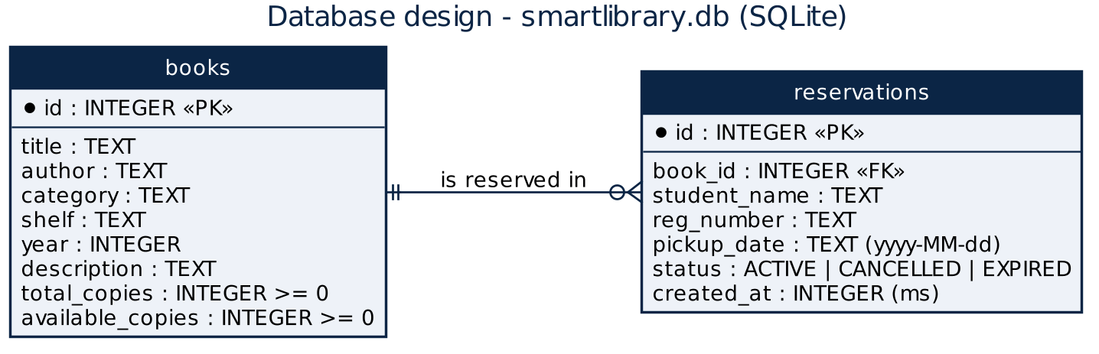
Figure 4: Database design. One book can have many reservations.

4.5 Wireframes
Figures 5a and 5b show low-fidelity wireframes of the account screens and the four library screens, and how the user moves between them. The implemented screens follow these layouts, with the USJM navy and gold colours added.
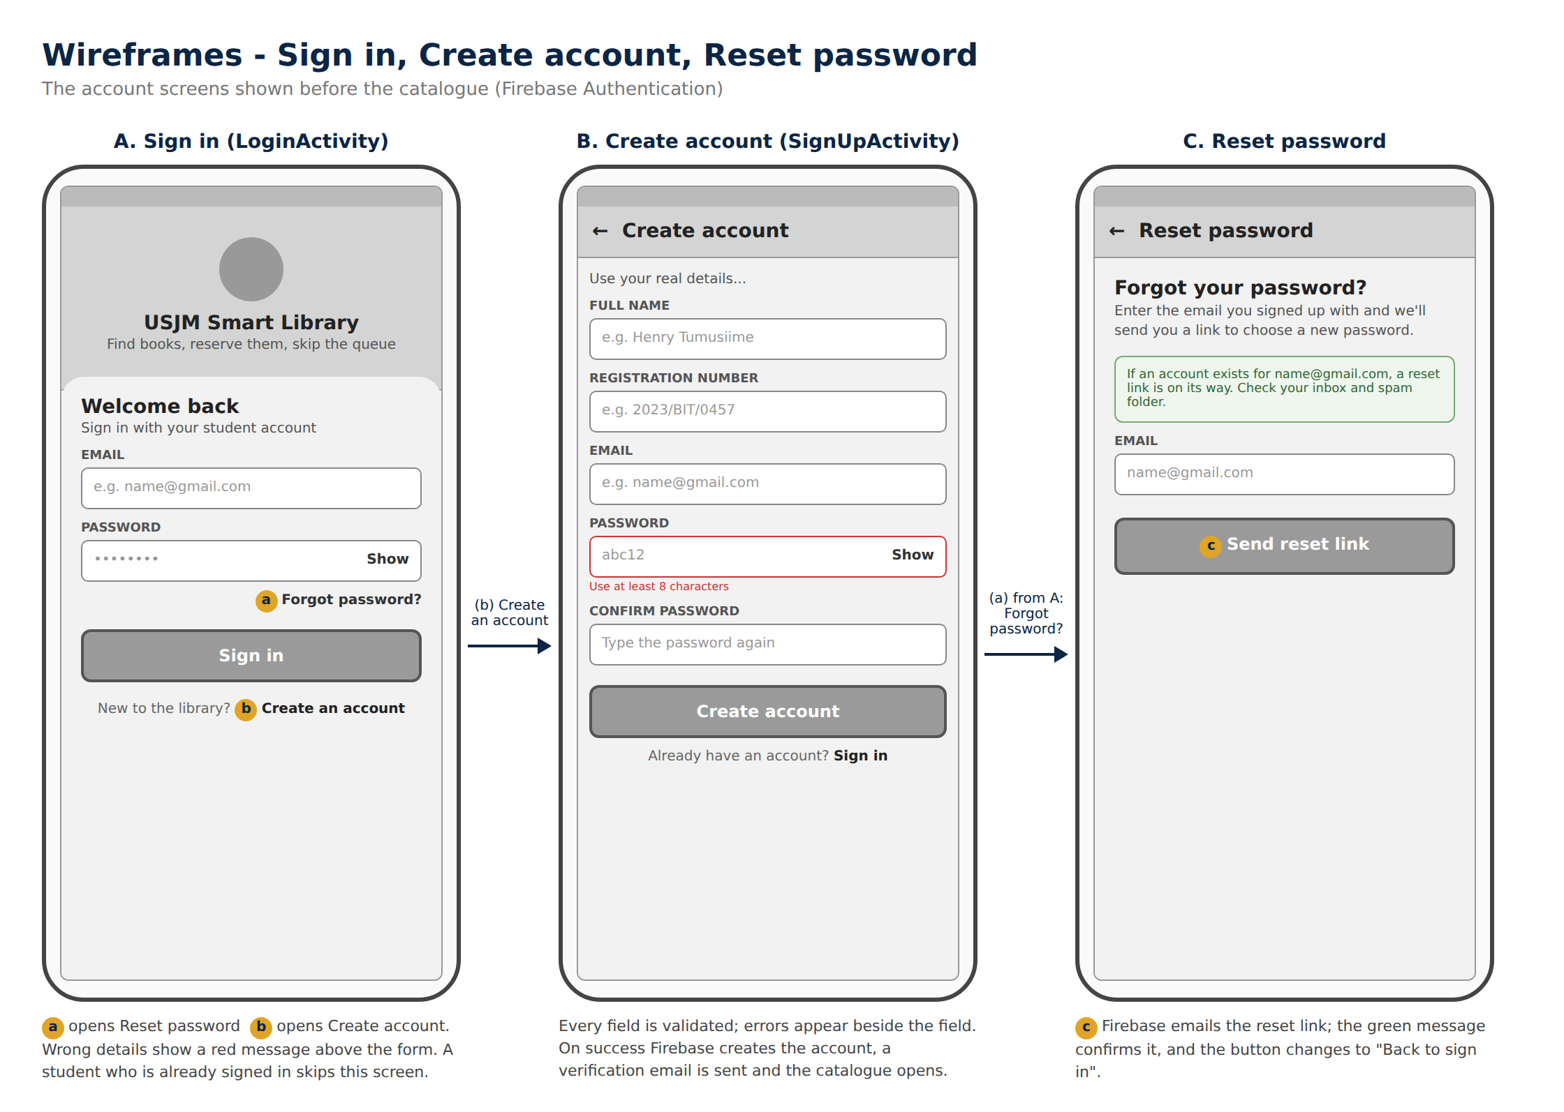
Figure 5a: Wireframes of the account screens. A Sign in, B Create account, C Reset password
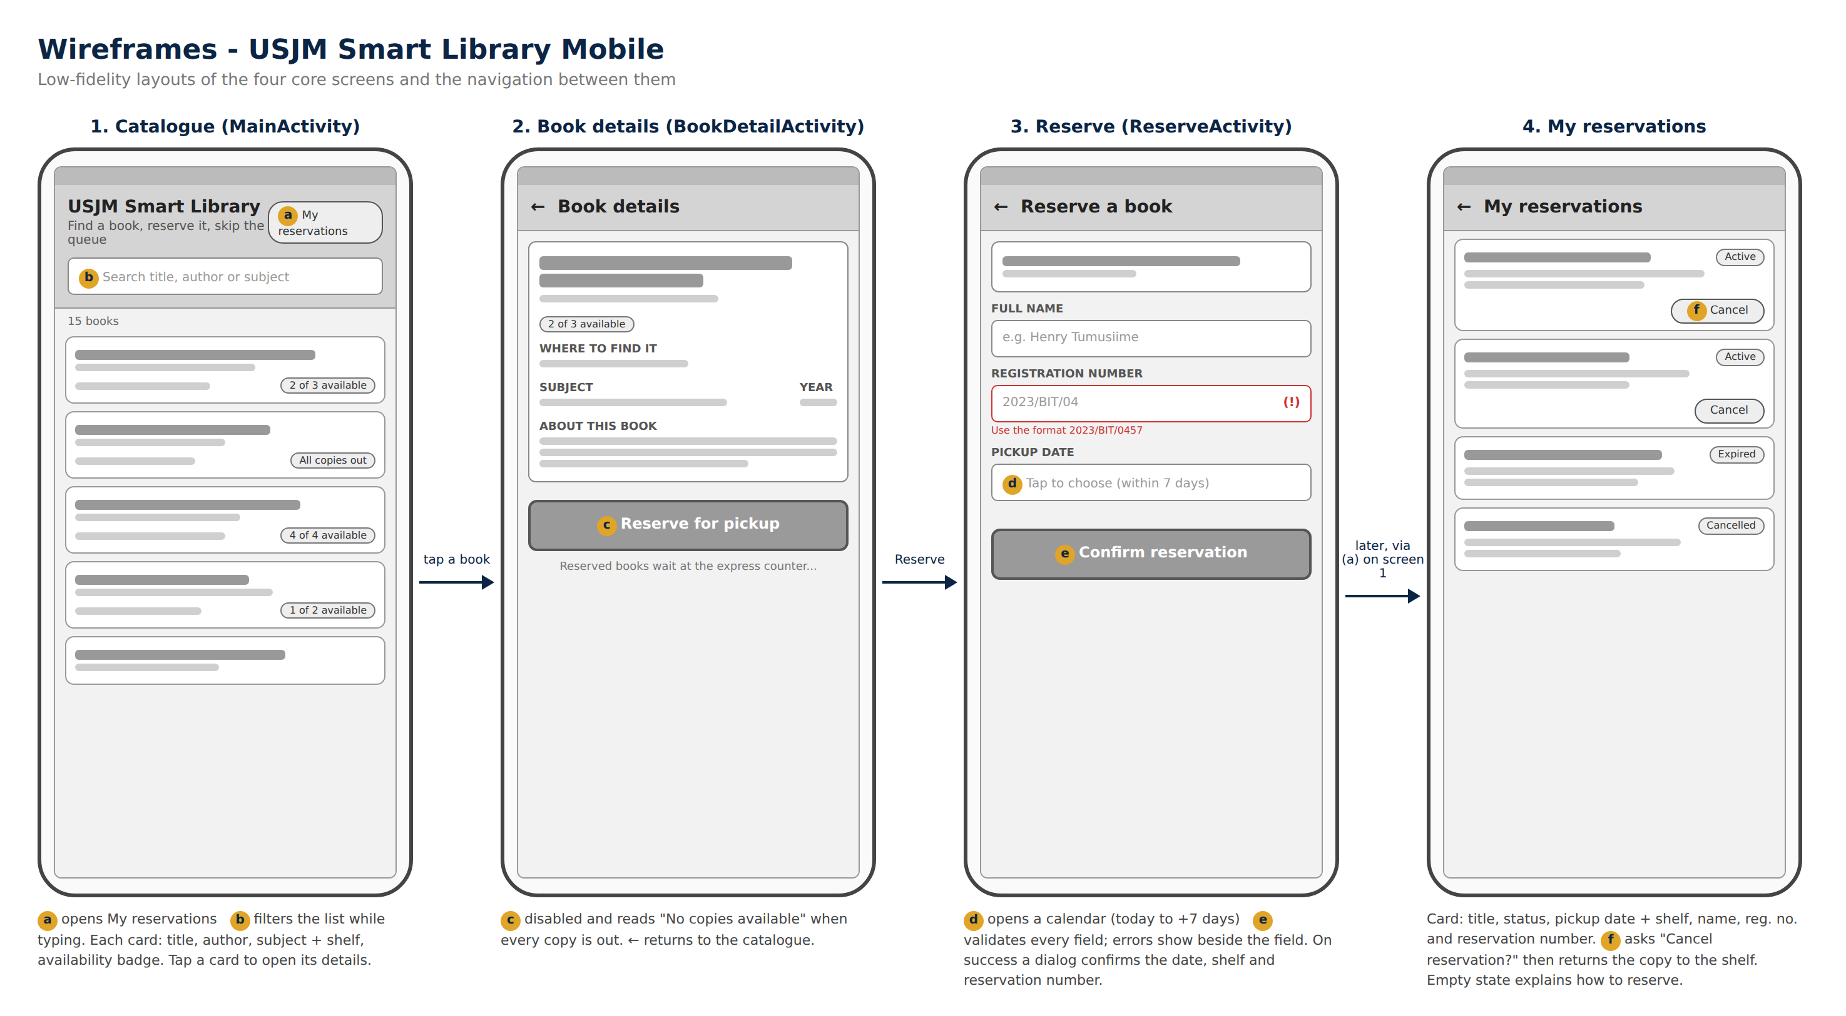
Figure 5b: Wireframes of the library screens. 1 Catalogue, 2 Book details, 3 Reserve, 4 My reservations

5. Working Prototype

5.1 Development environment
Item | Choice
IDE | Android Studio (Empty Views Activity template)
Language | Java
Minimum / target SDK | API 24 (Android 7.0) / the latest SDK installed with Android Studio
UI | XML layouts with AppCompat; ListView with custom adapters; DatePickerDialog; AlertDialog
Accounts | Firebase Authentication (email and password), through the Firebase Android BoM
Storage | SQLite through SQLiteOpenHelper; SharedPreferences
Testing | JUnit 4 (local unit tests); manual testing on an emulator and an Android phone
Version control | Git and GitHub
Design tools | PlantUML for UML diagrams; HTML mock-ups for the wireframes

5.2 Screens implemented
# | Screen | Class / layout | What it does
A | Sign in | LoginActivity / activity_login.xml | Email and password with Show/Hide; links to Forgot password and Create account; skipped when already signed in
B | Create account | SignUpActivity / activity_sign_up.xml | Name, registration number, email, password and confirmation; every field validated; sends a verification email
C | Reset password | ForgotPasswordActivity / activity_forgot_password.xml | Sends a password-reset link to the student's email
1 | Catalogue | MainActivity / activity_main.xml | Greets the student; lists all books from SQLite, searches as the user types, shows availability badges; Sign out
2 | Book details | BookDetailActivity / activity_book_detail.xml | Shows full details; the Reserve button is disabled when no copy is free
3 | Reserve | ReserveActivity / activity_reserve.xml | Validated form with a calendar; saves to SQLite in one transaction
4 | My reservations | MyReservationsActivity / activity_my_reservations.xml | Lists reservations by status; cancel with confirmation

Meeting the mid-semester requirement. The prototype has three account screens and four library screens (two are required). Navigation uses explicit Intents, and the selected book's id is passed as an Intent extra. Working features include sign-up, sign-in and password reset through Firebase Authentication, a screen that displays data from a local source (the catalogue read from SQLite) and a form that saves data (the reservation form).

5.3 Key code
Saving a reservation safely. The repository wraps the rule checks, the copy update and the insert in a single transaction. If any step fails, nothing is saved. This is how requirements FR10, FR11 and NFR3 are met.
public long reserve(long bookId, String name, String regNumber,
String pickupDate)
throws ReservationException {
SQLiteDatabase db = helper.getWritableDatabase();
db.beginTransaction();
try {
Book book = getBook(db, bookId);
if (!book.isAvailable())
throw new ReservationException("All copies ... are out");
if (countActive(db, regNumber, bookId) > 0)
throw new ReservationException("You already have ... this book");
if (countActive(db, regNumber, -1) >= MAX_ACTIVE_RESERVATIONS)
throw new ReservationException("... at most 3 reservations ...");
// take one copy off the shelf, then record the reservation
// take = "UPDATE books SET available_copies = available_copies - 1 ..."
take.bindLong(1, bookId);
take.executeUpdateDelete();
long id = db.insertOrThrow("reservations", null, values);
db.setTransactionSuccessful(); // commit
return id;
} finally {
db.endTransaction(); // rolls back if not marked successful
}
}
Listing 1: LibraryRepository.reserve() (shortened)
Signing in. The sign-in screen checks the fields first, then asks Firebase to verify the email and password. The result arrives in a callback; errors are turned into plain messages by AuthMessages:
auth.signInWithEmailAndPassword(email, password).addOnCompleteListener(this, task -> {
setBusy(false);
if (task.isSuccessful()) {
openCatalogue(); // signed in
} else {
showError(AuthMessages.from(task.getException())); // e.g. "Incorrect email or password."
}
});

// Forgot password: Firebase emails a reset link to the student
FirebaseAuth.getInstance().sendPasswordResetEmail(email).addOnCompleteListener(this, task -> { ... });
Listing 2: LoginActivity and ForgotPasswordActivity (shortened)
Validating input. The form rules are in a plain Java class, so they can be tested without a phone. Each method returns null when the value is valid, or the message to show:
public static String pickupDateError(String pickup, String today) {
if (pickup == null || pickup.trim().isEmpty())
return "Choose a pickup date";
...
if (days < 0) return "The pickup date cannot be in the past";
if (days > MAX_PICKUP_DAYS_AHEAD) return "Choose a date within 7 days";
if (p.get(Calendar.DAY_OF_WEEK) == Calendar.SUNDAY)
return "The library is closed on Sundays";
return null;
}
Listing 3: Validator.pickupDateError() (shortened)
Navigation. Tapping a book in the catalogue starts the details screen and passes the book's id:
Intent i = new Intent(MainActivity.this, BookDetailActivity.class);
i.putExtra(BookDetailActivity.EXTRA_BOOK_ID, id);
startActivity(i);
Listing 4: Passing data between screens

5.4 Screenshots
Run the app and replace each box with a screenshot (Android Studio emulator: camera icon in the side toolbar; phone: Power + Volume down).
[Insert screenshot]  Sign in screen | [Insert screenshot]  Create account showing a validation error
[Insert screenshot]  Reset password: "reset link sent" message | [Insert screenshot]  Screen 1: Catalogue with "Hi, <name>"
[Insert screenshot]  Screen 2: Book details | [Insert screenshot]  The password-reset email in your inbox
[Insert screenshot]  Screen 3: Reserve form showing a validation error | [Insert screenshot]  Screen 4: My reservations
Figure 6: Screenshots of the working prototype

6. Version Control
The project is tracked with Git and published on GitHub as <RegNo>_Tumusiime_AndroidExam, following the required naming format. Work was committed after each milestone, so the history shows the app growing step by step instead of arriving in a single upload.
# | Commit message | What it added | Date
0 | Initial project from Android Studio template | Empty Views Activity project (Java) | date
1 | Catalogue screen: SQLite database, sample books, book list and search | LibraryDbHelper, LibraryRepository, Book, MainActivity, BookAdapter, layouts, theme | date
2 | Login: sign up, sign in and password reset with Firebase Authentication | LoginActivity, SignUpActivity, ForgotPasswordActivity, auth/ helpers, Validator, ValidatorTest, Firebase Gradle setup | date
3 | Book details screen and navigation from the catalogue | BookDetailActivity, its layout, Intent navigation | date
4 | Reservation form with validation, My Reservations, cancel and unit tests | ReserveActivity, MyReservationsActivity, ReservationAdapter, README | date
5 | Add design documents and mid-semester report | docs/ folder: diagrams, wireframes, this report | date

Insert a screenshot of the commit history on GitHub (the "Commits" page), or the output of: git log --oneline

7. Testing at the Mid-Semester Stage

7.1 Unit tests
ValidatorTest (JUnit 4) checks the form rules on the computer, using a fixed "today" (Thursday 1 October 2026) so the results do not depend on the real date. All 20 tests pass.
Test group | What is checked | Result
Name (4 tests) | Full names accepted; empty, single-word and digit-containing names rejected | Pass
Registration number (3 tests) | Valid formats accepted; empty or wrong formats rejected; input trimmed and upper-cased | Pass
Email and password (6 tests) | Valid emails accepted; missing or malformed emails rejected; new passwords need 8+ characters with letters and numbers; confirmation must match; sign-in needs a password | Pass
Pickup date (6 tests) | Today and +7 days accepted; missing, past, more than 7 days ahead, Sunday and impossible dates (30 Feb) rejected | Pass
Date format (1 test) | Calendar month 0 is stored as January (2026-01-05) | Pass

7.2 Manual test cases
Run each case on the emulator or your phone and fill in the Result column.
ID | Steps | Expected result | Result
TC1 | Create an account with valid details | Catalogue opens with "Hi, <first name>"; a verification email arrives | Pass/Fail
TC2 | Create an account with password "abc12" | Error "Use at least 8 characters"; no account created | Pass/Fail
TC3 | Sign up again with the same email | "An account with this email already exists. Sign in instead." | Pass/Fail
TC4 | Sign in with a wrong password | "Incorrect email or password."; stays on Sign in | Pass/Fail
TC5 | Forgot password: enter your email, tap Send reset link | Green "reset link is on its way" message; the email arrives; the new password works | Pass/Fail
TC6 | Close and reopen the app while signed in | Opens straight to the catalogue (no sign-in needed) | Pass/Fail
TC7 | Sign out, then reopen the app | The Sign in screen is shown | Pass/Fail
TC8 | Sign in with mobile data and Wi-Fi off | "No internet connection…" message | Pass/Fail
TC9 | Open the catalogue | The catalogue shows 15 books with availability badges | Pass/Fail
TC10 | Type "network" in the search box | Only the two networking books remain | Pass/Fail
TC11 | Tap a book | The details screen shows the same book's shelf and copies | Pass/Fail
TC12 | Reserve with a valid name, registration number and date | A "Book reserved" dialog appears; the copy count drops by 1 | Pass/Fail
TC13 | Enter registration number "BIT-2023" | Error "Use the format 2023/BIT/0457"; nothing is saved | Pass/Fail
TC14 | Reserve the same book again | "You already have an active reservation for this book" | Pass/Fail
TC15 | Make a fourth active reservation | Refused: "at most 3 reservations at a time" | Pass/Fail
TC16 | Cancel a reservation in My reservations | Status becomes Cancelled; the copy count goes back up | Pass/Fail
TC17 | Close and reopen the app | Reservations are still there (persistent storage) | Pass/Fail

8. Demo Plan (3–5 minutes)
Time | What to show and say
0:00–0:30 | The problem: queues at the desk and low awareness of the catalogue. The users: USJM students.
0:30–1:30 | Accounts: show a sign-up error (weak password), create an account, sign out, sign in. Tap "Forgot password?" and show the reset email arriving.
1:30–2:00 | Catalogue: point out "Hi, <name>", scroll, search "java", and point out the availability badges. Explain that the data comes from SQLite on the phone.
2:00–2:20 | Tap a book to show navigation to the details screen. Show the shelf location and a book with "No copies available" (Reserve is disabled).
2:20–3:20 | Reserve: submit an empty form to show the errors, enter a wrong registration number, then a valid one, and pick a date. Show the success dialog.
3:20–4:00 | My reservations: show the new reservation, cancel one, and show that the copy count goes back up. Try a duplicate reservation to show the rule.
4:00–4:40 | Design choices: Firebase for accounts, the layered architecture, transactions, and validation in a testable class. Run ValidatorTest to show all tests passing.
4:40–5:00 | Next steps: API sync with the web system, notifications, and the QR scanner.

Plan for the final stage
Week | Work
1–2 | REST API client to sync the catalogue and reservations with the Smart Library web system; SQLite stays as the offline cache
3 | Pickup reminder notifications; QR-code scanner to open a book's details
4 | Usability review against Android design guidelines; accessibility checks; error handling for network failures
5 | Full test plan (unit and instrumented tests); signed release APK
6 | Final report, README, declaration of originality and submission

9. Tools, Sources and Acknowledgements
- Android Studio, the Android SDK and AndroidX AppCompat (Google); SQLite; Firebase Authentication (Google).
- PlantUML (diagrams); Git and GitHub (version control).
- The sample catalogue lists real published books (titles and authors only), used as test data.
- An AI assistant (Claude, by Anthropic) was used to help draft parts of the code, diagrams and this report. I have reviewed, run and tested all of it, and I can explain every part. Check your lecturer's policy on AI tools and keep or adjust this statement.

References
Android Developers. (n.d.). Save data using SQLite. Retrieved October 2026, from https://developer.android.com/training/data-storage/sqlite
Android Developers. (n.d.). Introduction to activities. Retrieved October 2026, from https://developer.android.com/guide/components/activities/intro-activities
Firebase. (n.d.). Authenticate with Firebase using password-based accounts on Android. Retrieved October 2026, from https://firebase.google.com/docs/auth/android/password-auth
Fowler, M. (2004). UML distilled: A brief guide to the standard object modeling language (3rd ed.). Addison-Wesley.
Sommerville, I. (2016). Software engineering (10th ed.). Pearson.

