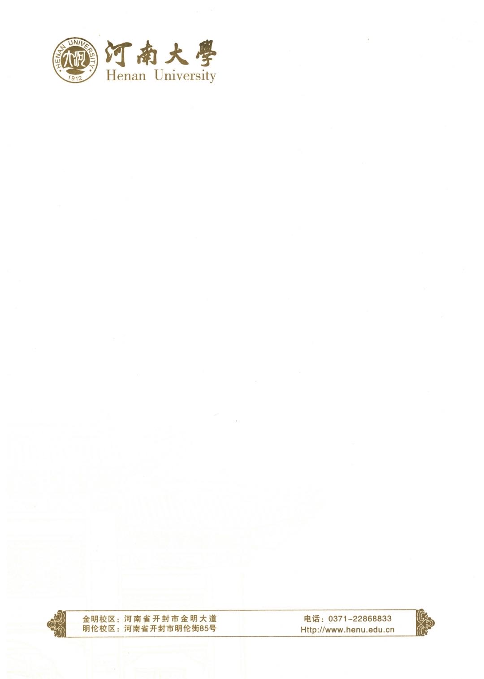

**证 明**

兹证明河小南 (学号：xxxxxxxxxx), 男，出生于xxxx年xx月xx日，自2020年9月起在河南大学国际商学院计算机科学与技术专业学习。目前x个学期成绩平均分为80.xx分。我院采用百分制记分体制。

特此证明

河南大学教务处

2023年xx月xx日

# **Certificate**

This is to certify that He Xiaonan (Student No.: xxxxxxxxxx), male, born on January 10, 2000, has been studying Computer Science and Technology in xx School of Henan University from September 2020. His current average score of the first six semester is 80.xx and our adopts 100-points scoring system.

Certified

Academic Affairs Office of Henan University

October 12, 2023