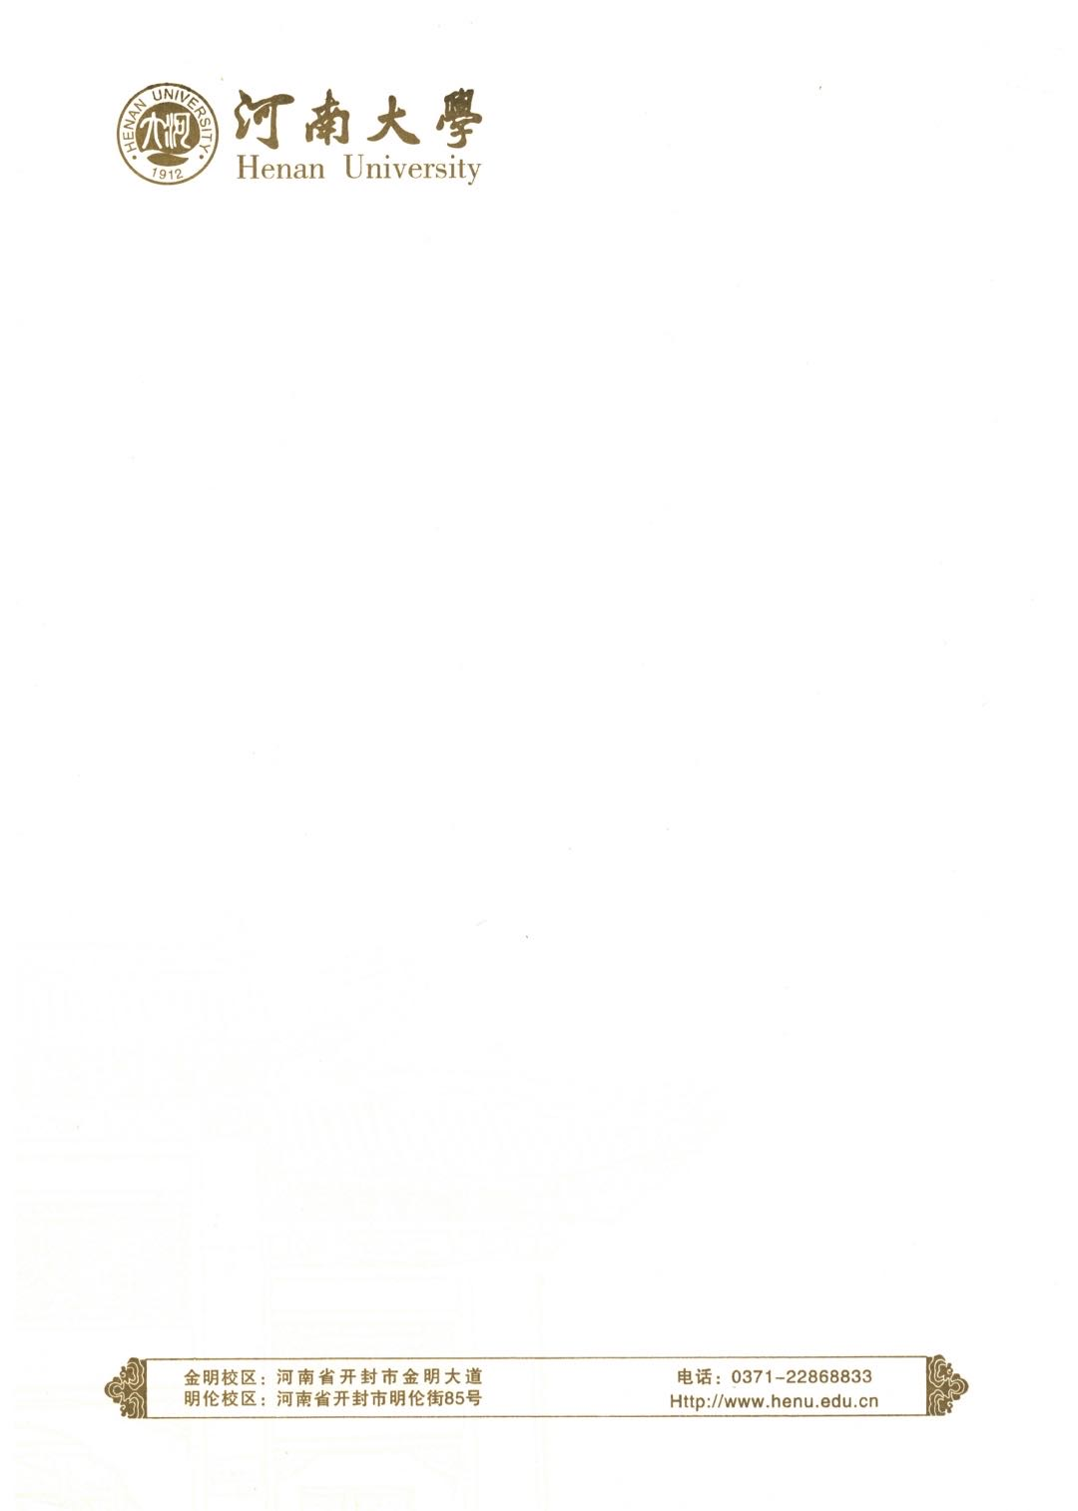

均分证明

河小南，男，学号xxxxxxxxxx，系xx学院2020级计算机科学与技术专业学生。根据该生河南大学学生中英文成绩单，其前八学期所修本科课程成绩算术平均分为80.xx/100.

特此证明

附：此证明上均分基于学生提供的河南大学学生中英文成绩单上全部课程，采用算术平均分算法进行计算，证明此原则和计算下的均分无误。

算数平均分算法为：算数平均分=所修全部课程百分制成绩之和/所修全部课程数。

河南大学教务处

2024年6月11日

Certificate of Arithmetic Average Score

It is hereby certified that He Xiaonan, male, Student No. xxxxxxxxxx, is enrolled at xx School in the major of Computer Science and Technology. According to the Henan University Student's Transcript, the arithmetic average score of the 8 semesters undergraduate courses of Fang Sen is 80.xx/100.

Hereby certify

Note: The arithmetic average of this certificate is based on all the courses appeared on the Henan University Student's Transcript, using the method of arithmetic average to prove the correctness of the arithmetic average.

The method of arithmetic average:

Arithmetic average=Sum of scores in percentage system of the courses taken/Sum of courses taken.

Academic Affairs Office of Henan University

June 11, 2024