Cohort Comparison between OMOP and Raw
Source of Data | Count of subjects
OMOP Cohort | 23386
Raw Cohort | 25138

From the counts above:
Subjects in both OMOP and Raw | 23,099
Subjects only in OMOP | 287
Subjects only in Raw | 2,039

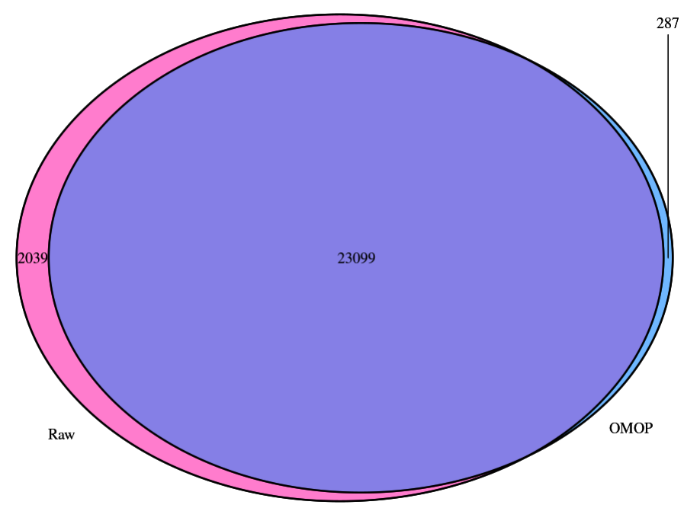
From Antonella: one reason could be that some patients have more than one patid in raw, but then when they are mapped in OMOP (and linked with HES), only one (the last) of their patid is maintained. So, this could explain why 685 patients in raw are not found in OMOP. in omop-hes only the last patid is mantained for the same patient. So, if someone has more than one patid in aurum only the last one is maintained.

Compare cohort/aurum start and end dates
Dataset | Variable | Min | Q1 | Median | Mean | Q3 | Max
OMOP | Cohort start date | 02-07-1910 | 22-03-1984 | 20-05-1993 | 08-04-1991 | 14-05-2003 | 19-02-2016
Raw | Aurum min accept date | 02-07-1910 | 11-05-1984 | 30-06-1993 | 26-04-1991 | 30-06-2023 | 19-02-2016
OMOP | Cohort end date | 28-04-2012 | 28-11-2018 | 17-03-2022 | 06-01-2020 | 17-03-2022 | 21-03-2022
Raw | Aurum max accept date | 28-04-2012 | 05-10-2018 | 17-03-2022 | 03-05-2020 | 17-03-2022 | 21-03-2022

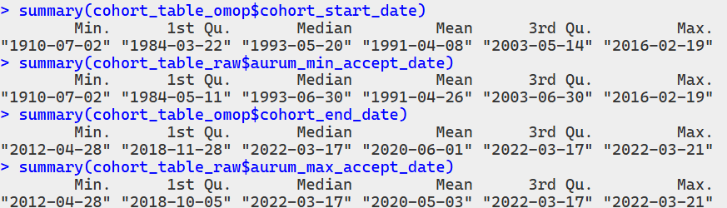

Below is done on the 23,099 patients who overlapped between OMOP and Raw
Compare cohort/aurum start and end dates
Dataset | Variable | Min | Q1 | Median | Mean | Q3 | Max
OMOP | Cohort start date | 02-07-1910 | 11-05-1984 | 30-06-1993 | 04-05-1991 | 21-06-2003 | 19-02-2016
Raw | Aurum min accept date | 02-07-1910 | 11-05-1984 | 30-06-1993 | 04-05-1991 | 21-06-2003 | 19-02-2016
OMOP | Cohort end date | 28-04-2012 | 05-12-2018 | 17-03-2022 | 03-06-2020 | 17-03-2022 | 21-03-2022
Raw | Aurum max accept date | 28-04-2012 | 05-12-2018 | 17-03-2022 | 03-06-2020 | 17-03-2022 | 21-03-2022

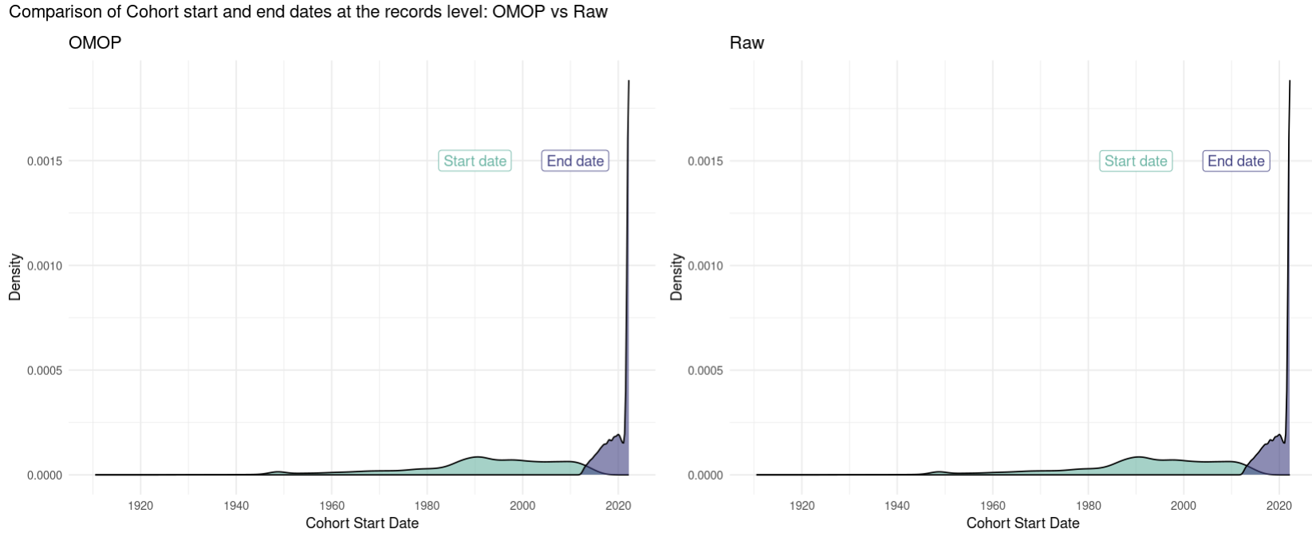
Comparing the age of fracture
Out of the 23,099, how many patients have the different fracture dates, different ages but with the same fracture site: 12 (0.051%)
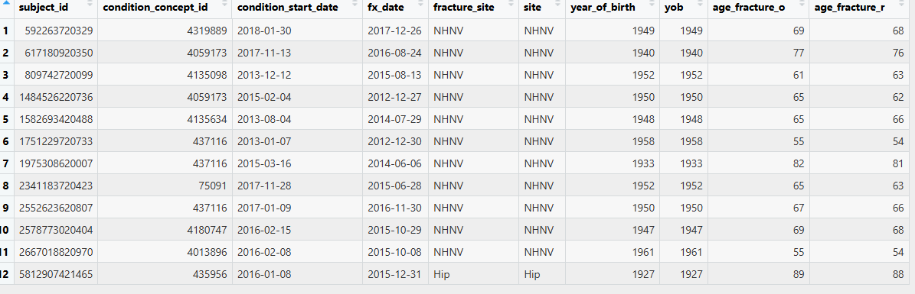
Out of the 23,099, how many patients have the same fracture site but with different ages: 12 (0.051%)
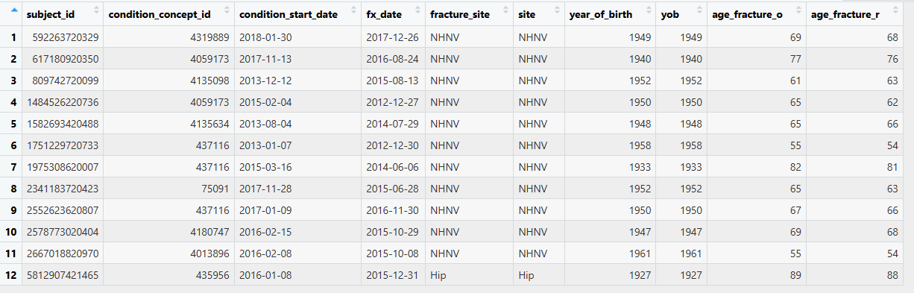
Out of the 23,099, how many patients have the different fracture sites with different: 11 (0.048%)

