Compare the number of patients
I begin with both datasets in long format (fracture tables). The size of the circle is equivalent to the number of fractures (i.e., records). I see an overlap of 30, 532 patients in both OMOP and raw. Patients only in OMOP are 153, 776 with 671, 907 records while those only in Raw are 685 with 27085.
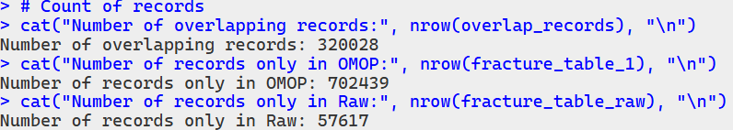
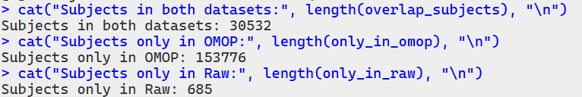

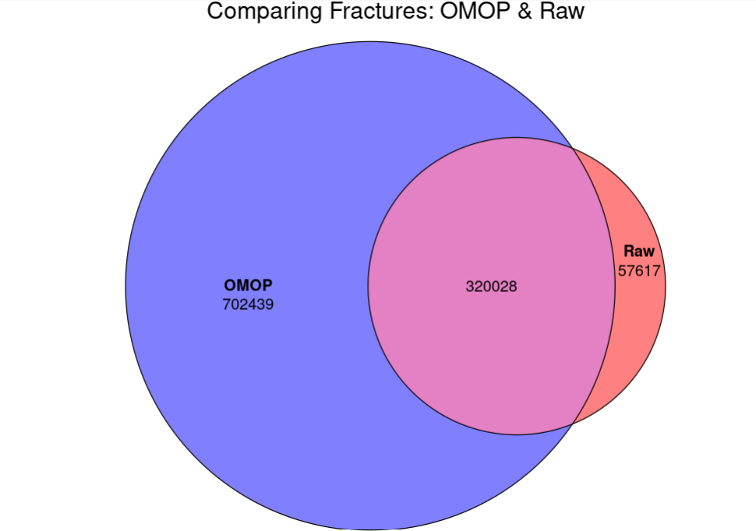
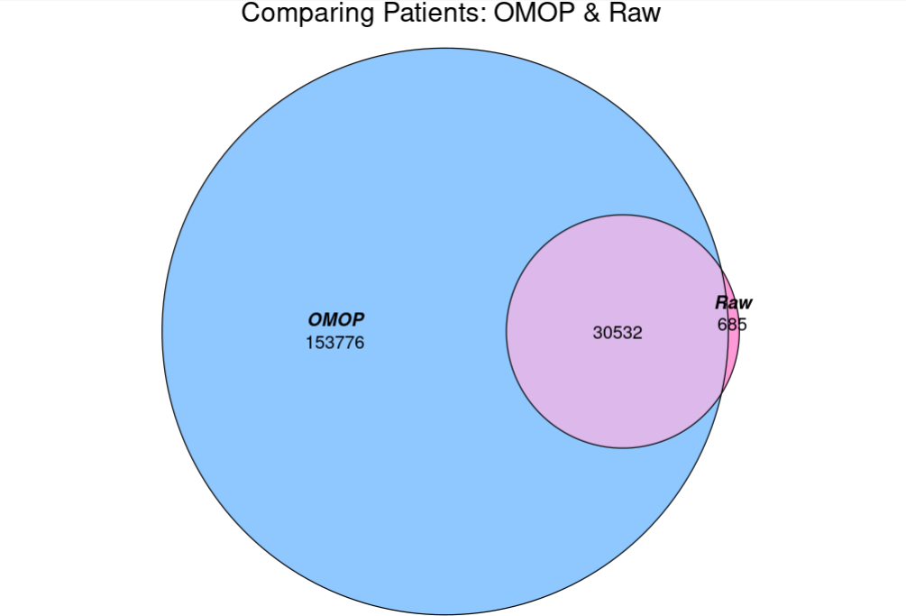

From Antonella: one reason could be that some patients have more than one patid in raw, but then when they are mapped in OMOP (and linked with HES), only one (the last) of their patid is maintained. So, this could explain why 685 patients in raw are not found in OMOP. in omop-hes only the last patid is mantained for the same patient. So, if someone has more than one patid in aurum only the last one is maintained.

Below is done on the 30,532 patients who overlapped between OMOP and Raw
Compare cohort/aurum start and end dates
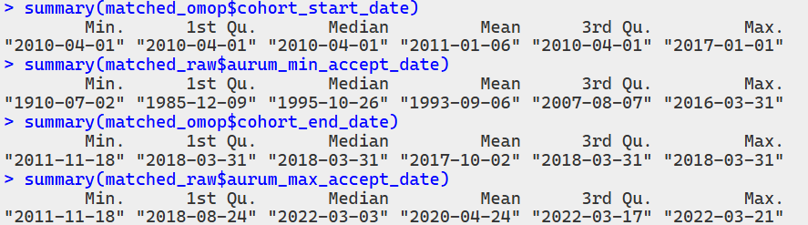

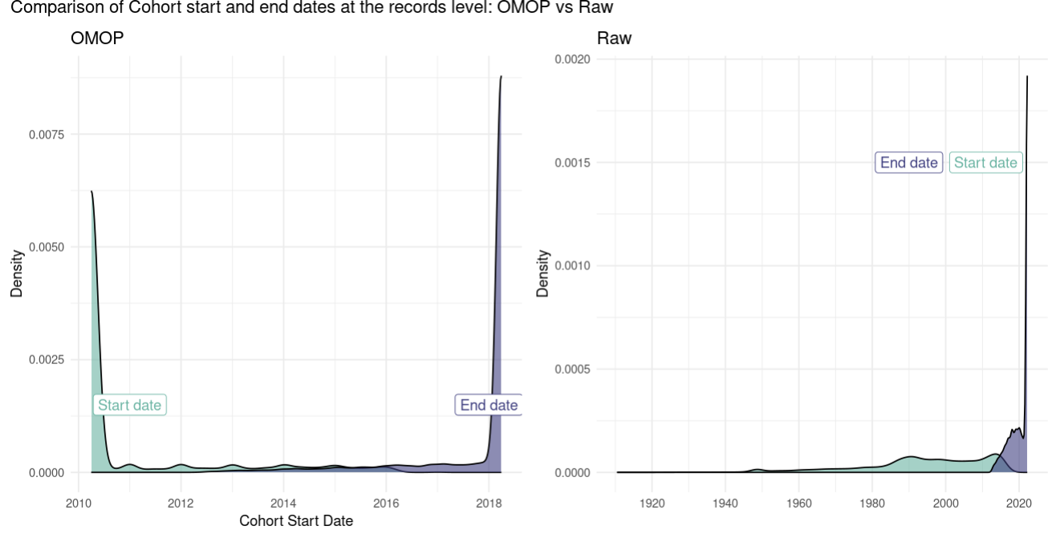

Comparing the age of fracture
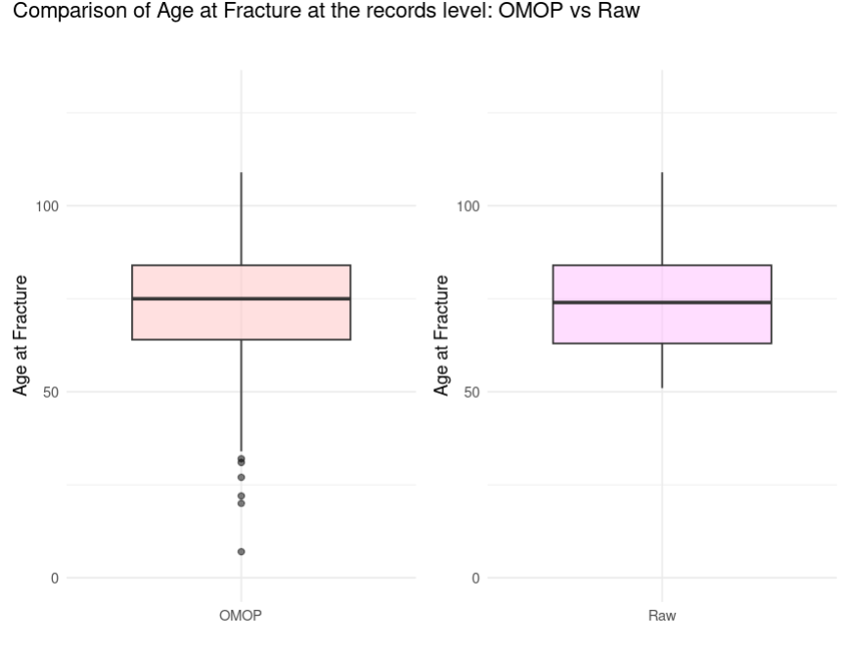
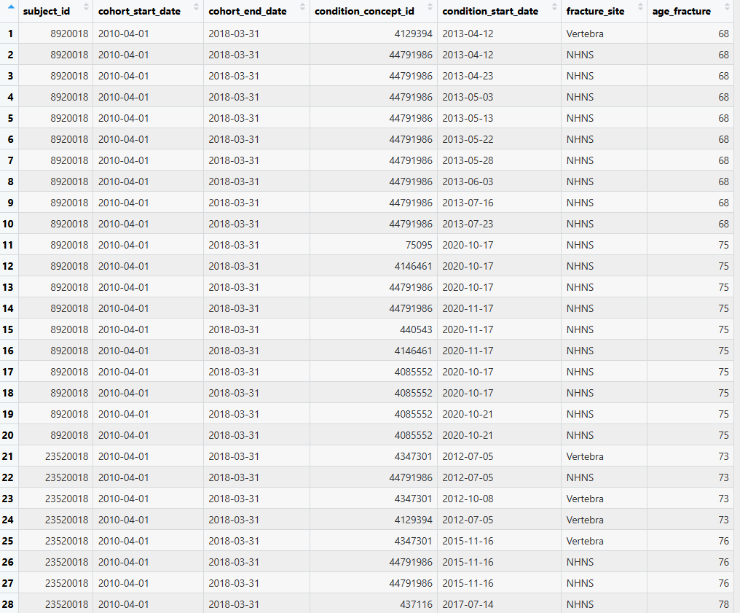
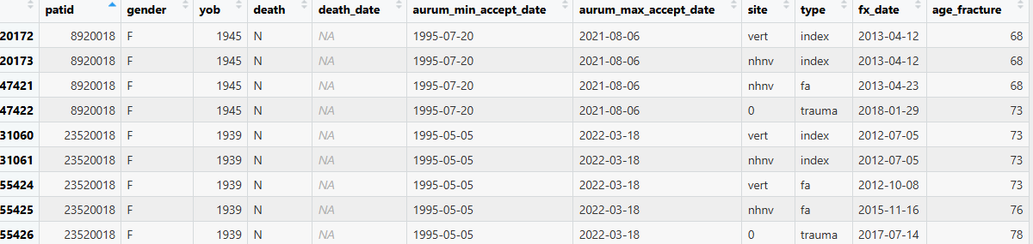
Similar median and IQR: Both datasets have similar distributions of fracture ages.
OMOP has more outliers: There are more extremely low fracture ages in OMOP, suggesting possible errors or more granular data capture.
Slightly wider range in OMOP: The whiskers extend further, indicating OMOP may include more extreme values.
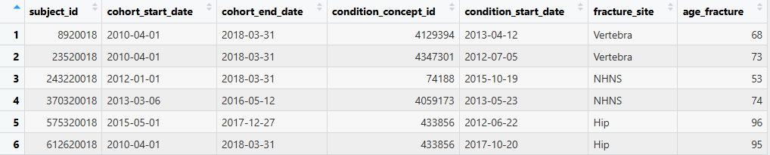
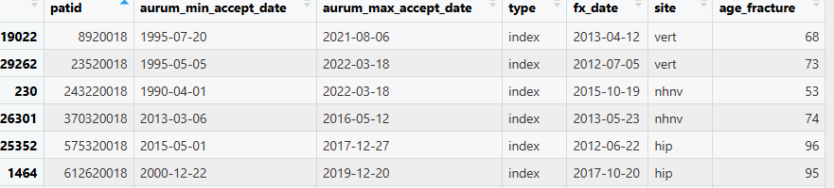
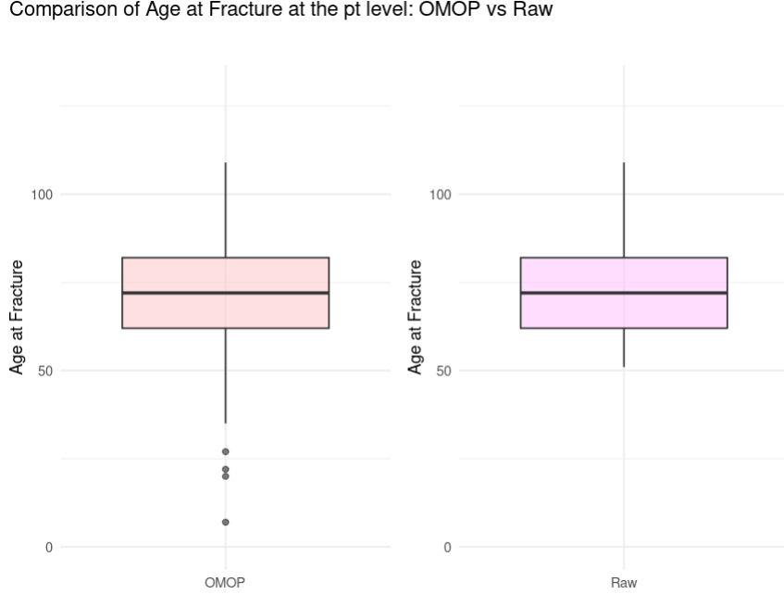
Filtering where condition_start_date == fx_date, then checking where age_fracture in OMOP and age_fracture in Raw where they are not the same, no patient in the overlap records dataset appears: 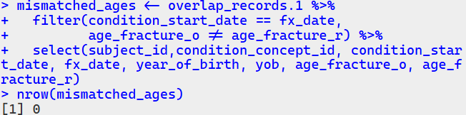
Compare the death date
