Differences between OMOP and RAW

Cleaning Fractures
Attrition Report for cleaning fractures:
OMOP: 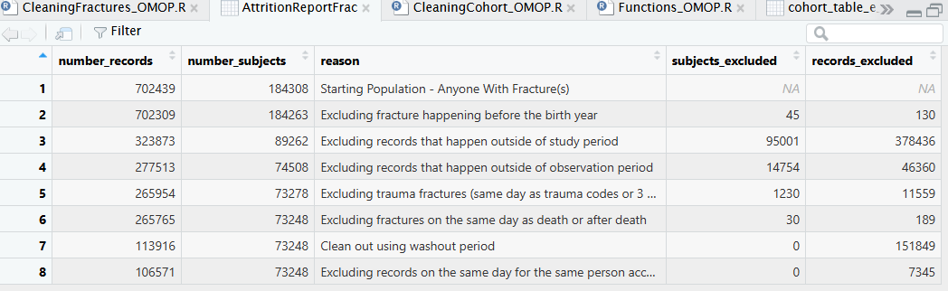
Raw: 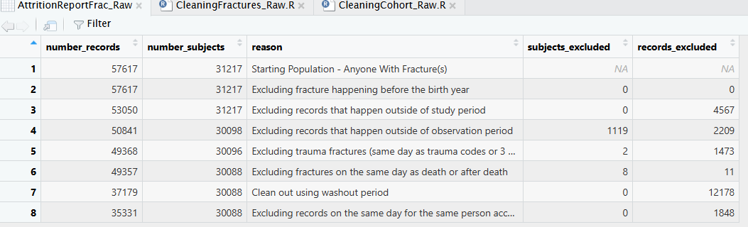
- Original data:
  - Some patients are not existing in the raw and they are present in OMOP data:
    - 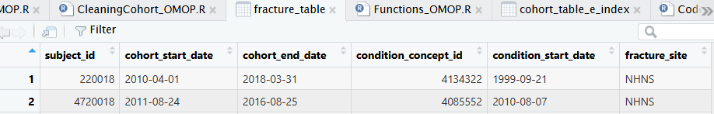
    - 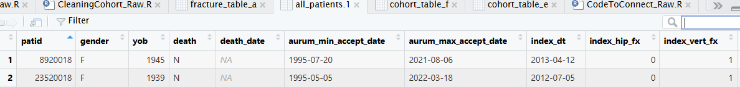
- Fracture table a
  - Similar records but more fractures in OMOP than Raw:
    - 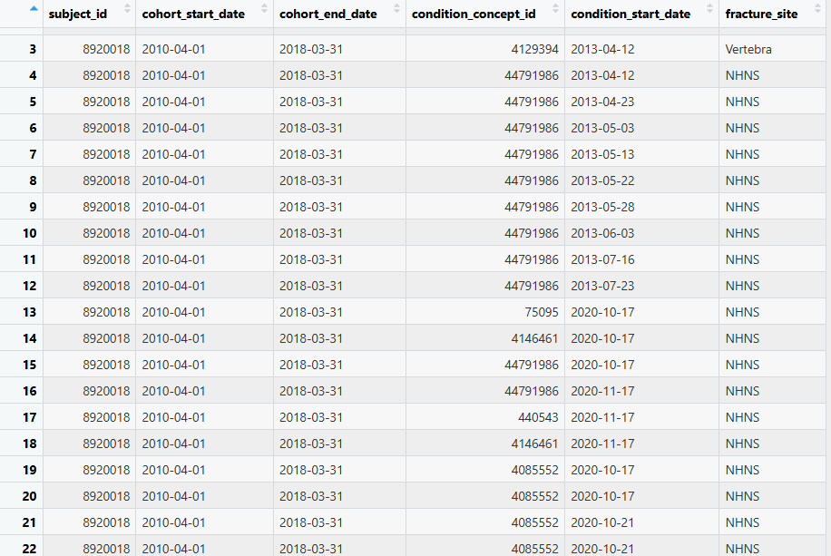
    - 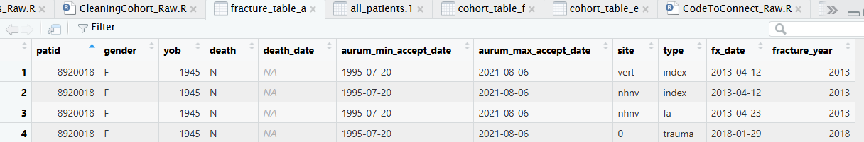
- Fracture table b:
  - More patients in OMOP than in Raw:
    - 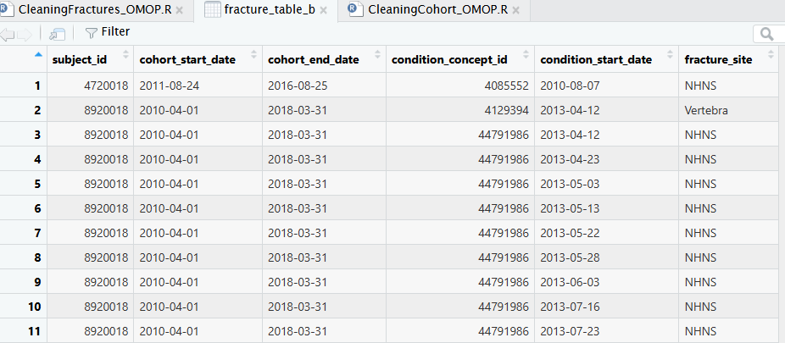
    - 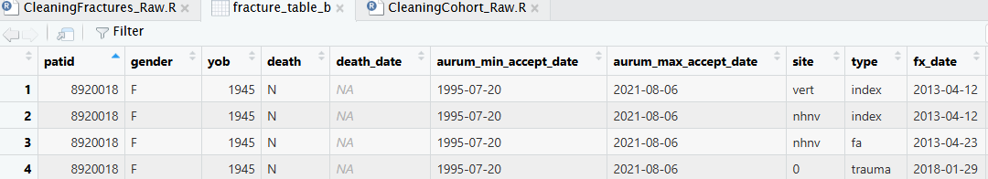
- Fracture table c:
  - More patients in OMOP than in Raw:
    - 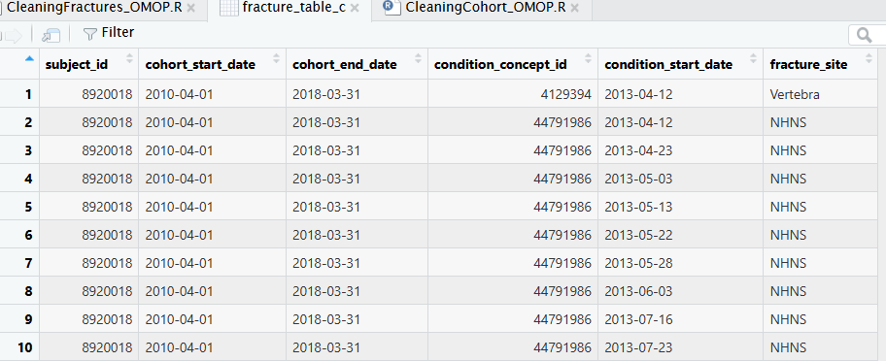
    - 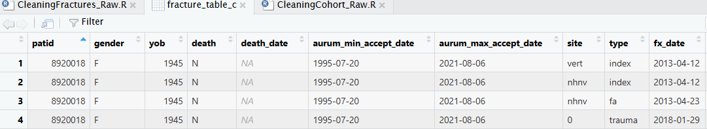
- Fracture table d:
  - More patients in OMOP than in Raw:
    - 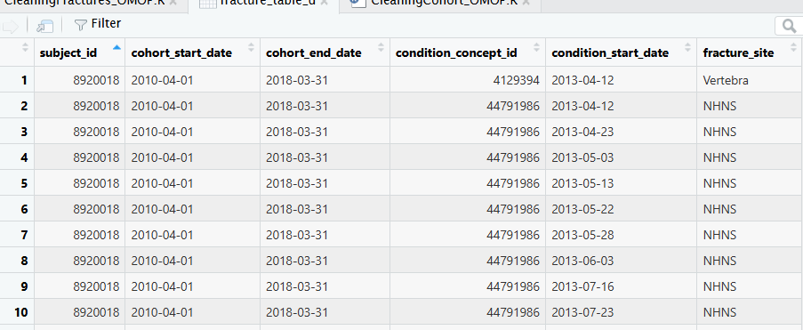
    - 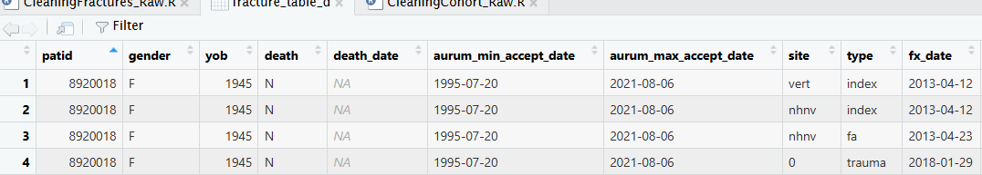
- Fracture table e:
  - More patients in OMOP than in Raw:
    - 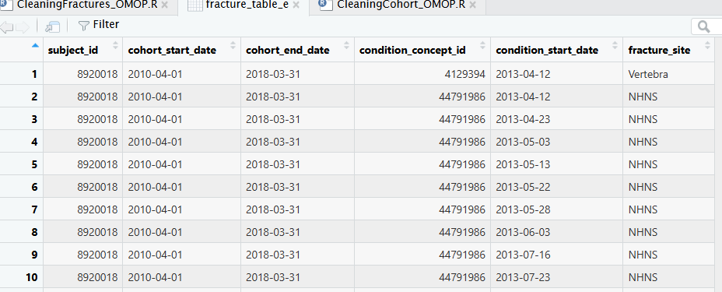
    - 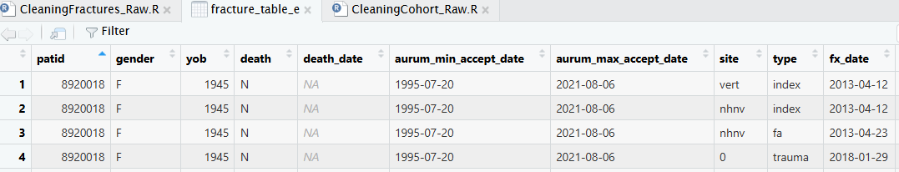
- Fracture table f:
  - More patients in OMOP than in Raw:
    - 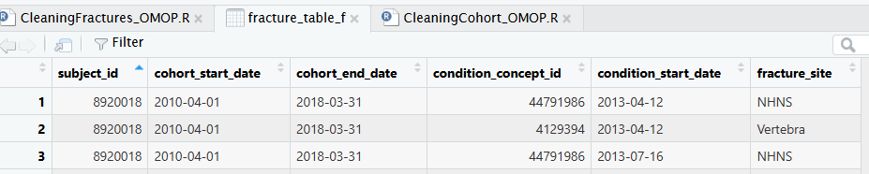
    - 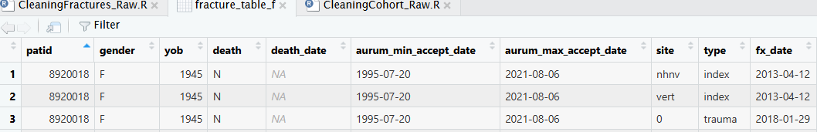
- Fracture table f:
  - More patients in OMOP than in Raw.
  - In the “Applying Hierarchy (hip, vertebra, NHNV) to multiple records on the same day” step, in Raw analysis, for this patient for example the site is Vertebral while in OMOP, NHNS is the site. Arranging the data by site, for some reason R is filtering to have vertebral instead of nhnv.
    - 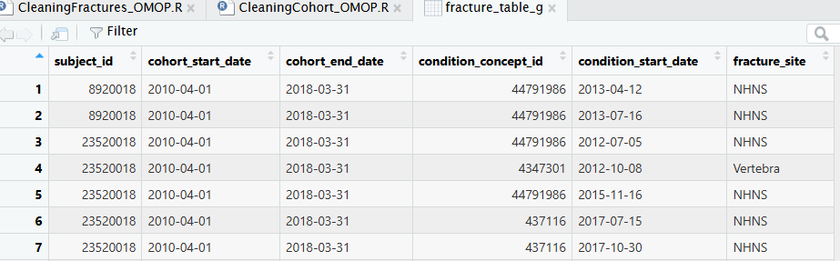
    - 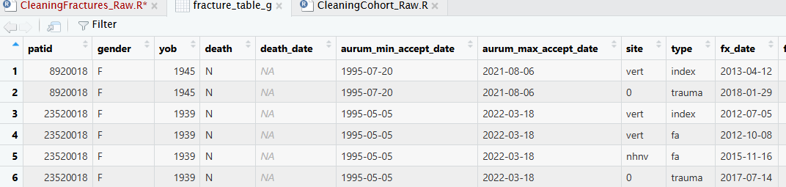
  - But after removing the arranging by site, the index date for OMOP and Raw have the same site.
    - 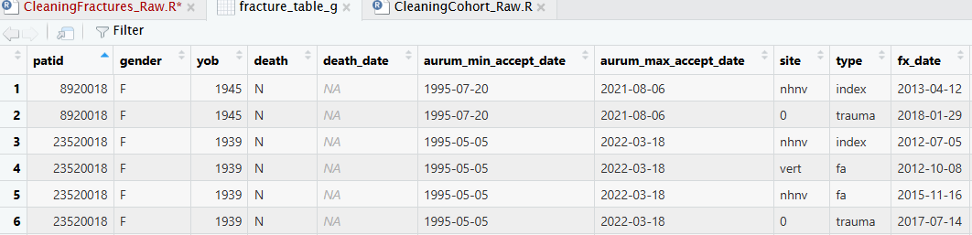

Cleaning Cohort
Attrition Report for cleaning fractures:
OMOP: 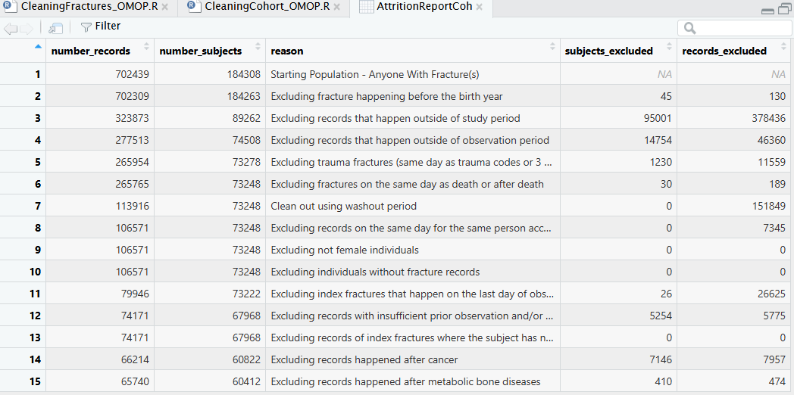
Raw: 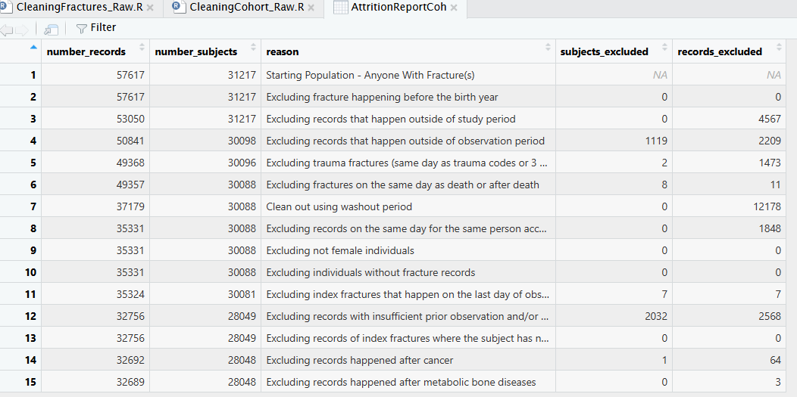
- Original data:
  - More patients in OMOP than in Raw:
    - 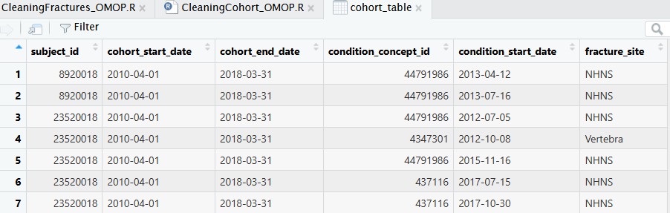
    - 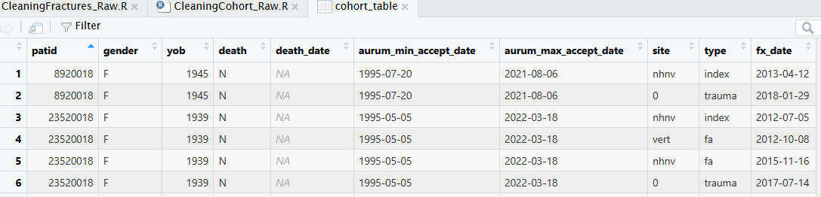
- Cohort table a
  - Similar records but more fractures in OMOP than Raw:
    - 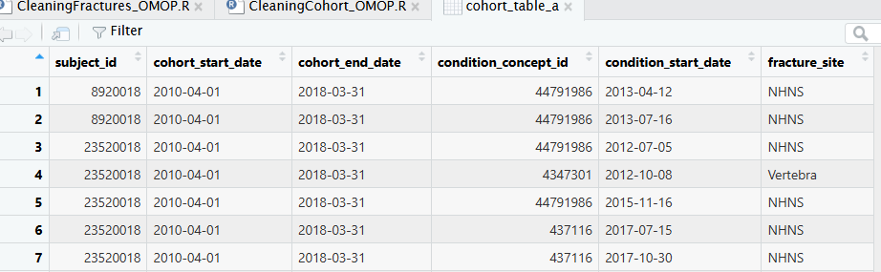
    - 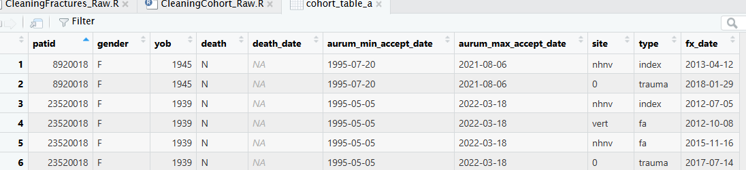
- Cohort table a
  - Similar records but more fractures in OMOP than Raw:
    - 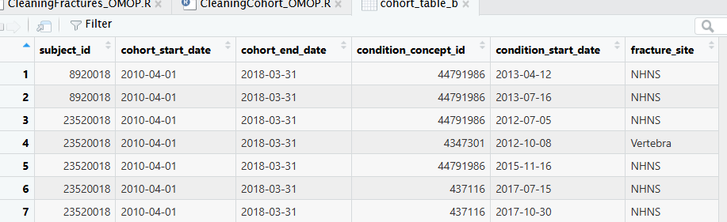
    - 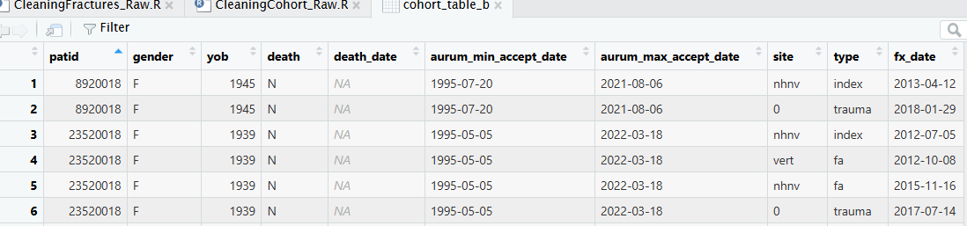
- Cohort table b
  - Similar records but more fractures in OMOP than Raw:
    - 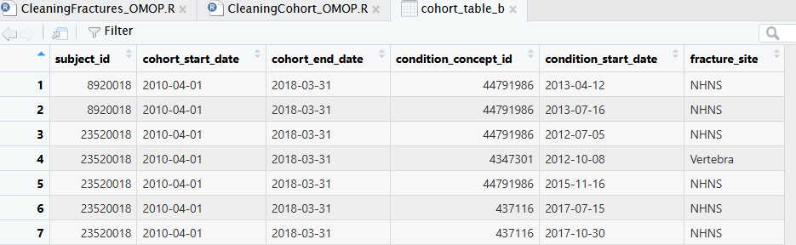
    - 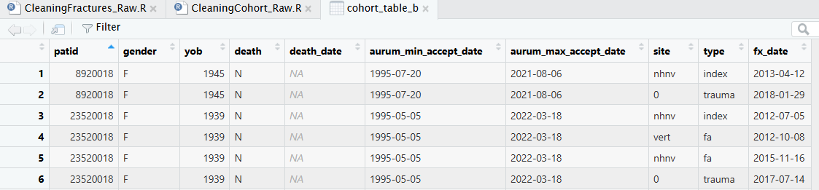
- Defining index
  - For OMOP, this is index data: 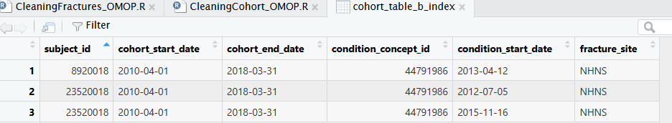
  - For Raw, the index date is the same with the same site for each patient: 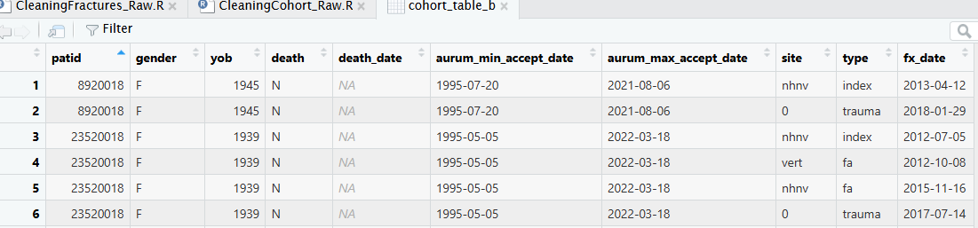
- Cohort table c
  - Similar dates for OMOP and Raw. However, in Raw since the first after index date was captured. And more patients in OMOP than Raw.
    - 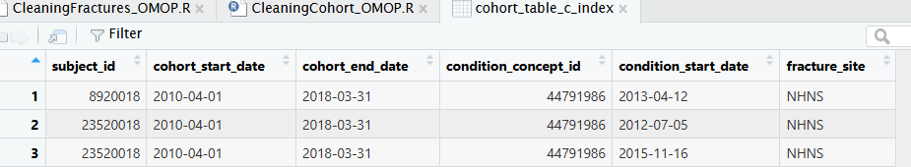
    - 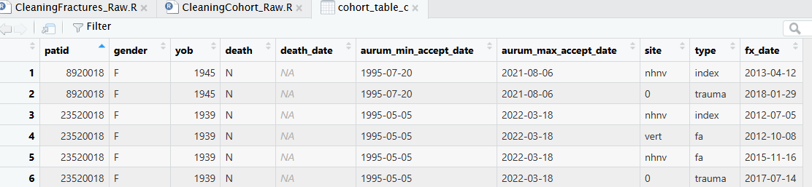
- Cohort table d
  - Similar dates for OMOP and Raw. However, in Raw since the first after index date was captured. And more patients in OMOP than Raw.
    - 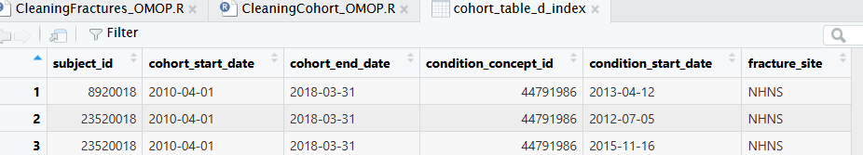
    - 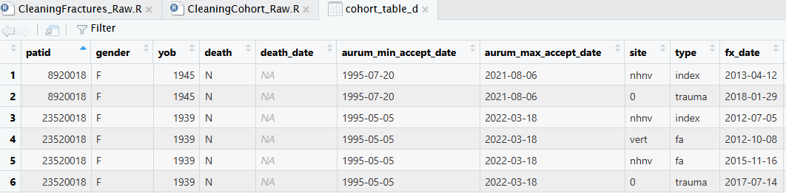
- Cohort e
  - Similar dates for OMOP and Raw. However, in Raw since the first after index date was captured. And more patients in OMOP than Raw.
    - 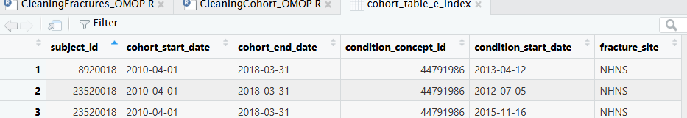
    - 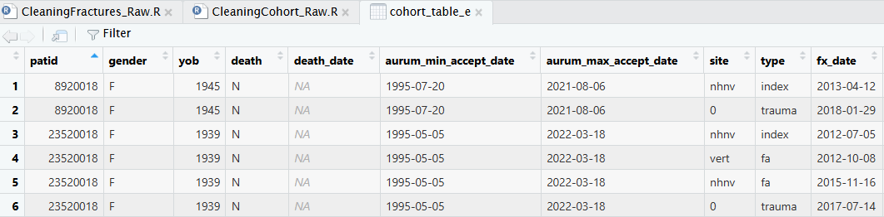
- Cohort f
  - Similar dates for OMOP and Raw. However, in Raw since the first after index date was captured. And more patients in OMOP than Raw.
    - 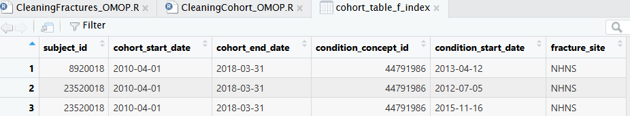
    - 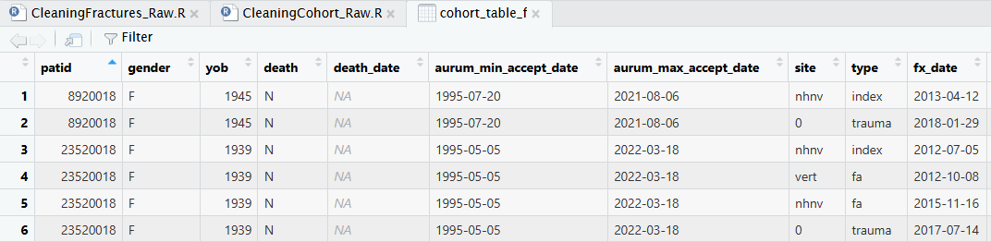
- Cohort g
  - Similar dates for OMOP and Raw. However, in Raw since the first after index date was captured. And more patients in OMOP than Raw.
    - 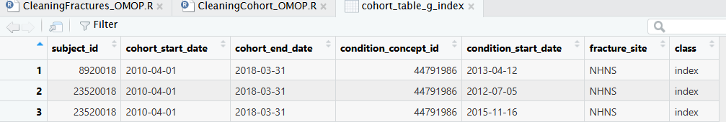
    - 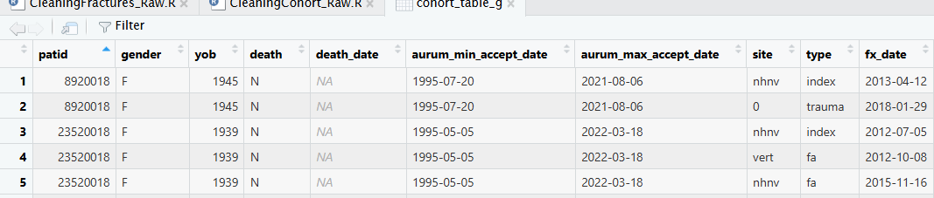
More patients in OMOP as opposed to Raw:
- There are 36,759 patients in OMOP that are not present in raw.