**实际应用中并发点对点查询的需求**

**1.Google Map**

More than a billion people use Google Maps every month. ([Google Cloud](https://cloud.google.com/blog/products/maps-platform/9-things-know-about-googles-maps-data-beyond-map))

5 million active apps and websites use Google Maps Platform core products weekly. ([Google Cloud](https://cloud.google.com/blog/products/maps-platform/9-things-know-about-googles-maps-data-beyond-map))

The average monthly time spent on Google Maps seems to be 152 minutes. People seem to be using Google Maps about 50 times a month for roughly 3 minutes per session. (<https://www.insiderintelligence.com/chart/234831/leading-us-map-navigation-smartphone-apps-ranked-by-monthly-unique-users-aug-2019>)

没有查到每秒钟多少次点对点查询的具体数据，根据上面信息可以估算，每秒处理的请求数约为1000000×50/30/24/60=1157。

**2.金融欺诈检测**

When detection is performed on off-platform systems, detection response times can reach upwards of 80 milliseconds, with throughput rates in the 1,000–1,500 transactions per second (tps) range.

参考：<https://www.ibm.com/downloads/cas/DOXY3Q94>page9

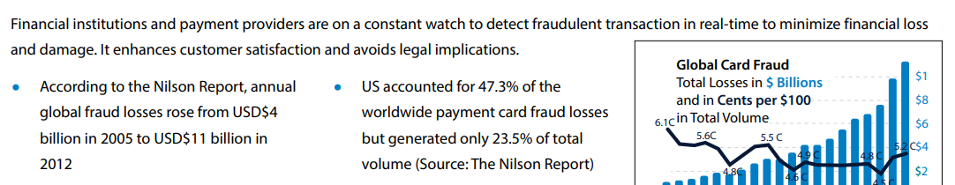

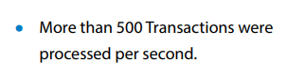

参考：<https://www.infosys.com/services/data-analytics/insights/documents/real-time-fraud-detection-engine.pdf>

**3.Facebook用户网络点对点查询**

Core Data invents, builds, and operates Facebook’s online transaction processing (OLTP) infrastructure. We provide access and storage to Facebook’s online data, including the social graph. The infrastructure is among the largest of its kind in the world, processing billions of queries each second.

参考：<https://engineering.fb.com/category/core-data/>

**4.Riot公司使用点对点循环网络**

Riot deployed a custom-built transmission kit featuring an Evertz router along with encoders and decoders for the various feeds coming in and going out. Typically, for a high-profile in-person event like this, Riot would use a point-to-point circuit on its Riot Direct dedicated network. However, after using the public internet to produce dozens of tournaments over the past year, Riot opted for a 10-Gbps DIA (dedicated internet access) public-internet connection (with a secondary line for backup) and heavily used SRT video-streaming protocol.

参考：[SVG Rewind: How Riot Games Pulled Off Its First LCS Event in Over a Year With Mid-Season Showdown (beverlyhillsaerials.com)](https://www.beverlyhillsaerials.com/post/svg-rewind-how-riot-games-pulled-off-its-first-lcs-event-in-over-a-year-with-mid-season-showdown)

**5.美国西南航空公司航空网**

Southwest increased the number of routes (airport-pairs) by more than 300%, from 81 routes in 1990 to 375 routes in 2006 while increasing the number of airports by only 100% during the same period. As a result, the average number of destinations out of an airport has increased from 5 in 1990 to 12 in 2006.

参考：[点对点网络效应探索：西南航空网络空间格局研究 — 理大学者中心 (polyu.edu.hk)](https://research.polyu.edu.hk/en/publications/exploring-network-effects-of-point-to-point-networks-an-investiga)

[点对点网络效应探索：西南航空网络空间格局研究 - ScienceDirect](https://www.sciencedirect.com/science/article/pii/S0967070X17308983)