Calibration Script File Updates
· create your own directory on /work to hold calibration scripts and helpers
o e.g. /work/03261/polonius/hetdex/calibrations
o this is on /work so it is not subject to TACC auto-deletion
· copy calibration scripts from Karl (or other) to that location
o you will be editing files to change paths
o a “bin” directory and “gettar” need to be at the same level and both under this top level calibrations directory
o NOTE: under gettar there are what appear to be shot specific corrections for a handful of old shots (e.g 201811.* or some /tmp stuff …. ignoring for now?)
rt1c.xxx (very old?)
awk.dat (ignore?)
rchsci (ignore?)
rchtwi (ignore?)
rbadsci (ignore?)
rgetsci* (ignore? … updated paths but seem to be old and temporary)
rgettwi1(ditto)
rgfplane, rgfplane_0 … leave pointing to Karl
rpan0, rpan1 … leave pointing to Karl
rsetvred … leave pointing to Karl
>> take a look at /work/03261/polonius/hetdex/calibrations/calscripts/karl.grep
· copy the templates.slurm from ~gebhardt (or other) into a template directory for you
(you will update the paths in jobsplitter and jobsplitter2s with this path later)
· copy /work/00115/gebhardt/maverick/panacea to your own directory
o NOT certain that this is ever needed?
· copy /home/00115/gebhardt/wcs to your own directory
·

Under your calibrations scripts directory
· rsetupc
o change dircal to be your top level calibration directory
· jobsplitter, jobsplitter2s
o update path for cp of templates.slurm (line 20) to be your path
· templatecall
o update path to your panacea path
· rtar2
o update path to your wcs path
· run1t
o .tar files under /work/03946/hetdex/maverick/${date}/virus/virus0000${shot}.tar
and that is fine. That is where they should live.
o Update: scriptdir to point to your script paths
· rback
· rback1 … leave it alone, want to still point to Karl (tarlists)
· rback_cal
· rbfits* (leave alone)
· rgetcmb (leave alone)

Running Calibrations
!! copy the rt.YYYYMM from Karl’s location:
/work/00115/gebhardt/maverick/gettar/rt.YYYYMM and runtYYYYMM and runsYYYYMM

From Karl’s readme (a bit out of date, I think):
rt1 reduce all exposure and tar up for an observation
rt1b untar over all obs for a month, combine results
rt1c move results to calib folder
rt2 run full-field to get A2A and tar up
rt3 untar over all obs for A2A and combine; no need to batch
rt1c move results to calib folder

need these locally:
run1t
rtara
rback
rgetcal0
rgetcal1
rgetcal2
rgetcmb
rgetcmb1
rgetata
rgetata1

1. there is an initial step to prepare the .tar files in each month (each observation, or is it each day?) needs a prep-step. Right now Karl is doing this and I think that is under his directory.
>> ?? does this create the rt.YYYYMM file in the /work/…./calscripts/gettar/
2. goto/create directory on your scratch (e.g. under /scratch/03261/polonius/calibrations) for the month (e.g. mkdir 202309) and cd into that directory
3. cp from your scripts directory: rsetupc
and run: rsetupc <yyyymm> (e.g. rsetupc 202309)
this will copy down the necessary scripts to get started
a. calYYYYMM (e.g. cal202310)
lib_calib
sciYYYYMM (e.g. sci202310)
4. change dir to “calYYYYMM” and run:

START HERE normally
/scratch/03261/polonius/calibrations
(base archival directory for executables, etc is /work/03261/polonius/hetdex/calibrations …. may need to copy from here if they have aged off of /scratch)
(0). make sure /work/00115/gebhardt/lib_calib/tarlists/YYYYMMtarlist exists
Run rsetupc YYYYMM
this will create directories cal<YYYYMM> and sci<YYYYMM>
cd into cal<YYYYMM> and then …

1 . rstep1 (slurm job)
a. sbatch rt1.YYYYMM_1.slurm
(notice: usually as 4 nodes with 80 TOTAL jobs (e.g. -n 80, not –ntasks_per_node 80) so, 20 per node.) The run file usually does two commands per line. And, yes, just operates with “exp01” for each date+shot.
b. which runs: run1t on each of the shots+exposure (but just listed as exp01)
c. (mostly de-tars and copies from storage on /work)?
When checking (check_ofile), there can be some backtrace or other issues. If just a few, these will get effectively handled at the end of calibration as we replace with earlier month(s) as needed.
That said, you can probably figure out which shots had a problem by listing the sizes of, say the *_1ds.tar files or other .tar (not virusxxx.tar) under each of the dxxx directories and seeing which one(s) are different. Follow up individual, manual run of those shots in a devnode (each match the call from rt1.YYYYMM_1.run) might show some bad traces, etc.

2. rstep2 (slurm job)
a. sbatch rt1b.YYYYMM_1.slurm
b. calls fixed number of rgetcal0 for each IFU in the shot ?
3. rstep3 (this is just a move)
a. mv i* ../lib_calib/<YYYYMM>/.
*. MANUAL STEP … have to change to hetdex user
a. copy the contents in ../lib_calib/<YYYYMM> over to /scratch/projects/hetdex/lib_calib/<YYYYMM>
b. !! must be run as hetdex user and you may need to create the <YYYYMM> directory unless you are overwriting one that already exists
4. rstep4 (this is a slurm job)
a. rt2.YYYYMM_1.slurm
b. calls fixed number of rgetcal1 for the ifu (by position?) and each exposure
i. not position? (example) rgetcal1 20230901 001 exp01 202309 0;
not sure about the 001 (which varies up to 025 only?)
(5). (rstep5 (NOT SLURM) … added to end of rstep4 .. do not run manually)
a. IF an amp is missing (or a bad amp, so deliberately missing) will get tar failures and that is okay
calls rgetcal2 for each IFU?
Makes a directory (on /tmp) named for the IFUID+YYYYMM, /tmp/013202309 for example, and cd there
Copies rgetata, rgetata1 there
Removes rt and rt2, if they exist under IFU+YYYYMM
Makes a new rt2 that calls rgetata1 on the IFU
Creates a file, j1, that has a listing of all the ‘d’YYYYMMdd’s’<shot#>’exp’xx/”ditto”_ata.tar files in the calXXXX directory
(so, should be ?? 3x _ata.tar per shot for how ever many shots
(however, I am only seeing exp01 … but that maybe is correct?)
(the *_ata.tar seems to have .dat files for all ifu amps? … maybe not bad amps?)
(contents are ascii: wavelength, some value? (maybe a flux?))
j2 strips away the paths:
../d20230901s001exp01/d20230901s001exp01_ata.tar BECOMES
D20230901s001exp01ia??ata.dat
rt runs first rgetata1 on one IFU, which calls rgetata for each AMP which
makes an inlist of: ls d*i${ifu}a${amp}ata.dat > inlist
then rt runs a series of tar commands
tar xf ../d20230930s005exp01/d20230930s005exp01_ata.tar d20230930s005exp01ia??ata.dat
then rt2 runs
calls rgetdata1 on each IFU, which calls rgetdata on each AMP for the IFU
rgetdata

6. rstep6 … simple move of all i* files to ../lib_calib
(copies from the calXXXX to ../lib_calib in MY /scratch path)
7. MANUAL STEP … have to change to hetdex user (like between steps 3 and 4)
copy the contents in ../lib_calib/<YYYYMM> over to /scratch/projects/hetdex/lib_calib/<YYYYMM>
(8. MANUAL STEP … still as hetdex user ..)
!!! AFTER examine for issues and make corrections !!! (see next section)
copy /scratch/projects/hetdex/lib_calib/<YYYYMM>
to /corral-repl/utexas/Hobby-Eberly-Telesco/lib_calib

Examine for Issues

—-----------
Sanity checks
(look at karl work under “analysis”)
“crazy file” rfixcal2 (rfixcal is from HDR2)
… has a set of cp statements that copy from some previous month to the new(current) month. Basically a reference. Can use a subset to copy over (run from the command line) under /scratch/projects/hetdex/lib_calib
>>

check IFU 028 in 2021??

>> how to generate the 3x2 plots

Generating 3x2 Plots:

There is Karl’s older version and my own. Generate Karl’s 3x2 as described immediately below, then run my notebook, “check_calibration_reductions” for my versions of plots and to check for out-of-range values and large month to month shifts.
Make a list of those to replace from previous month. (Since each month should be replaced as we go, you should only need to pull from the immediately prior month).
(make a file “listprof” (call run1 ?) under analysis ? change the top path
>> run from idev (or in SLURM) ?)

- make sure everything is copied to /scratch/projects/hetdex/lib_calib that you want to check
- #under /work/03261/polonius/hetdex/calibrations/analysis (work is for record/backup, run under scratch)
under /scratch/03261/polonius/calibrations/analysis
  - edit in_mth to add/adjust new YYYYMM, if needed
    - sets the months to check
    - if you edit here, you do not need to edit below
    - this will NORMALLY let you just execute run1 and not have to run the others individually
  - edit make_listall (to update the wildcard for the new month, if needed)
    - if you edit here, you will not need to edit later
  - edit run1
    - near top line dir=xxxx
    - set to whatever with wildcard that you want to review
    - set do_run2 as needed, depending on whether make_listall needs updating
  - open an idev session??
    - idev -p vm-small -t 2:00:00
    - this is probably recommended as it can take a while to run (about 25-30 minutes for run1 on 1 year of data)
  - execute run1
    - this builds up a new listprof file
    - this can take a long time to run … 15-20 minutes depending on the number of directories
  - edit make_listall (IF NOT ALREADY DONE)
    - update with wildcard selection as needed
  - execute make_listall (IF NOT DONE AS PART of run1 (see do_run2)
    - this makes a new “listall” file from data under Karl’s work to match with what should have been run (YYYYMMDD) from run1
  - edit in_mth to match listall (IF NOT ALREADY DONE)
  - remove bad data (specifically from listfib2.dat):
    - grep -v \* /work/03261/polonius/hetdex/calibrations/analysis/listfib2.dat > j1; mv j1 listfib2.dat
    - (or just: grep -v \* listfib2.dat > j1; mv j1 listfib2.dat )
      - !! note: added to the end of run1
  - execute run2 (unless running as part of updated run1)
    - This is pretty quick. Just a minute or so. Does not have to be in idev.
    - ?? need to update this s|t it runs on any/all amps not just those explicitly listed … that is find all the amps (which may change month to month) and run on them

CHECK Calibrations plots in notebook
Now can run my own stuff, “check_calibration_reductions” notebook … on laptop under notebooks/calibrations.

For any month+amp calibrations that need to be replaced …

  - edit rfixcal3 and execute (the new lines as added) on /scratch/projects/hetdex/lib_calib as needed (rfixcal3 is the command and records of what was done)

CHECK for Vignetting in lib_calib/*cmbf.fits files
Compare to prior months for example. There are 4 amps per IFU, suggest checking:
>> ds9 i<XXX>a<XX>cmbf.fits
e.g. for a single month, one IFU, all amps: ds9 i046*cmbf.fits (see below)
look for the hard striations … if exists it is a problem (notice: in the examples below, the upper left is okay and the others are bad)
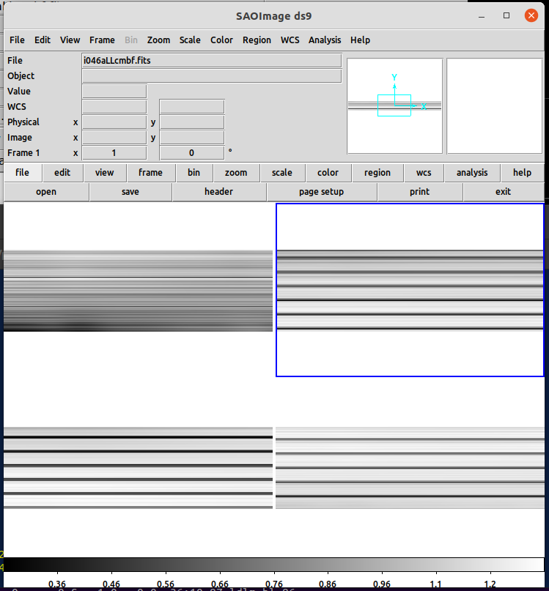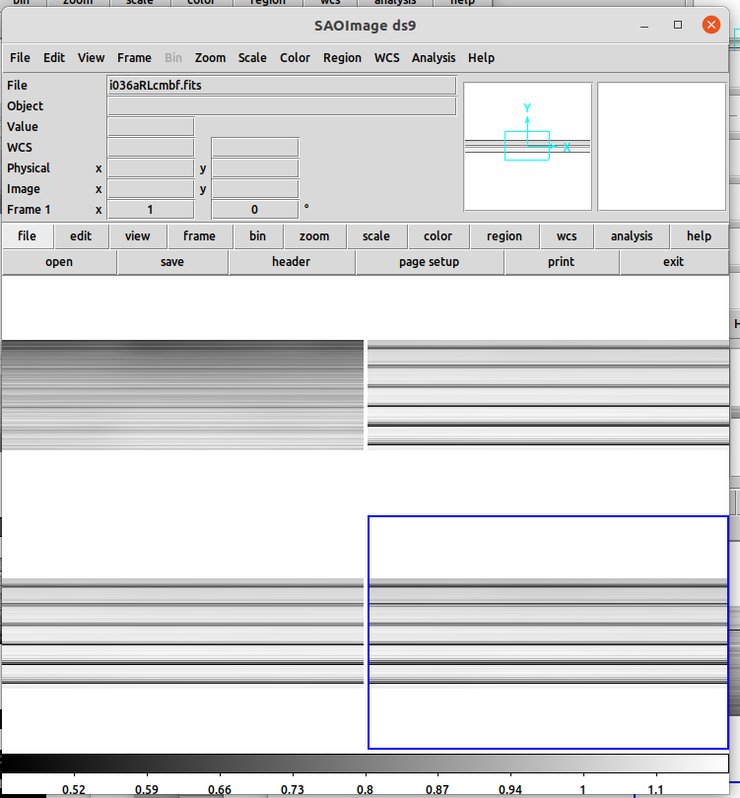

May also be apparent in the match_pngs (generated later). May look like a streak, like a meteor or satellite, but will be in ALL dithers. Harder to see in the coadds.
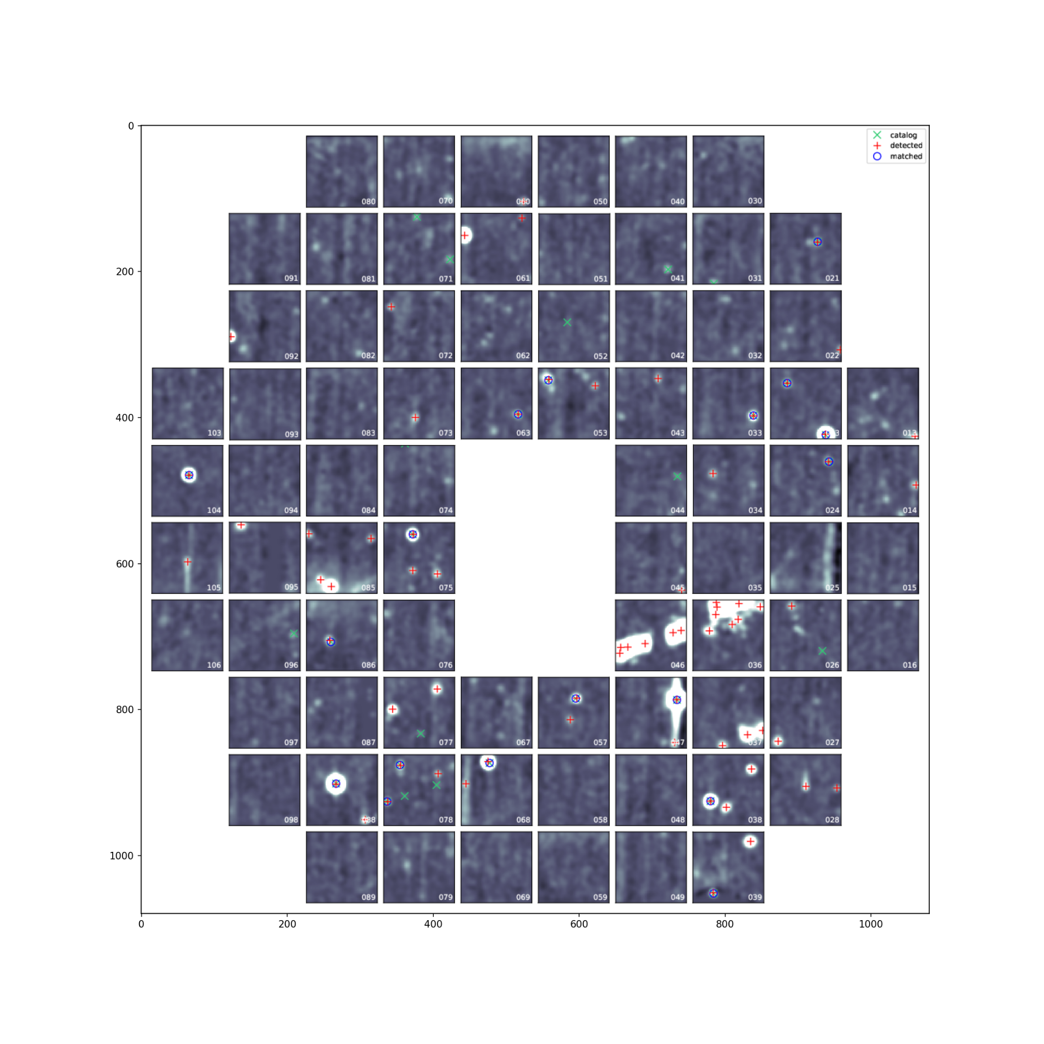
Can also see in the “clean_image” for a shot, for the affected IFU+amp. See notebook: check_shot_images.ipynb (/work/03261/polonius/hub/)
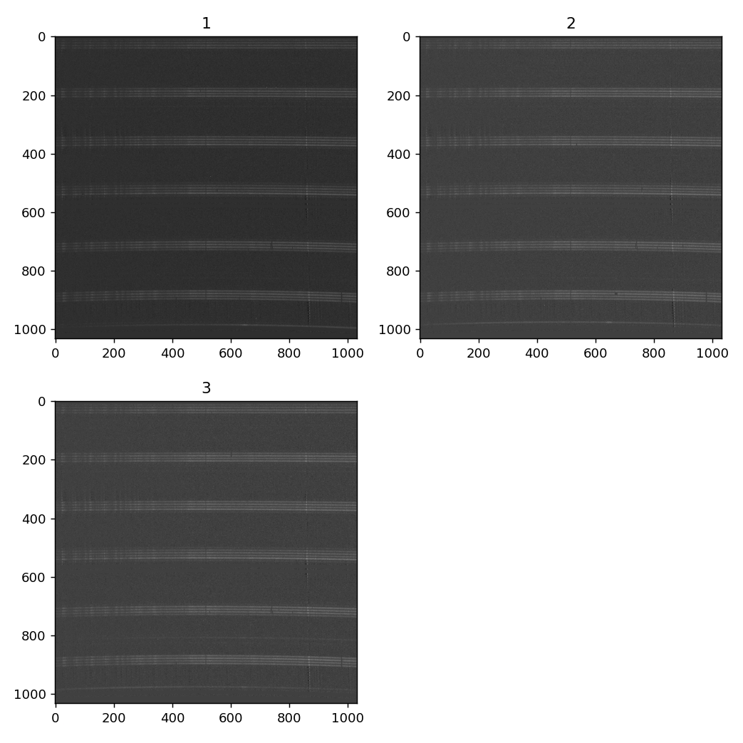

Now update the project calibration records

  - execute UNDER each YYYYMM subdir, runclean
    - e.g. cd 202401 ; ../runclean
  - execute rchata YYYYMM (from /scratch/projects/hetdex/lib_calib)
    - just once … updates the various *ata.dat files
    - creates listin, chata.out (which may show what was updated?)
    - so DON’t run again if there is a chata.out file?
      - !! added a check in the rchata script to not run if chata.out already exists
  - copy /scratch/projects/hetdex/lib_calib/<YYYYMM>
to /corral-repl/utexas/Hobby-Eberly-Telesco/lib_calib

is the option for plotting: /xs
- /work/03261/polonius/hetdex/analysis (copied from Karl)
edit/run: make_listall with the data ranges for the focal plane files to load (should correspond to the YYYYMM you want to check)
- edit: in_mth to match listall
- edit run1 (top line) to match which YYYYMM from where you want to pull data
- run: ./run1 (should be done in idev)
- run: ./run2 (I think this creates plots?)
can view single plots with (several different plotxxx in Karl’s bin)
/home1/00115/gebhardt/bin/plotcaliball [Return]
### (where ### is an IFUID)
then view plotting output is “/xs”

There can be errors (bad data) in listfib2.dat
remove any lines with “****” (eg.: 1127.32 ****** 202310 062 062 RL )
can use: grep -v \* /work/03261/polonius/hetdex/analysis/listfib2.dat > j1; mv j1 listfib2.dat

—--------

>> to fix (some) problems, just copy over previous YYYYMM
see lines in /work/03261/polonius/hetdex/calibrations/analysis/rfixcal2
!!! BE SURE TO ADD lines for ANY updates (cp) you do!!! in rfixcal3 AND rfixcal3.bydate !!!
e.g. cp 202308/i071aLU* 202309/.

---------------

to replace months: example 202309 to 10, and 11 for 014 RL
(like Karl's rfixcal2)
command looks like (for example): cp 202309/i014aRL* 202310/.
so: cp YYYYMM/i<IFUID>a<AMP>* YYYYMM/.
if ALL amps, replace the two letter amp with the *

can run: runclean (to remove unneeded files .... go to each subfolder under lib_calib)

>>!! rchata (202309) ... BUT ONLY RUN ONCE ... looks for zeros and then adds to to either side, but if run more than once they start growing

Inspection notes:
===================

calibration: check

Possible problems:

[DONE] 014 RL, (green) --maybe all zeros (if all (e.g in F2F) zeroes, just copy over the prior months) ... check listftf2.dat in "analysis" directory [DONE]

[DONE] 032 Fiber FWHM (LL, RL)? (go back and check 06,07,08) ... RL fiberpos-09 ... so replace 202309 with 202308

[OK?] 033 Fiber FWHM RU maxed out ... go back and look if out of focus, maybe tell phillip if out of focus, but also 202309 fiberpos for RL, so replace back for example this is okay ... look at listprof2.dat ... is y-axis of fiber profile, RU is fatter here than RL as example

[DONE] 043 RL Fiberpos , A wave etc 202311

044 like 033 (if really near 8.5 is okay, but if hugely past that is a problem)
## >> grep “033 *RU” listfib2.dat
>> grep “044 *RU” listprof2.dat (fiber profile … note two spaces between 044 and RU)
listprof2 are the y-positions of fiber profile … the single value on the figure is the FWHM computed by fitting this to a Gaussian. (Not sure about the wave positions .. assume they are in bins). Need to write a code that does the fit and kicks back the FWHM to see if it is really well above 8.5.
>> want to check vs Karl figures. Not getting the same FWHM … they are similar when fit, but not the same

[!!!] 045 look at data file (ATA is low) but is maybe okay

050 RL fiber position (all maxed) but should double check

[Done] 060 LL 202309 all replace (delta wave, fwhm, etc … ALL look bad)
>> this is the other (060 LL and 071 LU) that seem to have bad delta wave and maybe is the sci-reduction problem.

062 does look weird, re-check with 202306,07,08 (fiber position) for RL

067 - probably okay, but check F2F norm RU
(in re-run of 202306,07,08 lots of bad in 07,08, some 09, all AMPS)
(note in science reduction run, it uses back to 202305 instead and that one is okay)

[Done] 071 - LU check fiber position jump , check delta wave LU 202309 replace with last month
( cp 202308/i071aLU* 202309/.) and updated my rfixcal3
NOTE: this (delta wave?) was causing a segfault in the science reductions
>> May also be causing problems still but fewer?

089 - check vs 202306,07,08 RU

[Done for 202309 only] 095 - check RU in particular, might be junk for 202309, 10, 11 --- probably has a dummy calibration, but might not be used anymore
(probably just auto-replace with 202308)
re-run big jump delta wave at 06+

013 okay
015 bump in blue RU a little bump, but okay
?039 actually okay

>> backup 202306,07,08 on projects
>> re-run them to compare and put backup the original

delta wave not so important, as long as consistent

202310:

(014+RL) copied 202309 to 202310 and 11 …
BUT I don’t see anything wrong with the 2nd run …. the 1st (with 202306,07,08 copied
does have a problem with RL)

015+LL F2F is maxed 2.0, but is maxed for ALL months, so pointless to copy?

036+RL delta wave is high, but just (note LU is near the max, but still in good range)

044+RU FWHM not fitting

045+RL A2A is 0.0 (all months) … so pointless to copy?

053+RL FWHM high (but fitting) .. so prob okay

060+LL all bad, [Done] copied from 202309
062+RL fiber pos is masked

067+RU F2F is high (has been since 202303)

095+RU A2A is 0

Limiting to [202312]:

015+LL 202312: f2f (2.0), is near 2.0, but always is

033+RU 202312: fwhm (8.62), ignore

036+RL 202312: wave (30.2), right on the edge of high, but consistently so. ignore

039+LU 202312: fwhm (9.19), erratic, but ignoring

042+LL 202312: fwhm (8.64), ignore

*** 043+RL 202312: pos (838.0), check this one, fiber pos waay out of spec *** ... sky flats are zero??

*** 044+RU 202312: fwhm (14.24), check ... focus?? (but does not mean it should be replaced from prior month)

045+RL 202312: a2a (0.0), same as always, ignore it?

053+RL 202312: fwhm (8.87), ignore

067+RU 202312: f2f (1.5), high, but consistently so. ignore

*** 095+RU 202312: a2a (0.0), bad, always replace

096+RU 202312: fwhm (8.61), ignore

103+LU 202312: fwhm (8.64), ignore (consistent)

>>>>> DONE <<<<<

Limiting to [202312]:

Month to Month change > 33.0%

014+RL : pos [202312], still in okay range

*** 043+RL : pos [202312], check this one, fiber pos waay out of spec (also caught above) ***

*** 044+RU : fwhm [202312], check ... focus??

??? 062+LL : fwhm [202312], maybe a focus issue, but still in range

067+RU : fwhm [202312], big increase but in range, ignore ??

*** 095+RU : wave [202312], f2f [202312], a2a [202312], bad, always replce

>>>>> DONE <<<<<

202401

015+LL 202401: f2f (2.0), copy (if the official one is also high?) [have been ignoring]

036+RL 202401: wave (30.2), ignore

039+LU 202401: fwhm (9.20), have been ignoring

042+LL 202401: fwhm (8.69), ignore

044+RU 202401: fwhm (21.62), check ... focus?? (but does not mean it should be replaced from prior month) ... getting worse over last month … have been ignoring so far

045+RL 202401: a2a (0.0), have been ignoring ... see what is in the official data

053+RL 202401: fwhm (8.93), ignore

067+LL 202401: pos (832.0), probably replace (new) [done]

067+RU 202401: f2f (1.5), have been ignoring

083+RU 202401: fwhm (8.50), ignore

095+RU 202401: a2a (0.0), bad, always replace [done]

096+RU 202401: fwhm (8.57), ignore

103+LU 202401: fwhm (8.61), ignore

/scratch/projects/hetdex/lib_calib/202401
Results:
071+RU NaN=4128 i071aRUcbwt.fits
071+RU NaN=5160 i071aRUcmbf.fits
095+RU NaN=-1 i095aRUcbwt.fits
095+RU NaN=-1 i095aRUcbxt.fits
095+RU NaN=-1 i095aRUcmbf.fits
095+RU NaN=-1 i095aRUcmbp.fits

NaN or empty data in .fits for the following IFU+Amps:

071+RU
095+RU [done]

202402
--------------

015+LL 202402: f2f (2.0), #high but always high and Karl has not previously replaced it

033+RU 202402: fwhm (8.69), #not high in Karl’s version, ignore

036+RL 202402: wave (30.1), #borderline but super consistent, ignore

039+LU 202402: fwhm (8.86) , #a little on the high side, but have been ignoring

042+LL 202402: fwhm (8.59), #a little on the high side, but have been ignoring, very consistent

044+RU 202402: fwhm (16.34), #ask about checking focus

045+RL 202402: a2a (0.0), # have been ignoring ... Karl was using the 202303 date forward (to 202304) and backward (202205 to 202304), but it was always zero for a2a

053+RL 202402: fwhm (8.90), # a bit high, but okay in Karl’s version, have been ignoring

067+LL 202402: pos (906.6), #should replace [DONE]

067+RU 202402: f2f (1.5), #have been ignoring (Karl ignoring too)

071+LU 202402: pos (964.5), [new] Done

071+RL 202402: pos (967.0), [new] Done

095+RU 202402: a2a (0.0), Done (always)

096+RU 202402: fwhm (8.61), #a little high, but not past threshold in Karls, ignoring

Month to Month change > 33.0%

044+RU : fwhm [202402], #ask about focus

067+LL : pos [202402], replaced (out of range pos)

071+LU : pos [202402], replaced (out of range pos)

071+RL : pos [202402], replaced (out of range pos)

095+RU : wave [202402], f2f [202402], a2a [202402],

/scratch/projects/hetdex/lib_calib/202402
Results:
095+RU NaN=-1 i095aRUcbwt.fits
095+RU NaN=-1 i095aRUcbxt.fits
095+RU NaN=-1 i095aRUcmbf.fits
095+RU NaN=-1 i095aRUcmbp.fits

NaN or empty data in .fits for the following IFU+Amps:

095+RU

202403
--------------
015+LL 202403: f2f (2.0), #high but always high and Karl has not previously replaced it

033+RU 202403: fwhm (8.69),

039+LU 202403: fwhm (8.89),

042+LL 202403: fwhm (8.59),

043+LL 202403: a2a (0.0), **** DONE

044+RU 202403: fwhm (12.10),

045+RL 202403: a2a (0.0), (always zero) ... but need to copy? .. No, have been leaving as is

053+RL 202403: fwhm (8.87), (always high, ignore?)

062+RL 202403: pos (mask), *** (should check more??) [done]

062+RU 202403: pos (mask), *** (should check more or just replace)?? [done]

067+LL 202403: pos (mask), *** (should check more or just replace)?? [done]

067+RU 202403: f2f (1.5), (always high?)

(072+RL FWHM) -- wild swings?

095+RU 202403: a2a (0.0), *** [done]
095+RU 202403: dwave, *** still in range but big swings [done]

096+RU 202403: fwhm (8.62), (always high)

>>>>> DONE <<<<<

Month to Month change > 33.0%

043+LL : a2a [202403], [done]

044+RU : fwhm [202403],

072+RL : fwhm [202403],

095+RU : wave [202403], f2f [202403], a2a [202403], [done[

>>>>> DONE <<<<<

/scratch/projects/hetdex/lib_calib/202403
Results:
095+RU NaN=-1 i095aRUcbwt.fits
095+RU NaN=-1 i095aRUcbxt.fits
095+RU NaN=-1 i095aRUcmbf.fits
095+RU NaN=-1 i095aRUcmbp.fits

NaN or empty data in .fits for the following IFU+Amps:

095+RU

202404
Limiting to [202404]:

015+LL 202404: f2f (2.0), ignore per usual
033+RU 202404: fwhm (8.72), ignore per usual
042+LL 202404: fwhm (8.56), ignore per usual
044+RU 202404: fwhm (26.87), *** check on this one ***’ alwasy high, never replace
045+RL 202404: a2a (0.0), *** what did we do before *** check with Karl, never replace
053+RL 202404: fwhm (8.88), ignore
062+RL 202404: pos (mask), *** check *** [done]
067+LL 202404: pos (mask), *** check *** [done]
067+RU 202404: f2f (1.6), (always high … since 202303 and has not been replaced)?
095+RU 202404: a2a (0.0), always replace
096+RU 202404: fwhm (8.59),

>>>>> DONE <<<<<

Limiting to [202404]:

Month to Month change > 33.0%

044+RU : fwhm [202404],
067+RU : fwhm [202404],
095+RU : wave [202404], f2f [202404], a2a [202404],

/scratch/projects/hetdex/lib_calib/202404
Results:
095+RU NaN=-1 i095aRUcbwt.fits
095+RU NaN=-1 i095aRUcbxt.fits
095+RU NaN=-1 i095aRUcmbf.fits
095+RU NaN=-1 i095aRUcmbp.fits

NaN or empty data in .fits for the following IFU+Amps:

095+RU

202405

Limiting to [202405]:

015+LL 202405: f2f (2.0), [out of whack, but alwasy out of whack]
026+RU 202405: f2f (1.8), *check* jumps from 1.2xx to 1.8xx [done]
033+RU 202405: fwhm (8.81), has been slightly high for a while, check Karl's plot high there too

036+RU 202405: f2f (8.9), *check* jacked way up [done[
042+LL 202405: fwhm (8.59), slightly high for a while, okay in Karls
044+RU 202405: fwhm (3.36), *check* erratic high and low, same in Karls ... follow up?
045+RL 202405: a2a (0.0), always zero?? Yes and we never do anything about it

046+LL 202405: f2f (3.4), *check* jacked up
053+RL 202405: fwhm (8.98), considtently high (okay in Karls)?
067+RU 202405: f2f (1.6), *check* a little high for a while; been high since 202303 and has been ignored
095+RU 202405: a2a (0.0), *check* IGNORE ??
096+RU 202405: fwhm (8.59), a little high for a while; always a little high, always ignore

>>>>> DONE <<<<<

Limiting to [202405]:

Month to Month change > 33.0%
026+RU : f2f [202405], already check
036+RU : f2f [202405], already check
044+RU : fwhm [202405], already check
046+LL : f2f [202405], already check
095+RU : wave [202405], f2f [202405], a2a [202405],

/scratch/projects/hetdex/lib_calib/202405
Results:
095+RU NaN=-1 i095aRUcbwt.fits
095+RU NaN=-1 i095aRUcbxt.fits
095+RU NaN=-1 i095aRUcmbf.fits
095+RU NaN=-1 i095aRUcmbp.fits

NaN or empty data in .fits for the following IFU+Amps:

202406
Limiting to [202406]:

015+LL 202406: f2f (2.0), [out of whack, but always out of whack]
026+RU 202406: f2f (1.8), also in 202405, replace with 202404
033+RU 202406: fwhm (8.83), a little high for a long time, same in Karl’s ignoring as have for long time
036+RU 202406: f2f (5.5), also high (8.8) in 202405, update
042+LL 202406: fwhm (8.56), slightly high for a while, okay in Karls
044+RU 202406: fwhm (4.07), erratic, but has been for 18+ months and nothing done
045+RL 202406: a2a (0.0), always zero, always ignore
046+LL 202406: f2f (3.5), update with 202404 (also bad in 202405)
053+RL 202406: fwhm (8.89), always a little high, ignore
067+RU 202406: f2f (1.6), a little high for a while; been high since 202303 and has been ignored
096+RU 202406: fwhm (8.60), a little high for a while; always a little high, always ignore

Checking for large month to month shifts ...
Limiting to [202406]
Month to Month change > 33.0%
026+RU : f2f [202406],
036+RU : f2f [202406],
046+LL : f2f [202406],
088+RL : fwhm [202406],
095+RU : wave [202406], f2f [202406], a2a [202406],

NaN or empty data in .fits for the following IFU+Amps:

095+RU

202407

hecking value ranges ...
Limiting to [202407]:

015+LL 202407: f2f (2.0), [out of whack, but always out of whack]
026+RU 202407: f2f (1.7), update back to 202404
033+RU 202407: fwhm (8.93), a little high for a long time, same in Karl’s ignoring as have for long time
036+RU 202407: f2f (3.9), update back to 202404
042+LL 202407: fwhm (8.58), slightly high for a while, okay in Karls
044+RU 202407: fwhm (-1.00), erratic, but has been for 18+ months and nothing done
045+RL 202407: a2a (0.0), always zero, always ignore
046+LL 202407: f2f (2.6), update with 202404 (also bad in 202405)
048+RU 2024xx: a2a is now showing a little low for 202401 to 202404, but in range for 05,06,07 … follow up
053+RL 202407: fwhm (8.80), always a little high and always ignore
062+RU 202407: pos (mask), update with 202406
067+RU 202407: f2f (1.6), a little high for a while; been high since 202303 and has been ignored
095+RU 202407: always replace
096+RU 202407: fwhm (8.53), a little high for a while; always a little high, always ignore

>>>>> DONE <<<<<

Checking for large month to month shifts ...
Limiting to [202407]:

Month to Month change > 33.0%

026+RU : f2f [202407], DONE
036+RU : f2f [202407], DONE
044+RU : fwhm [202407], never make updates
046+LL : f2f [202407], DONE

>>>>> DONE <<<<<

Checking for NaNs by amp for main data files (this can take a while) ...
202407

100%
1248/1248 [24:26<00:00, 1.66s/it]

/scratch/projects/hetdex/lib_calib/202407
Results:
095+RU NaN=-1 i095aRUcbwt.fits
095+RU NaN=-1 i095aRUcbxt.fits
095+RU NaN=-1 i095aRUcmbf.fits
095+RU NaN=-1 i095aRUcmbp.fits

NaN or empty data in .fits for the following IFU+Amps:

095+RU

