Game Design Document

Fill up the following document

1. Write the title of your project.

Save Mother Earth

1. What is the goal of the game?

Shooting the asteroids coming towards earth.

1. Write a brief story of your game.

Space Agencies all over the world have received a report from the International Space station that a group of asteroids are coming towards the Mother Earth with a great speed. The player is selected for controlling or guiding a special fighter jet created to destroy all the asteroids.

1. Which are the playing characters of this game?

* Playing characters are the ones who respond to the user based on the input from the user.
* Cars, monkeys, dinos, wizards, etc., are the playing characters in the game.

|  |  |  |
| --- | --- | --- |
| Number | Character Name | What can this character do? |
| 1 | Fighter Jet | Destroy asteroids |
| 2 |  |  |
| 3 |  |  |
| 4 |  |  |
| 5 |  |  |
| 6 |  |  |
| 7 |  |  |
| 8 |  |  |

1. Which are the Non-Playing Characters of this game?

* Non-Playing characters are the ones that don't have an action or behavior when the user interacts with the game.
* Hurdles, stones, bananas, coins, etc., are non-playing characters in the game.

|  |  |  |
| --- | --- | --- |
| Number | Character Name | What can this character do? |
| 1 | Asteroids | Move towards Earth |
| 2 |  |  |
| 3 |  |  |
| 4 |  |  |
| 5 |  |  |
| 6 |  |  |
| 7 |  |  |
| 8 |  |  |

Draw your imagination of this game. What does this game look like?

* Draw the game either on your computer or on paper.
* Add images of the game scenes to show each of the playing and non-playing characters at least once.

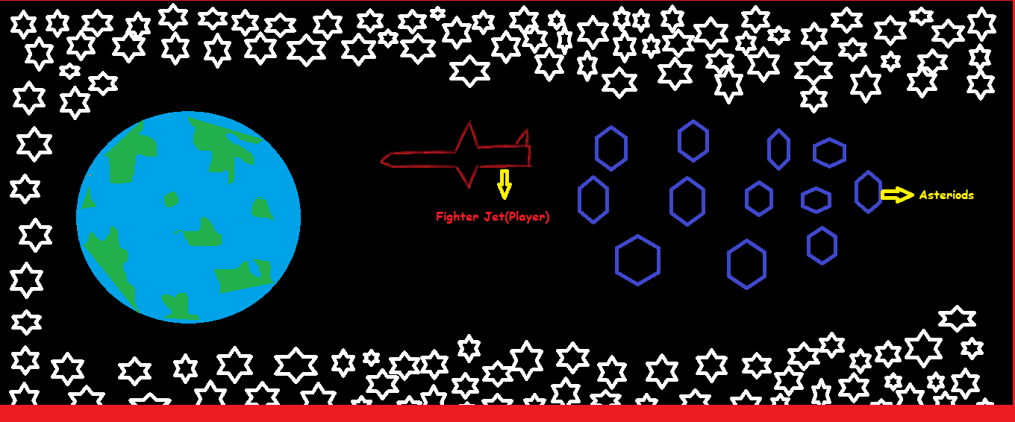

The Above is somewhat about blueprint of the Game.

How do you plan to make your game engaging?

After some time or after destroying some asteriods increase the speed of the game or the movement of asteroids moving towards the Earth and if any one asteroid touches the jet(player) or the Earth then the Game is Over.