CHARUSAT UNIVERSITY OF SCIENCE AND TECHNOLOGY (CHARUSAT)
Faculty of Computer Science & Engineering
Subject : Software Group Project (SGP) – B.Tech (CE)

SquadUP
Real-Time Group Collaboration Platform

Software Requirements Specification (SRS)
Document Version : 1.0 | Date: February 2026
Standard: IEEE 830-1998 SRS Standard

Project Team
Riya Thesia
Hetvi Undhad
Siya Thakker
Shreeji Sojitra

Table of Contents
- Introduction
1.1 Purpose
1.2 Scope
1.3 Definitions , Acronyms and Abbreviations
1.4 References
1.5 Overview
- Overall Description
2.1 Product Perspective
2.2 Product Functions
2.3 User Classes and Characteristics
2.4 Operating Environment
2.5 Design and Implementation Constraints
2.6 Assumptions and Dependencies
- System Features
3.1 User Authentication
3.2 User Profile Management
3.3 Group Management
3.4 Real-Time Group Messaging
3.5 File Sharing within Groups
3.6 Dashboard & Landing Page
- External Interface Requirements
4.1 User Interfaces
4.2 Hardware Interfaces
4.3 Software Interfaces
4.4 Communications Interfaces
- Other Nonfunctional Requirements
5.1 Performance Requirements
5.2 Safety Requirements
5.3 Security Requirements
5.4 Software Quality Attributes
- Other Requirements
Appendix A: Glossary
Appendix B: Analysis Models
Appendix C: Open Issues / To-Be-Decided Items

1. Introduction
1.1 Purpose
The purpose of this Software Requirements Specification (SRS) document is to provide a complete, unambiguous, and testable description of the functional and non-functional requirements of SquadUp - a web-based real-time collaboration platform specifically designed for student project groups, mini-projects, final-year projects, study groups, hackathon teams, and semester-long academic teamwork.

- This document serves as:

- The primary reference for the development team
- The basis for design, implementation, testing, and validation activities
- The main deliverable evaluated during project viva / external examination
- A foundation for future enhancements or maintenance (if the project is extended by junior batches)

- SquadUp aims to solve common problems faced by students such as:

- Over-reliance on WhatsApp groups that become chaotic with too many messages
- Difficulty in tracking who has read important announcements
- Scattered files across Google Drive links, email attachments, Telegram
- No easy way to conduct quick polls inside group chats
- Lack of academic context (who is in which semester/branch) when collaborating with classmates from different divisions

1.2 Scope
SquadUp shall provide the following core capabilities:
- Secure user registration and login using email + OTP verification Optional password-based login + forgot/reset password flow
- Creation and management of private collaboration groups
- Email-based invitations to join groups (using secure token links)
- Real-time group chat with delivery & read receipts (WhatsApp-style)
- File upload, preview, download and deletion inside groups
- Personal profile containing academic information (enrollment no, branch, semester, skills, social links)
- Personalized dashboard showing joined groups and quick actions
- Public landing page with live statistics (total users, total groups created)
The product shall NOT include (explicitly out of current scope):
- One-to-one private messaging
- End-to-end encryption of messages
- Push notifications (browser or mobile)
- Mobile native application (only responsive web)
- Cloud storage integration for files (files stored locally on server)
- Super-admin / moderator panel
- Message editing or deletion after sending
- Message reactions (emojis)

1.3 Definitions, Acronyms and Abbreviations

Term / Acronym | Definition / Expansion
SRS | Software Requirements Specification
MERN | MongoDB, Express.js, React.js, Node.js (technology stack used)
JWT | JSON Web Token - used for session management and secure links
OTP | One-Time Password - 6-digit code sent via email for verification
Socket.io | Real-time bidirectional event-based communication library
SPA | Single Page Application
CORA | Cross-Origin Resource Sharing
ODM | Object Document Mapper (Mongoose in this case)
Group Room | Socket.IO room corresponding to one SquadUp group - isolates real-time messages
Delivery Receipt | Message status: sent → delivered (gray ✓✓)
Read Receipt | Message status: delivered → read (blue ✓✓)

1.4 References

1. IEEE Std 830-1998 – Recommended Practice for Software Requirements
Specifications
2. Socket.IO v4 Documentation - https://socket.io/docs/v4/
3. React Documentation - https://react.dev/
4. Express.js Documentation - https://expressjs.com/
5. MongoDB Manual - https://www.mongodb.com/docs/manual/
6. Nodemailer Documentation - https://nodemailer.com/
7. JSON Web Tokens Introduction - https://jwt.io/introduction
8. CHARUSAT Project Report Guidelines (2025–2026)
9. GTU Final Year Project Manual (for reference structure

1.5 Overview
The remainder of this SRS is organized as follows:
- Section 2 gives an overall view of the product, its perspective, major functions, users, environment and constraints
- Section 3 describes each major system feature in detail (functional requirements)
- Section 4 lists all external interfaces (UI, hardware, software, communication)
- Section 5 specifies non-functional (quality) requirements
- Section 6 covers miscellaneous requirements not fitting elsewhere
- Appendices provide supporting material (glossary, models, open issues)

2. Overall Description
2.1 Product Perspective
SquadUp is a purpose-built academic collaboration tool that sits between general-purpose
instant messengers and heavyweight enterprise tools like Microsoft Teams or Google
Workspace.
It addresses the specific pain points of engineering students working in small-to-medium sized groups (typically 3-20 members):
- Need for academic identity verification
- Requirement for fast, reliable real-time communication
- Easy sharing of large files (project reports, code, diagrams)
- Quick group decision-making without leaving the chat
- Separation of project-related communication from personal WhatsApp/Instagram

2.2 Product Functions
ID | FUNCTION | PRIORITY | SHORT  DESCRIPTION
F-1 | User Registration + ОТР  Verification | Must | Email + password + OTP → account activation
F-2 | Login / Forgot Password | Must | Standard credential login + email-based reset
F-3 | Profile Management | Must | Edit name, academic details, skills, links
F-4 | Create Group | Must | Name group → become admin
F-5 | Invite Members via Email | Must | Send secure invitation link
F-6 | Accept Invitation & Join Group | Must | Click link → join group (register if new user)
F-7 | Real-time Group Chat | Must | Send/receive messages instantly, read & delivery receipts
F-8 | File Upload / Download / Delete | Must | Share documents, images, code files inside group
F-9 | Create & Vote on Polls | Must | Quick in-chat polls for decisions (topic selection, event timing, etc.)
F-10 | Dashboard | Must | Overview of joined groups, quick actions, profile summary
F-11 | Public Landing Page | Colud | Marketing page with live counters (users / groups)

2.3 User Classes and Characteristics
User Type | Expected Skills | Frequency | Goals / Needs
Visitor | Basic browsing | One-time | Understand what SquadUp is, see stats, register/login
Normal Student | Moderate | Daily | Chat, share files, vote in polls, manage profile
Group Admin | Moderate - High | Daily | Invite/remove members, moderate group (future: delete messages?)

2.4 Operating Environment
- Client: Modern browsers (Chrome 100+, Edge 100+, Firefox 100+, Safari 15+)
- Server OS: Linux (production), Windows/macOS (development)
- Runtime: Node.js 18+
- Database: MongoDB 6+ (local or Atlas)
- Network: HTTP/HTTPS + WebSocket (wss:// preferred in production)

2.5 Design and Implementation Constraints

- Frontend → React 18 + Vite, Tailwind CSS or plain CSS + Socket.IO client
- Backend → Node.js 18+, Express 4/5, Socket.IO 4, Mongoose 8
- Authentication → JWT (access token) + email OTP / password
- File storage → local filesystem (/uploads ) - no cloud in phase 1
- OTP storage → in-memory (lost on restart) - acceptable for academic project
- No Redis / message queue → single server deployment only
- No rate limiting / CAPTCHA in phase 1

2.6 Assumptions and Dependencies
Assumptions
- Users have valid college email or personal email
- Users have basic internet connection (for WebSocket)
- Server has enough disk space for uploaded file
- No legal requirement for data privacy beyond college project scope
Dependencies
- MongoDB instance (local or free Atlas tier)
- Gmail / SMTP server for sending OTPs & invitation links
- Node.js runtime and npm packages listed in package.json

3. System Features

(Each feature follows pattern: Description, Priority, Functional Requirements, Input/Output,Constraints)

3.1 User Authentication
Description
- Allows new users to register securely and existing users to log in. Prevents spam accounts via OTP.
Priority
Must-have
Functional Requirements
- User enters full name, email, password, enrollment no, branch, semester
System checks email uniqueness
- Generates 6-digit OTP → sends via Nodemailer
- User enters OTP → account created + JWT issued (7 days expiry)
- Login with email + password → JWT returned
- Forgot password → send reset link (JWT token, 15 min expiry)
3.1.2 Functional Requirements
FR-3.1.1: User Registration
- System shall allow new users to register with email, full name, password, enrollment number, course, semester, and college
- System shall send 6-digit OTP to user's email for verification
- OTP shall expire after 5 minutes
- System shall create user account only after successful OTP verification
- System shall hash passwords using bcrypt before storing in database
FR-3.1.2: User Login
- System shall allow registered users to login with email and password
- System shall verify user credentials against database
- System shall generate JWT token valid for 7 days upon successful login
- System shall store user information in localStorage for session management
- System shall redirect user to dashboard after successful login
FR-3.1.3: Forgot Password
- System shall allow users to request password reset via email
- System shall send password reset link valid for 15 minutes
- System shall allow user to set new password using reset token
- System shall update password in database after successful reset
FR-3.1.4: Logout
- System shall allow users to logout from current session
- System shall clear localStorage data on logout
- System shall redirect user to login page after logout

3.2 User Profile Management
3.2.1 Description and Priority
- Description: Allows users to view and manage their profile information
- Priority: Medium
3.2.2 Functional Requirements
FR-3.2.1: View Profile
- System shall display user's full name, email, enrollment number, course, semester, and college
- System shall show profile information on dashboard
- System shall display user statistics (total groups joined)
FR-3.2.2: Profile Information
- System shall store user profile data in MongoDB User collection
- System shall retrieve user data using JWT token authentication
- System shall display user's name in chat messages
FR-3.2.3: Account Information
- System shall show user's registration date
- System shall display verification status (verified via OTP)
- System shall show user's active groups count

3.3 Group Management
3.3.1 Description and Priority
- Description: Enables users to create groups, invite members, and manage group settings
- Priority: High
3.3.2 Functional Requirements
FR-3.3.1: Create Group
- System shall allow any registered user to create a new group
- System shall require group name (minimum 3 characters)
- System shall automatically assign creator as group admin
- System shall add creator as first member of the group
- System shall store group data in MongoDB Groups collection
FR-3.3.2: Invite Members via Email
- System shall allow group admin to invite users via email
- System shall generate unique invitation token valid for 24 hours
- System shall send invitation email with acceptance link
- System shall allow invited users to accept invitation and join group
- Non-registered users shall be prompted to register first
FR-3.3.3: Add Members
- System shall allow admin to add existing registered users to group
- System shall display "Add Members" button only to group admin
- System shall show list of available users to add
- System shall prevent duplicate member additions
FR-3.3.4: Remove Members
- System shall allow admin to remove any member except themselves
- System shall display "Remove" button next to each member (admin view only)
- System shall require confirmation before removing member
- System shall update group member list after removal
FR-3.3.5: View Group Details
- System shall display group name, admin email, and total member count
- System shall show list of all group members with their emails
- System shall allow toggling member list visibility
- System shall display group creation date
FR-3.3.6: Leave Group
- System shall allow non-admin members to leave group voluntarily
- System shall require confirmation before leaving
- System shall remove user from group member list
- Admin cannot leave group (must transfer admin rights first)
FR-3.3.7: Group Permissions
- Only group admin can add/remove members
- Only group admin can send invitations
- All group members can view group details
- All group members can access group chat

3.4 Real-Time Group Messaging
3.4.1 Description and Priority
- Description: Provides real-time text messaging within groups using Socket.IO
- Priority: High (Core feature)
3.4.2 Functional Requirements
FR-3.4.1: Send Text Messages
- System shall allow group members to send text messages
- System shall display message input box at bottom of chat
- System shall prevent sending empty messages
- System shall show sender's name with each message
- System shall timestamp each message
FR-3.4.2: Real-Time Message Delivery
- System shall use Socket.IO for real-time communication
- System shall broadcast messages to all group members instantly
- System shall deliver messages within 1 second
- System shall maintain WebSocket connection for active users
FR-3.4.3: Message Persistence
- System shall save all messages to MongoDB Messages collection
- System shall store message content, sender info, group ID, and timestamp
- System shall load message history when user opens chat
- Messages shall persist after page refresh
FR-3.4.4: Message Display
- System shall display messages in chronological order (oldest first)
- System shall show sender's name for messages from other users
- System shall align own messages to right, others to left
- System shall auto-scroll to latest message
FR-3.4.5: Message Status
- System shall show message status: sent, delivered, read
- System shall display single tick (✓) for sent messages
- System shall display double tick (✓✓) for delivered messages
- System shall display blue double tick for read messages
FR-3.4.6: Socket.IO Connection
- System shall connect to Socket.IO server on chat page load
- System shall join group-specific room using group ID
- System shall handle reconnection on network failure
- System shall disconnect on page close

3.5 File Sharing within Groups
3.5.1 Description and Priority
- Description: Allows users to upload and share files (documents, photos, videos) within groups
- Priority: High
3.5.2 Functional Requirements
FR-3.5.1: Upload Files
- System shall allow users to upload files via menu button (⋮)
- System shall support two categories: Documents and Photos/Videos
- System shall accept file types: .pdf, .doc, .docx, .txt, .jpg, .png, .mp4, .mpeg, .webm
- System shall limit file size to 50MB maximum
- System shall show upload progress indicator
FR-3.5.2: File Storage
- System shall store uploaded files in
/uploads
folder on server
- System shall generate unique filename using timestamp and random number
- System shall save file metadata in MongoDB Files collection
- System shall store original filename, file type, size, uploader info
FR-3.5.3: File Display in Chat
- System shall display uploaded files as messages in chat
- Photos shall show image preview (thumbnail)
- Videos shall show video player with controls
- Documents shall show file icon (📄) with filename
- System shall show uploader name and upload time
FR-3.5.4: Download Files
- System shall allow users to download shared files
- System shall provide "Download" button for each file
- System shall download file with original filename
- System shall verify user is group member before allowing download
FR-3.5.5: Delete Files
- System shall allow file uploader to delete their own files
- System shall allow group admin to delete any file
- System shall show "Delete" button only to authorized users
- System shall require confirmation before deletion
- System shall remove file from server and database
FR-3.5.6: File Persistence
- Uploaded files shall remain available after page refresh
- System shall load all group files when chat opens
- Files shall be stored permanently until manually deleted
FR-3.5.7: File Validation
- System shall validate file type before upload
- System shall reject files larger than 50MB
- System shall show error message for invalid files
- System shall prevent malicious file uploads (.exe, .bat, .sh)

3.6 Dashboard & Landing Page
3.6.1 Description and Priority
- Description: Provides main navigation interface and welcome page for users
- Priority: High
3.6.2 Functional Requirements
FR-3.6.1: Landing Page (Welcome Page)
- System shall display welcome page for non-logged-in users
- System shall show application name "SquadUp" and tagline
- System shall display "Login" and "Register" buttons
- System shall show total users and groups statistics
- System shall have attractive gradient design
FR-3.6.2: User Dashboard
- System shall display dashboard after successful login
- System shall show welcome message with user's name
- System shall display "Create Group" button prominently
- System shall list all groups user is member of
- System shall show logout button
FR-3.6.3: Group List Display
- System shall display each group as a card with:
  - Group name with first letter avatar
  - Admin email
  - Total member count
  - "View Details" button
- System shall show "No groups yet" message if user has no groups
- System shall update group list in real-time when user joins/leaves groups
FR-3.6.4: Navigation
- System shall allow navigation to:
  - Create Group page
  - Group Details page
  - Group Chat page
  - Profile/Logout
- System shall use React Router for client-side routing
- System shall protect routes (require authentication)
FR-3.6.5: Create Group Interface
- System shall provide form with group name input
- System shall validate group name (minimum 3 characters)
- System shall show success message after group creation
- System shall redirect to dashboard after successful creation
FR-3.6.6: Responsive Design
- Dashboard shall be responsive on mobile, tablet, and desktop
- System shall use modern UI with gradient backgrounds
- System shall provide smooth transitions and animations
- System shall follow consistent color scheme (blue theme)

4. External Interface Requirements
4.1 User Interfaces
- Responsive web design (mobile-first)
- Color scheme: deep blue (#0b3e71 → #1f5fa3), accent green (#34a853)
- Glassmorphism cards, rounded corners, smooth transitions
- Chat bubbles: green (own), white/gray (others)

4.2 Hardware Interfaces
None specific - standard laptop / mobile device with browser

4.3 Software Interfaces
. Browser APIs: WebSocket, File API, LocalStorage
• Libraries: React, Socket.IO-client, Axios, Tailwind / Bootstrap

4.4 Communications Interfaces
• HTTPS for all API calls
WSS (secure WebSocket) for real-time
• SMTP (port 587) for emails
5.Other Nonfunctional Requirements
5.1 Performance Requirements
5.2 Safety Requirements
5.3 Security Requirements
5.4 Software Quality Attributes

ID | Category | Requirement
NFR-01 | Performance | Page load time shall not exceed 3 seconds on standard broadband connection.
NFR-02 | Performance | WebSocket message delivery latency shall not exceed 1 second.
NFR-03 | Performance | API response time shall not exceed 500 ms for 95% of requests.
NFR-04 | Scalability | System shall support at least 50 concurrent active users in current deployment.
NFR-05 | Availability | System shall maintain minimum 99% uptime when backend server is operational.
NFR-06 | Security | All passwords shall be hashed using bcrypt (cost factor ≥ 10).
NFR-07 | Security | JWT access tokens shall expire within 7 days and require re-authentication.
NFR-08 | Security | Unauthorized users shall not access protected routes or group data.
NFR-09 | Usability | User interface shall be responsive across mobile, tablet, and desktop devices.
NFR-10 | Usability | System shall provide clear and user-friendly error messages.
NFR-11 | Reliability | Failed WebSocket connections shall automatically reconnect.
NFR-12 | Maintainability | Codebase shall follow modular architecture with separation of concerns.
NFR-13 | Portability | Frontend shall function on Chrome, Firefox, Edge, and Safari browsers.
NFR-14 | Data Integrity | Messages shall be stored in the database before broadcasting in real time.

6. Other Requirements
- Basic sitemap.xml generation
- robots.txt (allow all for academic project)
- Favicon + PWA manifest (optional)

6.1 Database Requirements

- Database: MongoDB (NoSQL) with database name squadup_db
- Collections: users, groups, messages, files
- All schemas use Mongoose with automatic timestamps
- Key indexes:
  - users.email (unique)
  - groups: compound unique on {name, admin}
  - messages: compound on {groupId, createdAt} (descending)

6.2 Internationalization

- Language: English only (en-IN) for the current version
- All strings are centralized (future-ready for i18n libraries like react-i18next)

6.3 Legal & Ethical Aspects

- Data collected: name, email, enrollment, branch, semester (academic only)
- Passwords: hashed with bcrypt (never stored in plain text)
- No commercial use; prototype for academic evaluation only
- Users informed via footer: “Student project – use at own risk”

6.4 Deployment Considerations

- Development: localhost (frontend: 3000, backend: 5000)
- Production/demo: Render.com / Railway.app / Vercel + Render
- HTTPS required for WebSocket (wss://)
- Environment variables managed via .env (JWT_SECRET, MONGO_URI, EMAIL credentials)

6.5 Documentation Needs

- README.md: setup guide, tech stack, env variables, folder structure
- In-code comments: JSDoc style for major functions/routes
- User help: brief “How to use” section on landing page and dashboard

6.6 Maintenance & Monitoring

- Basic console logging for key events (registration, group creation, errors)
- Global error handler returns generic 500 message (no stack trace in production)
────────────────────────────
Appendix A: Glossary
Term | Definition
API | Application Programming Interface – REST endpoints for frontend-backend communication
bcrypt | Password hashing library
CORS | Cross-Origin Resource Sharing – allows frontend to access backend
CRUD | Create, Read, Update, Delete operations
Dashboard | Main screen after login showing groups and profile
Delivery Receipt | Message reached another member (gray ✓✓)
Group Room | Socket.IO room isolating real-time messages per group
JWT | JSON Web Token – used for authentication and secure links
MERN | MongoDB, Express.js, React.js, Node.js – core stack
MongoDB | NoSQL database used for persistent storage
Mongoose | ODM library for MongoDB schemas and queries
Nodemailer | Library for sending OTPs and invitation emails
OTP | One-Time Password – 6-digit email verification code
Poll | In-chat multiple-choice question for group decisions
Read Receipt | Message viewed by recipient (blue ✓✓)
Responsive Design | UI adapts to mobile, tablet, desktop screens
Socket.IO | Real-time bidirectional communication library
SPA | Single Page Application – React frontend
────────────────────────────
Appendix B: Analysis Models

B.1 Use Case Diagram Actors: Visitor, Registered Student, Group Admin Main use cases: Register, Login, Create Group, Send Message, Upload File, Create Poll, View Dashboard, etc.
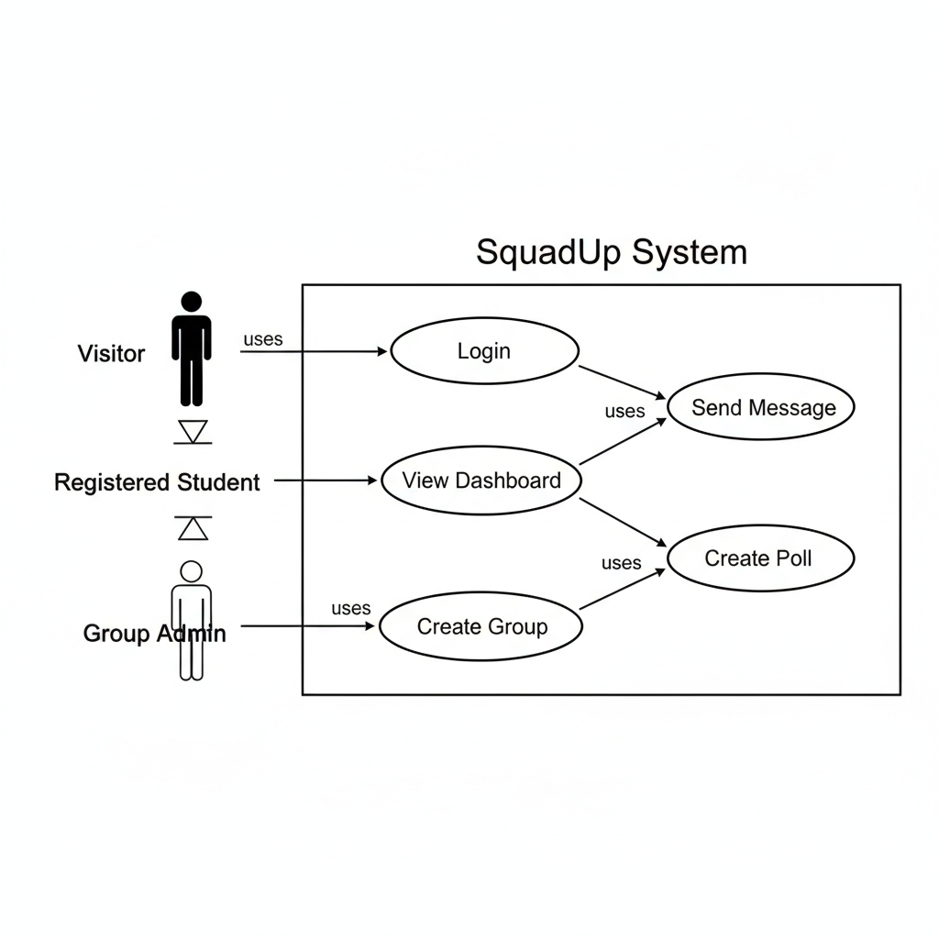

B.2 Entity-Relationship Diagram (simplified)
- User —(creates)→ Group (admin)
- User —(member of)→ Group (many-to-many)
- Group —(contains)→ Message
- Group —(contains)→ File
- Message —(may contain)→ Poll (embedded)

B.3 Data Flow Diagram – Level 0 (Context) External entity: User ↔ SquadUp System ↔ Email Service

B.4 Sequence Diagram – Example: Send Message User → Frontend → Socket.IO → Backend → MongoDB → Broadcast to group members
────────────────────────────
Appendix C: Issues List
# | Issue Description | Status | Priority | Proposed Resolution / Remark
1 | Message deletion after sending | Open | Medium | Not implemented in v1.0 (risk of misuse); consider for phase 2
2 | Cloud file storage (AWS S3 / Cloudinary) | Deferred | High | Local filesystem sufficient for demo
3 | Rate limiting on API & Socket.IO | Open | Medium | Add in future to prevent spam
4 | Browser push notifications | Deferred | Medium | Out of scope for initial submission
5 | Message search in long chats | Open | Low | Nice-to-have future feature
6 | End-to-end encryption | Deferred | High | Not required for academic project
7 | Typing indicators (“User is typing…”) | Deferred | Low | Easy Socket.IO addition in future
8 | MongoDB backup strategy | Open | Medium | Manual mongodump sufficient for now

