Session-1

Introduction_to_web_technologies
1.Open Instagram's home page in Chrome, right-click on a post image, and use Inspect Element to find the exact HTML tag and CSS class used for the image container. Write down the tag name and class.

2.Create a simple HTML file named myprofile.html that displays your name, a short bio, and a profile picture using appropriate HTML tags (h1, p, img). Open it in your browser and view the result.

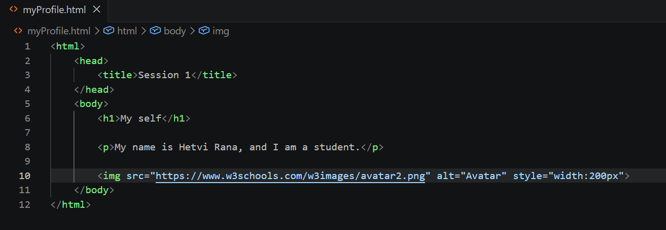
Output:
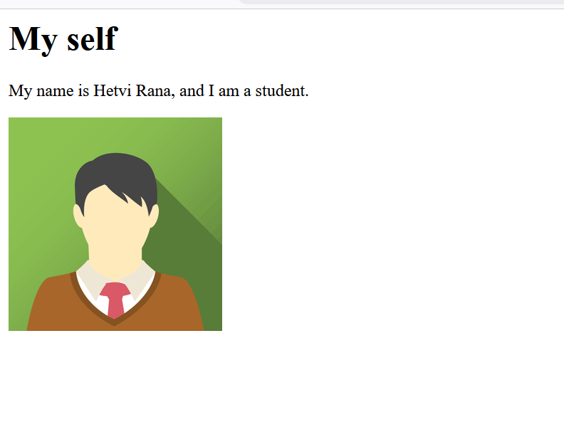
3. Use Chrome DevTools to change the background color of your name (in myprofile.html) to any color you like, live in the browser, without editing the HTML file.

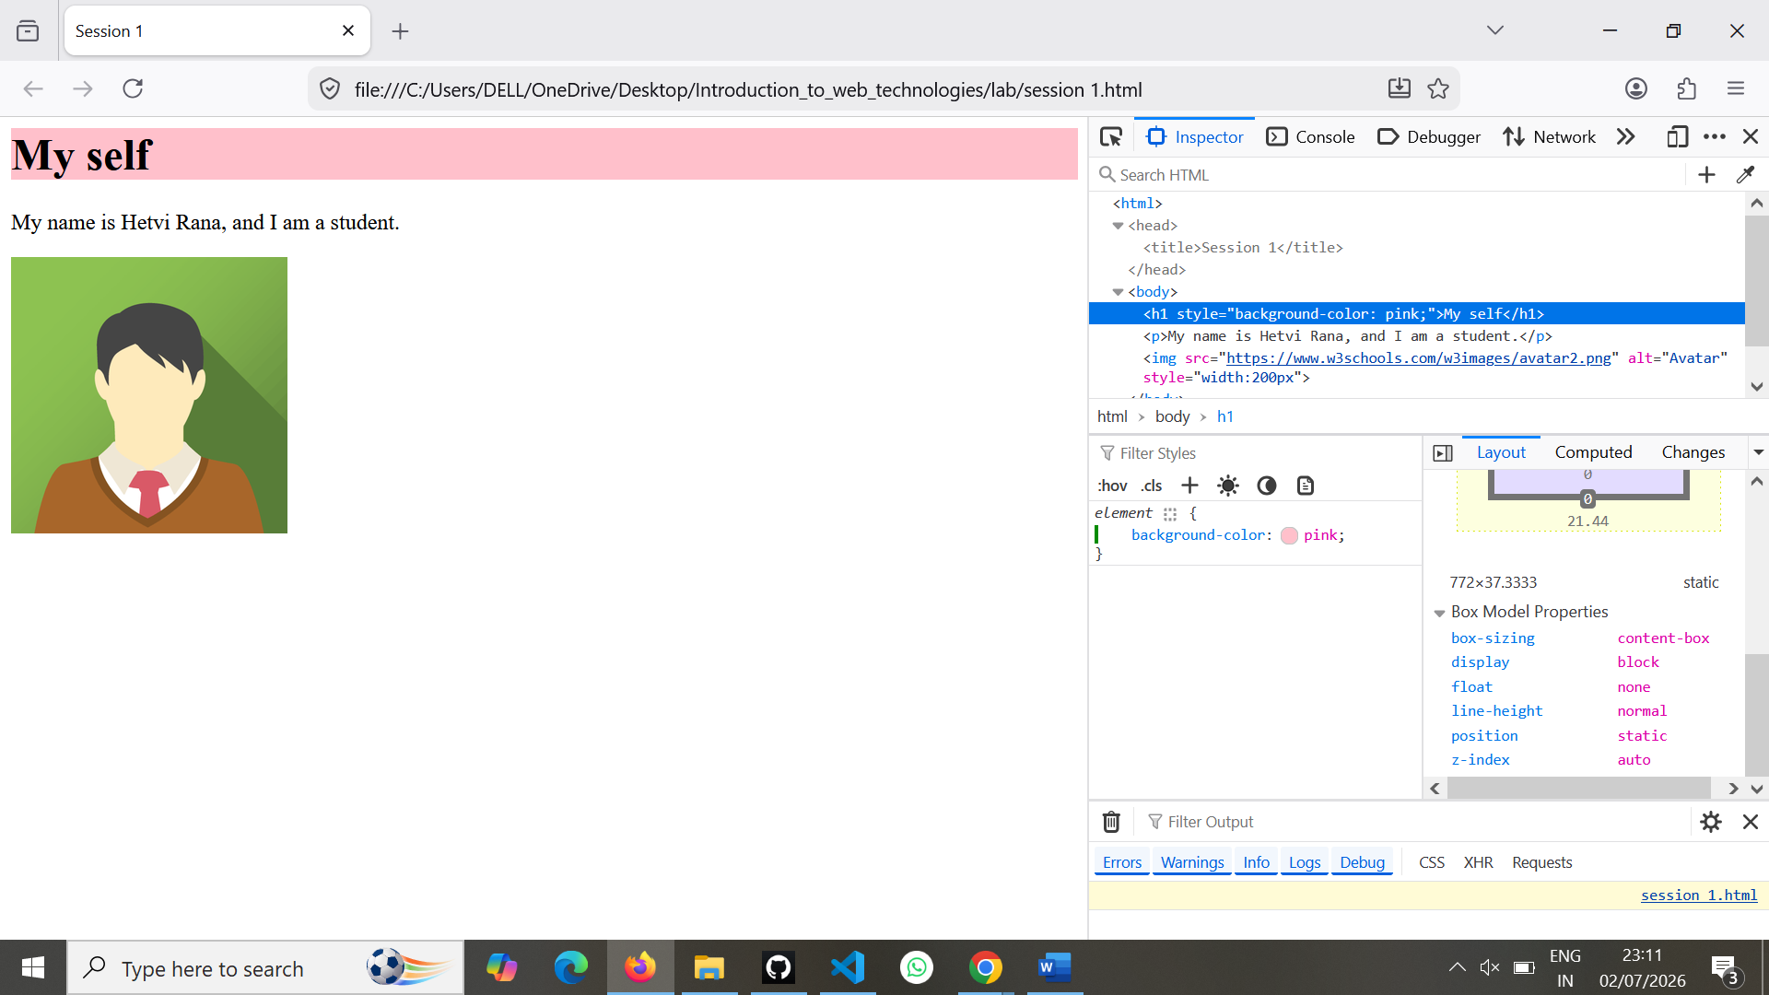

4.Draw a diagram or write a list showing the DOM structure (parent-child relationships) of your myprofile.html page. Include at least 3 levels (html > body > your content).

DOM Structure
html
│
├── head
│ └── title
│
└── body
├── h1
├── p
└── img
Parent-Child Relationship

- html
  - head
    - title
  - body
    - h1
    - p
    - img

