Session-1

Introduction_to_web_technologies
1.Open Instagram's home page in Chrome, right-click on a post image, and use Inspect Element to find the exact HTML tag and CSS class used for the image container. Write down the tag name and class.

- <div style="padding-bottom:85.90225563909775%" class="_aagv">
<img alt="Photo by Shri Dwarkadhish Mandir on July 07, 2026. May be an image of barong, headdress, tambourine, sugarcane and text." class="x5yr21d xu96u03 x10l6tqk x13vifvy x87ps6o xh8yej3" crossorigin="anonymous" src="https://instagram.famd5-4.fna.fbcdn.net/v/t39.30808-6/740881115_15100…_ss=7a22e&oh=00_AQAQsmCPHSYegcNB3RHA0lqLBL9us9n9Z-StIsAbMusvxQ&oe=6A53F67A" style="object-fit:cover">

2.Create a simple HTML file named myprofile.html that displays your name, a short bio, and a profile picture using appropriate HTML tags (h1, p, img). Open it in your browser and view the result.

<!DOCTYPE html>
<html lang="en">
<head>
<meta charset="UTF-8">
<title>My Profile</title>
</head>
<body>
<h1>Hetvi</h1>
<img src="profile.jpg" alt="Photo of Hetvi" width="200">
<p>
BCA student focused on backend development with Python and
Django. I enjoy building small projects to sharpen my web
development and problem-solving skills.
</p>
</body>
</html>

3. Use Chrome DevTools to change the background color of your name (in myprofile.html) to any color you like, live in the browser, without editing the HTML file.

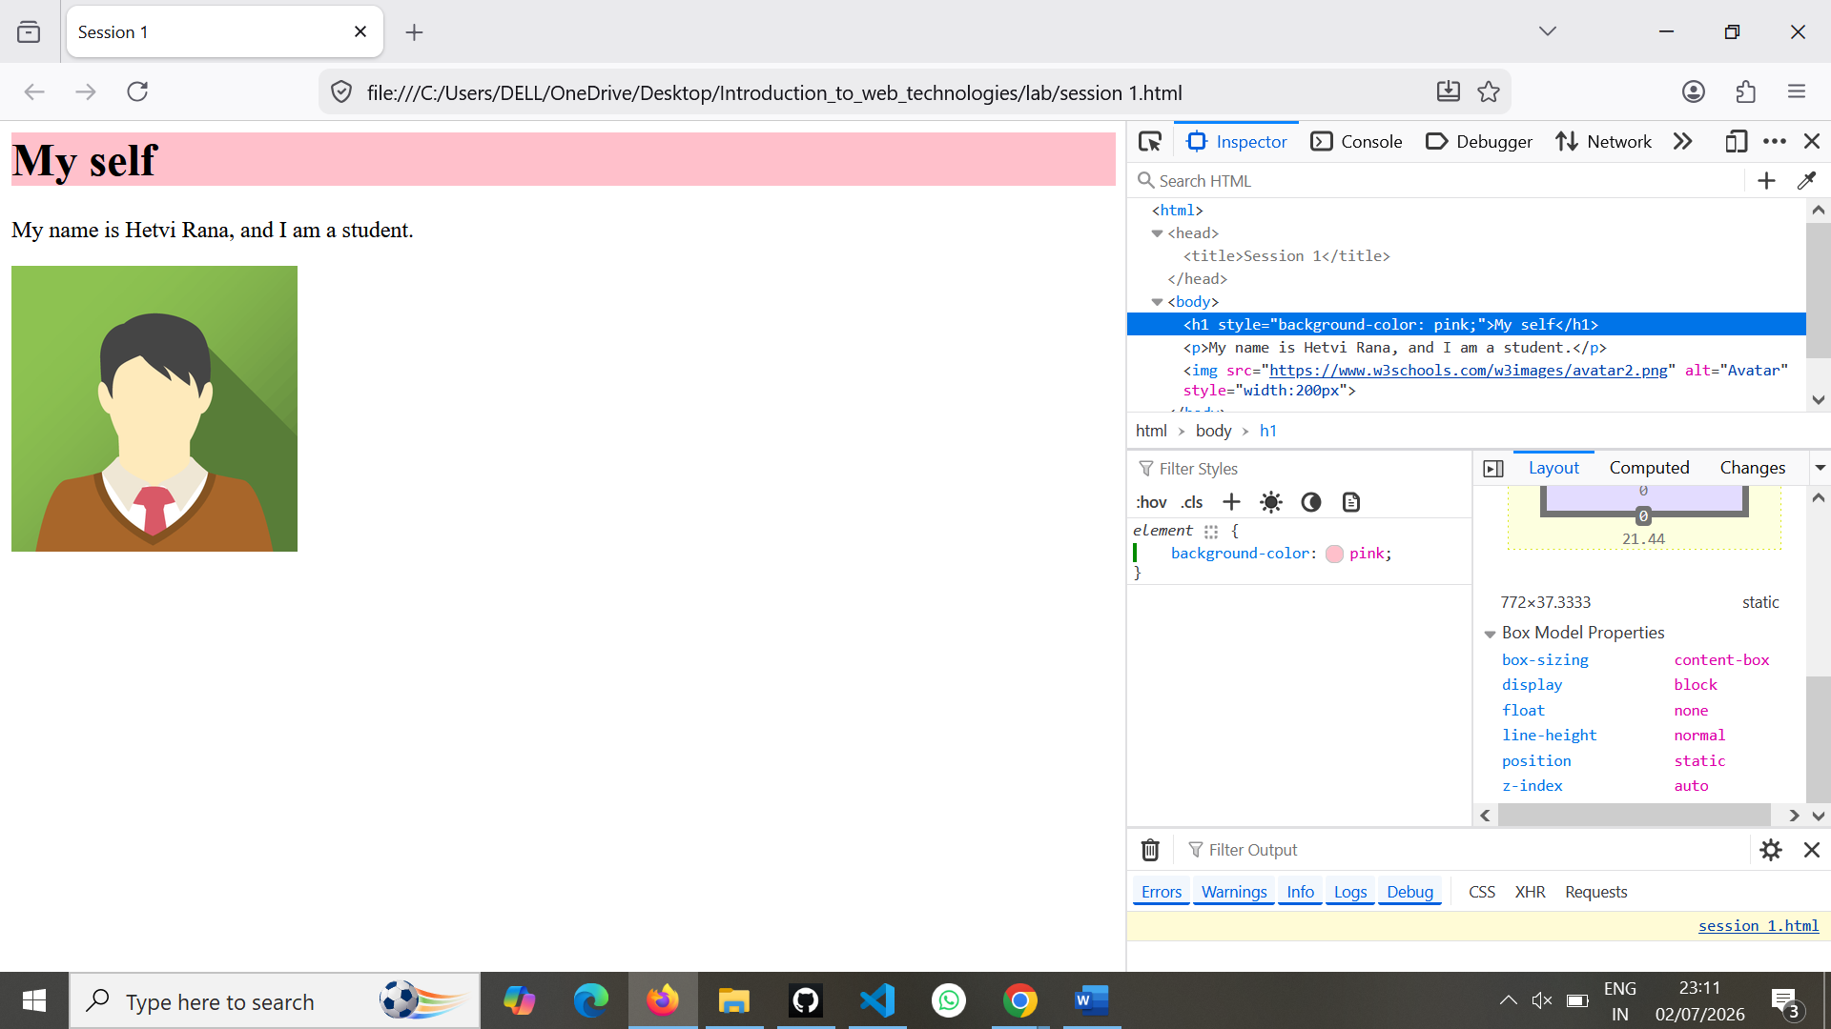

4.Draw a diagram or write a list showing the DOM structure (parent-child relationships) of your myprofile.html page. Include at least 3 levels (html > body > your content).

DOM Structure::
html
│
├── head
│ └── title
│
└── body
├── h1
├── p
└── img
Parent-Child Relationship::

- html
  - head
    - title
  - body
    - h1
    - p
    - img

