**FTP sampler**

Open jmeter and add thread group

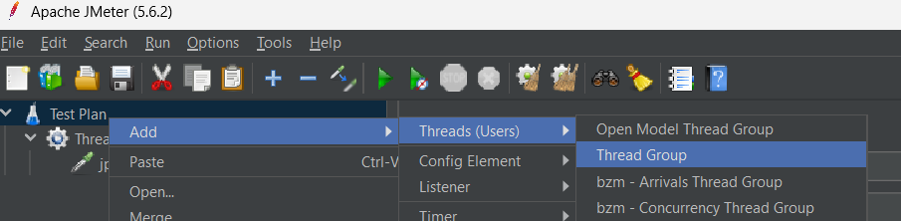

Add ftp request defaults

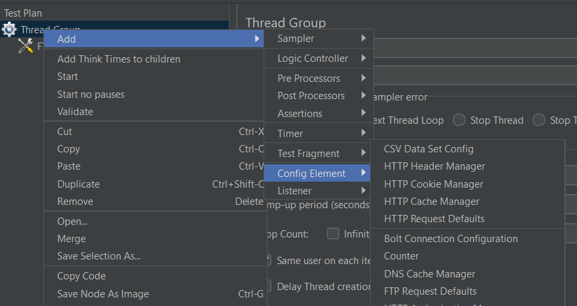

Add ftp sampler request

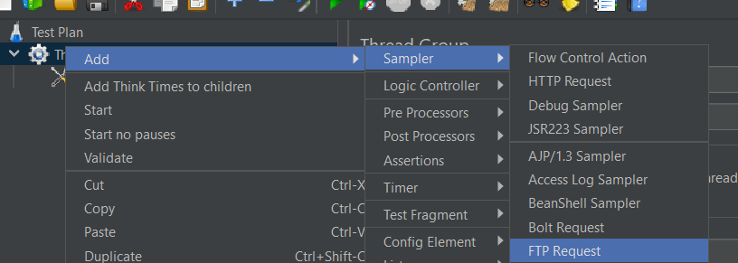

Add the server ip, filename, username and password to get the file

You can get a file or send a file

Add listener to see the output

