**OS process, debug and test action sampler – script**

Open jmeter and add thread group. You can add multiple thread groups

Right click and add os process sampler

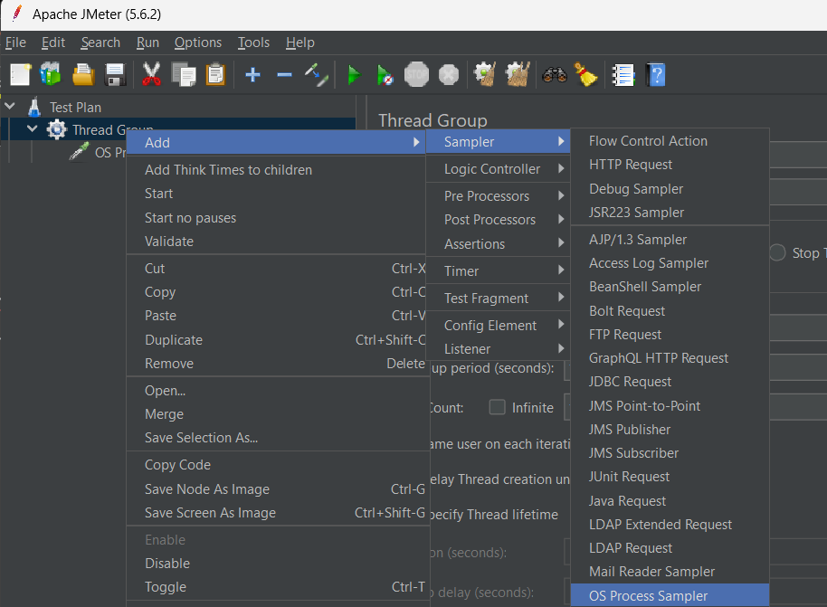

It can perform OS commands which we use in cli

