**Random and Random order controllers**

Add a thread group

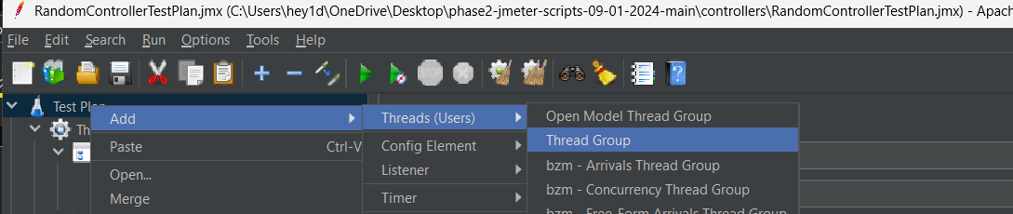

Add random controller

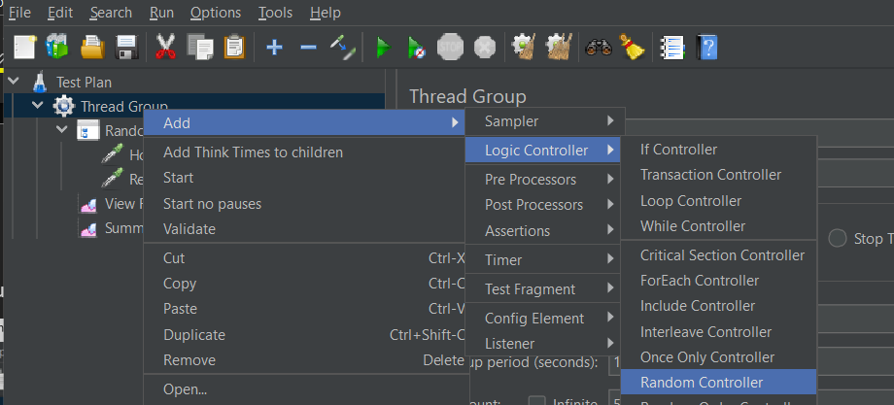

Add http request, a listener to view the output

Random controller runs random number of requests

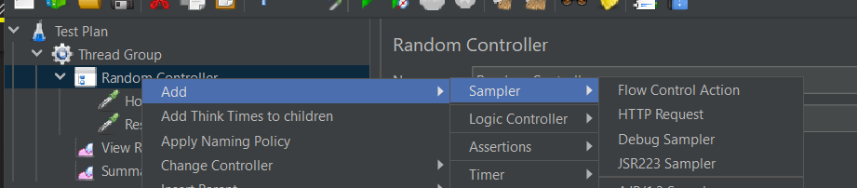

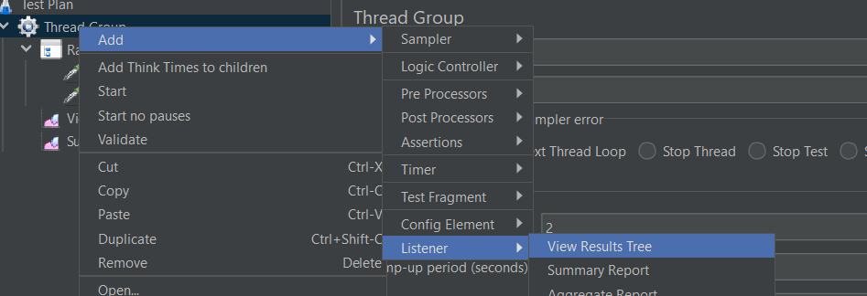

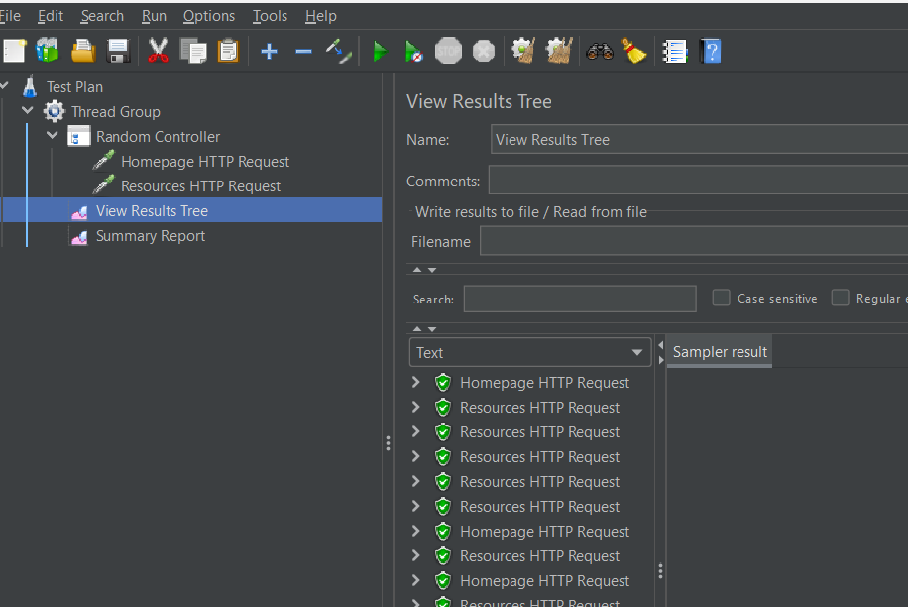

Random order controller

This is used to run tests randomly with same number of tests

Adding random order controller

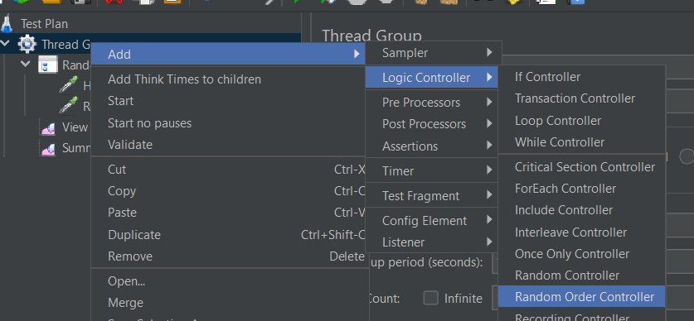

Result

