**Interleave controller**

Add a thread group

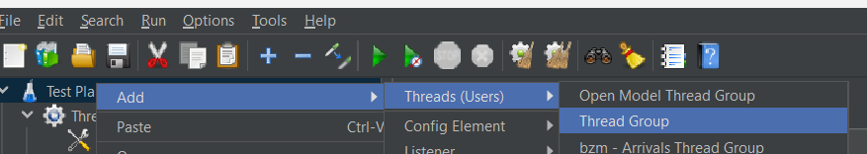

Add a random controller and http requests in it

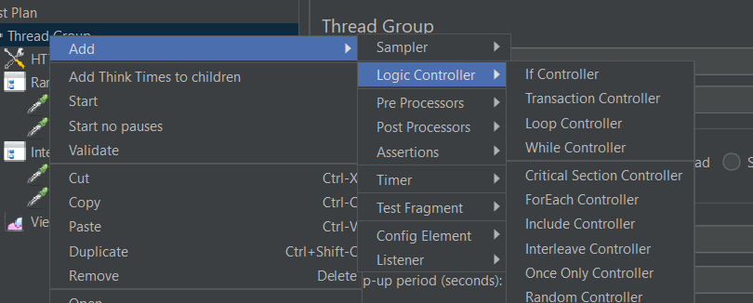

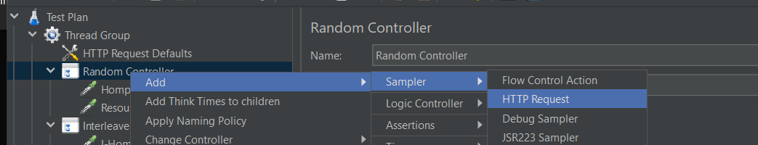

This will help you to understand interleave controller

Add interleave controller

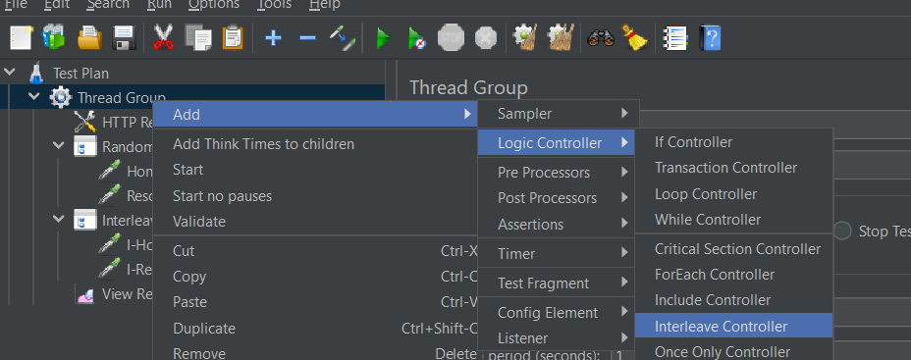

Now when you run the test interleave controller selects a request on one loop and selects the other requests in order with other loops

