**Throughput controller**

Add a thread group

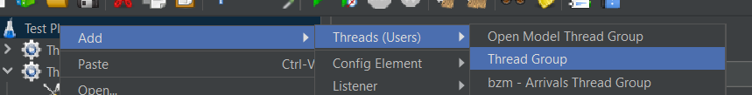

Add a throughput controllers

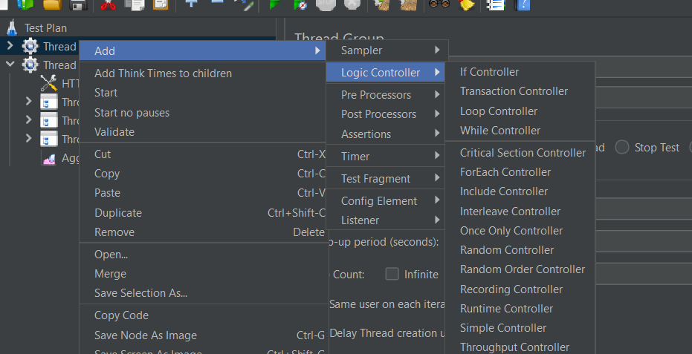

Add http requests under that controller



Throughput controller is used to define number of times the test can run by giving it a percentage value

Adding a listener to see the output

Aggregate report

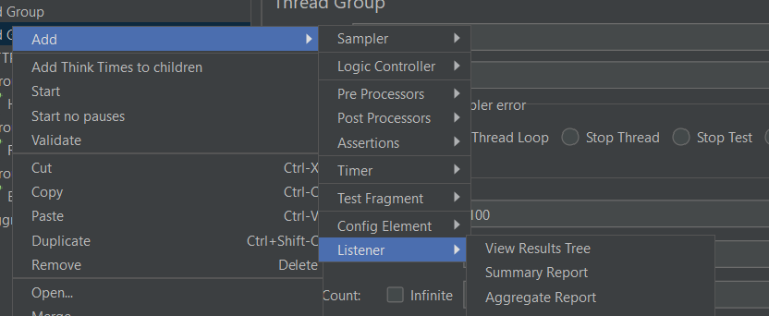

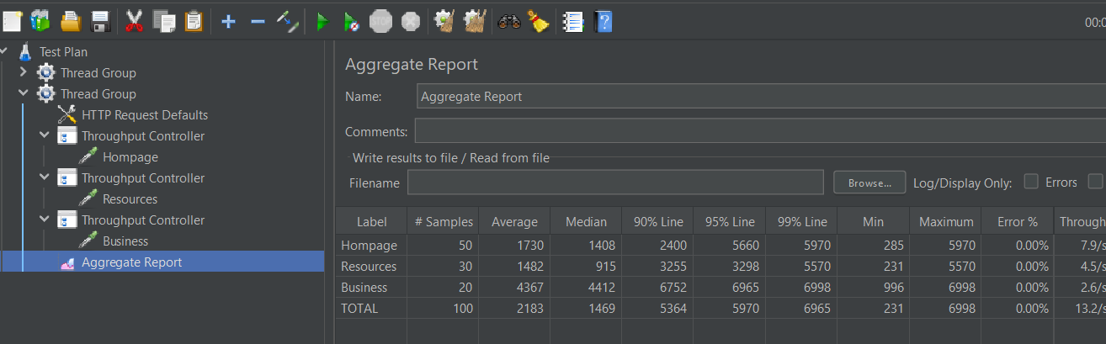

We have added 3 throughput controllers and each having http request and we give values to them

So that the requests are executed according to the percentage value