**Runtime controller**

Add a thread group

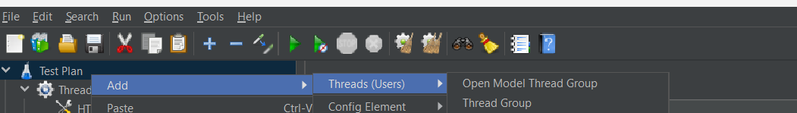

Add a runtime controller

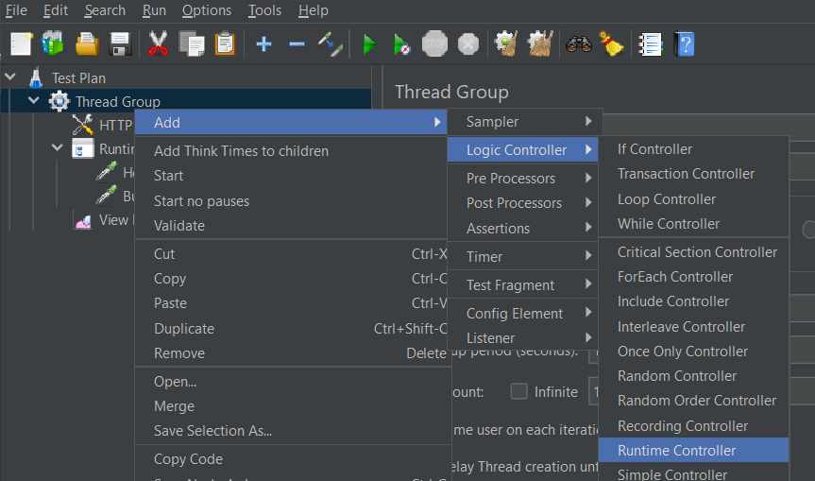

Add http request under it

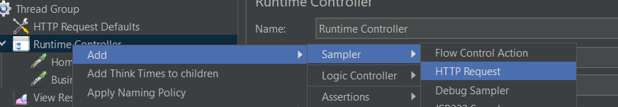

Runtime controller keeps tests running until given time

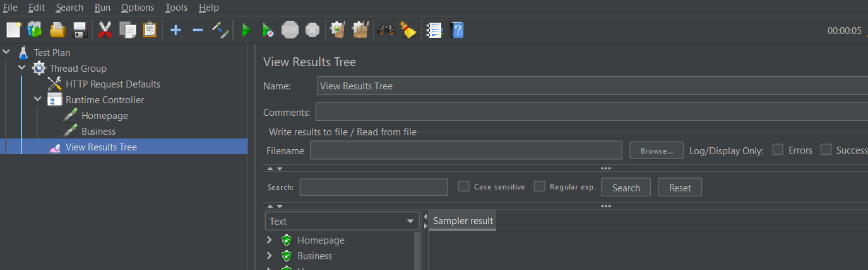

Here we mentioned 5 seconds. So, the tests keep running for 5 seconds