**If and while controllers**

Add thread group

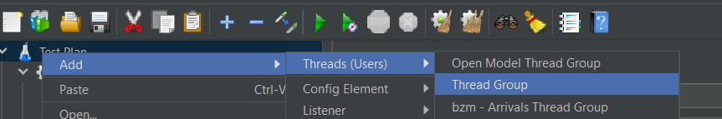

Add a if controller

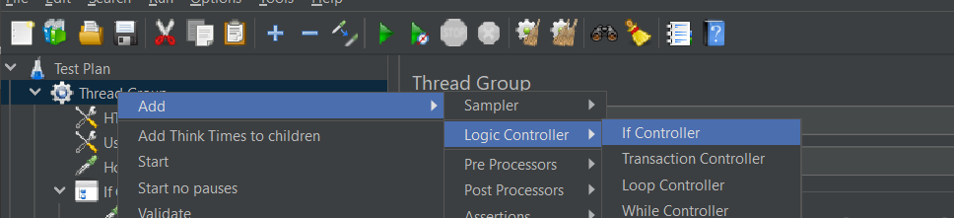

Under it add a http request

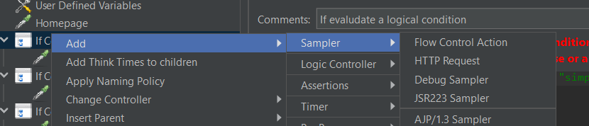

You can use a condition to run the http request

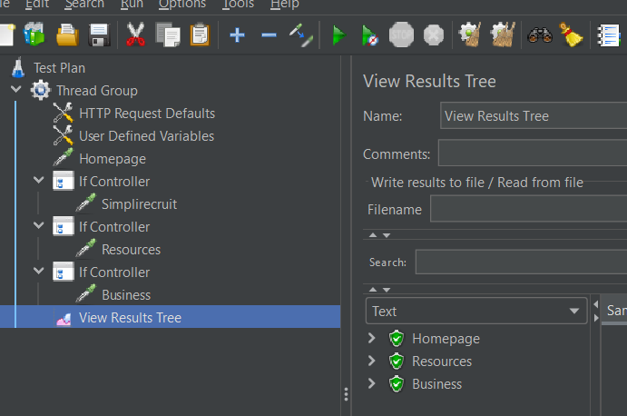

Same way add a while controller

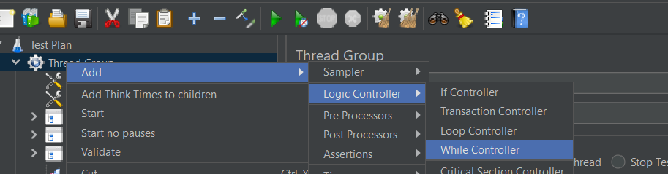

While controller is used to run tests repeatedly until it meets the condition