**Switch, module, and include controller**

Add a thread group

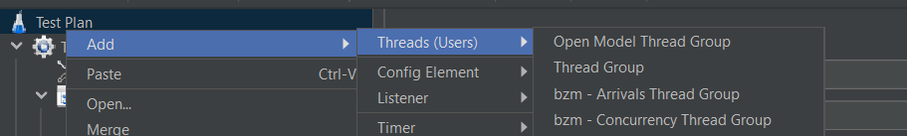

Add switch controller

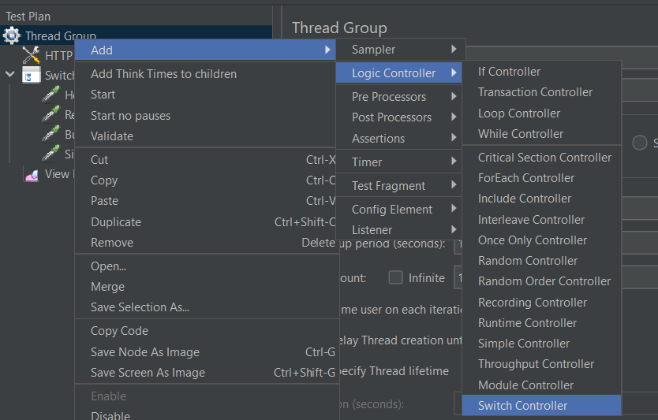

Switch controller is used to execute tests based on the value

Add listener to see the output

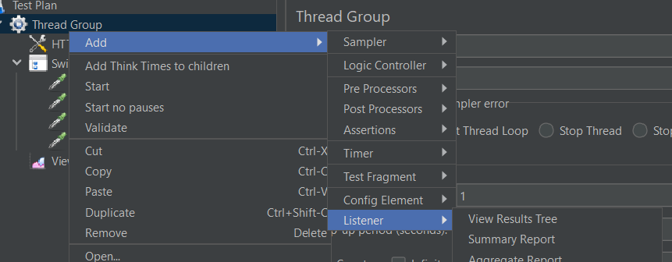

Result

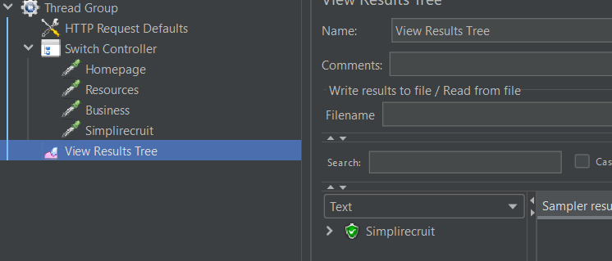

The value we provided in switch is 3 so last one gets executed

Add module controller

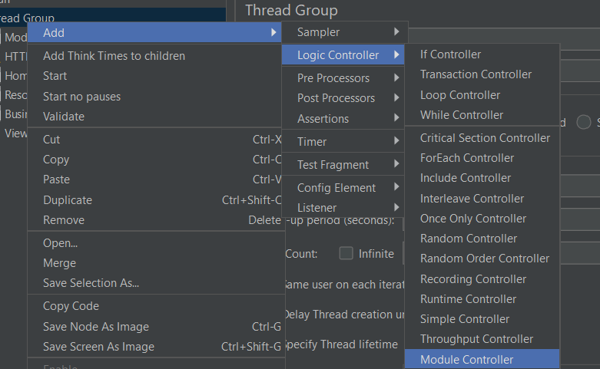

Using module controller we can run the selected fragments or modules

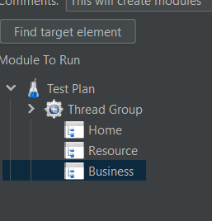

Result

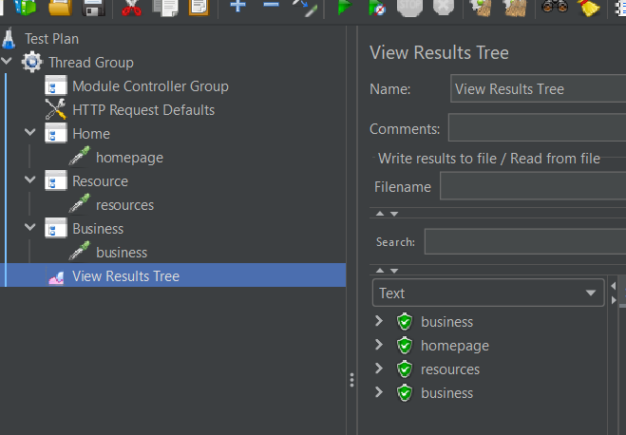

Add include controller

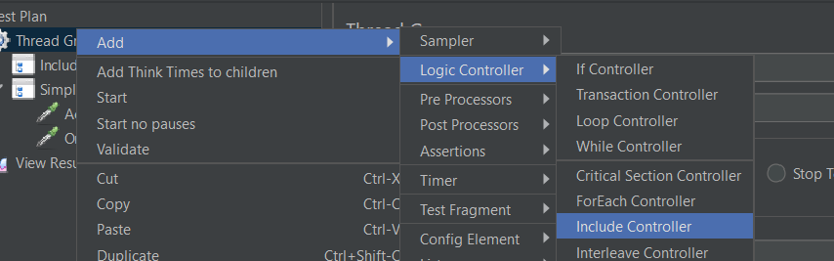

Include controller helps you to run tests from other jmeter files

We have to include jmeter in the current file

Result

