**For each controller with regular expression extractor**

Add a thread group

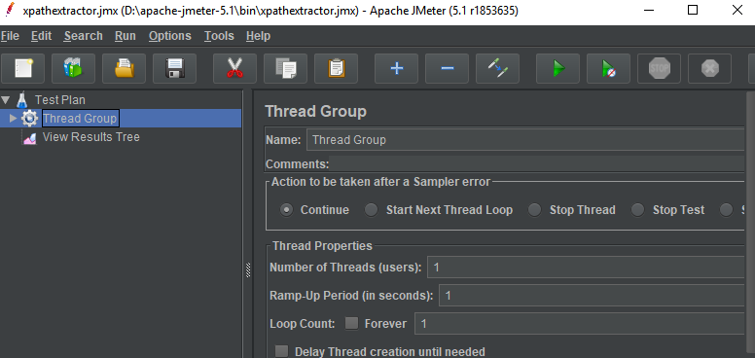

Add http request

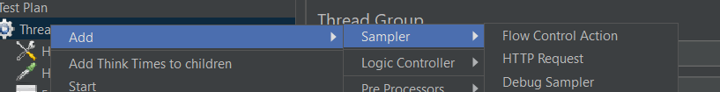

Add for each controller

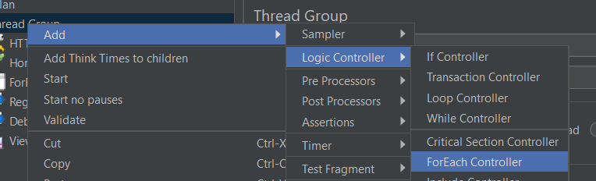

For each controller is used to loop through each entry in the JSON Array and make the HTTP requests to the URLs.

Result

