**For each controller with xpath extractor**

Add a thread group



add a for each controller

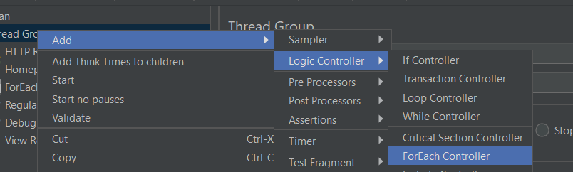

Add xpath extractor under it

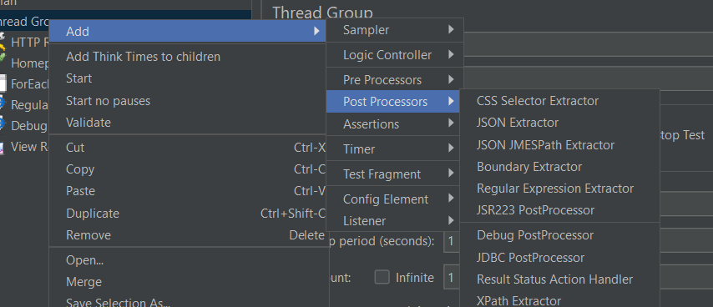

The xpath extractor is particularly useful when working with xml or html responses, allowing you to extract specific pieces of data and use them in subsequent requests or for validation purposes in your performance tests

add a listener to see the output

