**Pre and post processors**

Add a thread group



Pre processor is a JMeter element that allows you to execute specific actions or modifications before a sampler runs.

Adding a pre processor

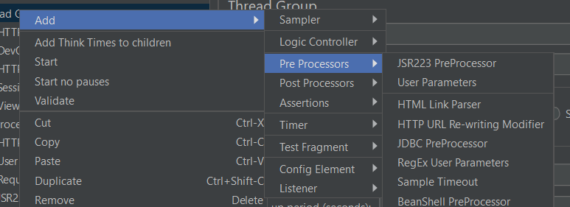

Add HTTP URL Re-writing Modifier, which helps you to use caching session id, url encoding

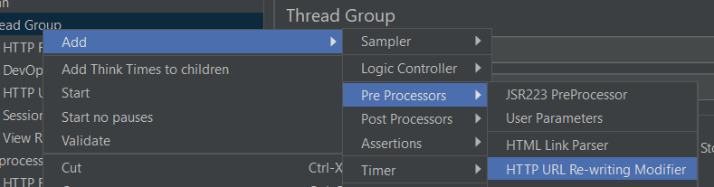

Result

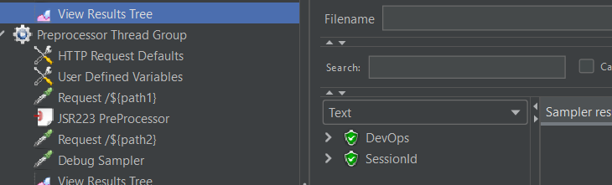

Post processor allows you to extract information from the response received after the execution of a sampler

Add post processor

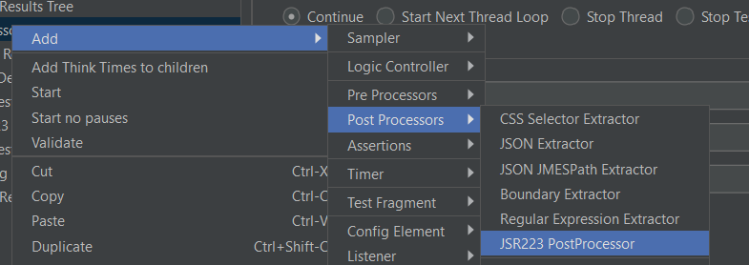

Result

