**XML and XML schema assertion**

Add a thread group



Add a sampler

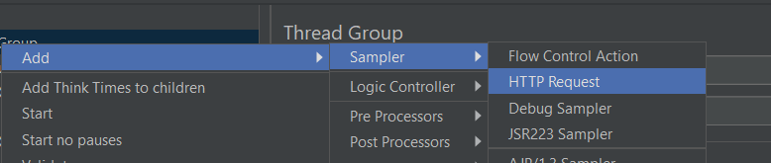

Add xml assertion

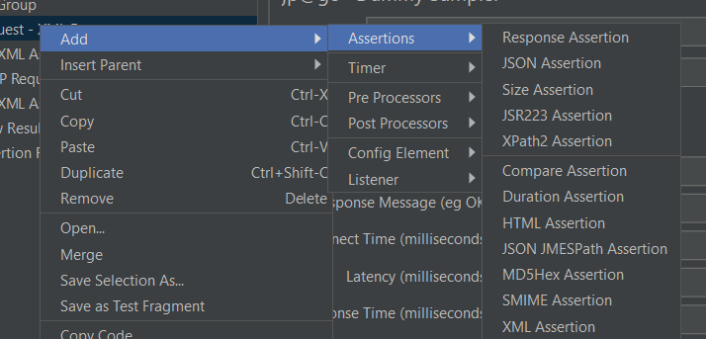

Xml assertion is used to check whether the response from a sampler meets the certain criteria

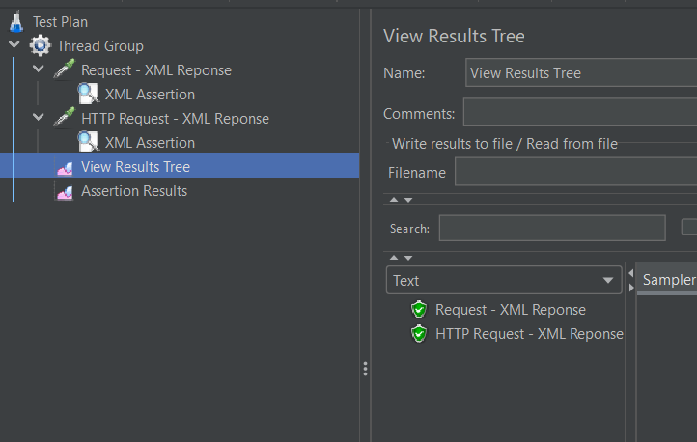

Xml schema assertion

Add xml schema assertion

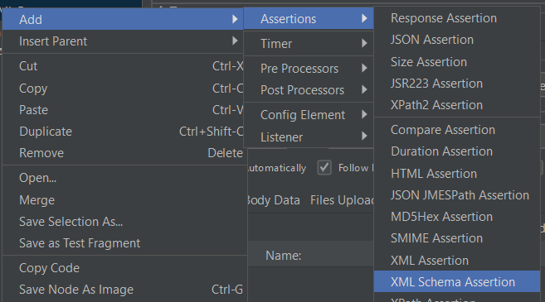

It allows you to validate XML responses against and XML schema definition

Result

